Final Submission
Digital Dice Rolling Application
Reed Fox and Elijah Satrom
Directly used functions:
- Rolling(Dice which have just been rolled)
- Resetting(Dice which have just been reset)
- Direct manipulation of dice through motion control(A die being actively manipulated)

Other functions:
- Rolling Function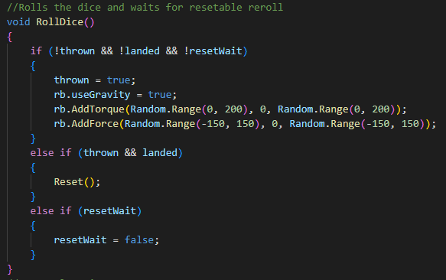 (called when “rolling” as previously mentioned. As parts of this are abstract, it cannot be shown graphically any better than the user-controlled function.
- Automatic resetting based on position (A die having its position controlled by the wall, this function is more sophisticated than just this, resetting any dice which were teleported outside the box by some sort of glitch)
- Output calculation (note, this is not displayed, though a result for each roll is calculated) 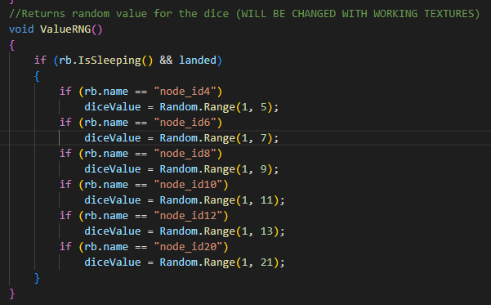 Unable to be displayed in project, though it is implemented and executes during run. Generates an output for die when rolled.

Citation/Resources Used:
- Dice Models - https://sketchfab.com/3d-models/simple-rpg-dice-982af89a4f63466cb873b73e95f1e84a
- UltraLeap Unity Plugin for LEAPMotion (Motion controls)
- Unity

