The following query replaces the IDs of the students and managers in the occurs table for more readability.

SELECT m.name as manager, s.name as student, w.name as write_up, to_char(o.dTime, 'DD-Mon-YYYY') as assign_time

FROM occurs o

JOIN managers m ON o.mid = m.id

JOIN students s ON o.sid = s.id

JOIN writeUps w ON o.wid = w.id

ORDER BY o.dTime;

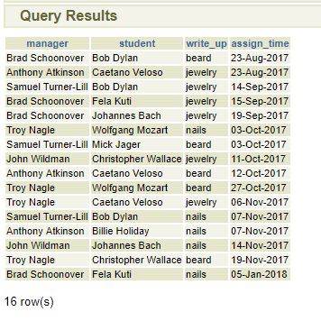

-- Number of times managers have used certain types of write ups

SELECT m.name as manager, w.name as write_up, COUNT(*)

FROM occurs o

JOIN managers m ON o.mid = m.id

JOIN writeUps w ON o.wid = w.id

GROUP BY m.name, w.name

ORDER BY w.name;

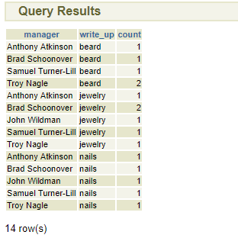

-- Number of times mangers have written up certain students:

SELECT m.name as manager, s.name as student, COUNT(*)

FROM occurs o

JOIN managers m ON o.mid = m.id

JOIN students s ON o.sid = s.id

GROUP BY m.name, s.name

ORDER BY s.name;

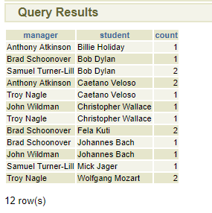

-- Number of different types of write ups each student received

SELECT s.name as student, w.name as write_up, COUNT(*)

FROM occurs o

JOIN students s ON o.sid = s.id

JOIN writeUps w ON o.wid = w.id

GROUP BY s.name, w.name

ORDER BY s.name;

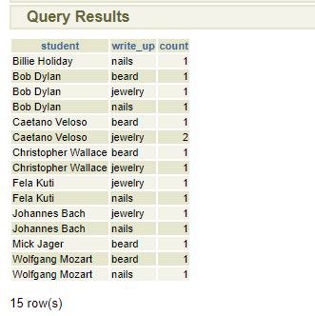

-- Replace ids with names in the works table to make it more readable

SELECT s.name as student, d.name as day, to_char(w.strt, 'HH:MI:SS AM') as start, to_char(w.fnsh, 'HH:MI:SS AM') as finish, a.name as area, j.name as job

FROM works w

JOIN students s ON w.sid = s.id

JOIN days d ON w.did = d.id

JOIN areas a ON w.aid = a.id

JOIN jobs j ON w.jid = j.id

ORDER BY w.did, w.strt;

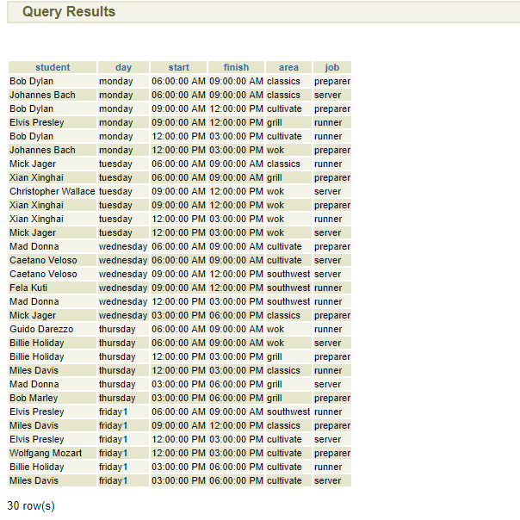

-- Get all write ups for all students that work together

SELECT m.name as manager, s.name as student, wr.name as write_up, to_char(o.dTime, 'DD-Mon-YYYY') as assign_time, d.name as work_day, a.name as work_area, to_char(o.strt, 'HH:MI:SS AM') as work_time

FROM (SELECT o.mid, w.sid, o.wid, o.dTime, w.did, w.aid, w.strt

     FROM occurs o

     RIGHT JOIN (SELECT w1.sid, w1.did, w1.aid, w1.strt

                 FROM works w1

                 JOIN works w2 ON w1.aid = w2.aid AND w1.did = w2.did AND w1.strt = w2.strt AND NOT w1.sid = w2.sid) w

     ON o.sid = w.sid) o

LEFT JOIN managers m ON o.mid = m.id

LEFT JOIN students s ON o.sid = s.id

LEFT JOIN writeUps wr ON o.wid = wr.id

LEFT JOIN days d ON o.did = d.id

LEFT JOIN areas a ON o.aid = a.id

ORDER BY o.did, a.name, o.strt;

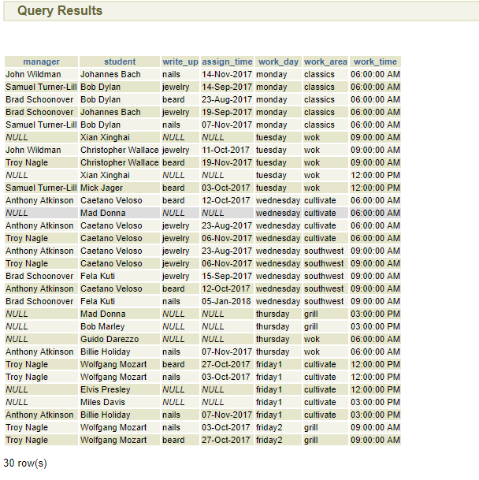

-- Get number of strikes for all students that work together

SELECT s.name as student, d.name as day, a.name as area, to_char(o.strt, 'HH:MI:SS AM') as time, COUNT(o.wid) as strikes

FROM (SELECT o.mid, w.sid, o.wid, o.dTime, w.did, w.aid, w.strt

     FROM occurs o

     RIGHT JOIN (SELECT w1.sid, w1.did, w1.aid, w1.strt

                 FROM works w1

                 JOIN works w2 ON w1.aid = w2.aid AND w1.did = w2.did AND w1.strt = w2.strt AND NOT w1.sid = w2.sid) w

     ON o.sid = w.sid) o

LEFT JOIN students s ON o.sid = s.id

LEFT JOIN days d ON o.did = d.id

LEFT JOIN areas a ON o.aid = a.id

GROUP BY s.name, d.name, a.name, o.strt

ORDER BY d.name, a.name, o.strt;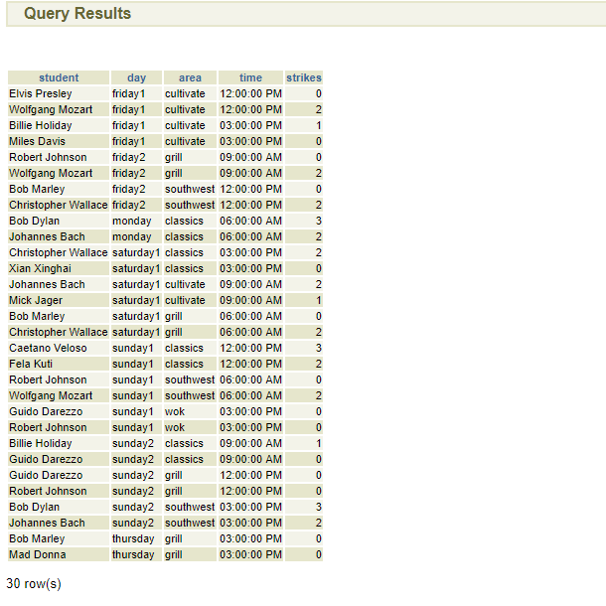

-- Get the schedules of students who have been put on the offenders table

SELECT s.name as student, d.name as day, to_char(w.strt, 'HH:MI:SS AM') as start, to_char(w.fnsh, 'HH:MI:SS AM') as finish, a.name as area, j.name as job, to_char(o.dTime, 'DD-Mon-YYYY') as strike_date

FROM works w

JOIN offenders o ON w.sid = o.sid

JOIN students s ON w.sid = s.id

JOIN days d ON w.did = d.id

JOIN areas a ON w.aid = a.id

JOIN jobs j ON w.jid = j.id

ORDER BY w.did, w.strt;

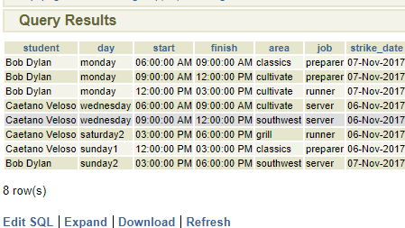

-- Get all the students with a certain number of strikes

SELECT s.name as student

FROM (

   SELECT o.sid, COUNT(*) as count

   FROM occurs o

   GROUP BY o.sid

) c

JOIN students s ON c.sid = s.id

WHERE c.count = {}