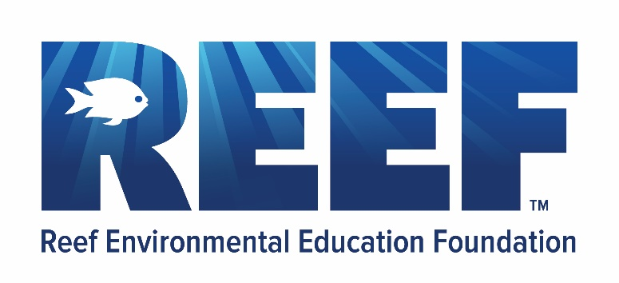

REEF Ocean Explorers Expedition Agreement
The Benjamin School

The Benjamin School
Erin Gigele
7th Grade Marine Science
561-626-3747 (ext. 3362)
erin.ryan@thebenjaminschool.org

Contract Date: 9/2/2025

Program Dates: 4/16/26- 4/17/26
Program Location: Key Largo: REEF Campus, Pennekamp Coral Reef State Park, MOTE Coral Nursey

Total Participants: 90
Total Program Cost Rate: $24,510
Program Rate Per Person (90): $272

Program Information:
The 2-day REEF Ocean Explorers Expedition includes two full days of educational programming led by REEF marine life experts for 90 students and 10 free of charge chaperones. This includes the Volunteer Fish Survey Project includes Fish ID & Behavior lessons, and a snorkel trip by boat on a coral reef to conduct fish surveys for REEF’s marine life database. It also includes lessons in Florida Ecology and Invasive Species including a kayaking tour through the mangroves, educational activities centered around lionfish, and lesson/tour of MOTES Coral Nursey. REEF materials also include a Volunteer Fish Survey Starter Kit (fish identification card, survey slate, survey paper, wrist band), and the use of lionfish dissection materials. Travel, meals, and accommodations are not included in the package price.

Program Overview:
Topics covered during the 2 days of instruction will include:
- Marine Fish ID
- REEFs Volunteer Fish Survey Project (Citizen Science)
- Florida Keys Ecology
- Invasive Species; Lionfish

REEF Ocean Education and Conservation Program Payment Policies

Payment Options:
- Checks payable to REEF. Send to PO Box 370246, Key Largo, FL 33037
- Pay directly through your bank account with ACH
- Credit or Debit card
Please note that if you choose to pay by credit or with debit card, an additional 2.4% charge will apply to your total.

Payment Schedule:
To secure your group’s space, the following deposit schedule applies:

Booking greater than 180 days before the program start:
- $1000 deposit to secure your group’s space
- Payment #2 (50% of the remaining balance) is due 180 days/6 months before the program starts.
- Final Payment (remaining balance) due 90 days/3 months before the program starts.

Booking between 90 – 180 days before the program start:
- $500 deposit (amount may vary depending on the program, please see above) plus Payment #2 (50% of remaining balance) due at the time of booking.
- Final Payment (remaining balance) due 90 days/3 months before the program starts.

Booking 90 days or fewer before the program start:
- Amount in full due. 100% of the program price.

If payment is not received within 14 days past the due date, a 10% late fee will be added to the balance owed. If a payment is outstanding for 30 days, the group's program space may be released, and all funds paid will be forfeited.

Group Deposit Information:
$1000 to secure group space
$11,755 by 8/18/2025 (Half after 1000)
$11,755 by 1/16/2026 (Final Payment)

Cancellations:
Cancellations: If your plans change and you must cancel your program, the following schedule applies. This cancellation schedule and policy will also apply if group size decreases by 50% or greater. Notifications must be made in writing.
- Cancellation greater than 90 days in advance: full refund, minus $100 per day of scheduled programming. For example, if your REEF Expedition includes 4 days of programming, there will be a $400 cancellation fee.
- Cancellation between 60 - 90 days of the program: 50% of the total deposit on hand with REEF at the date of cancellation is refundable
- Cancellation fewer than 60 days from the program date: No refunds available.

When a credit is issued due to a cancellation (by the participants or vendor), REEF will apply the credit to outstanding invoices for other programs first and then issue a refund of any remaining credit per the refund policy terms. Participants can also convert any refund owed to a charitable donation to REEF.

Credit on hand must be used within two years of issue unless other arrangements have been made.
REEF may alter the payment schedule or cancellation policy based on vendor rules for a particular program. Any variations from the standard policy will be provided in writing in the program-specific agreement.

Travel & Dive Insurance
REEF strongly recommends that each REEF Explorer’s Program group or participant carry adequate travel and dive insurance (if applicable) to protect themselves in advance against any unforeseen circumstances that may occur with travel. Any liabilities for program interruptions, cancellations, or general travel disputes will be the responsibility of the group/participant. Please read the information on your travel and/or dive insurance policy for a full understanding of the coverage.

Program Terms:
An adult chaperone must accompany student groups with participants under 18. The teachers/adult chaperones accompanying the group are directly responsible for students at all times, including during free time and meals and in the overnight lodging.
If the program includes scuba diving, all participants must be at least Open Water Scuba Certified before arrival.
Scuba tanks and weights will be provided for each participant. All other scuba equipment is the responsibility of the participant.
REEF staff will work with the dive or snorkel operator to plan a schedule that best meets the needs and objectives of the group. However, the charter operation crew and boat captain(s) ultimately make all dive/snorkel site and schedule decisions. A trip may have to be diverted in cases of weather conditions if the dive operation feels that there is a safety risk.
REEF Education Programs require a minimum number of participants. Program prices are subject to change or cancellation if the number of participants changes from the original agreement. In the event of a program cancellation, REEF and/or any of our program booking partners are not responsible for airline tickets purchased for travel or other expenses before the program.

Liability Forms:
All REEF program participants must submit a signed REEF Liability Form before the program. Visit https://waiver.smartwaiver.com/w/6087251614121/web/ to complete the online form. In addition to the above Liability Form, REEF Invasive Lionfish Study participants must also submit a signed Lionfish Assumption of Risk form before the trip. Visit https://www.smartwaiver.com/v/lionfishwaiver/. Additional waivers will be necessary via outside vendors, including, but not limited to, dive and snorkel operators and kayaking operators.

Liability and Insurance:
Neither party to this agreement shall be responsible for any obligation or liability incurred or assumed by the other party or its employees, affiliates, or representatives. Each party shall be responsible for its own acts or omissions and those of its employees, affiliates, or other representatives. Nothing contained herein is intended to shift such responsibility from one party to another.

REEF will provide instructional services and educational programming focused on ocean science. REEF will coordinate logistics and secure reservations with independent vendors for the group excursions, such as snorkeling, diving, kayaking, housing, and other amenities. These independent vendors are responsible for following their industry’s safety protocols and operations standards and maintaining all relevant liability insurance.

Booking Group REEF

Signature Signature

Position Title and Organization Education Coordinator

Print Name Rose Kelly

Date Date

