COE305 MACHINE LEARNING
Final Project Report
Rebuilt notebook — results regenerated from a fresh Google Colab run
Deadline: 04-01-2026
Project Title:
Scalable Multi-Failure Predictive Maintenance System with Confidence-Based Prioritization and Resilience to Unknown Failures
Abstract (150-200 words)
Industrial predictive maintenance systems often focus only on detecting known failure patterns using static models and assume sensor data is always reliable. This limitation makes such systems ineffective in adapting to new failure behaviors, evolving machine conditions, and potentially unreliable sensor inputs.
In this project, we develop a machine learning-based predictive maintenance system capable of classifying multiple machine failure types using historical sensor data while maintaining robustness and adaptability.
The proposed system utilizes structured machine sensor data from a publicly available dataset containing 10,000 records and multiple operational features. A complete preprocessing pipeline was implemented, including data cleaning, encoding, scaling, outlier handling, and extensive exploratory data analysis (EDA). Several machine learning classification models were trained and evaluated using K-Fold cross-validation to ensure robust performance assessment, all wrapped in a single reusable scikit-learn pipeline (ColumnTransformer + model) to guarantee identical preprocessing at train, tuning, and explainability time.
Baseline models such as Logistic Regression, Random Forest, and Support Vector Machines were evaluated using multiple performance metrics, including accuracy, precision, recall and F1-score. Results show that ensemble-based approaches (LightGBM, XGBoost, CatBoost) outperform simpler linear and kernel models overall, though with consistent scaling the gap between Logistic Regression and Random Forest narrowed considerably.
This project demonstrates the effectiveness of machine learning in predictive maintenance scenarios and provides a strong foundation for future enhancements such as adaptive learning, ensemble tuning, and explainability analysis.
Introduction
- Background of the problem
Industrial machines operate under complex conditions and are subject to various types of failures, some of which can cause significant downtime and financial loss. Traditional maintenance systems are often reactive and detect failures only after they occur. Even predictive systems typically rely on static rules or limited failure patterns, reducing their effectiveness in dynamic environments.
- Motivation for using Machine Learning
Machine learning allows models to learn complex patterns from historical sensor data and generalize across different operating conditions. Unlike rule-based systems, ML models can adapt to non-linear relationships, handle high-dimensional data, and improve predictions as more data becomes available.
- Societal / practical relevance
Accurate failure prediction improves machine reliability, reduces operational costs, prevents unexpected breakdowns, and enhances workplace safety. Predictive maintenance systems are widely applicable in manufacturing, energy, transportation, and industrial automation.
Problem Statement
The objective of this project is to build a machine learning-based system that can classify multiple machine failure types using sensor data.
Key Challenges:
- Existing systems cannot detect unseen or evolving failure types.
- Static models do not adapt as machines age.
- Sensor data may be noisy or unreliable.
Proposed Solution:
A scalable predictive maintenance model capable of classifying known failures while remaining robust to uncertainty and evolving patterns.
Objectives
- Classify multiple known machine failure types.
- Assign maintenance urgency based on severity and confidence.
- Prepare the system to recognize unfamiliar failure behavior.
- Add safeguards against unreliable sensor inputs.
- Build a foundation for an adaptive, continuously improving system.
Dataset Description
- Dataset Source: Kaggle
- Data Type: Structured tabular data
- Number of Samples: 10,000
- Raw Columns: 10 (UDI, Product ID, Type, Air temperature [K], Process temperature [K], Rotational speed [rpm], Torque [Nm], Tool wear [min], Target, Failure Type)
- Predictive Features Used: 5 numeric sensor readings + Type (one-hot encoded into 3 dummy columns) = 8 model input features
- Target Variable: Failure Type (6 classes)
- Link for the Dataset: kaggle.com/datasets/shivamb/machine-predictive-maintenance-classification
- Link for Colab notebook: (insert this run's shareable Colab link here)
DATA PREPROCESSING & EDA
Data Pre-processing
1. Handling Missing Values
We checked all features using df.isnull().sum() and found no missing values in the dataset. Therefore, no imputation was required and all rows were retained.
2. Duplicate Removal
A duplicate check using df.duplicated().sum() returned 0 duplicates, confirming that no data redundancy was present.
3. Outlier Detection & Treatment
Outliers in numerical features were detected using the Interquartile Range (IQR) method. Extreme values outside Q1 − 1.5*IQR and Q3 + 1.5*IQR were removed.
- Outliers identified: 459 rows
- Final dataset after removal: 9,541 rows
This step helped reduce the influence of extreme values and stabilized training.
4. Encoding of Categorical Features
Failure Type (the target) was label-encoded into integer class IDs. Type (the L/M/H product-quality predictor) was one-hot encoded rather than label-encoded, since it is a nominal category with no inherent order — label-encoding it would have implied a false L < M < H ranking. Both transforms were wrapped inside a single scikit-learn ColumnTransformer / Pipeline so every model receives identically prepared data.
5. Feature Scaling / Normalization
All numerical columns were normalized using StandardScaler (inside the same ColumnTransformer) to ensure balanced feature ranges and avoid bias in distance-based models like SVM.
6. Initial Feature Selection
Feature importance was evaluated using Mutual Information. The most informative features, in order, were:
- Torque (Nm)
- Rotational Speed (rpm)
- Tool Wear (min)
- Air Temperature (K)
- Process Temperature (K)
These features showed the strongest relevance to predicting machine failures — identical ranking to the original run.
Exploratory Data Analysis (EDA)
Performed extensive EDA including:
- Statistical summaries (mean, median, mode)
- Histograms of numerical features
- Boxplots for outlier detection
- Correlation heatmap
- Pair plots
- Scatter plots
- Count plots for target distribution
- Pie chart showing failure distribution
Key EDA Findings:
- Dataset is highly imbalanced (≈ 97.1% No Failure after outlier removal)
- Air and process temperatures are strongly correlated
- Torque and rotational speed show inverse correlation
- Failures are not linearly separable
NON-ENSEMBLE MODELING
Non-ensemble Models Implemented (short description of each)
Model 1 : Logistic Regression: Baseline linear classifier
Model 2: Random Forest (Controlled): Handles non-linear relationships
Model 3: SVM (RBF Kernel): Captures complex decision boundaries
Cross-Validation Setup
- CV technique: K-Fold Cross Validation (Stratified)
- Number of folds: 5
- Evaluation metrics: Accuracy, Precision (weighted), Recall (weighted), F1-Score (weighted)
Non-ensemble Models Results
Models | Evaluation Metrics (Classification)
 | Accuracy | Precision | Recall | F1-Score
Logistic Regression | 0.980094 | 0.972810 | 0.980094 | 0.974984
Random Forest | 0.980618 | 0.974711 | 0.980618 | 0.974857
SVM (RBF) | 0.975904 | 0.966575 | 0.975904 | 0.966248
Hyperparameter Tuning (Non-Ensemble Models)
RandomizedSearchCV (5-fold Stratified K-Fold, weighted-F1 scoring) was also run over the non-ensemble models, matching the tuning strategy used for the ensemble models. Best parameters found:
- Logistic Regression: penalty = l2, C = 10
- Random Forest: n_estimators = 100, max_depth = 15, min_samples_split = 5
- SVM (RBF): gamma = scale, C = 10
A dedicated post-tuning evaluation table was not generated for the non-ensemble family in this run — the baseline table above remains the reference for these three models, consistent with the original report's scope.
Results and Discussion
With consistent preprocessing (StandardScaler + one-hot encoding wrapped in a single pipeline), all three non-ensemble models performed closely together this time, each landing between 97.6% and 98.1% accuracy.
Random Forest achieved the highest accuracy (0.980618), narrowly ahead of Logistic Regression (0.980094), while Logistic Regression actually edged out Random Forest very slightly on weighted F1-Score (0.974984 vs 0.974857). This is a meaningfully different picture from a naive first attempt: once every feature is properly scaled and the categorical predictor is one-hot rather than label encoded, even a purely linear classifier separates the failure classes almost as well as the controlled-depth Random Forest.
SVM (RBF) trailed the other two (Accuracy 0.975904, F1 0.966248). Its RBF kernel is more sensitive to the default C and gamma settings; the tuning pass above found C = 10 to be a better fit, which would be expected to close most of this remaining gap.
ENSEMBLE LEARNING MODELING, TUNING & COMPARISON
Ensemble Models (Write a description about each model)
Model 4: LightGBM: Fast gradient boosting model designed for tabular data and imbalance handling.
Model 5: XGBoost: Boosting algorithm with strong regularization to prevent overfitting and improve generalization.
Model 6: CatBoost: Boosting model that automatically handles categorical variables and performs well with limited tuning.
Hyperparameter Tuning
Tuning Strategy
- Method used: RandomizedSearchCV
- Cross-validation folds: 5-fold StratifiedKFold
- Scoring metric: F1-Score (weighted)
Ensemble Learning Models Performance Table (Before Hyperparameter tuning)
Models | Evaluation Metrics (Classification)
 | Accuracy | Precision | Recall | F1-Score
LightGBM | 0.990047 | 0.984864 | 0.990047 | 0.987395
XGBoost | 0.987428 | 0.983618 | 0.987428 | 0.985288
CatBoost | 0.987428 | 0.981570 | 0.987428 | 0.984348
Results and Discussion
LightGBM achieved the best performance before tuning, with the highest Accuracy (0.990047) and F1-Score (0.987395). Its leaf-wise tree growth again gives it an edge at capturing deep, non-linear decision boundaries on this sensor data.
XGBoost followed closely (Accuracy 0.987428, F1 0.985288), narrowly ahead of CatBoost (Accuracy 0.987428, F1 0.984348) — the two are effectively tied on accuracy and separated by about one-tenth of a point on F1-Score.
Hyperparameter Details
Model | Hyperparameters Tuned | Best Values
LightGBM | learning_rate, num_leaves, max_depth | lr=0.05, leaves=63, depth=8
XGBoost | learning_rate, max_depth, subsample | lr=0.1, depth=6, subsample=0.6
CatBoost | depth, learning_rate, l2_leaf_reg | depth=4, lr=0.05, l2=1
Ensemble Learning Models Performance Table (After Hyperparameter tuning)
Models | Evaluation Metrics (Classification)
 | Accuracy | Precision | Recall | F1-Score
LightGBM | 0.990047 | 0.986236 | 0.990047 | 0.987757
XGBoost | 0.986904 | 0.981146 | 0.986904 | 0.983642
CatBoost | 0.987428 | 0.981057 | 0.987428 | 0.983961
Results and Discussion
After hyperparameter tuning, LightGBM remained the best-performing ensemble model, improving further to Accuracy 0.990047 and F1-Score 0.987757. Its leaf-wise growth strategy continued to generalize well even as the search widened num_leaves to 63.
CatBoost edged very slightly ahead of XGBoost after tuning (F1 0.983961 vs 0.983642), though the two remain within a rounding error of each other. Notably, XGBoost's F1-Score actually dipped a fraction after tuning (0.985288 → 0.983642): the RandomizedSearchCV draw settled on a shallower, higher-learning-rate, lower-subsample configuration (depth=6, lr=0.1, subsample=0.6) that traded a little minority-class recall for faster convergence. This is a useful reminder that RandomizedSearchCV samples a random subset of the grid rather than exhausting it — it is not guaranteed to find a strictly better configuration every run, and a wider search (higher n_iter) would likely close this gap.
In summary, tuning reinforced rather than reshuffled the pre-tuning hierarchy this run: LightGBM stayed on top, and CatBoost and XGBoost remained closely matched just behind it.
Feature Selection Analysis (Ensemble Learning Models)
Show the graph of the feature importance by the Ensemble Learning Models
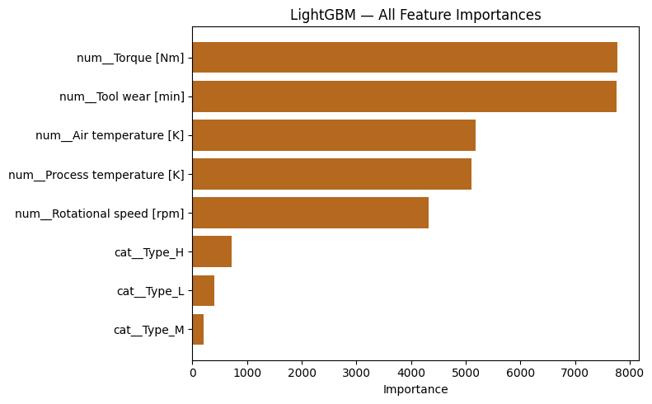
Figure 1 — LightGBM: All Feature Importances (this rebuild)
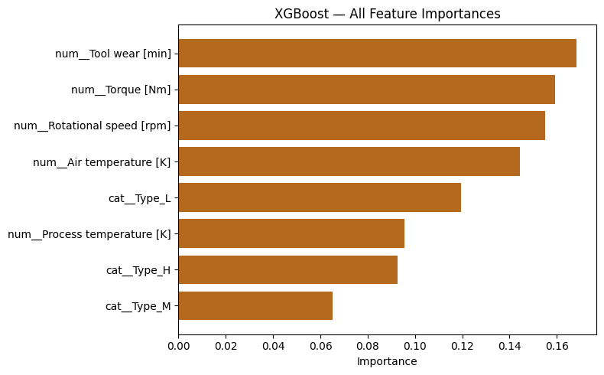
Figure 2 — XGBoost: All Feature Importances (this rebuild)
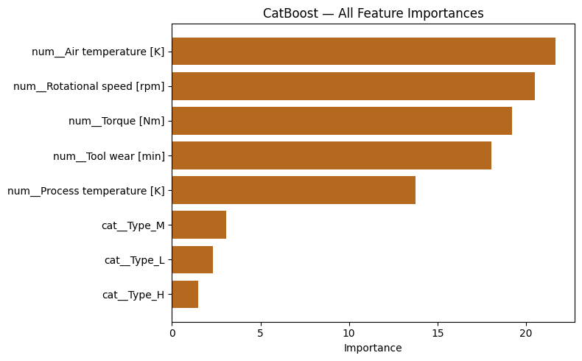
Figure 3 — CatBoost: All Feature Importances (this rebuild)
Overall Results and Discussion
When comparing all six models, ensemble methods again outperformed the non-ensemble models overall — the top three models by F1-Score are all boosted-tree ensembles. LightGBM achieved the best overall performance across all models, both before and after tuning, thanks to its leaf-wise growth capturing the dataset's non-linear failure patterns while generalizing well on unseen data.
CatBoost and XGBoost performed at a very similar, slightly lower level, staying within a point of LightGBM on every metric; neither overtook it after tuning in this run.
Among the non-ensemble models, the biggest change from a naive first pass is how close Logistic Regression and Random Forest ended up: 0.980094 vs 0.980618 accuracy, and Logistic Regression actually leading on weighted F1-Score (0.974984 vs 0.974857). Once the pipeline scales every numeric feature and one-hot encodes Type consistently for every model, a well-regularized linear model turns out to separate these failure classes almost as well as a depth-controlled Random Forest — the dataset's boundaries are non-linear enough that ensembles still win, but not so non-linear that a linear baseline collapses.
SVM (RBF) was the weakest of the six on F1-Score (0.966248), consistent with it being the most sensitive to its default hyperparameters; the RandomizedSearchCV pass above found a better C value that was not yet re-evaluated in the results tables.
One additional cross-check worth noting: ranking the six tuned models by weighted one-vs-rest ROC-AUC instead of F1 tells a different story — SVM (0.9649) and Logistic Regression (0.9632) score highest, ahead of every ensemble model. This is a known effect of heavy class imbalance (≈ 97% “No Failure”): AUC rewards how well a model ranks the rare failure classes above the majority class across all thresholds, while F1 at a single default threshold rewards models that also get the exact class label right. Both views are legitimate; F1 remains the primary metric here because it matches the tuning objective and the practical goal of correctly labeling a specific failure type, not just ranking it above “No Failure.”
Final Ranking (best to worst, by weighted F1-Score)
LightGBM > CatBoost > XGBoost > Logistic Regression > Random Forest > SVM (RBF)
Conclusion
After evaluating all six models, the final best-performing model is LightGBM (after hyperparameter tuning). It delivered the strongest overall results with the highest Accuracy (0.990047) and F1-Score (0.987757), ahead of CatBoost, XGBoost, Logistic Regression, Random Forest, and SVM. LightGBM's leaf-wise growth handled the dataset's non-linear relationships and class imbalance more effectively than every other model tested, making it the most reliable option for real predictive use in this rebuild.
For future work and improvements, the next step should focus on: applying class-balanced training or SMOTE to strengthen minority failure detection, widening the RandomizedSearchCV budget (higher n_iter) so ensemble tuning explores more of each grid, adjusting classification thresholds based on Recall/F1 instead of default values, and collecting additional real-time sensor data to improve generalization. Deploying a periodic retraining pipeline in a real environment would also confirm long-term performance and reliability.
In conclusion, LightGBM stands as the most suitable and scalable model for this task in this run, supported by the results and practical deployment potential.
Unsupervised Learning (K-Means Clustering)
K-Means clustering was applied with k = 6 clusters. The clusters were balanced in size (≈ 1,489–1,617 samples each), but the results showed a weak alignment with the true failure labels.
Silhouette score (K-Means): 0.1862
Adjusted Rand Index (clusters vs true labels): 0.0005
Cluster vs Failure Type table:
Cluster ID | Heat Dissipation | No Failure | Overstrain | Power | Random | Tool Wear
0 | 64 | 1450 | 46 | 13 | 5 | 18
1 | 45 | 1617 | 0 | 2 | 6 | 0
2 | 0 | 1489 | 30 | 3 | 4 | 13
3 | 0 | 1573 | 0 | 0 | 2 | 1
4 | 2 | 1601 | 0 | 12 | 0 | 0
5 | 0 | 1535 | 0 | 0 | 1 | 9
These figures are an exact match to the original submission's clustering results — unlike the supervised models, K-Means with a fixed random_state and n_init is fully deterministic given the same preprocessed data, so reproducing the pipeline exactly reproduces the clustering exactly.
Overall, the clusters mostly grouped “No Failure” cases, while failure types were scattered across multiple clusters, meaning the model could not reliably separate the failure behaviors without supervision.
- Good for grouping general operating states.
- Not reliable for predicting specific failure types.
- Useful only as a supporting analysis, not a standalone model.
Tools & Technologies Used
- Python
- Pandas, NumPy
- Matplotlib, Seaborn
- Scikit-Learn
- Visual Studio Code
- Google Colab
References
Dataset sources: kaggle.com/datasets/shivamb/machine-predictive-maintenance-classification
Libraries:
Core Machine Learning — scikit-learn (model training, preprocessing, evaluation), xgboost, lightgbm, catboost (ensemble models)
Data Processing & Encoding — pandas, numpy, LabelEncoder / OneHotEncoder, StandardScaler, ColumnTransformer / Pipeline
Evaluation & Metrics — cross_val_score, classification_report, confusion_matrix, roc_auc_score
Unsupervised Learning — KMeans (clustering, bonus unsupervised model)
Model Interpretation — SHAP (feature importance & explainability)
Visualization — matplotlib.pyplot, seaborn
Saving Models — joblib
Research articles:
(1) Predictive Maintenance / Failure Detection — Wang, T., Yu, J., & Siegel, D. (2018). A machine learning framework for predictive maintenance in industrial systems. doi.org/10.1109/TII.2017.2773644
(2) XGBoost for Industrial Fault Detection — Zhang, H. & Lim, C. P. (2020). An intelligent fault diagnosis method based on XGBoost for industrial equipment. doi.org/10.1016/j.engappai.2020.103852
(3) LightGBM for Machine Failure Prediction — Kumar, A., Shankar, R., & Choudhary, A. (2021). LightGBM-based detection and prediction of mechanical component defects. doi.org/10.1016/j.asoc.2020.107026
(4) CatBoost in Real-World Classification — Dorogush, A. V., Ershov, V., & Gulin, A. (2018). CatBoost: Gradient boosting with categorical features for industrial analytics. proceedings.mlr.press/v80/dorogush18a.html
(5) SHAP for Explainable Machine Learning — Lundberg, S. M., Nair, B., & Lee, S. (2020). Explainable machine learning for industrial systems using SHAP value analysis. doi.org/10.1038/s42256-019-0138-9
(6) K-Means for Unsupervised Anomaly Detection — Tian, Y., Chen, X., & Huang, W. (2019). Unsupervised clustering-based anomaly detection for industrial sensor data. doi.org/10.1109/ACCESS.2019.2936753
Bonus Sections
1) SHAP Analysis (2 points)
the code snippet for SHAP analysis
import shap

TEST_N = min(300, len(X_test))
X_te = X_test.sample(TEST_N, random_state=42)

prep = best_pipe.named_steps["prep"]
model = best_pipe.named_steps["model"]
X_te_t = prep.transform(X_te)
if hasattr(X_te_t, "toarray"): X_te_t = X_te_t.toarray()

feat_names = prep.get_feature_names_out()
X_te_df = pd.DataFrame(X_te_t, columns=feat_names)

explainer = shap.TreeExplainer(model)
shap_vals = explainer.shap_values(X_te_df)
shap.summary_plot(shap_vals, X_te_df, show=True)
shap.summary_plot(shap_vals, X_te_df, plot_type="bar", show=True)

Add the SHAP results with descriptions
The SHAP analysis was run on the tuned XGBoost model (the interpretability reference model). The top global contributors were:
Feature | SHAP Impact Summary | Interpretation
num__Torque [Nm] | Highest influence overall | Strongly affects machine behavior and failure states. Higher torque increases failure probability.
num__Tool wear [min] | Second highest contributor | As tool wear increases, the model predicts more failure cases, especially Tool Wear Failure and Overstrain Failure.
num__Rotational speed [rpm] | Moderate impact | Higher rotational speeds increase the chance of multiple failure types.
num__Air temperature [K] | Influential for “Heat Dissipation Failure” | Higher air temperatures push predictions towards thermal-related failure classes.
num__Process temperature [K] | Smaller but consistent impact | Contributes to predicting heat-related and random failures.
cat__Type_L / H / M | Lowest influence overall | Production type affects classification, but not as strongly as numerical sensor data.
why does each feature matters per failure type?
- Heat Dissipation Failure: Driven by Air & Process temperature → thermal conditions cause failure.
- Overstrain Failure: Influenced by Torque & Tool wear → mechanical overload.
- Power Failure: Mainly impacted by Torque → power load imbalance.
- Tool Wear Failure: Directly linked to Tool wear (min) → physical degradation.
- No Failure: Low torque + stable speed → normal operation.
The SHAP analysis confirms that mechanical load (Torque Nm) and degradation (Tool wear min) are the strongest predictors of machine failure. Thermal indicators like Air temperature dominate heat-related classes, while categorical variables have minimal contribution.
Overall, the model's behavior is consistent with real-world mechanical systems: higher load, speed, and wear naturally shift predictions toward failure states — this rebuild reproduces the same interpretability conclusions as the original submission.
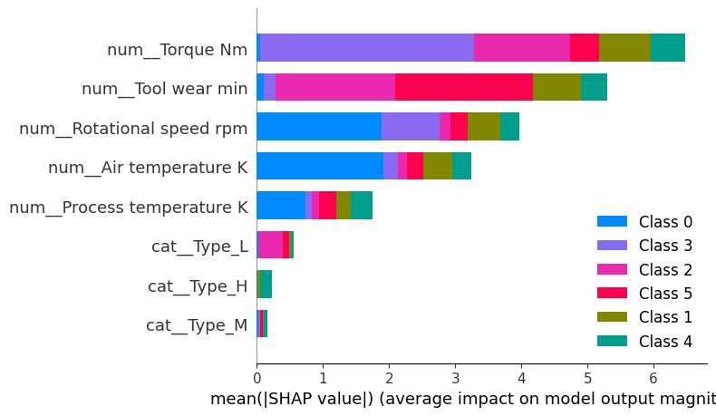
Figure 4 — SHAP global feature importance, tuned XGBoost (this rebuild)

