This is the title

D. Author

14-02-2013

# Section 1

Include the JPEG figure

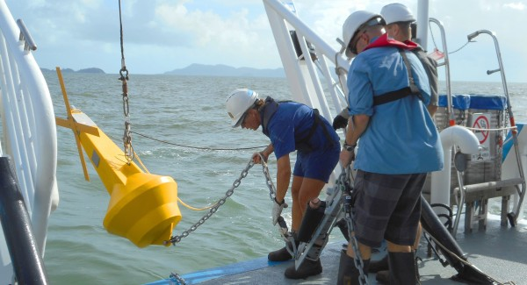

schematic

And a PNG figure

|  |
| --- |
| base-r |

base-r