# HTML implementation of sample jobad

## Task description

The layout of the sample jobad should be implemented by using the following techniques:

* CSS(3) / Less
* HTML5
* Javascript / jQuery

If you like to, you can also use a CSS framework like for example Bootstrap 3. Please also bear in mind that the HTML should be generated by using actual standards for SEO and also accessibility.

If you are familiar with Less, it would be fine if you could use this a pre-processor.

You don’t need to add any responsive features for this template. But if you have time and ideas how to display this jobad on smaller devices you are allowed to add some extra features.

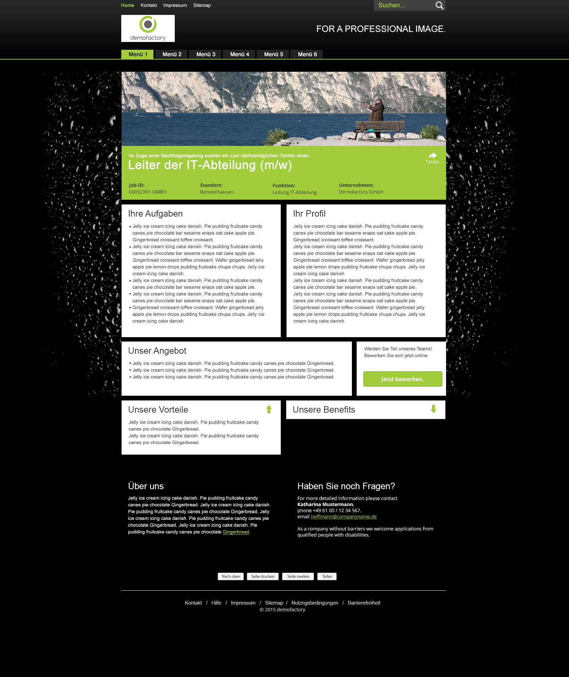

## Material

In the folder „material“ you will find the following images:

* bg_content.jpg
  + this image should be used as the background of the content area
* icon_arrow_down.png / icon_arrow_up.png
  + these arrows should be used for the expandable panels
* icon_forward.png
  + icon used for sharing jobad link
* icon_search.png
  + background image of the search button in the top navigation
* logo.jpg
* visual.jpg
* jobad.psd
  + photoshop file with layers for each element
* jobad_dimension.psd
  + photoshop file with layers and also information regarding the respective dimensions

## Interaction

The containers for „Unsere Vorteile“ and „Unsere Benefits“ should be collapsible. So by clicking on the headline the direction of the arrow should change and the content of the box should be hidden respectively shown. You can use effects like slide or something similar for this function

## Texts

### Top Navigation:

* Home
* Kontakt
* Impressum
* Sitemap

### Slogan:

* for a professional image.

### Visual box:

* Im Zuge einer Nachfolgeregelung suchen wir zum n‰chstmˆglichen Termin einen Leiter der IT-Abteilung (m/w)
  + Job-ID:
    - 60032391-GMBH
  + Standort:
    - Beispielhausen
  + Funktion:
    - Leitung IT-Abteilung
  + Unternehmen:
    - Demofactory GmbH

### Sample text used for several elements:

* Jelly ice cream icing cake danish. Pie pudding fruitcake candy canes pie chocolate bar sesame snaps oat cake apple pie. Gingerbread croissant toffee croissant. Wafer gingerbread jelly apple pie lemon drops pudding fruitcake chupa chups. Jelly ice cream icing cake danish.

### Container Headlines:

* Ihre Aufgaben
* Ihr Profil
* Unser Angebot
* Unsere Vorteile
* Unsere Benefits
* Über uns
* Haben Sie noch Fragen?

### Application box:

* Werden Sie Teil unseres Teams! Bewerben Sie sich jetzt online.
* Jetzt bewerben

### Contact box:

* Haben Sie noch Fragen?
* For more detailed information please contact
* Katharina Mustermann,
* phone +49 61 00 / 12 34 567.
* email hoffmann@companyname.de
* As a company without barriers we welcome applications from qualified people with disabilities.

### Buttons:

* Nach oben
* Seite drucken
* Seite merken
* Teilen

### Footer navigation:

* Kontakt
* Hilfe
* Impressum
* Sitemap
* Nutzngsbedingungen
* Barrierefreiheit
* © 2015 demofactory