Quiz 1
Name_刘瑞康_ StudentNo._2016302580242_
I. Single-choice question (25x2 =50')
a | d | a | a | b | c | b | c | a | a
b | a | a | d | b | c | b | b | a | d
b | d | d | b | d
1. Software companies often release so-called "beta" versions of software. A beta version of a program is usually given away to a selected group of users who agree to test and comment on the program before it is released to the wider market. A company that releases beta versions is thus engaging in
(a) iterative design.
(b) leverage of affordance.
(c) word-of-mouth advertising.
(d) aggressive marketing.

2. Feedback from users of the software systems we build is useful, and even necessary. This is because such feedback
(a) pleases users by showing that we are interested in their opinion.
(b) helps us select the best of our users.
(c) helps us assign blame among the programmers in our team.
(d) is the only way to discover unforeseen shortcomings of our software.

3. Which section of a usability aspect report (UAR) can serve as the UAR's "name"?
(a) Succinct description of the usability aspect
(b) Evidence for the aspect
(c) UAR Identifier
(d) Explanation of the aspect

4. Which of the following describes the most appropriate use of the technique heuristic evaluation?
(a) Evaluating the usability of a design in its final stages
(b) Critiquing the designer of a system
(c) Evaluating the usability of a design in its early stages
(d) Advising people during a therapy session

5. Your supervisor has requested that you use a toolkit to build a fancy new user interface, and she has given you the following reasons to do so (besides enticing you with a promise of a pay raise):
I.Toolkits have widgets that allow you to generate prototypes rapidly.
II.If you use the same toolkits, all of the programs you write will have interfaces with a similar look and feel.
III.The Internet requires that we use the prescribed open-standard UI toolkits.
Which of the reasons are sound? (Again, besides the pay raise!)
(a) I only.
(b) I and II only.
(c) II only.
(d) II and III only.
(because the open-standard UI is encapsulated, cannot be modified after use.)

6. According to the information processing model of human cognitive activity, which of the following happens to information from the outside world immediately after it is perceived by the perceptual processor?
(a) The cognitive processor determines that an action needs to be taken.
(b) The motor processor completes an action based on the information.
(c) It is deposited into working memory.
(d) It is deposited into long-term memory.

7. Valid Visual Basic data types include which of the following?
I.Boolean
II.String
III.VariantType
(a) II and III only
(b) I and II only
(c) I, II, and III
(d) I only

8. Which of the following is a similarity between the heuristics Consistency and Standards and Match Between the System and the Real World?
(a) There is no similarity.
(b) Both advocate ignoring the users' experiences with other software.
(c) Both draw upon the users' prior knowledge and experience.
(d) Both recognize the tendency of users to make errors.

9. Which of the following are differences between the techniques of heuristic evaluation (HE) and think-aloud usability testing (TA)?
I.A heuristic evaluation can be carried out on a paper prototype, whereas a TA requires a functioning prototype.
II.A heuristic evaluation can be conducted by an expert analyst working alone, whereas a TA requires the participation of people who are like the application's intended users.
III.TAs require the developer to 'think like a user,' whereas HEs do not.
(a) II
(b) I and III
(c) I only
(d) I, II, and III

10. The Visual Basic Properties window allows the developer to
I.change a Visual Basic object's appearance.
II.change a Visual Basic object's behavior.
III.change a Visual Basic object's name.
(a) I, II, and III
(b) I only
(c) II and III only
(d) II only

11. In the context of writing a usability aspect report, what is meant by the statement:
"Always step back and try to see the bigger picture."
(a) A usability aspect report should be no longer than one page.
(b) Looking for patterns in usability problems is an important step in the analysis process.
(c) It is important not to waste time on insignificant usability problems.
(d) Usability aspect reports should be grouped by where they were found in the program.

12. Which of the following situations violates the heuristic visibility of system status?
(a) A computer system that appears to have crashed.
(b) A progress indicator showing how much of a file is left to download
(c) The full Recycle Bin icon showing that the bin has files in it
(d) The MS Windows taskbar showing the applications that are running

13. When you click the mouse on a Visual Basic control named panicButton which of the following is invoked?
(a) panicButton_Click()
(b) Click_panicButton()
(c) myPanicButton_Click()
(d) panicButton-Click

14. Because Visual Basic buttons can only be manipulated in one way (by clicking), they are suitable to be used for
(a) actions that require additional information not supplied by the click
(b) mouse-initiated actions only
(c) a greater variety of actions than most other controls
(d) actions that require no additional information beyond that supplied by the click

15. When, on your computer screen, you drag the image of a folder to a different window, you are
I.directly manipulating the bits of the disk file.
II.manipulating an image that represents the bits of the disk file.
III.generating mouse events that cause the windows interface program to redraw the image of the folder continuously, in different locations, as it appears to move.
(a) III only.
(b) II and III only.
(c) II only.
(d) I only.

16. Assign an array data type must be （）
(a)same
(b)not same
(c) both correct
(d)both wrong

17. To change the breadth control, should modify the properties ( ) of the controls.
(a)Top
(b)Width
(c)Left
(d)Height

18. In order to prevent users from casual place the cursor over the control, should be set to（）
(a) the control of TabIndex attribute is set to 0
(b) the control of TabStop property is set to True
(c) the control of TabStop property is set to False
(d) the control the Enabled attribute is set to False

19. The following is not a VB Basic data type is _____.
(a)Char
(b)String
(c)Integer
(d) Double

20. How many the number of usability principles?
(a) 7
(b) 8
(c) 9
(d) 10

21. Which heuristic is described in the following statement?
Information that is the same should appear to be the same (same words, icons, and position on the screen). Information that is different should be expressed differently.
(a) Flexibility and efficiency of use
(b) Consistency and standards
(c) Visibility of system status
(d) Help and documentation

22. A heuristic used in evaluating prototypes of a user interface:
(a) should be carefully criticized before use.
(b) endorses or criticizes the interface as a whole.
(c) unambiguously endorses or criticizes the aspect of the interface to which it applies.
(d) may occasionally both endorse and criticize one aspect of the interface.

23. Which of the following are reasons why it is necessary that usability aspect reports be clear and complete?
I.The usability problem may need to be described to other members of the development team who did not see the problem first-hand.
II.The author of the reports needs to be able to understand them long after they are written.
III.The participants in a user study need to be able to read accounts of their sessions written in lay terms.
(a) I only
(b) I and II
(c) III only
(d) II and III

24. No matter what widget, they have the same ( ) attribute.
(a) Text
(b) Name
(c) ForeColor
(d)Caption

25. The event-redraw loop is
(a) an affordance commonly found in drawing programs.
(b) a programming construct used in redrawing event objects on the screen (e.g., a meeting in a scheduling program).
(c) a built-in Java method invoked when you throw an exception for a visible icon.
(d) the main programming construct of interactive programs.

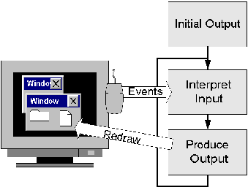
II. Fill-in-the-blank(10x2 =20')
1. The main characteristics of VB program design are visual programming tool and Event-driven programming.

2. In VB, two of the most main object is system object and custom object .

3. In VB, modify height and widthibute value of the form, can change the size of the form.

4. If you want to make A command button cannot operation, should set the attribute Enable of the system.

5. Save a project shall be kept at least two files, the two files respectively are .vbp and .frm .

- Set up the Clock project, the data types should use date .

7. A forms designer is used to design __custom form_____.

IV. Use VB to program the "Hello world!" project. (10')

Private Sub Form_Load()
MsgBox("Hello World!")
End Sub

V. Please draw a Picture(flowchart) to describe the logical relationship between Outside world, Perceptual Processor, Motor Processor, Working Memory (WM), Long term Memory (LTM) and cognitive Processor.(10')

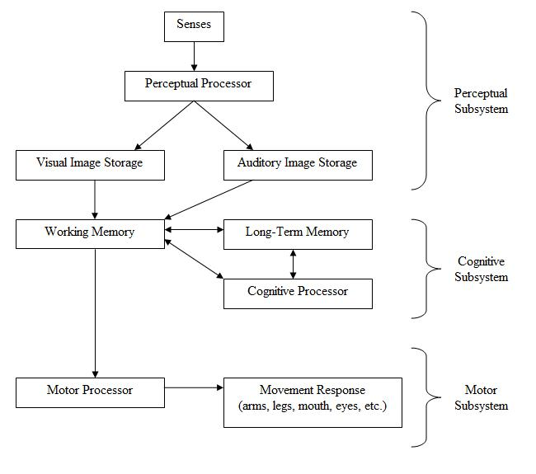

VI. As we know that there are Ten Usability Heuristics: Visibility of system status, Match between system and the real world, User control and freedom, Consistency and standards, Help and documentation, Flexibility and efficiency of use, etc. Please choice two of them, then describe the contend and function.(10')
Visibility of system status: The system should always keep users informed about what is going on, through appropriate feedback within reasonable time.
Match between system and the real world: The system should speak the user's language, with words, phrases and concepts familiar to the user, rather than system-oriented terms. Follow real-world conventions, making information appear in a natural and logical order.

