武汉大学国际软件学院
《数据库课程设计》综合实验任务书
年 级： 专 业：

- 实验名称
Java Web项目实践
- 实验目的
      - 理解Web项目中的数据库交互机制；
      - 学会在Java Web项目中使用JDBC接口，实现对数据库的连接及操作；
      - 学会部署Java Web项目，并演示该项目。
- 实验环境
- 操作系统：Window XP及以上
- 开发语言：Java
- 开发平台：Eclipse\MyEclipse
- 服务器：Tomcat 6.0及以上、Oracle 9i及以上
- 参考资料
JDBC API文档（http://docs.oracle.com/javase/8/docs/technotes/guides/jdbc/）
- 实验要求
本次为综合实验，要求结合前7次实验内容，自行设计并开发一个Java Web项目。具体需要完成的工作如下：
- 在Eclipse配置tomcat服务器，并建立、部署Java Web项目；
- 自行设计系统要实现的功能，原则上要能体现对数据库的增、删、查、改操作。如有实现附加操作（例如实现了触发器、存储过程等），视情况酌情加分；
- 要求利用JDBC接口实现对数据库的连接、操作，以响应用户的前台交互；
- 所有的功能必须有相应的前台展示页面，不得以手动运行代码的形式实现。

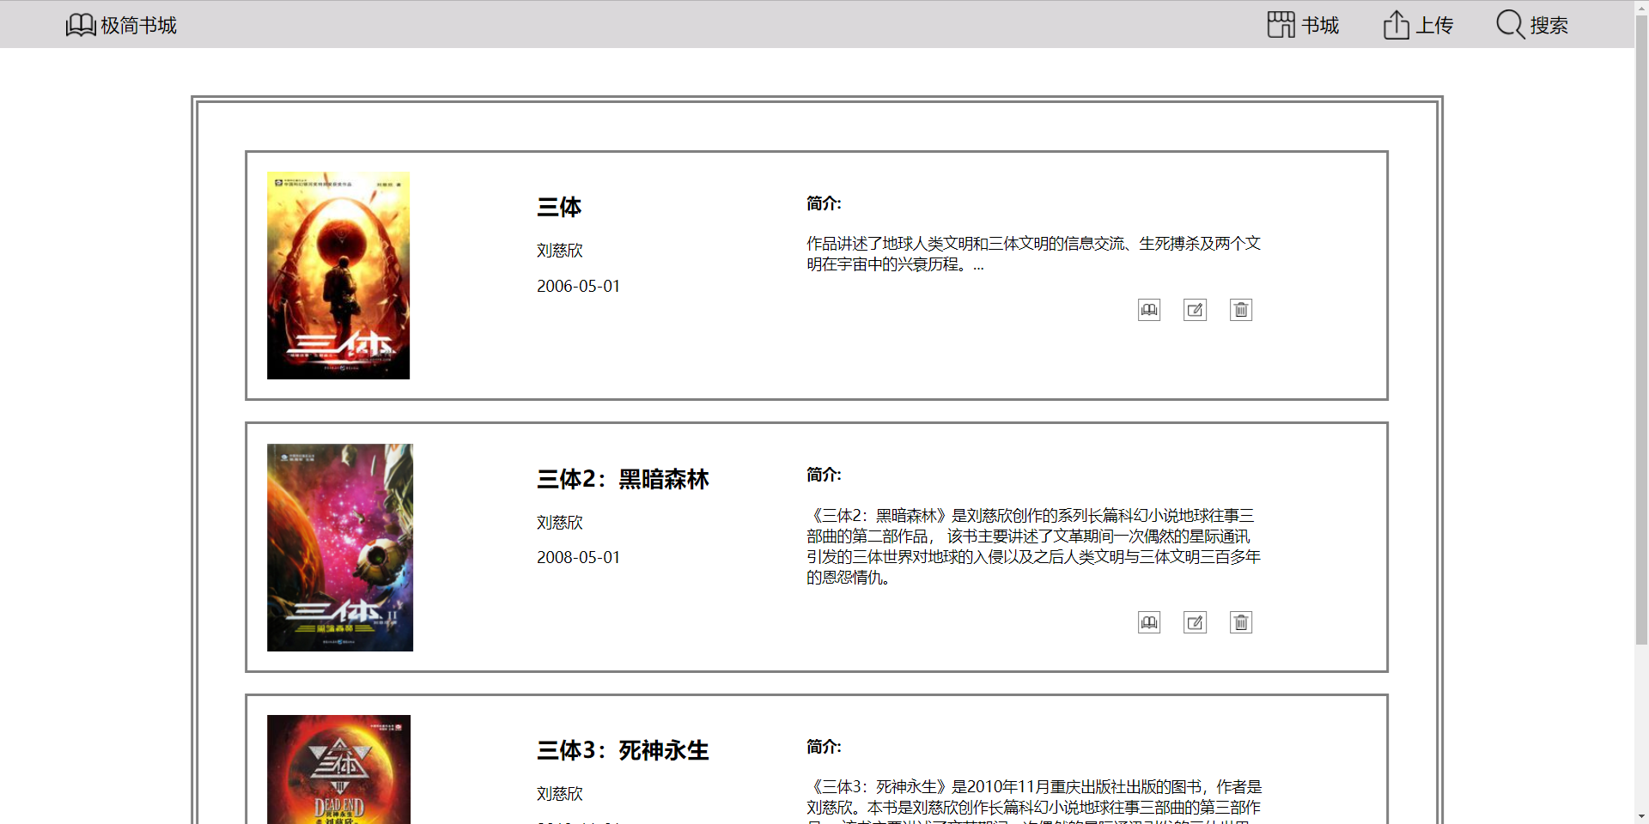
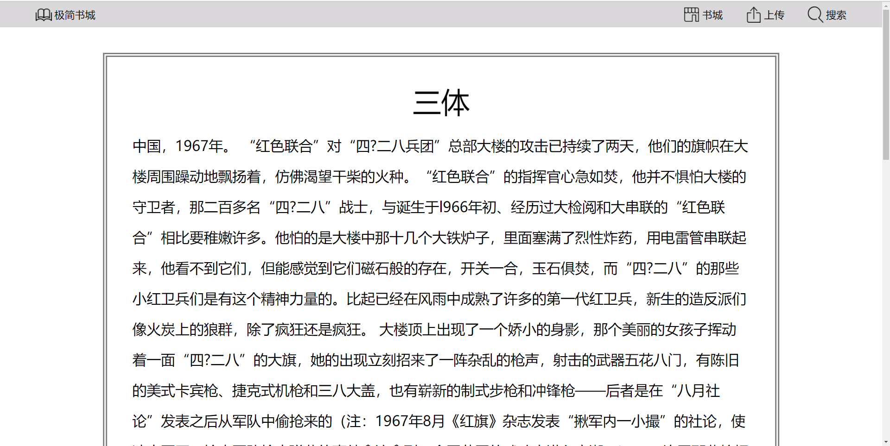
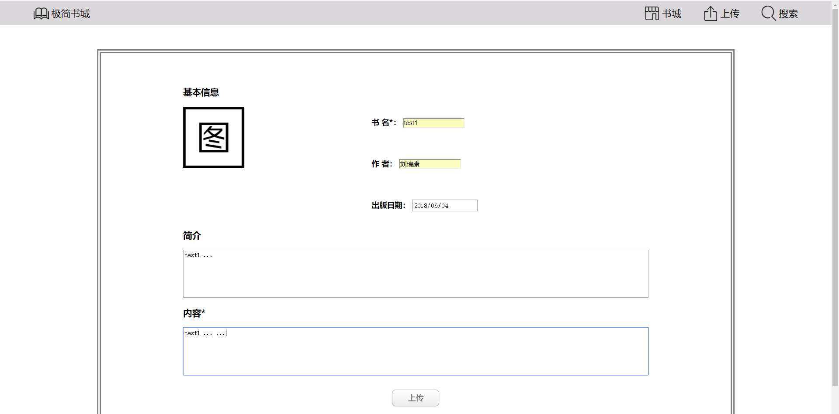
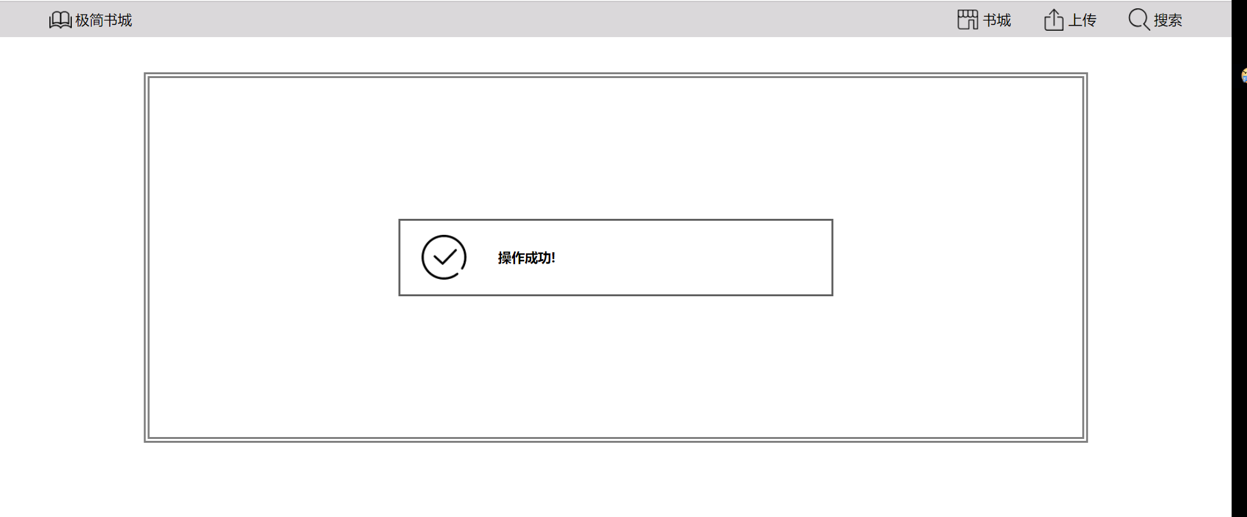
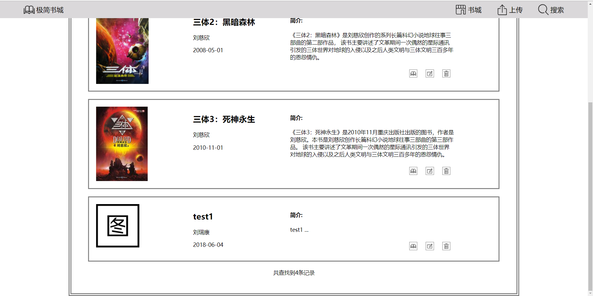
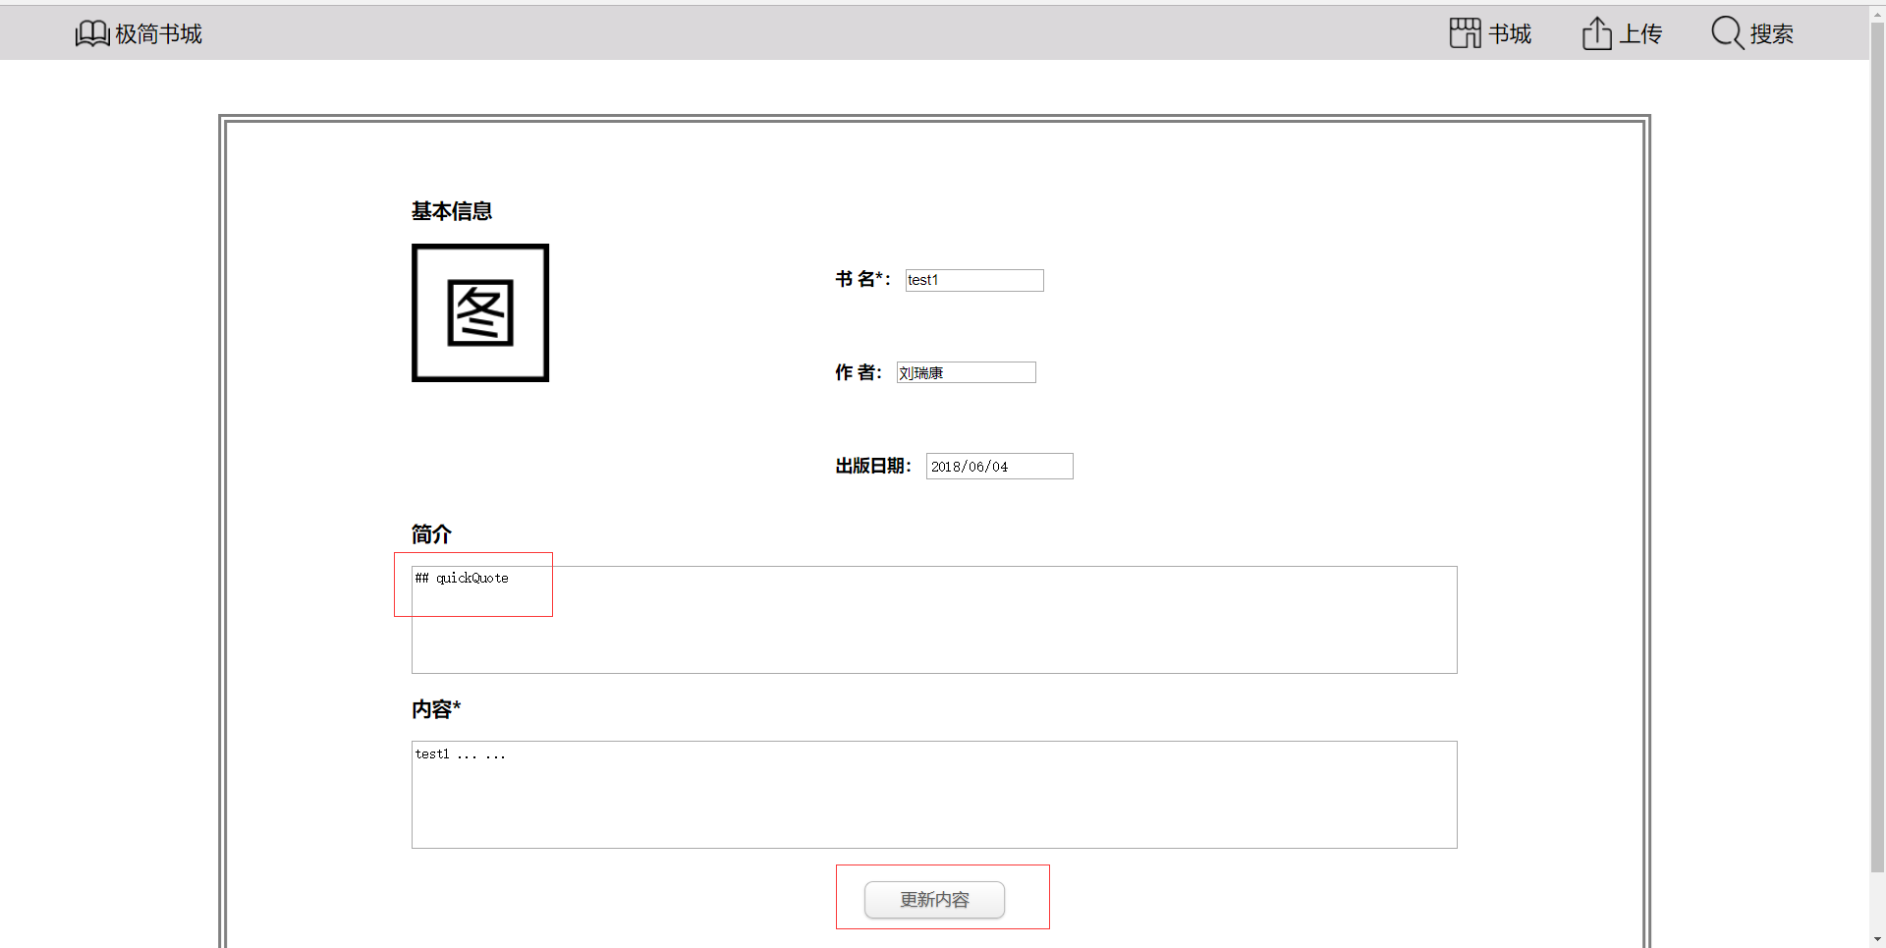
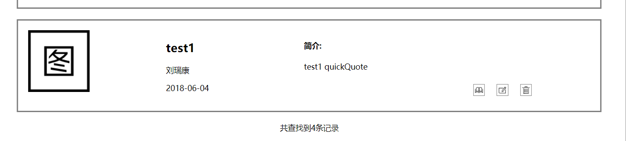
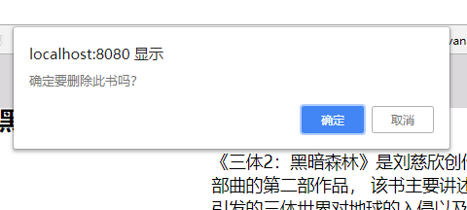
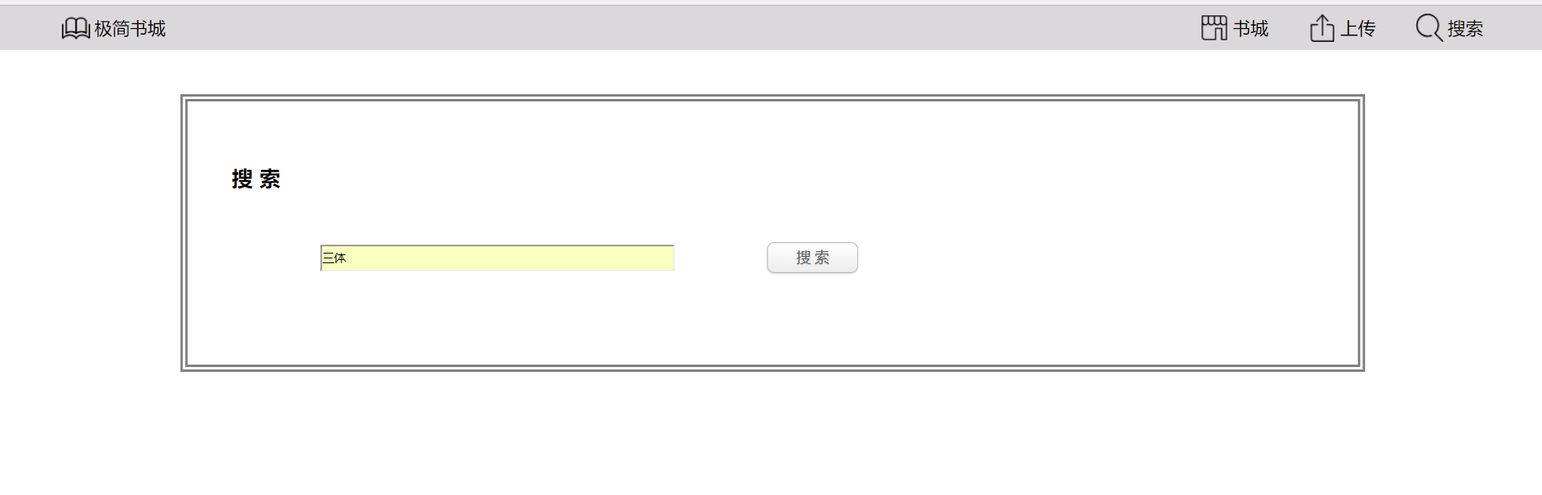

数据库
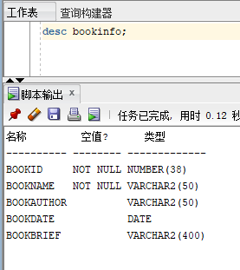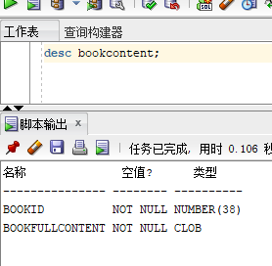
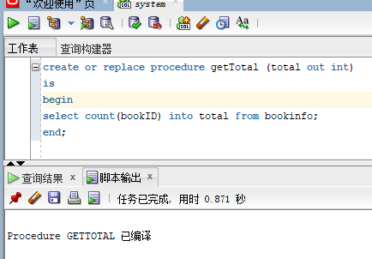
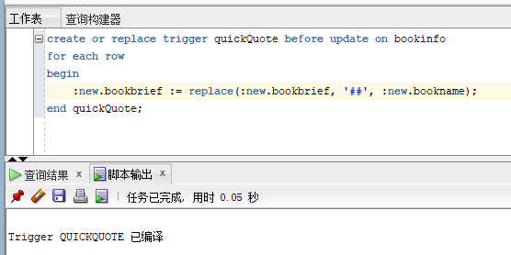

代码
index.jsp
<%@ page import="java.util.Vector" %>
<%@ page import="java.util.ArrayList" %>
<%@ page import="com.LRK.ConnectOracle" %>
<%--
Created by IntelliJ IDEA.
User: 刘瑞康
Date: 2018/5/30
Time: 20:13
To change this template use File | Settings | File Templates.
--%>
<%@ page contentType="text/html;charset=UTF-8" language="java" %>
<html>
<head>
<meta charset="UTF-8">
<title>极简书城</title>
<link rel="stylesheet" href="index.css" type="text/css">
<script>
function deleteById(ID) {
var check = confirm("确定要删除此书吗？")
if(check)
{
location.href='process.jsp?operation=delete&bookID='+ ID;
}
}
</script>
</head>
<body>
<%@include file="header.jsp"%>
<div id="container">
<div id="leftContainer">
<div>
</div>
</div>
<div id="centerContainer">
<% ArrayList<Vector<String>> bookInfos = ConnectOracle.getBookInfos(); %>
<% for (Vector<String> book: bookInfos) { %>
<div class="bookInfo">
<div class="bookImg">
<img src="bookCover/<%=book.elementAt(1)%>.jpg" onError="this.src='bookCover/book0.png';">
</div>
<div class="bookBasic">
<h2><%=book.elementAt(1)%></h2>
<p><%=book.elementAt(2)%></p>
<p><%=book.elementAt(3).substring(0,10)%></p>
</div>
<div class="bookBreif">
<div>
<h4>简介:</h4>
<p><%=book.elementAt(4)%></p>
</div>
<div class="quickBt">
<div class="quickBts" onclick="location.href='reader.jsp?bookID='+<%=book.elementAt(0)%>"><img class="quickBtsImg" src="img/office16.png"></div>
<div class="quickBts" onclick="location.href='edit.jsp?bookID='+<%=book.elementAt(0)%>"><img class="quickBtsImg" src="img/edit16.png"></div>
<div class="quickBts" onclick="deleteById(<%=book.elementAt(0)%>)"><img class="quickBtsImg" src="img/delete16.png"></div>
</div>
</div>
</div>
<br>
<% } %>
<div align="center">共查找到<%=ConnectOracle.getTotal()%>条记录 </div>
</div>
<div id="rightContainer">
<div>
</div>
</div>
</div>
<br><br><br><br>
</body>
</html>

reader.jsp
<%@ page import="java.util.Vector" %>
<%@ page import="java.util.ArrayList" %>
<%@ page import="com.LRK.ConnectOracle" %>
<%@ page import="javafx.util.Pair" %>
<%--
Created by IntelliJ IDEA.
User: 刘瑞康
Date: 2018/5/30
Time: 20:13
To change this template use File | Settings | File Templates.
--%>
<%@ page contentType="text/html;charset=UTF-8" language="java" %>
<html>
<head>
<meta charset="UTF-8">
<title>极简书城</title>
<link rel="stylesheet" href="index.css" type="text/css">
</head>
<body>
<%@include file="header.jsp"%>
<div id="container">
<div id="leftContainer">
<div>
</div>
</div>
<div id="centerContainer">
<div class="reader">
<div class="readerTitle">
<% String bookID = request.getParameter("bookID"); %>
<% Pair<String,String> bookContent = ConnectOracle.getBookContent(bookID); %>
<%= bookContent.getKey()%>
</div>
<div class="readerContent">
<%= bookContent.getValue()%>
</div>
</div>
</div>
<div id="rightContainer">
<div>
</div>
</div>
</div>
<br><br><br><br>
</body>
</html>

edit.jsp
<%@ page import="java.util.Vector" %>
<%@ page import="java.util.ArrayList" %>
<%@ page import="com.LRK.ConnectOracle" %>
<%@ page import="javafx.util.Pair" %>
<%--
Created by IntelliJ IDEA.
User: 刘瑞康
Date: 2018/5/30
Time: 20:13
To change this template use File | Settings | File Templates.
--%>
<%@ page contentType="text/html;charset=UTF-8" language="java" %>
<html>
<head>
<meta charset="UTF-8">
<title>极简书城</title>
<link rel="stylesheet" href="index.css" type="text/css">
</head>
<script type="text/javascript">
function check() {
if(document.getElementById("bookName").value == ""||
document.getElementById("bookContent").value ==""){
alert("书名和内容不能为空");
return false;
}
return true;
}
</script>
<body>
<%@include file="header.jsp"%>
<div id="container">
<div id="leftContainer">
<div>
</div>
</div>
<div id="centerContainer">
<form class="formContent" action="process.jsp" method="post">
<% String bookID = request.getParameter("bookID"); %>
<% Pair<String,String> bookContent = ConnectOracle.getBookContent(bookID); %>
<% Vector<String> bookInfo = ConnectOracle.getBookInfo(bookID); %>
<div>
<h3>基本信息</h3>
<div class="formImg">
<img class="uploadImg" src="img/bookImg.png" name="bookImg">
</div>
<div class="formBasic">
<div>
<h4 class="formBasicTitle">书&nbsp;名*：</h4> <input class="formBasicInput" type="text" name="bookName" id="bookName" size="15" value=<%=bookInfo.elementAt(1)%>>
</div>
<br>
<div>
<h4 class="formBasicTitle">作&nbsp;者：</h4> <input class="formBasicInput" type="text" name="bookAuthor" size="15" value=<%=bookInfo.elementAt(2)%>>
</div>
<br>
<div>
<h4 class="formBasicTitle">出版日期：</h4> <input class="formBasicInput" type="date" name="bookDate" value=<%=bookInfo.elementAt(3)%>>
</div>
</div>
</div>
<div>
<h3>简介</h3>
<textarea class="formTextarea" name="bookBrief"><%=bookInfo.elementAt(4)%></textarea>
<h3>内容*</h3>
<textarea class="formTextarea" name="bookContent" id="bookContent"><%=bookContent.getValue()%></textarea>
</div>
<div class="formBottom">
<input class="nondisplay" name="bookID" value=<%=bookID%>>
<input class="nondisplay" name="operation" value="edit">
<input class="Bt" type="submit" value="更新内容" onclick="return check()">
</div>
</form>
</div>
<div id="rightContainer">
<div>
</div>
</div>
</div>
<br><br><br><br>
</body>
</html>

upload.jsp
<%@ page import="java.util.Vector" %>
<%@ page import="java.util.ArrayList" %>
<%@ page import="com.LRK.ConnectOracle" %>
<%@ page import="javafx.util.Pair" %>
<%--
Created by IntelliJ IDEA.
User: 刘瑞康
Date: 2018/5/30
Time: 20:13
To change this template use File | Settings | File Templates.
--%>
<%@ page contentType="text/html;charset=UTF-8" language="java" %>
<html>
<head>
<meta charset="UTF-8">
<title>极简书城</title>
<link rel="stylesheet" href="index.css" type="text/css">
</head>
<script type="text/javascript">
function check() {
if(document.getElementById("bookName").value == ""||
document.getElementById("bookContent").value ==""){
alert("书名和内容不能为空");
return false;
}
return true;
}
</script>
<body>
<%@include file="header.jsp"%>
<div id="container">
<div id="leftContainer">
<div>
</div>
</div>
<div id="centerContainer">
<form class="formContent" action="process.jsp" method="post">
<div>
<h3>基本信息</h3>
<div class="formImg">
<img class="uploadImg" src="img/bookImg.png" name="bookImg">
</div>
<div class="formBasic">
<div>
<h4 class="formBasicTitle">书&nbsp;名*：</h4> <input class="formBasicInput" type="text" name="bookName" id="bookName" size="15">
</div>
<br>
<div>
<h4 class="formBasicTitle">作&nbsp;者：</h4> <input class="formBasicInput" type="text" name="bookAuthor" size="15">
</div>
<br>
<div>
<h4 class="formBasicTitle">出版日期：</h4> <input class="formBasicInput" type="date" name="bookDate">
</div>
</div>
</div>
<div>
<h3>简介</h3>
<textarea class="formTextarea" name="bookBrief"></textarea>
<h3>内容*</h3>
<textarea class="formTextarea" name="bookContent" id="bookContent"></textarea>
</div>
<div class="formBottom">
<input class="nondisplay" name="operation" value="upload">
<input class="Bt" type="submit" value="上传" onclick="return check()">
</div>
</form>
</div>
<div id="rightContainer">
<div>
</div>
</div>
</div>
<br><br><br><br>
</body>
</html>

search.jsp
<%@ page import="java.util.Vector" %>
<%@ page import="java.util.ArrayList" %>
<%@ page import="com.LRK.ConnectOracle" %>
<%@ page import="javafx.util.Pair" %>
<%--
Created by IntelliJ IDEA.
User: 刘瑞康
Date: 2018/5/30
Time: 20:13
To change this template use File | Settings | File Templates.
--%>
<%@ page contentType="text/html;charset=UTF-8" language="java" %>
<html>
<head>
<meta charset="UTF-8">
<title>极简书城</title>
<link rel="stylesheet" href="index.css" type="text/css">
</head>
<body>
<%@include file="header.jsp"%>
<div id="container">
<div id="leftContainer">
<div>
</div>
</div>
<div id="centerContainer">
<div>
<h2>搜 索</h2>
<form action="process.jsp" method="get">
<input class="searchtxt" type="text" name="bookName">
<input class="nondisplay" type="text" name="operation" value="search">
<input class="Bt" type="submit" value="搜 索">
</form>
</div>
</div>
<div id="rightContainer">
<div>
</div>
</div>
</div>
<br><br><br><br>
</body>
</html>

process.jsp
<%@ page import="java.util.Vector" %>
<%@ page import="java.util.ArrayList" %>
<%@ page import="com.LRK.ConnectOracle" %>
<%@ page import="javafx.util.Pair" %>
<%--
Created by IntelliJ IDEA.
User: 刘瑞康
Date: 2018/5/30
Time: 20:13
To change this template use File | Settings | File Templates.
--%>
<%@ page contentType="text/html;charset=UTF-8" language="java" %>
<% request.setCharacterEncoding("UTF-8"); %>
<html>
<head>
<meta charset="UTF-8">
<title>极简书城</title>
<link rel="stylesheet" href="index.css" type="text/css">
</head>
<body>
<%@include file="header.jsp"%>
<div id="container">
<div id="leftContainer">
<div>
</div>
</div>
<div id="centerContainer">
<% String operation = request.getParameter("operation");
boolean success = true; %>
<% if(operation.equals("delete")){ %>
<% int result1 = ConnectOracle.deleteBook(request.getParameter("bookID"));
if(result1 == -1)
success = false; %>
<% } else if (operation.equals("upload") ){%>
<% int result2 = ConnectOracle.uploadBook(request.getParameter("bookName"),
request.getParameter("bookAuthor"),
request.getParameter("bookDate"),
request.getParameter("bookBrief"),
request.getParameter("bookContent"));
if(result2 == -1)
success = false; %>
<% } else if (operation.equals("edit") ){%>
<% int result3 = ConnectOracle.updateBook(request.getParameter("bookID"),
request.getParameter("bookName"),
request.getParameter("bookAuthor"),
request.getParameter("bookDate"),
request.getParameter("bookBrief"),
request.getParameter("bookContent"));
if(result3 == -1)
success = false; %>
<% } else if (operation.equals("search") ){%>
<% String matchedID = ConnectOracle.searchBook(request.getParameter("bookName"));
if(matchedID == null)
success = false;
else{ %>
<jsp:forward page="reader.jsp">
<jsp:param name="bookID" value="<%=matchedID%>"></jsp:param>
</jsp:forward>
<%}%>
<%} %>
<% if(success) {%>
<div class="warning">
<div class="waringImg"><img src="img/success64.png"></div>
<div class="warningtxt"><h3>操作成功!</h3></div>
</div>
<% }else { %>
<div class="warning">
<div class="waringImg"><img src="img/warning64.png"></div>
<div class="warningtxt"><h3>操作失败.</h3></div>
</div>
<% } %>
</div>
<div id="rightContainer">
<div>
</div>
</div>
</div>
<br><br><br><br>
</body>
</html>

header.jsp
<%@ page contentType="text/html;charset=UTF-8" language="java" %>
<div id="header">
<div class="bookCity">
<div class="items" onclick="location.href='index.jsp'">
<img src="img/office32.png">
<span class="itemstxt">极简书城</span>
</div>
</div>
<div class="headerItems">
<div class="items" onclick="location.href='index.jsp'">
<img src="img/store32.png">
<span class="itemstxt">书城</span>
</div>
<div class="items" onclick="location.href='upload.jsp'">
<img src="img/share32.png">
<span class="itemstxt">上传</span>
</div>
<div class="items" onclick="location.href='search.jsp'">
<img src="img/search32.png">
<span class="itemstxt">搜索</span>
</div>
</div>
</div>

ConnectOracle.java
package com.LRK;
import javafx.util.Pair;
import java.sql.*;
import java.util.ArrayList;
import java.util.List;
import java.util.Vector;
import static jdk.nashorn.internal.objects.NativeString.substring;
public class ConnectOracle {
static private Connection con;
static private String user="system";
//private String user = "sys as sysdba";
static private String password="Oracle11g";
static private String className="oracle.jdbc.driver.OracleDriver";
//private String url="jdbc:oracle:oci@localhost:1158:orcl";这个url可能无效
static private String url = "jdbc:oracle:thin:@localhost:1521:orcl";
/**创建数据库连接*/
static private Connection getCon(){
try{
Class.forName(className);
System.out.println("加载数据库驱动成功！");
}catch(ClassNotFoundException e){
System.out.println("加载数据库驱动失败！");
e.printStackTrace();
return null;
}
try {
con=DriverManager.getConnection(url,user,password);
System.out.println("创建数据库连接成功！");
} catch (SQLException e) {
System.out.print(con);
System.out.println("创建数据库连接失败！");
con=null;
e.printStackTrace();
}
return con;
}
static private void closed(){
try{
if(con!=null){
con.close();
}
}catch(SQLException e){
System.out.println("关闭con对象失败！");
e.printStackTrace();
}
}
static public ArrayList<Vector<String>> getBookInfos()
{
getCon();
ArrayList<Vector<String>> bookInfos = null;
if(con != null)
{
try
{
bookInfos = new ArrayList<Vector<String>>();
Statement stmt = con.createStatement();
ResultSet rs = stmt.executeQuery("SELECT * FROM BookInfo") ;
while (rs.next())
{
Vector<String> newRow = new Vector<String>();
for(int i = 1; i <= 5; i++)
{
newRow.add(rs.getString(i));
}
bookInfos.add(newRow);
}
stmt.close();
} catch (SQLException e) {
e.printStackTrace();
}
}
closed();
return bookInfos;
}
static public Vector<String> getBookInfo(String id)
{
getCon();
Vector<String> bookInfo = null;
if(con != null)
{
try
{
bookInfo = new Vector<String>();
Statement stmt = con.createStatement();
ResultSet rs = stmt.executeQuery("SELECT * FROM BOOKINFO WHERE BookID = " + id) ;
if(rs.next())
{
for(int i = 1; i <= 5; i++)
{
bookInfo.add(rs.getString(i));
}
}
stmt.close();
} catch (SQLException e) {
e.printStackTrace();
}
}
closed();
return bookInfo;
}
static public Pair<String, String> getBookContent(String id)
{
getCon();
Pair<String, String> bookContent = null;
if(con != null)
{
try
{
String name, content;
Statement stmt = con.createStatement();
ResultSet rs = stmt.executeQuery("SELECT BookName FROM BOOKINFO WHERE BookID = " + id) ;
if(rs.next())
{
name = rs.getString(1);
}
else
return null;
stmt.close();
Statement stmt2 = con.createStatement();
ResultSet rs2 = stmt2.executeQuery("SELECT BookFullContent FROM BOOKCONTENT WHERE BookID = " + id) ;
if(rs2.next())
{
content = rs2.getString(1);
}
else
return null;
bookContent = new Pair<String, String>(name, content);
stmt2.close();
} catch (SQLException e) {
e.printStackTrace();
}
}
closed();
return bookContent;
}
static public String searchBook(String bookName)
{
getCon();
String matchedID = null;
if(con != null)
{
try
{
Statement stmt = con.createStatement();
ResultSet rs = stmt.executeQuery("SELECT bookid FROM BOOKINFO WHERE bookName LIKE '%" + bookName + "%'") ;
if(rs.next())
{
matchedID = rs.getString(1);
}
stmt.close();
} catch (SQLException e) {
e.printStackTrace();
}
}
closed();
return matchedID;
}
static public int uploadBook(String bookName, String bookAuthor, String bookDate, String bookBrief, String bookContent)
{
getCon();
int result = -1;
if(con != null)
{
try
{
String currentID = "1";
Statement stmt = con.createStatement();
ResultSet rs = stmt.executeQuery("SELECT MAX(BookID)+1 FROM bookinfo") ;
if(rs.next())
{
currentID = rs.getString(1);
}
stmt.close();
bookName.replaceAll("\"","'");
bookAuthor.replaceAll("\"","'");
bookBrief.replaceAll("\"","'");
bookContent.replaceAll("\"","'");
String sql = "INSERT INTO bookinfo VALUES (" + currentID + ", '" + bookName + "','" + bookAuthor + "',date'" + bookDate + "','" +bookBrief + "')";
Statement stmt2 = con.createStatement();
result = stmt2.executeUpdate(sql) ;
stmt2.close();
PreparedStatement pstmt = con.prepareStatement("INSERT INTO BOOKCONTENT VALUES (" + currentID + ", ?)");
pstmt.setString(1,bookContent);
pstmt.executeUpdate();
} catch (SQLException e) {
e.printStackTrace();
}
}
closed();
return result;
}
static public int updateBook(String bookID, String bookName, String bookAuthor, String bookDate, String bookBrief, String bookContent)
{
getCon();
int result = -1;
if(con != null)
{
try
{
bookName.replaceAll("\"","'");
bookAuthor.replaceAll("\"","'");
bookBrief.replaceAll("\"","'");
bookContent.replaceAll("\"","'");
String sql = "UPDATE bookinfo SET bookName = '" + bookName + "', bookAuthor = '" + bookAuthor + "', bookDate = date'" + bookDate + "', bookBrief = '" +bookBrief + "' WHERE bookID = " + bookID;
Statement stmt = con.createStatement();
result = stmt.executeUpdate(sql) ;
stmt.close();
PreparedStatement pstmt = con.prepareStatement("UPDATE BOOKCONTENT SET bookFullContent = ? WHERE bookID = " +bookID);
pstmt.setString(1,bookContent);
pstmt.executeUpdate();
} catch (SQLException e) {
e.printStackTrace();
}
}
closed();
return result;
}
static public int deleteBook(String id)
{
getCon();
int result = -1;
if(con != null)
{
try
{
Statement stmt = con.createStatement();
result = stmt.executeUpdate("DELETE FROM BOOKCONTENT WHERE bookID = " + id);
result = stmt.executeUpdate("DELETE FROM BOOKINFO WHERE bookID = " + id);
stmt.close();
} catch (SQLException e) {
e.printStackTrace();
}
}
closed();
return result;
}
static public int getTotal()
{
getCon();
int total = -1;
if(con != null)
{
try
{
CallableStatement cs = con.prepareCall("{call getTotal(?)}");
cs.registerOutParameter(1, Types.INTEGER); //注册返回类型(sql类型)
cs.execute();
Object objRtn = cs.getObject(1); //得到返回值
total = (int)objRtn;
} catch (SQLException e) {
e.printStackTrace();
}
}
closed();
return total;
}
}

