**GRAFEEX ART GROUP**

Is a multi-disciplinary entity of creatives and thinkers, creating meaningful design solutions and experiences for brands and audiences.

While very diverse, our aesthetic approach often involves distinct sense of play, aiming to put the fun in functional. Strategically, our work aims to elevate brand offerings by distilling core messaging down to its clearest and freshest visual form. We work with brands to tell compelling stories and build meaningful products.

We collaborate closely with our clients across a full range of brand, physical, digital, and content disciplines.

**1. What’s our story?**

**INTRODUCTION**

Since setting up in 2018, Grafeex has grown from a single founder to a multi-skilled team meeting high-level business needs through coordinated brand building and strategic, design-led work.

GRAFEEX, is an agency specializing in Branding, Creative design, products & Graphics Creativity Solutions providers founded in 3rd August 2018 and located in Nairobi, Kenya with a definite vision to provide top creative, artistic designs and multimedia solutions. Our main strength is based on providing good enough visual and performing arts solutions with a valuable artistic depth. This brand was founded by Collins Omondi Ooko an artist with experience in Graphics Designing.

**VISION**

Our vision is to provide the wide quality and solutions in Graphics and Theatre consumer with a highly, mature visual and performing arts through the customer’s requests which by turn affects the consumer’s way of thinking and raises the artistic sense that is consequently reflected on the whole society positively.

**MISSION**

Our mission is to provide passion of art to both customers and designers with proficiency for outputs that we creatively design. Our priority is to help clients achieve their goals from the potential creative designs we offer.

**2. What’s our Team**

Our Team is up and ready to represent you in a way that delightfully announces your identity either through online presence or through any media that you adopt. We go completely outside the typical moulds and mingle your required expertise with passionate art. The outcome clearly stands out to tell about your enterprise values and commitment in a balanced context.

Holistic, fluid and at times playfully unpredictable, our approach to crafting visual identities is macro in framework and micro in detail. Work that is critically selective yet emotionally rich, spanning disciplines and bringing together teams of creatives attuned to the needs of today’s clients.

### **Collins.O.Ooko**

### **CEO/Founder/Graphic Designer/Illustrator**

A designer, Art and Creative director. Collins enjoys designing and leading creative execution for brands and companies to bring meaningful and beautiful experiences to life. Graduated with a second class upper in Bsc in Development Studies at Mount Kenya University. His work at grafeex is guided by a strong belief in design as a problem-solving tool, as a way of recognizing and forming relationships between ideas and reality, and as a method for improving the connections between people and the products we use.

**Operations Manager**

**Rambo Oracha** is a playwright, director and a statistician. Graduated with a second class upper in Mathematics Applied, at the University of Eastern Africa, Baraton. Where I prodigiously headed the drama club, became an advisor in the student's Leadership Association board(SABU) and played a crucial role in the strategic team of the Nyanam Organization of the university. At Grafeex, I head the department of performing art as an Operation lead. I have scripted and directed plays for the church (Christmas, Easter etc...) inclusive of the school drama festivals. A staunch believer in teamwork, hard work, dedication and result.

### **Linda Mogire**

### **Brand and Product Designer**

Amanda’s work distinguishes itself with bold, unexpected materials & color combinations while her love of fine art is peppered throughout with the inclusion of african art forms such as xxxxxxxx. Through collaboration with a diverse range of clients & varied industries, she explores function, encourages interaction, and successfully differentiates narratives through the visualization of her design work.

**Linda blends her analytical and artistic abilities as the top product designer. With her exceptional attention to detail and ability to take on challenging projects, Linda brings immense value to the agency, with her focus on what works best for the clients and their business goals.**

### FRED **Creative/Art Directors**

xxxxxxxxxxxxxx

**Nahashon Mutahi**

**Motion Graphics Producer** is a result-oriented professional with over 10 years of experience in the video and audio production industry. He is skilled in video and audio editing using software such as ADOBE PREMIER PRO, DAVINCI RESOLVE, and FINAL CUT PRO. Nahashon is also a proficient photographer and videographer with technical knowledge in handling professional cameras, lighting, griping, and sound equipment. He possesses skills and knowledge in graphic production, graphic animation, and general animation and visual effects using software such as Adobe Photoshop, Adobe After Effects, and Adobe InDesign. Nahashon brings a unique human relatable theme to every aspect of Video, Audio, and Photo production, making him a valuable asset to any team.

**TEAM SET UP**

* Business & Strategic Market Planning.
* Creative Team.
* Web Design Solutions Team.
* Graphic Design Team.
* Multimedia Team.
* Account Management Team

**3. Our Strategies**

**As a branding and theatric agency, our key strengths are in creating your brand, launching it but also rebranding a brand.**

Our strengths are in creating, planning and managing creative strategies that will create a positive impact for your brand in the market but also leave a unique footprint to differentiate it from other brands whereby advertisement and promotions will be inclusive.

We present a promise to the customer, reflecting the expectations they can have from the products and

Services offered, as well as offering difference amongst the competitors but also allows organizations to gain competitive advantage, define a coherent brand communication strategy, and to reach the target market and expand it.

Grafeex services start with an artistic design and digital strategy that evolves into a complete solution that includes creativity, technology, and marketing solutions.

Grafeex works with small to medium-sized businesses as well as leading brands, to create comprehensive and result driven Marketing campaigns.

**GRAPHIC DESIGN**

**Service Preview**

**BRAND IDENTITY**

* Naming & Brand positioning
* Concept Creation & Art Direction
* Logo Designing
* Brand Creative and deployment
* Brand Guideline creation and management
* Stationary design (letterheads, envelopes etc.)
* Business cards
* Company profile
* Book covers
* T-shirt logo Designing and Printing.

**CONTENT**

* Photography
* Corporate Documentaries.
* Corporate Identity Branding
* Printed Media (Magazines / Newspapers Execution/ Art Direction)

**MARKETING, PROMOTION & PACKAGING.**

* Wall Graphics & Billboards art.
* T-shirts, mugs, calendars, pens, gift certificates, event tickets, keychains etc.
* Newsletter Campaigns.

**WEB SERVICES**

* Hosting & Domain name registration
* Web Design. [ Dynamic, Static websites & Flash based websites]
* E -business Consultation [ Website Marketing & Promotion – E -marketing solutions - Maintenance &Support ]
* Social media admin and management.
* Digital marketing

**Portifolio**

We do not know what will save the world, but we are sure that whatever it was, it should be perfectly designed. Whether it is graphics, ads layout or packing design, grafeex work drive people to action.

As they say, Fine dress helps to impress. We consider each and every element in the formation of the image of the brand that will appeal to the customers

**\*\*\*\*\*\*\*\*\*\*add photos (logos, posters, designs, business cards etc)**

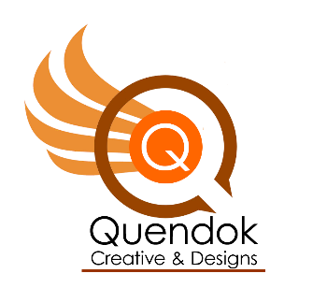



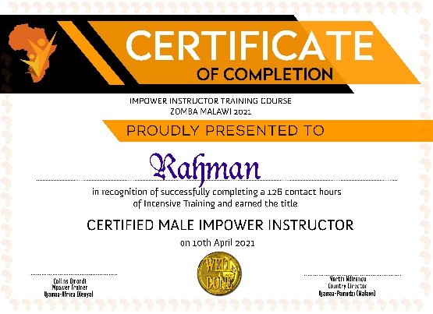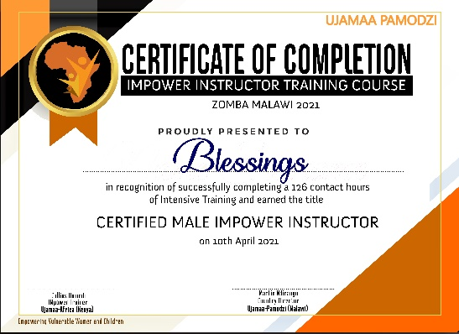







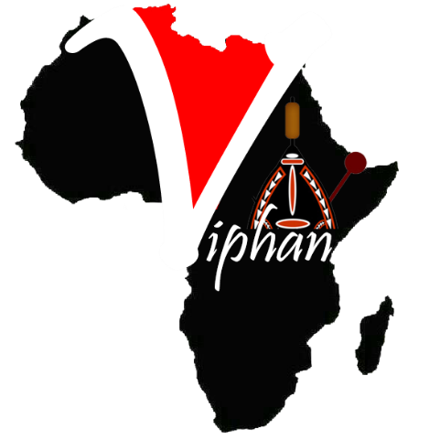

**6. Our Clients**

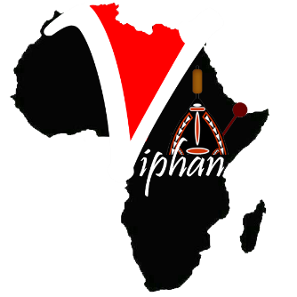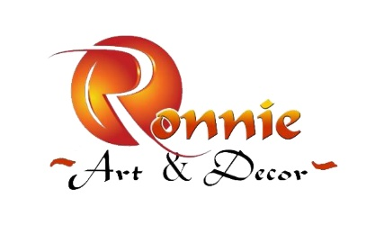********We work closely with all of our clients, whether they are in Kenya or South Sudan. That can mean early mornings and late evenings, travel by tube or plane, a pop round the corner or a conference call. Whatever is required w e adapt and deli ver.

**Performing Arts**

Grafeex Arts Group has a performing arts component that operates in all Counties in Kenya with its base in Nairobi, Kenya. GAG specializes in high quality live drama and Music scripting, directing and recording performances among other Theatrical activities. GAG achieves this by combining new and existing technology to embrace changes in the theatre, Music and drama industry for primary school pupils, high school students, colleges and universities, church youths and community institutions’ artists of all disciplines and diversity which is grounded in the classics and commitments in the creations of new works, new forms and innovative live performance practices.

Grafeex Arts Group, with the directors undertakes all operations, including resource mobilization for the group. The company's ensemble approach to artistic rigor garners enthusiastic response from schools, community audiences, artists and critics alike. With a focus on children and youths’ talents and artistic training, Grafeex Arts Group’s activities have grown to fill a vital need in the drama, music and theatre market especially the live performances in churches, primary and secondary schools as an edutainment entity.

**Aim**

To educate and entertain through drama, music and theatre performances in order to promote intellectual growth of youths, pupils and students in schools, communities and faith based organizations.

**Objectives**

* Build the capacity of the actors and actresses.
* Create awareness, share information and experiences for the betterment and understanding of the literary works.
* Collaborate with likeminded parties in improving the standards of Kenyan literary works.
* Enter into any arrangement with any government or authorities that may seem conducive to the group’s objectives, and to obtain any rights, privileges and concessions which we may think desirable to obtain;
* Generate the resources required for supporting and sustaining the functions of Grafeex Arts Group in realization of its goals.
* To discover and nature artistic Talents.

**Areas of expertise**

1. Scriptwriting for Plays, solo verses, choral verses, traditional dances, narratives etc
2. Directing all items.
3. Painting and Drawing of backdrops and décor.
4. Training music and modern dances.
5. Costumes creation.
6. Life skills facilitations.
7. Team-Buildings

**Schools and churches directed and Competitive levels**

1. Thika Road Primary: Regionals 2019
2. Bishop Perlo Muranga: Nationals 2019
3. Blessed Pavel primary school: Regionals 2018
4. Moi forces academy primary: Regionals 2018
5. St. Monica Njiru Catholic Church: Nationals 2016, Nationals 2017, 2018, 2021.
6. St Dominic Ruiru Catholic Church: 2018 ongoing archdiocese level.
7. Divine Mercy Catholic Church: Nationals Kitale 2013
8. Ngenda High school (Gatundu): Nationals 2011
9. Mwiki Primary school: Nationals 2012
10. St Leo Kakuma Boys Secondary School 2020

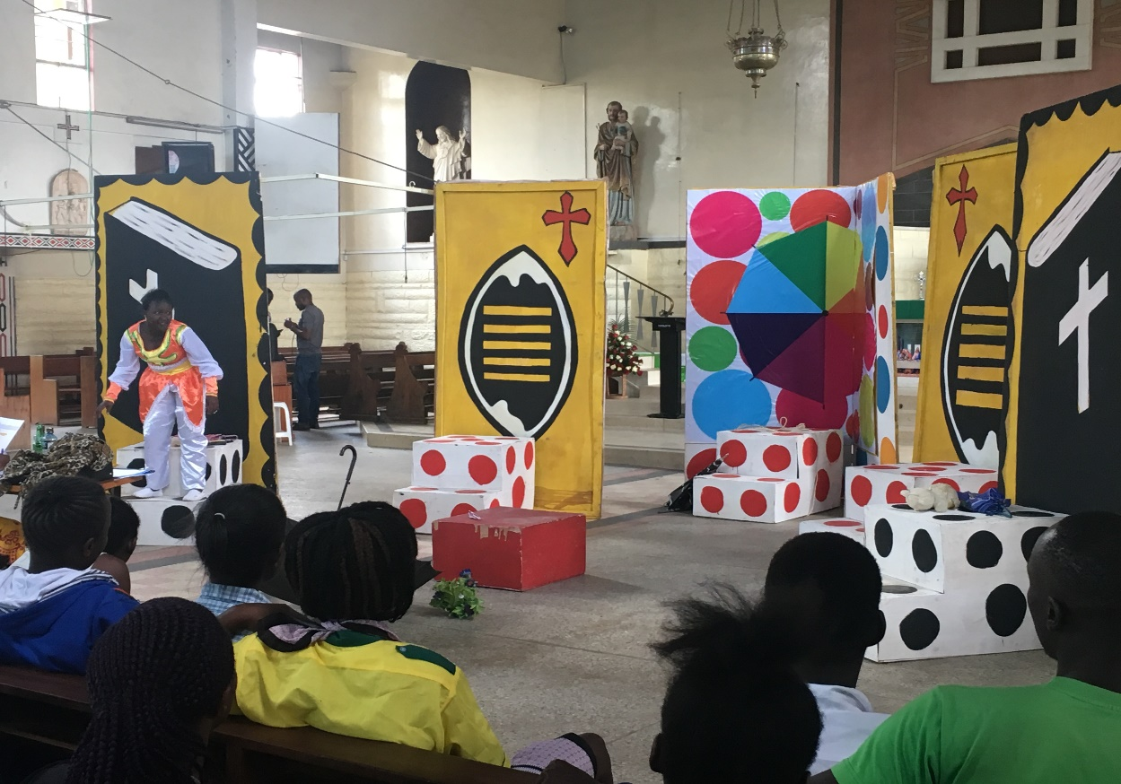

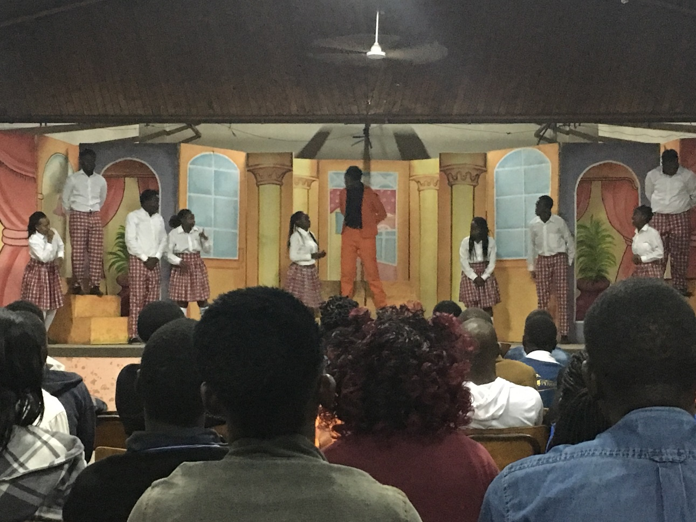

**PAINTING AND DRAWING PROFILE**

Grafeex also specializes in painting backdrops, murals, faux finishing, and fine arts for churches, schools, residential and commercial spaces. We have successfully created a niche in painting, in that grafeex work is recognizable for its festive color, attention to detail, and often whimsical children's subjects. We have painted theater sets, simulating many styles of architecture, stone, landscape, and portraiture.

**"Art for All"—**We believe that every school, church and home is a haven and should reflect the passions of its inhabitants; In this society, we can help an institution become a unique expression of its owners or believers.

**Services Offered**

We offer free, in-home design consultation, portfolio review, and initial sketches.

We custom-design murals or hand-painted subjects in a variety of styles, most often painted directly on a client's walls, ceilings, furniture, and also as framed fine art.

We custom design faux finishes, which are painting techniques that imply stone, aging or pattern, while maintaining hand-painted, custom color mixing and matching, as opposed to wallpaper or commercially mixed and applied pattern and color.

**Production Plan**

After receipt of a design fee deposit, grafeex schedules time to create painted samples or black and white/color drawn samples, according to the agreed and received fee.

The client is then contacted for an appointment to review samples within a couple of weeks, and repeat the design process (for the original fee) until the client is happy and agrees to a sample.

Grafeex presents a quote and contract for signature—copy for client, copy for grafeex, and schedule a begin date, with 70% of the quote due as deposit and calendar commitment.

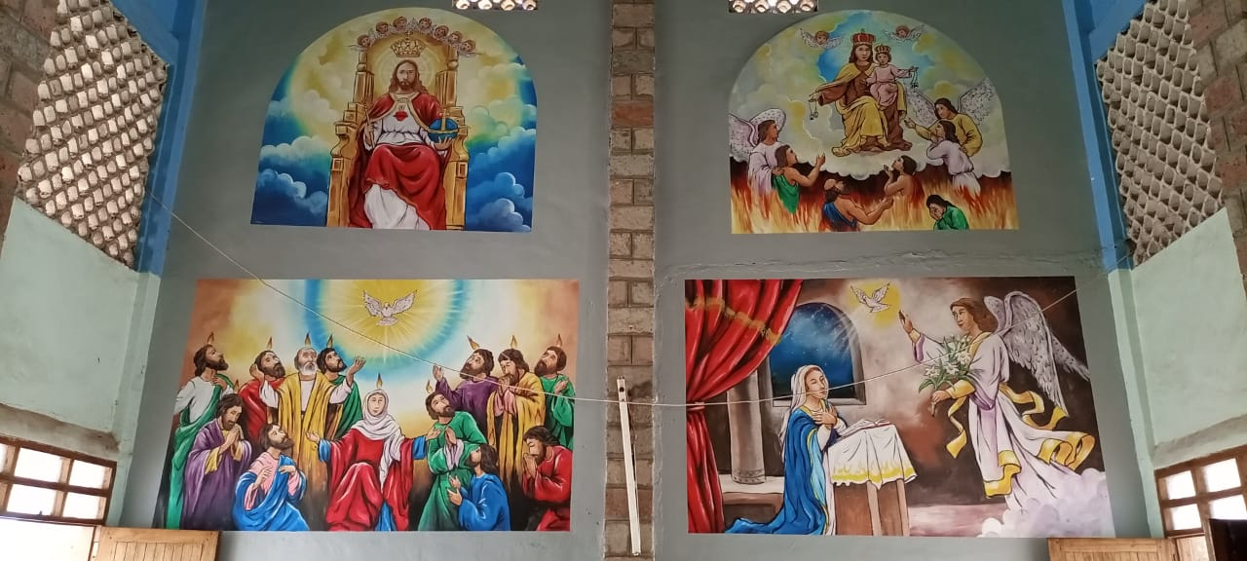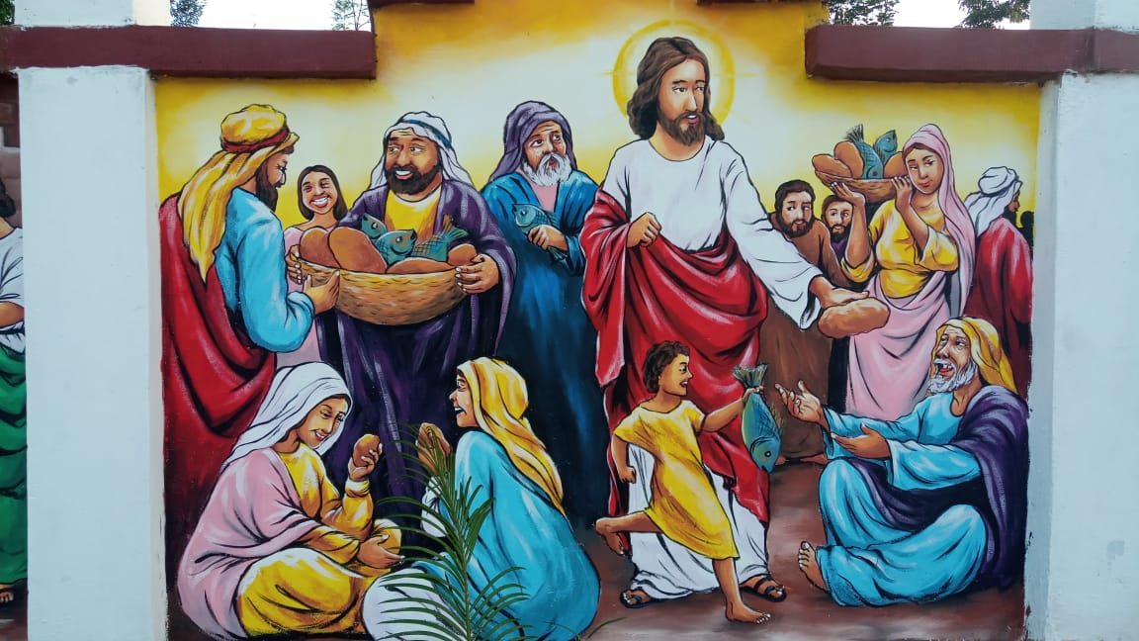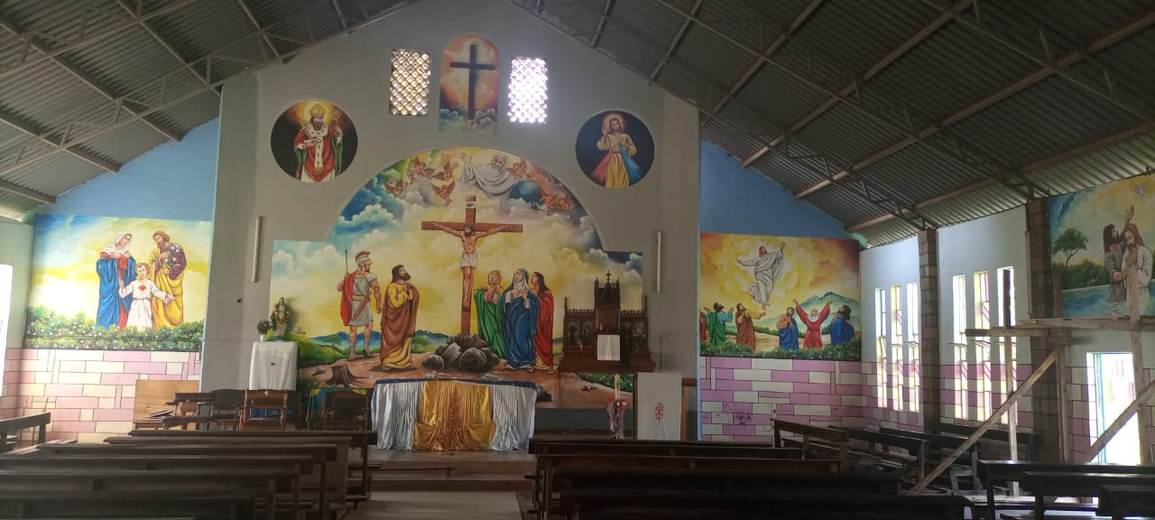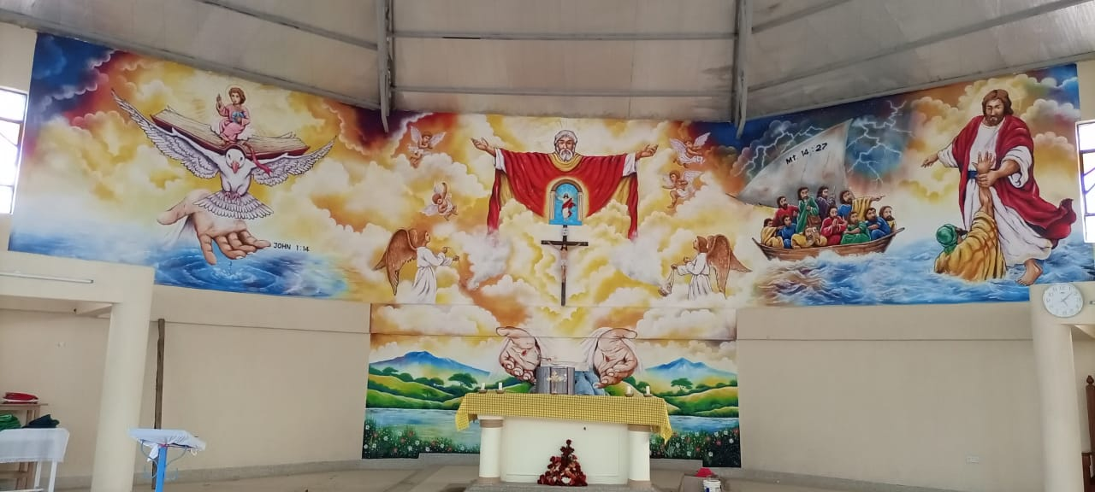At the completion of the project, grafeex photographs the work for promotional use, and receive the remaining 30% of the fee.

