🎬 CineFan
A Social Media Platform for Movie & Series Enthusiasts

CMPS 350 Web Development Project Phase 2
Group 8 | Spring 2026

Student Name | QUID
Reem Al-Hajjaji | 202203198
Rim Gharamah | 202203515
Fatima Naqadan | 201801820
Rouaa Elshafey | 202208035

1. Introduction
CineFan is a social media platform designed for movie enthusiasts. It allows users to register, share posts about movies, like and comment on posts, follow other users, and discover trending films. This report documents Phase 2, which migrated the application from local storage to a real relational database using Prisma ORM with SQLite, and adds a statistics use-case built exclusively with Next.js and React.

2. Data Model

2.1 Conceptual Model
The CineFan data model consists of five entities: User, Post, Comment, Like, and Follow. The relationships are:
- User writes many Posts (one-to-many)
- User writes many Comments (one-to-many)
- User gives many Likes (one-to-many)
- User follows many Users through the Follow table (many-to-many self-referential)
- Post has many Comments (one-to-many)
- Post receives many Likes (one-to-many)

2.2 Data Model Diagram
The following diagram was generated from the Prisma schema and shows all five entities and their relationships:
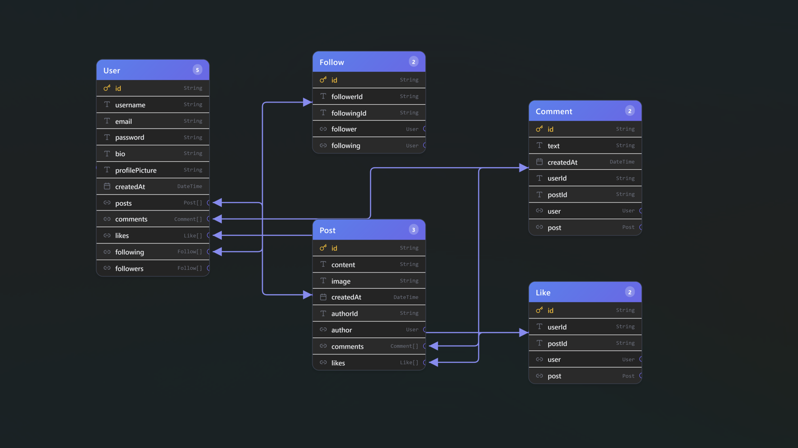

Figure: Prisma schema entity-relationship diagram

2.3 Prisma Studio
The database structure was verified using Prisma Studio (localhost:5555), which shows all five models: User, Post, Like, Follow, and Comment.

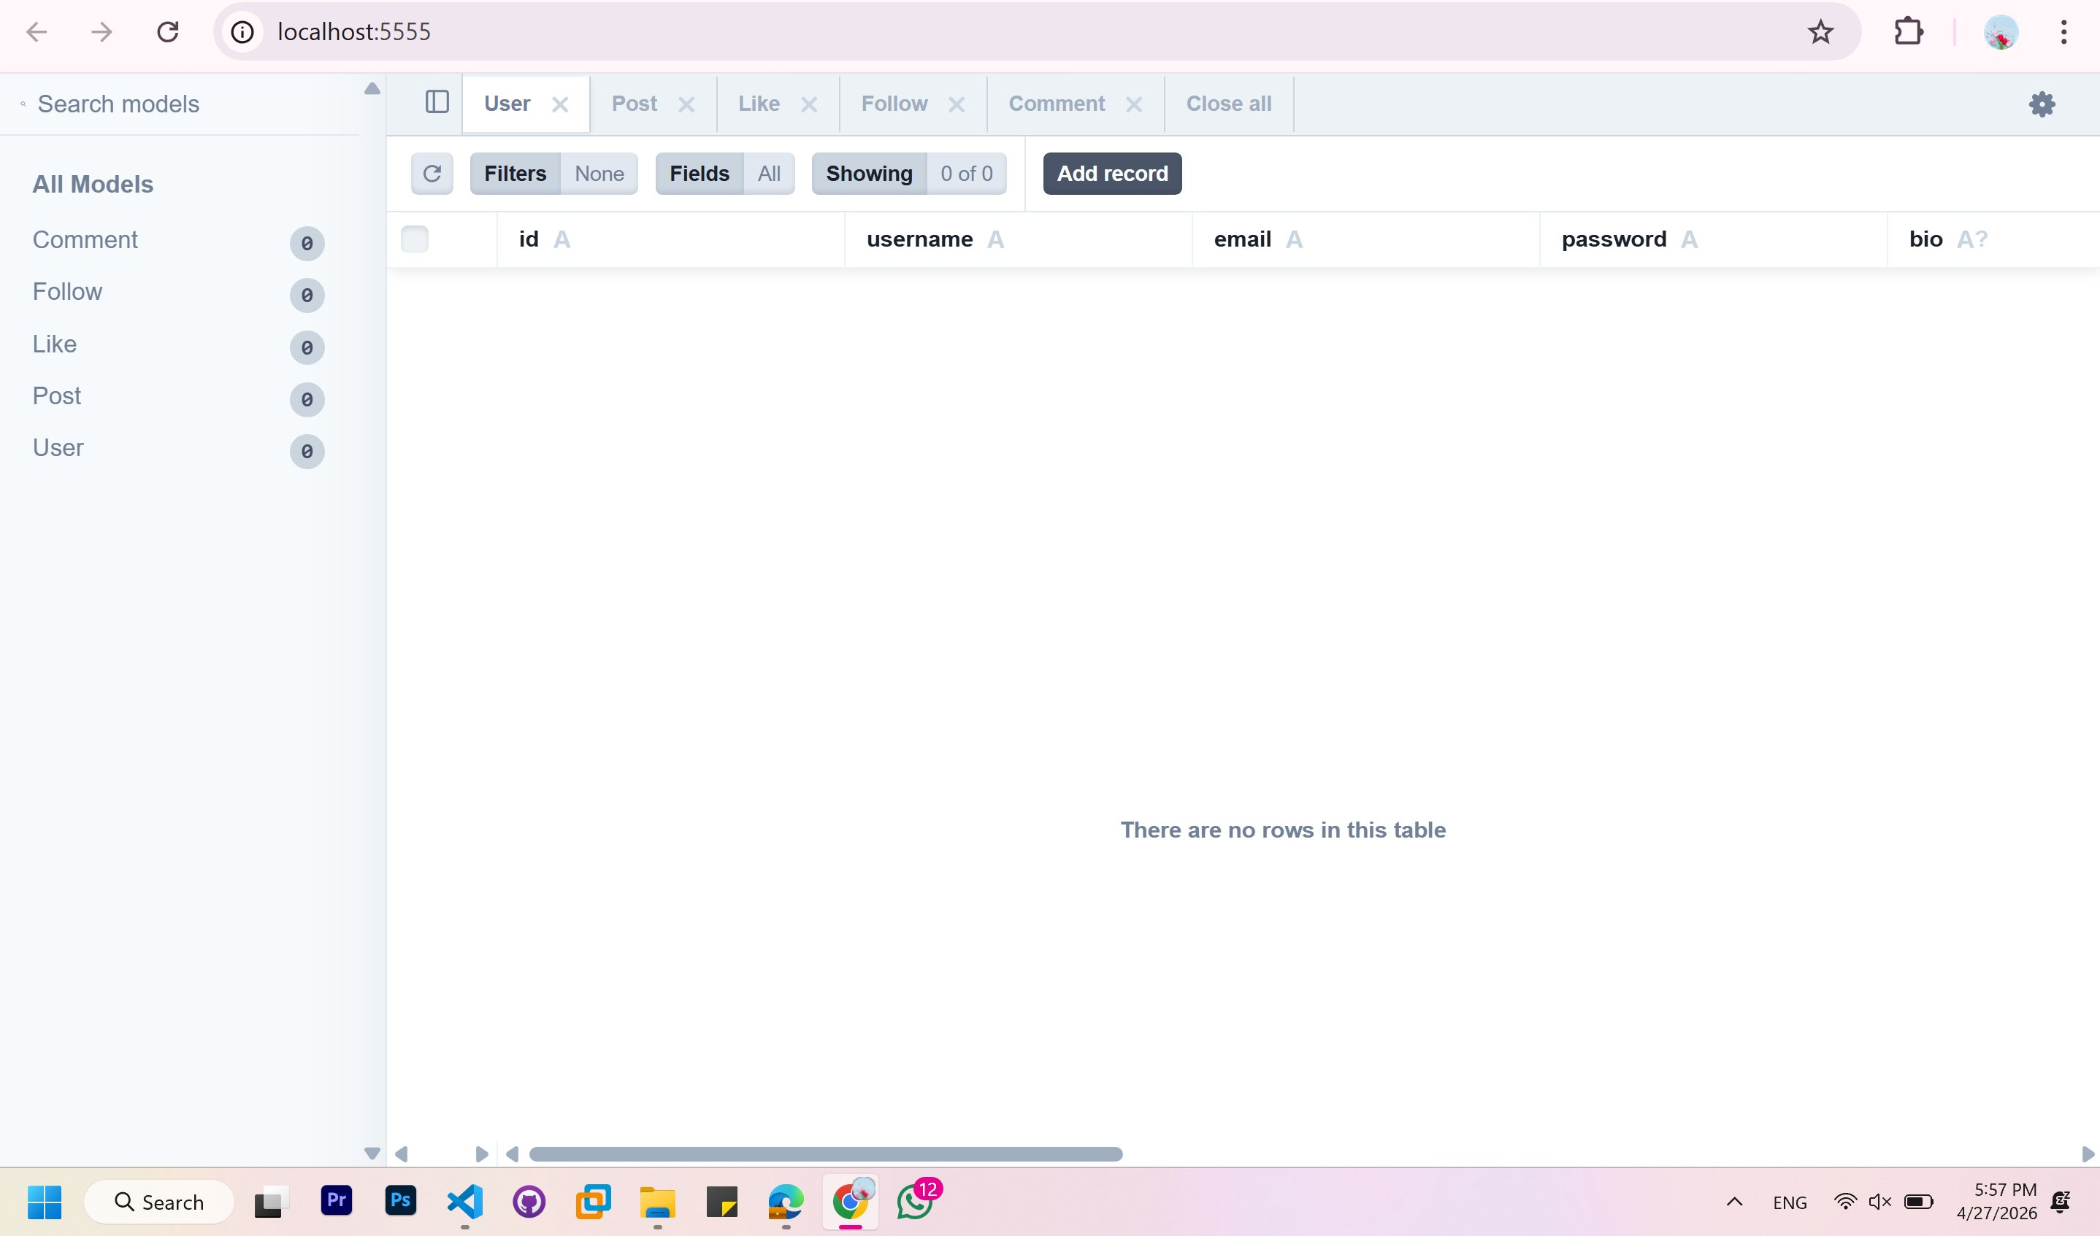
Figure: Prisma Studio showing database models

3. Database Initialization
The database was populated using prisma/seed.js, configured in package.json as shown below. The seed creates 5 users, 8 posts, 6 comments, 8 likes, and 8 follow relationships to provide realistic data for the statistics use-case.

"prisma": {
"seed": "node --experimental-vm-modules prisma/seed.js"
}

4. APIs and Repository Implementation

4.1 Data Repository
All database access is centralized in lib/repository.js using Prisma Client. Only required fields are selected, and all filtering, sorting, and aggregation is performed at the database level — never in application code.

Function | Description
getUserById(id) | Fetches user profile with follower/following counts using _count select
getFeedPosts(userId) | Gets posts from followed users and own posts, ordered by date descending
getPostsByUser(userId) | Gets all posts by a specific user for the profile page
followUser / unfollowUser | Creates or deletes a Follow record, checking for duplicates first
likePost / unlikePost | Toggles Like with unique constraint on userId + postId pair
addComment | Creates a Comment record and returns it with user details
searchUsers(query) | Searches users by username using Prisma contains filter

4.2 API Routes
Endpoint | Method | Description
/api/auth/register | POST | Register a new user
/api/auth/login | POST | Authenticate user and return session data
/api/posts | GET/POST | Get feed posts or create a new post
/api/posts/[id] | GET/DELETE | Get or delete a specific post
/api/posts/[id]/like | POST | Toggle like on a post (like or unlike)
/api/posts/[id]/comment | POST | Add a comment to a post
/api/users/[id] | GET/PUT | Get user profile or update profile details
/api/users/[id]/posts | GET | Get all posts by a specific user
/api/users/[id]/follow | GET/POST/DELETE | Get followers/following list, follow or unfollow
/api/users/search | GET | Search users by username query
/api/stats | GET | Get all platform statistics

5. Statistics Use-Case

5.1 Overview
A dedicated statistics page was built exclusively using Next.js and React at app/stats/page.js, accessible at /stats. It fetches data from /api/stats and displays 8 platform statistics. The queries are implemented in lib/statsQueries.js.

5.2 Database Queries

Query 1 — Total Users
export async function getTotalUsers() {
return await prisma.user.count();
}

Query 2 — Total Posts
export async function getTotalPosts() {
return await prisma.post.count();
}

Query 3 — Total Comments
export async function getTotalComments() {
return await prisma.comment.count();
}

Query 4 — Total Likes
export async function getTotalLikes() {
return await prisma.like.count();
}

Query 5 — Average Posts Per User
export async function getAvgPostsPerUser() {
const [totalPosts, totalUsers] = await Promise.all([
prisma.post.count(), prisma.user.count(),
]);
return totalUsers > 0 ? (totalPosts / totalUsers).toFixed(2) : 0;
}

Query 6 — Most Active User
export async function getMostActiveUser() {
return await prisma.user.findFirst({
orderBy: { posts: { _count: "desc" } },
include: { _count: { select: { posts: true } } },
});
}

Query 7 — Most Liked Post
export async function getMostLikedPost() {
return await prisma.post.findFirst({
orderBy: { likes: { _count: "desc" } },
include: {
author: true,
_count: { select: { likes: true, comments: true } },
},
});
}

Query 8 — Top 5 Most Followed Users
export async function getTopFollowedUsers() {
return await prisma.user.findMany({
take: 5,
orderBy: { followers: { _count: "desc" } },
include: { _count: { select: { followers: true } } },
});
}

5.3 Statistics Page Screenshot

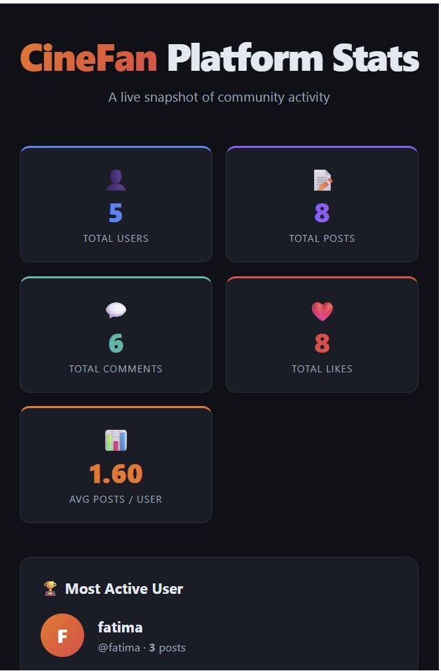
Figure 1: CineFan Platform Statistics Dashboard (/stats)

6. UI Design and Screenshots

6.1 Register Page
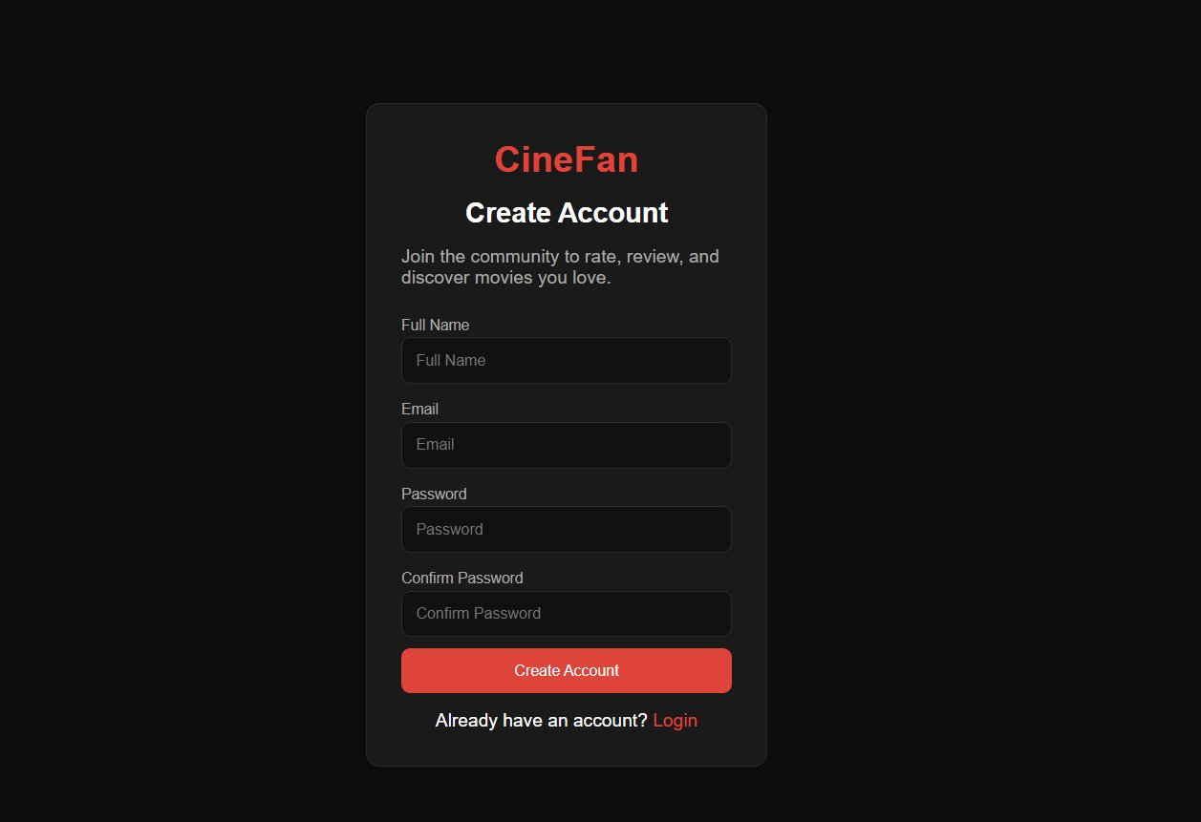
Figure 2: Registration form at /register.html

6.2 Registration Success
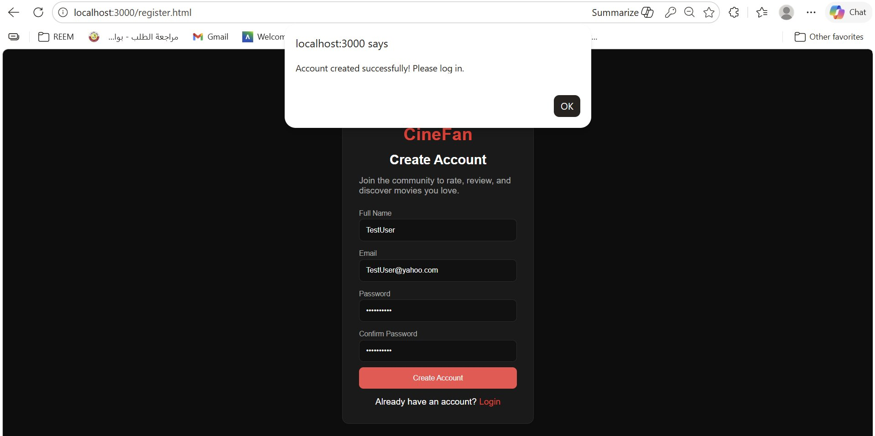
Figure 3: Success message after account creation

6.3 Feed After Login
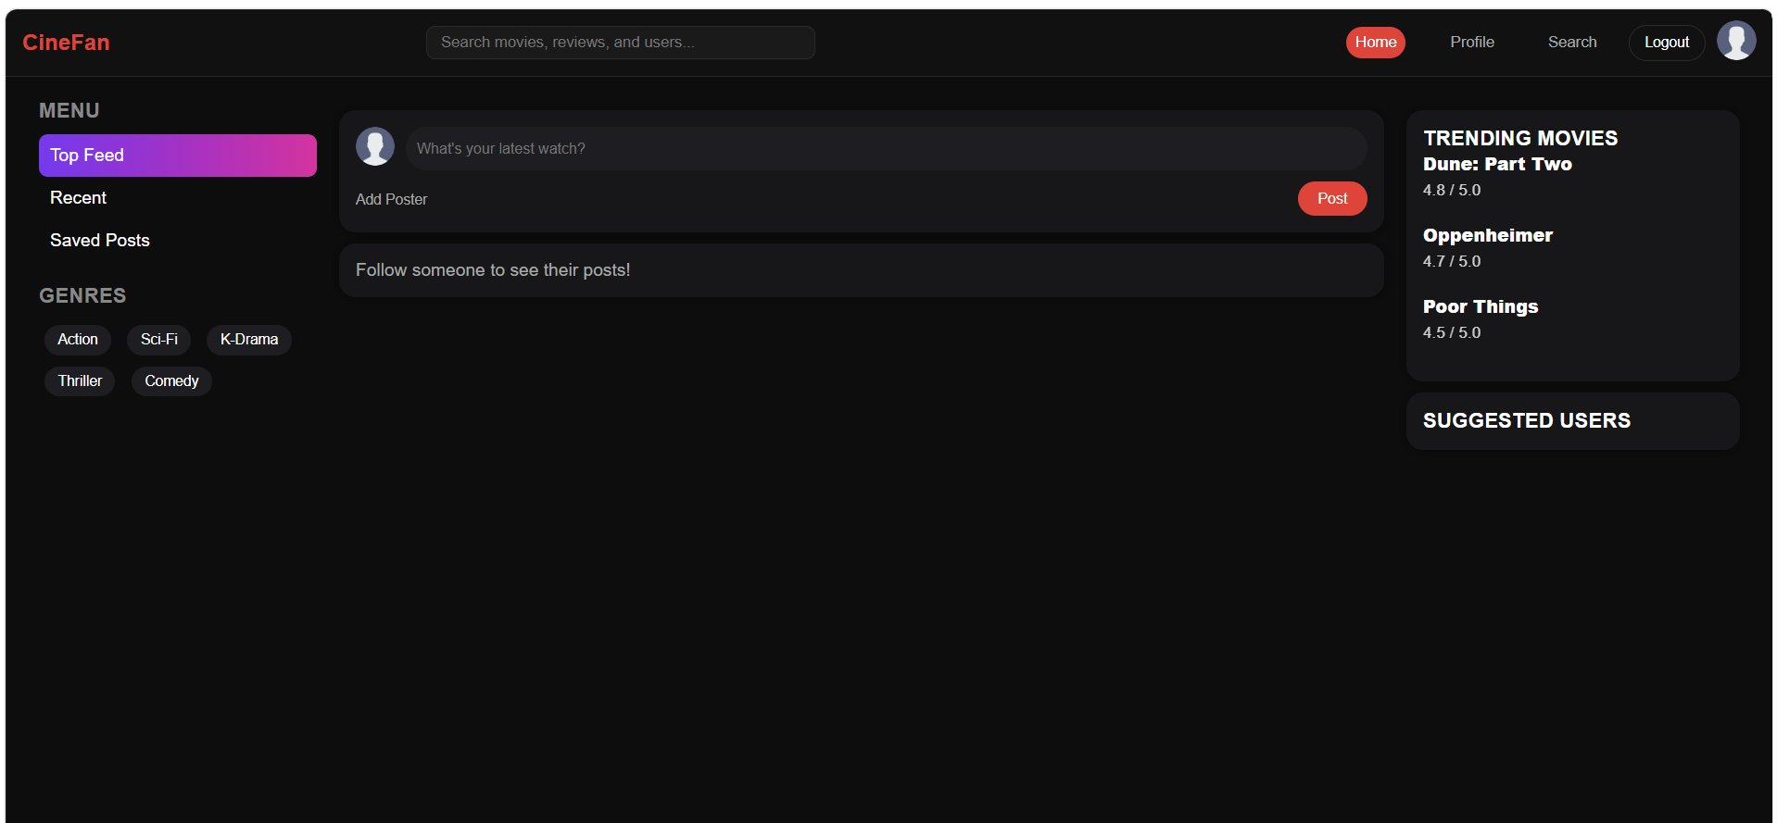
Figure 4: User auto-redirected to feed after successful login

6.4 Create Post
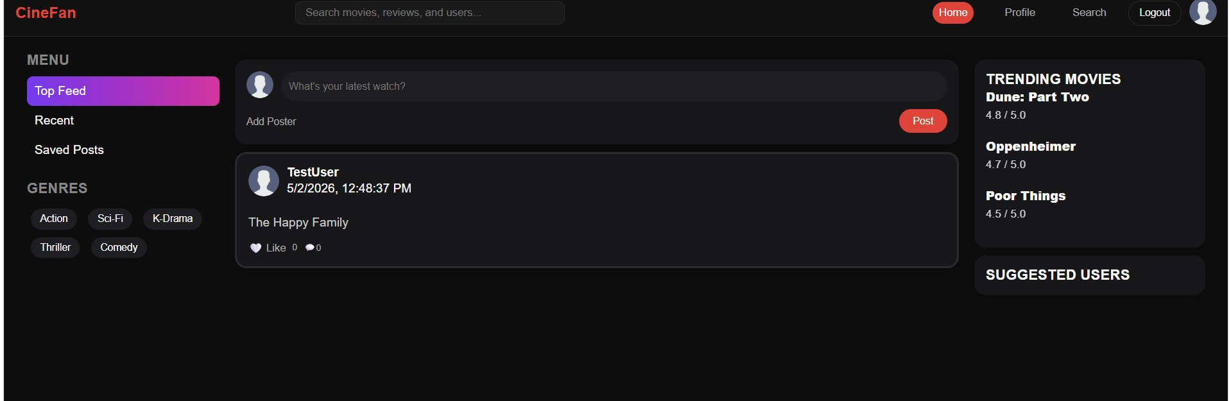
Figure 5: Post "The Happy Family" created and displayed in feed

6.5 Like a Post
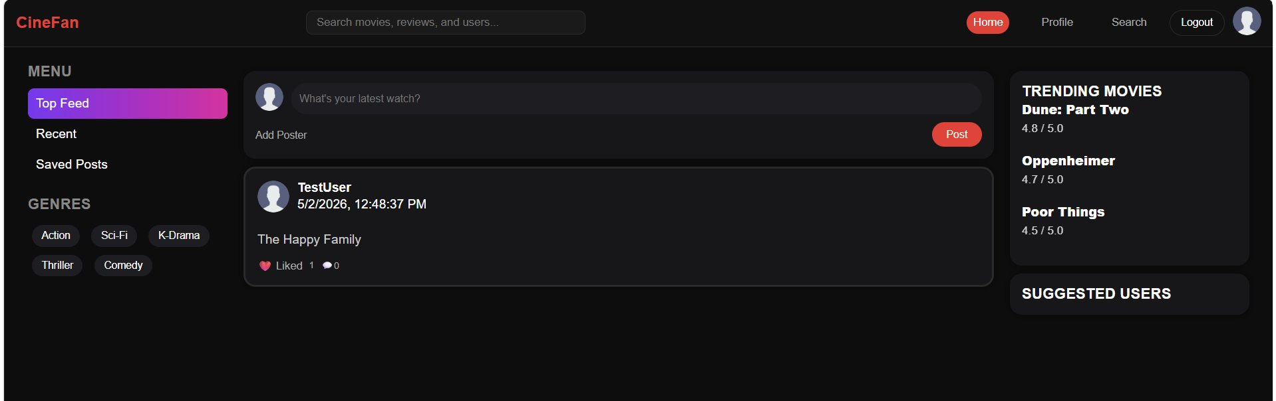
Figure 6: Like count updates to 1 after clicking the like button

6.6 Comment on a Post
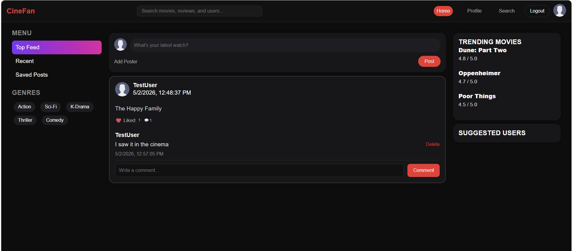
Figure 7: Comment "I saw it in the cinema" added and displayed

6.7 Search Users
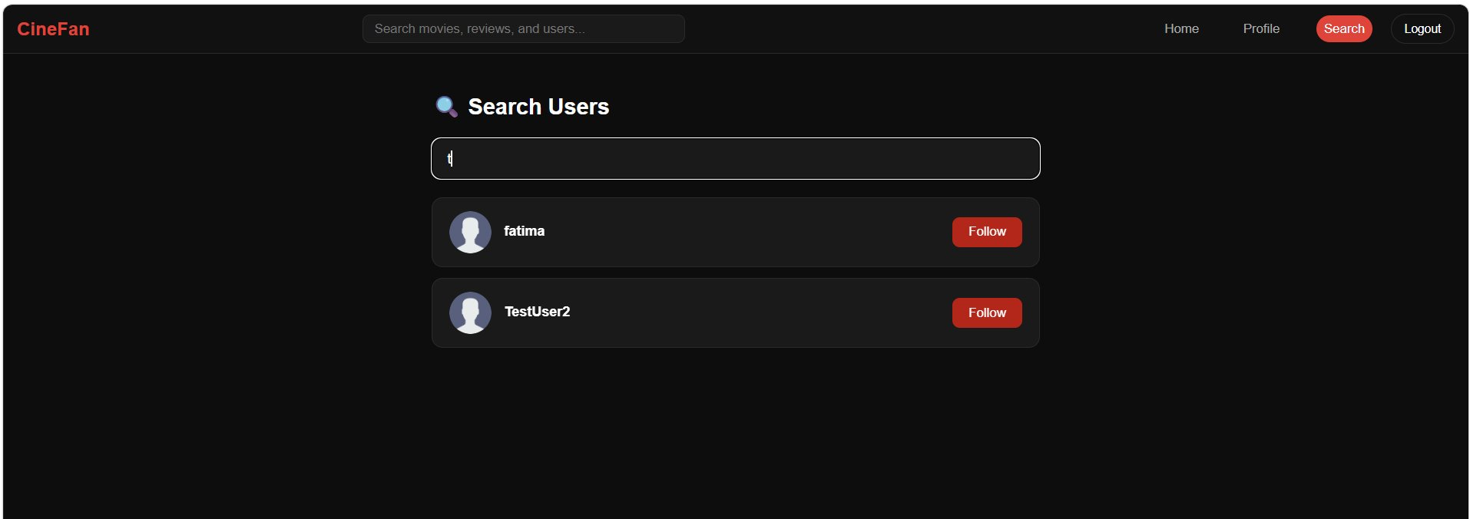
Figure 8: Search results with follow status indicators

6.8 Follow a User
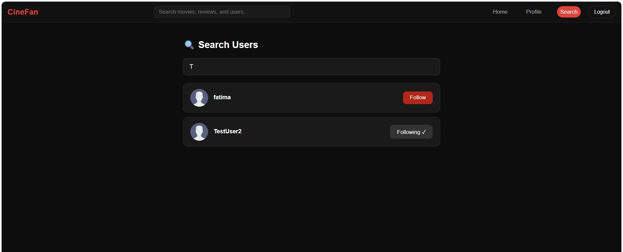
Figure 9: "Following ✓" status shown after following a user

6.9 View User Profile
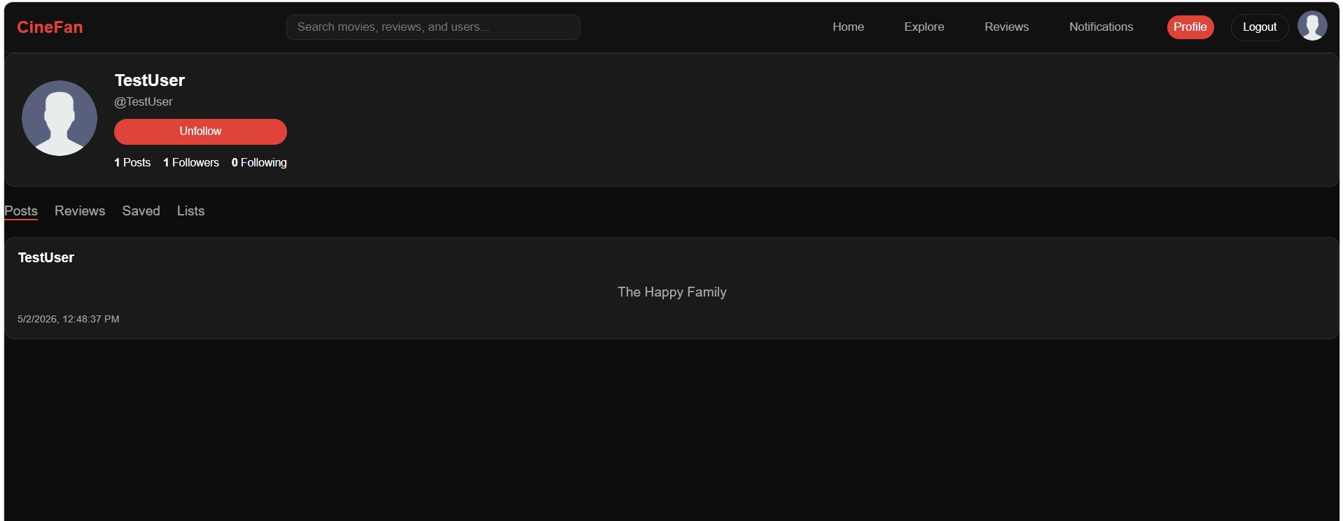
Figure 10: Profile page showing username, posts, and follower count

7. Integration Testing
The following integration tests were conducted to verify end-to-end functionality with the real database:

# | Test Case | Expected Result | Status
1 | User Registration | Account created in DB, success message shown | PASS
2 | User Login | User authenticated, redirected to feed | PASS
3 | Create Post | Post saved to DB and displayed in feed | PASS
4 | Like a Post | Like saved to DB, count increments to 1 | PASS
5 | Comment on Post | Comment saved to DB and displayed under post | PASS
6 | Follow a User | Follow record created, button shows Following | PASS
7 | Search Users | Users returned from DB matching the query | PASS
8 | View User Profile | Profile loaded from DB with correct counts | PASS
9 | Statistics Page | All 8 stats loaded and displayed correctly | PASS
10 | Database Seed | seed.js populates DB with all required data | PASS

8. Team Member Contributions
Team Member | Contribution
Rouaa Elshafey | Next.js project setup, Prisma schema and database migrations, auth APIs (/api/auth/register, /api/auth/login), user APIs (/api/users), search API, statistics queries and /api/stats endpoint, seed database
Fatima Naqadan | Data repository (lib/repository.js) with all Prisma CRUD functions, seed.js database population, posts API (/api/posts), statistics page UI (app/stats/page.js) with React components
Rim Gharamah | Like and comment APIs (/api/posts/[id]/like, /api/posts/[id]/comment), user search page (search.html, search.js) connected to API, follow/unfollow integration, final UI fixes and auth guards
Reem Al-Hajjaji | Profile page (profile.js) connected to API with follow/unfollow and edit profile, feed.js fully connected to API (load feed, create post, like, comment, delete, suggested users), integration testing, project report

9. Setup Instructions

9.1 Prerequisites
Before running the project, make sure the following are installed on your computer:
- Node.js version 18 or higher (download from https://nodejs.org)
- npm (comes with Node.js)
- Git (to clone the repository)

9.2 Step-by-Step Setup
Step 1 — Clone the repository
Open a terminal and run:
git clone https://github.com/Reem-202203198/Web-Project.git
cd Web-Project
git checkout phase2
cd cinefan
Step 2 — Install dependencies
npm install
Step 3 — Set up the database
Run the Prisma migration to create the database tables:
npx prisma migrate dev
Step 4 — Seed the database
Populate the database with test users, posts, comments, likes, and follows:
node prisma/seed.js
This creates 5 users, 8 posts, 6 comments, 8 likes, and 8 follow relationships. You will see “Seed done!” in the terminal when complete.
Step 5 — Start the application
npm run dev
The application will start at http://localhost:3000

9.3 Accessing the Application
Once running, open your browser and go to the following pages:
- Login page: http://localhost:3000/Login.html
- Register page: http://localhost:3000/register.html
- Statistics page: http://localhost:3000/stats

9.4 Seed User Accounts
After running the seed, the following test accounts are available to log in with:
- Email: fatima@test.com / Password: 123456
- Email: reem@test.com / Password: 123456
- Email: haya@test.com / Password: 123456
- Email: sara@test.com / Password: 123456
- Email: noor@test.com / Password: 123456

9.5 GitHub Repository
Repository URL: https://github.com/Reem-202203198/Web-Project
Phase 2 branch: phase2

