Princess Sumaya University for Technology
King Abdullah II School of Engineering
Computer Engineering Department


Embedded Systems (22442)
Autonomous Mobile Robots Challenge Report

Prepared By:
Lara Zghayer 20220664
Reem Abu Abed 2022031
Leen Abu Nimeh 20221132

Supervised by:
Dr. Essam Al Qaralleh
Dr. Belal Sababha

Abstract:
This project focuses on the design and programming of a mobile robot capable of autonomously navigating a multi-zone track. The objective is to complete all stages of the map smoothly, accurately, and in the shortest time possible. The robot successfully performed the start zone, line-following zone, tunnel zone, path navigation zone, bump, and the parking using embedded sensors and interrupt-based control.

Table of Contents
Abstract 2
Introduction and Background 4
Our Design 4
Mechanical 5
Electrical 7
Software 9
Problems and Recommendations 10
Conclusion 10

Introduction and Background:
This project presents the design and implementation of an Autonomous Robot based on the PIC 16F877A microcontroller architecture. Unlike standard line-followers, this robot is engineered to handle a dynamic environment, navigating through complex scenarios that simulate real-world logistical challenges, including tunnels, obstacles, and a parking zones.

The robot is designed and programmed to navigate through all the following stages:
- Line Following: using TCRT5000 (IR) floor sensors
- T-intersection handling: Ultrasonic sensor (HC-SR04) and TCRT5000 (IR) floor sensors
- Tunnel navigation: using an LDR (Light-dependent Resistor) and a buzzer
- Obstacle Avoidance: Ultrasonic sensor (HC-SR04) and side IR sensor module
- Parking: detecting the parking spot, stop and raise the flag using the servo motor

Our Design:
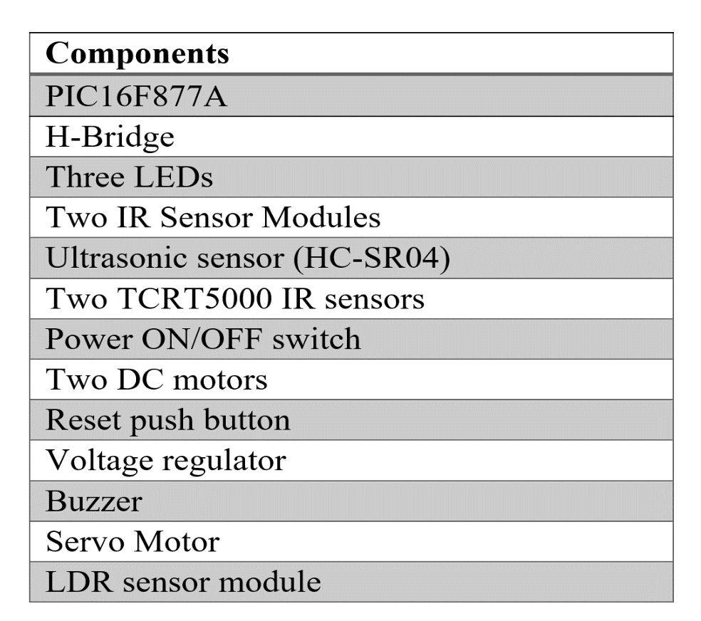

Mechanical Design:
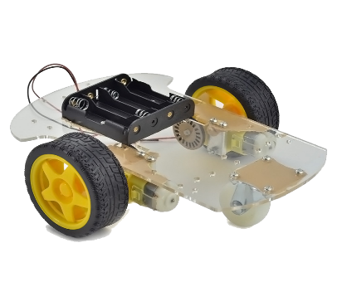
- We used Standard 2WD robot kit:

- Independent speed control of each wheel; providing smooth direction changes when navigating in curves, obstacle avoidance, and T-intersection.
- Lower power consumption
- Easy to install and maintain

- Dimensions:
- Height: 12 cm
- Width: 15 cm
- Length: 23 cm

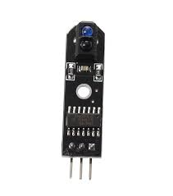
- Sensors:

- TCRT5000 (IR) sensors: at the front left and front right of the robot, and close to the ground. Used as a digital input:
- Logic 1: White
- Logic 0: Black

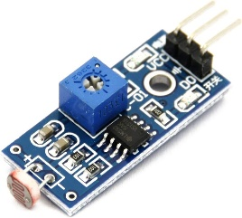
- LDR sensor (used as analog input): at the top front of the robot. light intensity detection used for the tunnel.
- High light intensity:
- LDR resistance decrease
- Voltage at ADC increase
- Low light intensity:
- LDR resistance increase
- Voltage at ADC decrease

- Ultrasonic (HC-SR04): front, used for obstacle detection:
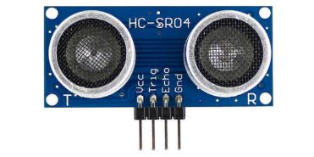
- We need at least 10us pulse for the trigger input to start the ranging
- The module automatically sends eight 40 kHz cycle and detects whether there is a pulse signal back.
- If the ultrasonic signal is reflected back, the echo pin goes high, and the duration of this high-level signal represents the time between transmitting the ultrasonic pulse and receiving its echo.

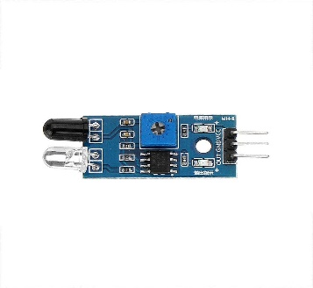
- IR sensor module: at each side of the robot for obstacle detection

- Logic 1: White
- Logic 0: Black

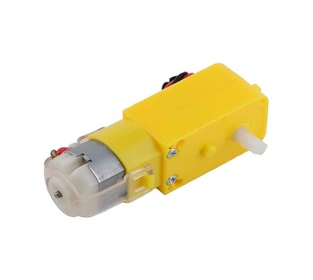
4- Actuators:
- DC Motors (connected to H-Bridge):
- Left motor: speed on CCPR2L (PWM), Direction on RC4/RC5
- Right motor: speed on CCPR1L (PWM), Direction on RC6/RC7

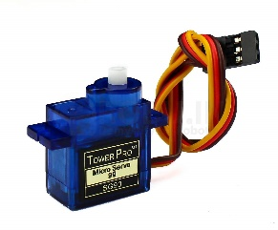
- Servo Motor (Controlled via Software PWM in the Interrupt): used for raising the flag at the end of the parking stage.

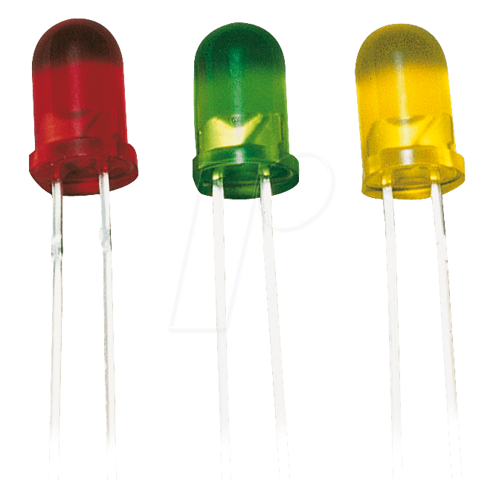
- LEDs: used at the start zone, and the obstacle detection zone.

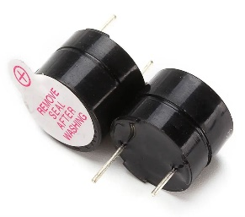
- Buzzer: used at the tunnel zone, and the parking zone.

Electrical Design:
The electrical design of the system is centered around a PIC 16F877A microcontroller that serves as the main control unit, operating with an external crystal oscillator to ensure stable timing. The microcontroller interfaces with multiple sensor modules, including infrared line sensors, an ultrasonic distance sensor, and a light-dependent resistor (LDR). The DC motors are driven through an H-bridge motor driver and powered via a voltage regulator to provide stable and safe operating voltages. A servo motor is also controlled by the PIC to perform positional movements. Additional output devices such as LEDs and a buzzer are connected to the microcontroller for visual and audio status indication.

PORTA (RA0–RA5)
RA0 | LDR
RA1 | LED (red)
RA2 | IR (left)

PORTB (RB0–RB7)
RB1 | Trig (Ultrasonic sensor)
RB2 | Echo (Ultrasonic sensor)
RB4 | Buzzer (active high)
RB5 | IR (right)
RB6 | Servo motor

PORTC (RC0–RC7):
RC1 | ENA (H-bridge)
RC2 | ENA (H-bridge)
RC4 | IN1 (left motor)
RC5 | IN2 (left motor)
RC6 | IN3 (right motor)
RC7 | IN4 (right motor)

PORTD (RD0–RD7):
RD0 | LED (blue)
RD2 | IR (left)
RD3 | IR (right)
RD4 | LED (yellow)

Hardware Schematic Design:
The following schematic design illustrates the complete circuit design of the autonomous robot, detailing the interface between the PIC 16F877A microcontroller and its peripheral components. The diagram explicitly maps the I/O connections across Ports A, B, C, and D, demonstrating the precise wiring for the motors via the H-bridge, the sensor array (IR, LDR, and Ultrasonic), and the flag-raising servo mechanism. This visual representation confirms the integrated system architecture required to support the robot's navigation and decision-making logic.

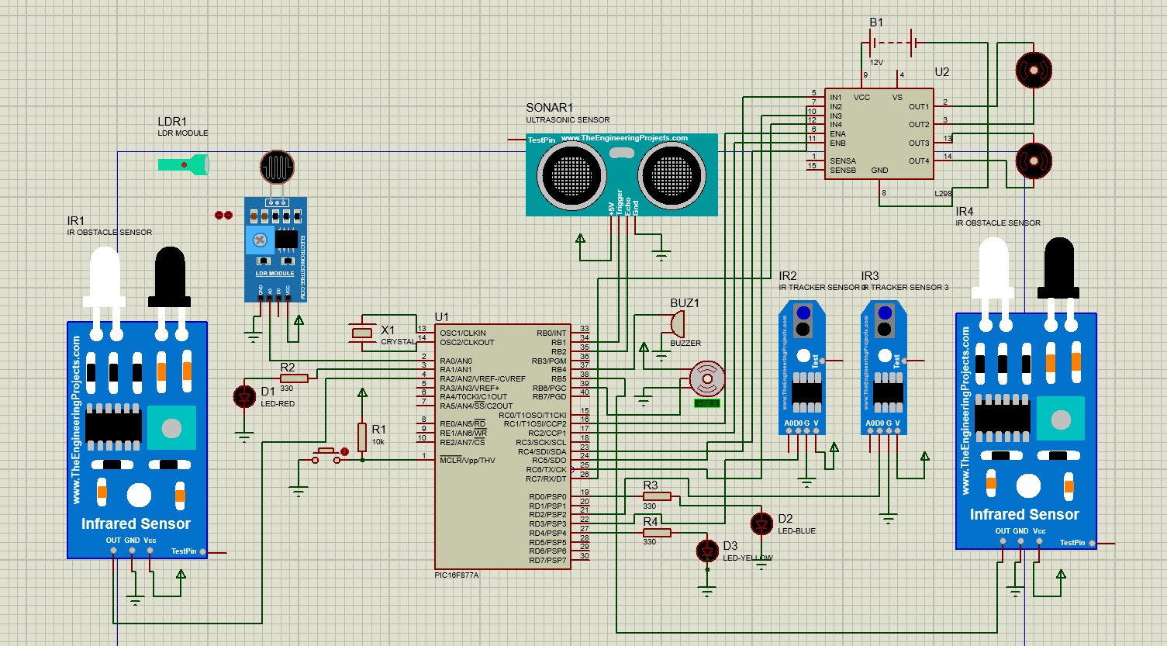

Software Design:
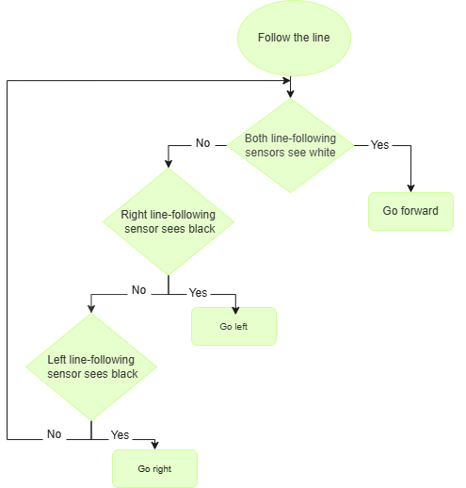
The flowchart below illustrates the sequential control logic implemented on the PIC microcontroller to meet the navigation requirements. The process initiates with hardware configuration and a mandatory 3 second start delay using TMR0 interrupts. The main execution loop is divided into distinct operational states: Line Following, where IR sensors adjust motor PWM for stability; Tunnel Mode, which triggers the buzzer upon detecting low light intensity and Obstacle Avoidance, which utilizes ultrasonic feedback to navigate the pathless zone. The routine concludes with the Parking zone, ensuring the vehicle stops at the black spot, generates a beeping sound, and actuates the servo to raise the completion flag.

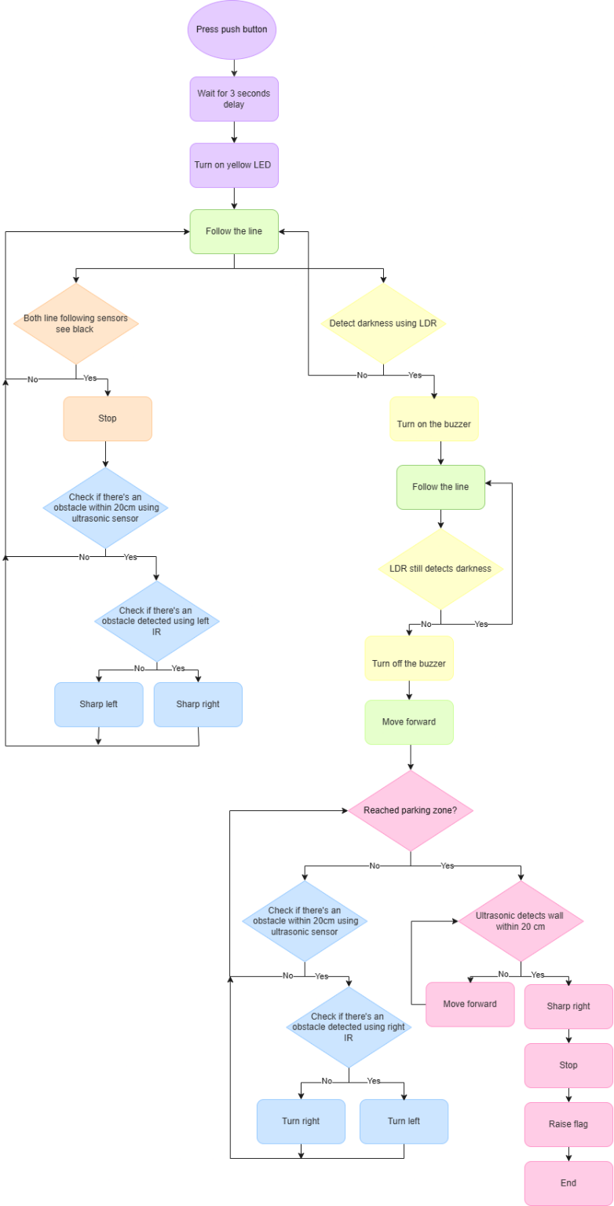

Problems and Recommendations:
Motors Speed:
We faced a problem where each wheel started to operate at a different speed, given that we programmed the wheels to run at the same speed (PWM). Then, we figured out that the motors consume different voltages, causing one wheel to moves faster than the other. We found out that the root cause of this problem is that the motors degrade and operate less efficiently over time.

We solved the problem through trial and error, assigning different pwm to each motor. Therefore, the motor that consumes less voltage takes a higher pwm (higher speed), and the motor that consumes more voltage takes a lower pwm (lower speed). So, both motors operate together, consuming the same voltage. Then, the problem got even worse so we decided to change the motors.

Github link:
https://github.com/ReemAa44/Autonomous-Mobile-Robots-Challenge

Conclusion:
This project successfully demonstrated the design and implementation of an autonomous robot capable of navigating a complex multi-zone track. By integrating a PIC microcontroller with a collection of sensors including IR line sensors, an LDR for light detection, and ultrasonic modules for distance measurement, the robot effectively transitioned between distinct operational states.

