DSP PROJECT REPORT

NAME: Rania Khaled

ID: 4288

NAME: Reem Mahmoud

ID: 4525

**DSP lab (final project)**

(1) **Sampling and periodicity of sinusoidal signals :**

a)

%1

%a-1

n1=[-12:12]

x1=[-2,-1,0,1,2];

x1=[x1 x1 x1 x1 x1];

figure('Name','1)a-1')

stem(n1,x1)

%a-2

n2=[0:21];

e=exp(0.1*n2);

x52=e.*(stepseq(0,0,21)-stepseq(20,0,21));

nt=[-22:43]

x52=[x52 x52 x52];

figure('Name','1)a-2')

stem(nt,x52)

%a-3

n3=[0:11]

s=sin(0.1*pi*n3);

x3=s.*(stepseq(0,0,11)-stepseq(10,0,11));

%figure(3)

%stem(n3,x3)

nt1=[-12:35]

x3=[x3 x3 x3 x3];

figure('Name','1)a-3')

stem(nt1,x3)

%a-4

n4=[0:24]

x4_1=[1, 2, 3]

x4_2=[1 ,2 ,3, 4]

x4_1=[x4_1 x4_1 x4_1 x4_1 x4_1 x4_1 x4_1 x4_1 x4_1 x4_1]

x4_2=[x4_2 x4_2 x4_2 x4_2 x4_2 x4_2 x4_2]

x4=x4_1(1:25)+x4_2(1:25);

figure('Name','1)a-4')

stem(n4,x4)

%b-1

n5=[-3:3]

x5=[2,4,-3,1,-5,4,7]

[x51,n51]=sigshift(x5,n5,3);

[x52,n52]=sigshift(x5,n5,-4);

%[x53,n53]=sigshift(x5,n5,0);

[x54,n54]=sigadd(2*x51,n51,3*x52,n52);

[x55,n55]=sigadd(x54,n54,-x5,n5);

figure('Name','1)b-1')

stem(n55,x55)

%b-2

[x61,n61]=sigshift(x5,n5,-4);

[x62,x62]=sigshift(x5,n5,-5);

[x63,n63]=sigadd(4*x61,n61,5*x62,x62);

[x64,n64]=sigadd(x63,n63,2*x5,n5);

figure('Name','1)b-2')

stem(n64,x64)

%b-3

[x71,n71]=sigshift(x5,n5,-3);

[x72,n72]=sigshift(x5,n5,2);

[x73,n73]=sigshift(x5,n5,1);

[x74,n74]=sigshift(x5,n5,-1);

[x75,n75]=sigmult(x71,n71,x72,n72);

[x76,n76]=sigmult(x73,n73,x74,n74);

[x77,n77]=sigadd(x75,n75,x76,n76);

figure('Name','1)b-3')

stem(n77,x77)

%b-4

ntt=[-10:10]

x81=2*exp(0.5*ntt);

x82=cos(0.1*pi*ntt);

[x83,n83]=sigshift(x5,n5,-2);

[x84,n84]=sigmult(x81,ntt,x5,n5);

[x85,n85]=sigmult(x82,n84,x83,n83);

[x86,n86]=sigadd(x84,n84,x85,n85);

figure('Name','1)b-4')

stem(n86,x86)

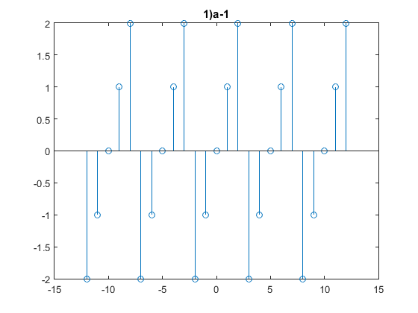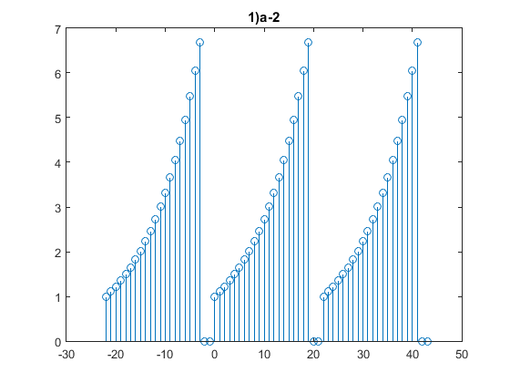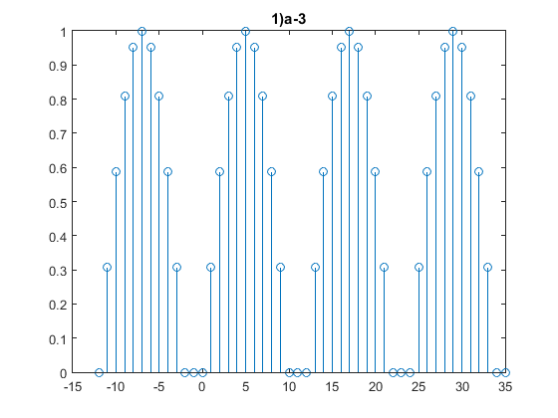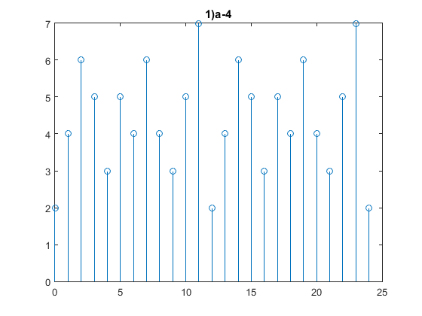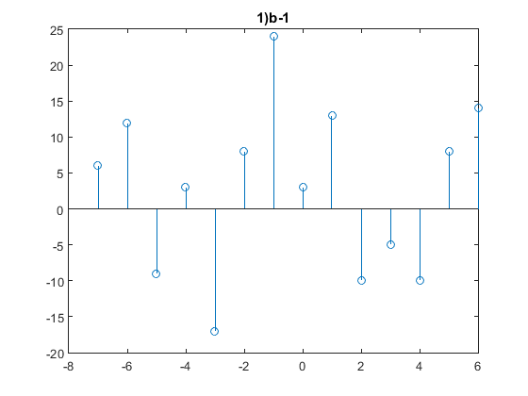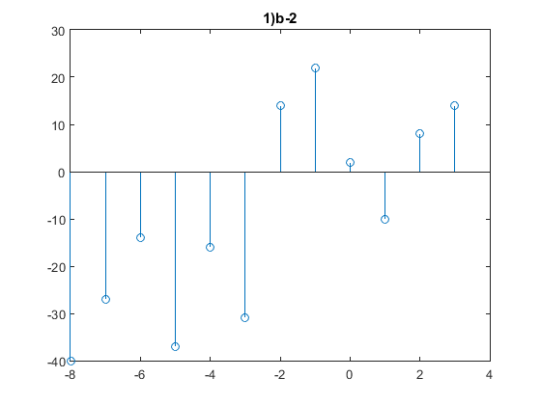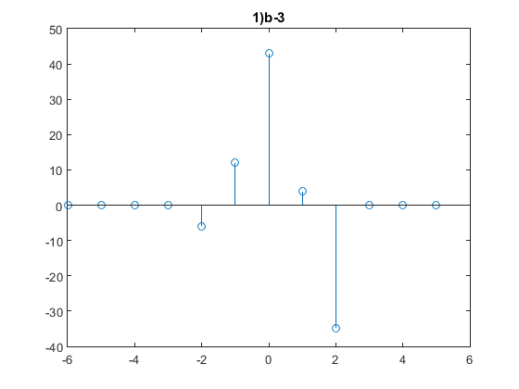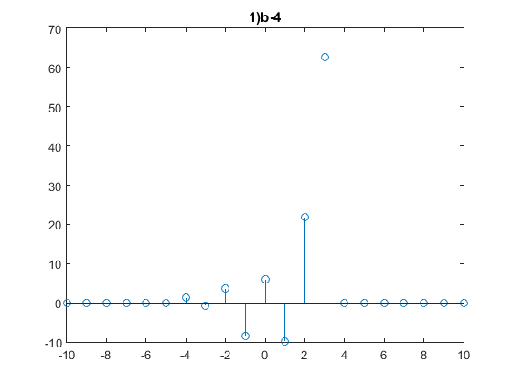

**(2) Time domain analysis of LTI systems:**

%2)

%i

x1=[1,2,4];

h1=[1,1,1];

y1=conv(x1,h1);

figure('Name','2)i')

stem(y1)

title('2)i')

%ii

x2=[0,1,-2,3,-4];

h2=[1,2,1,0.5,0];

y2=conv(x2,h2);

figure('Name','2)ii')

stem(y2)

title('2)ii')

%iii

x3=[1,2,3,4];

h3=[4,3,2,1];

y3=conv(x3,h3);

figure('Name','2)iii')

stem(y3)

title('2)iii')

%iv

x4=[1,2,3,4];

h4=[1,2,3,4];

y4=conv(x4,h4);

figure('Name','2)iv')

stem(y4)

title('2)iv')

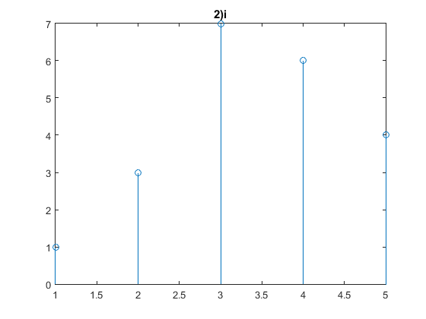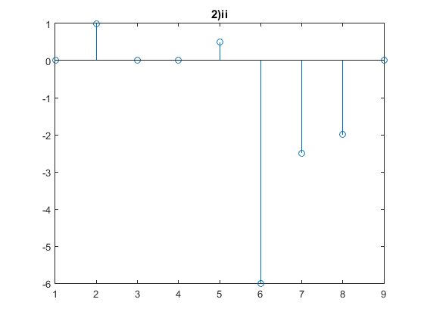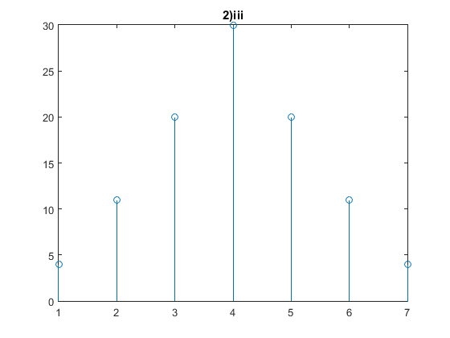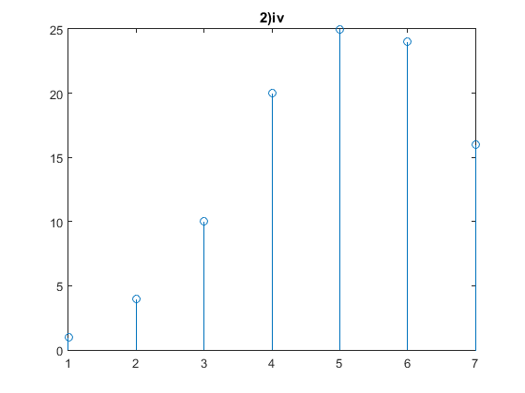

**(3) Z-transform analysis of discrete systems:**

%3)

%a-i

num1=[1 -2 2 -1];

den1=[1 -1];

den2=[1 -0.5];

den3=[1 -0.2]

den4=conv(den1,den2);

den5=conv(den4,den3);

H1=tf(num1,den5,0.1,'variable','z^-1');

figure('Name','3)a-i')

zplane(num1,den5) %stable

title('3)a-i')

%a-ii

h=filter(num1,den5,[1 zeros(1,39)]);

figure('Name','3)a-ii')

stem(h)

title('3)a-ii')

%b

num2=[0.03 -0.02 0.01];

den6=[1 -2.8 3.02 1.468 0.27];

H2=tf(num2,den6,0.1, 'variable', 'z')

figure('Name','3)b')

zplane(num2, den6)

title('3)b')

s=filter(num2,den6,5*ones(1,50));

figure('Name','3)b-1')

stem(s)

title('3)b-1')

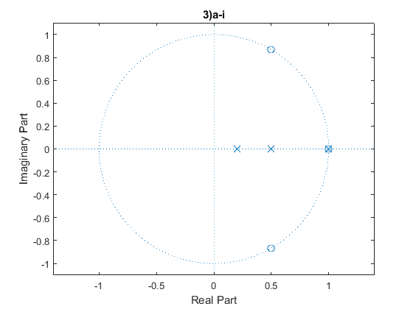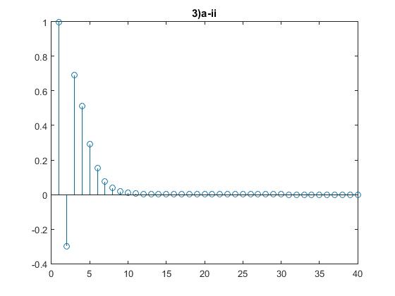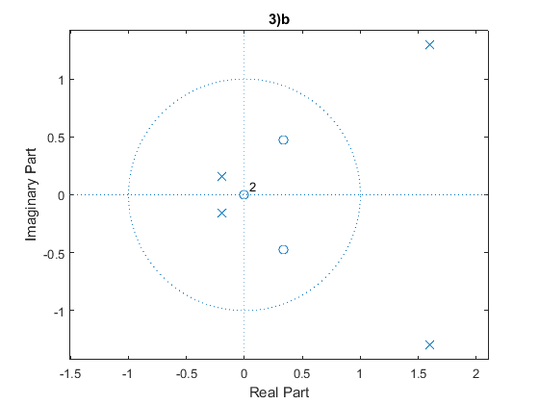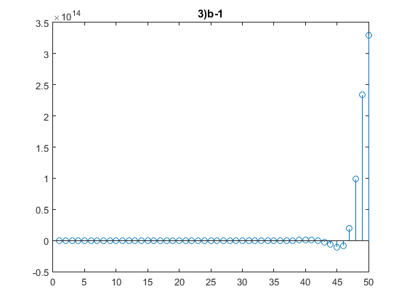

**(4) Fourier-transform analysis of discrete systems:**

%4

%4-a

n=[0:10];

[x1,n1]=stepseq(0,0,10);

[x2,n2]=stepseq(6,0,10);

[x3,n3]=sigadd(x1,n1,-1*x2,n2);

y1=fft(x3);

figure('Name','4)a')

stem(abs(y1))

title('4)a')

figure('Name','4)a-1')

stem(angle(y1))

title('4)a-1')

%4-b

t=2.^n;

[x4,n4]=stepseq(0,0,10);

[x5,n5]=sigfold(x4,n4);

[x6,n6]=sigmult(t,n,x5,n5);

y2=fft(x6);

figure('Name','4)b')

stem(abs(y2))

title('4)b')

figure('Name','4)b-1')

stem(angle(y2))

title('4)b-1')

%4-c

t1=0.25.^n;

[x7,n7]=stepseq(4,0,10);

[x8,n8]=sigmult(t1,n,x7,n7);

y3=fft(x8);

figure('Name','4)c')

stem(abs(y3))

title('4)c')

figure('Name','4)c-1')

stem(angle(y3))

title('4)c-1')

%4-d

t2=0.25.^n;

t3=sin(2*pi*0.25*n);

[x9,n9]=stepseq(0,0,10);

[x10,n10]=sigmult(t2,n,t3,n);

[x11,n11]=sigmult(x10,n10,x9,n9);

y4=fft(x11);

figure('Name','4)d')

stem(abs(y4))

title('4)d')

figure('Name','4)d-1')

stem(angle(y4))

title('4)d-1')

%4-e

t4=0.5.^n;

t3=sin(2*pi*0.25*n);

[x12,n12]=sigmult(t4,n,t3,n);

y5=fft(x12);

figure('Name','4)e')

stem(abs(x12))

title('4)e')

figure('Name','4)e-1')

stem(angle(y5))

title('4)e-1')

%4-f

nf=[-4:4];

[x13]=2-0.5*nf;

y6=fft(x13);

figure('Name','4)f')

stem(abs(y6))

title('4)f')

figure('Name','4)f-1')

stem(angle(y6))

title('4)f-1')

%4-g

ng=[-2:2]

[x14]=[-2,-1,0,1,2];

y7=fft(x14);

figure('Name','4)g')

stem(abs(y7))

title('4)g')

figure('Name','4)g-1')

stem(angle(y7))

title('4)g-1')

