1. **HOME PAGE**

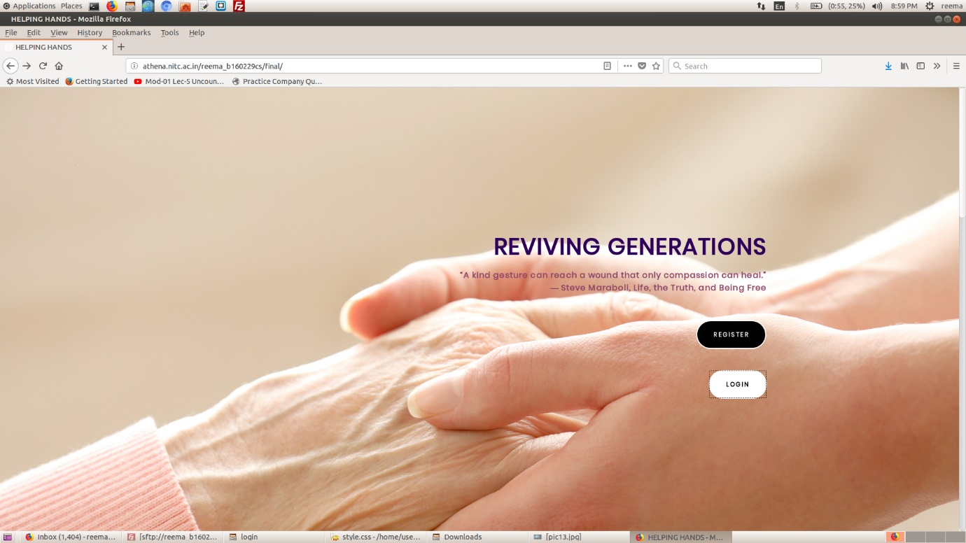

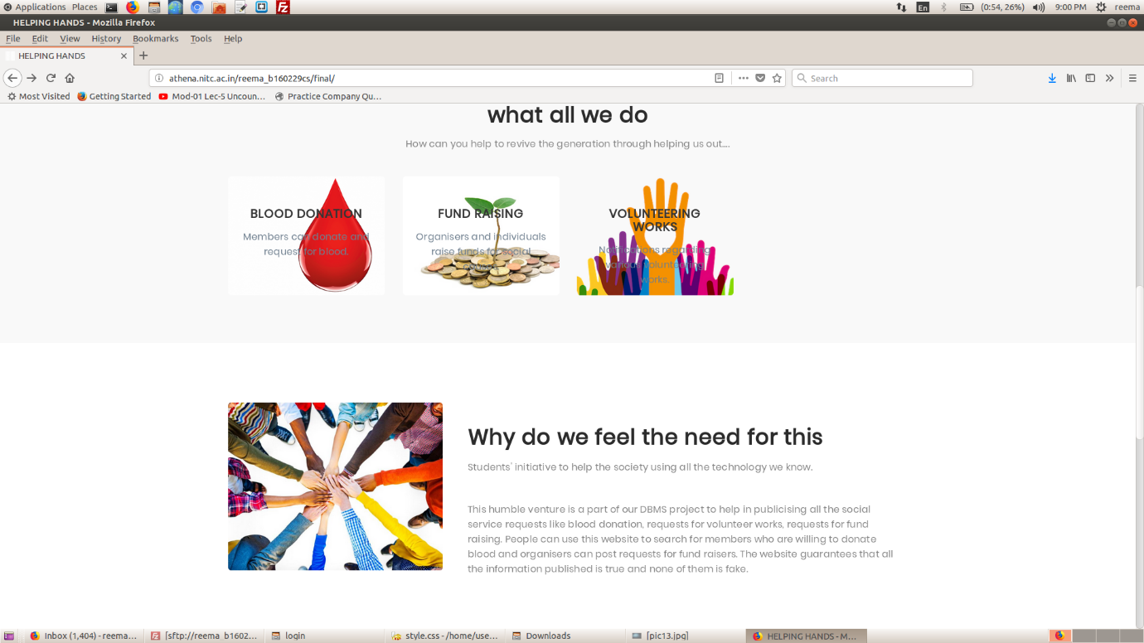

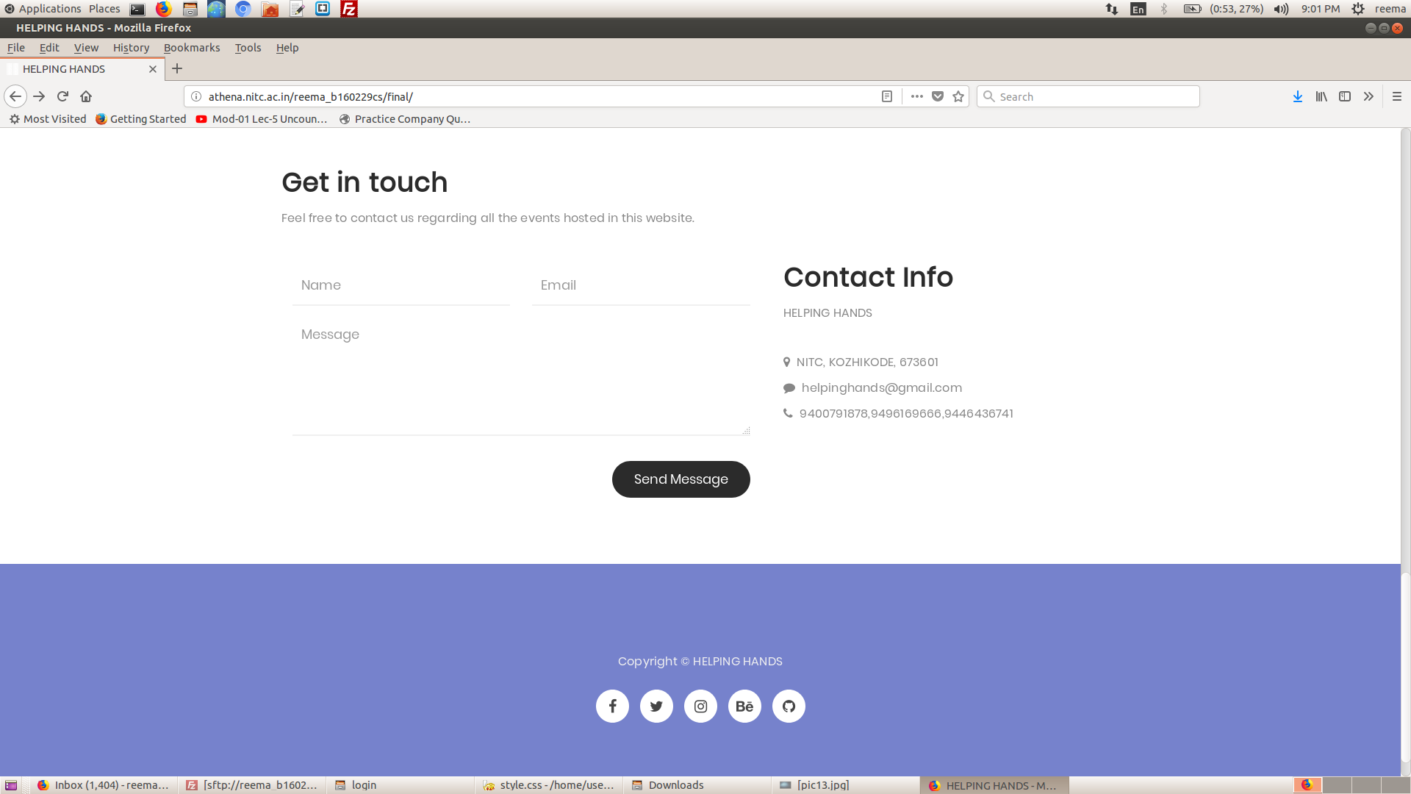

This is the homepage of our website which is titled ‘**HELPING HANDS**’.

There are two options available in the top pf this page (First Image). One option is to register as a new user if you haven’t already done so. To do that you need to click the REGISTER button which takes you to the REGISTER page. If you have already registered you can click the LOGIN button to go to the login page

The next section shows three different areas in which you can contribute. There are options for blood donation, fund raising and volunteering for social campaigns. It also explains what is the need for such an initiative in the current scenario.

The bottom section contains a GET IN TOUCH option where you can send messages and feedback to the page admin. After filling the three fields, pressing the Send Message button will send a message to the admin. The contact info is also provided.

1. **REGISTER PAGE (WITH OPTIONS)**

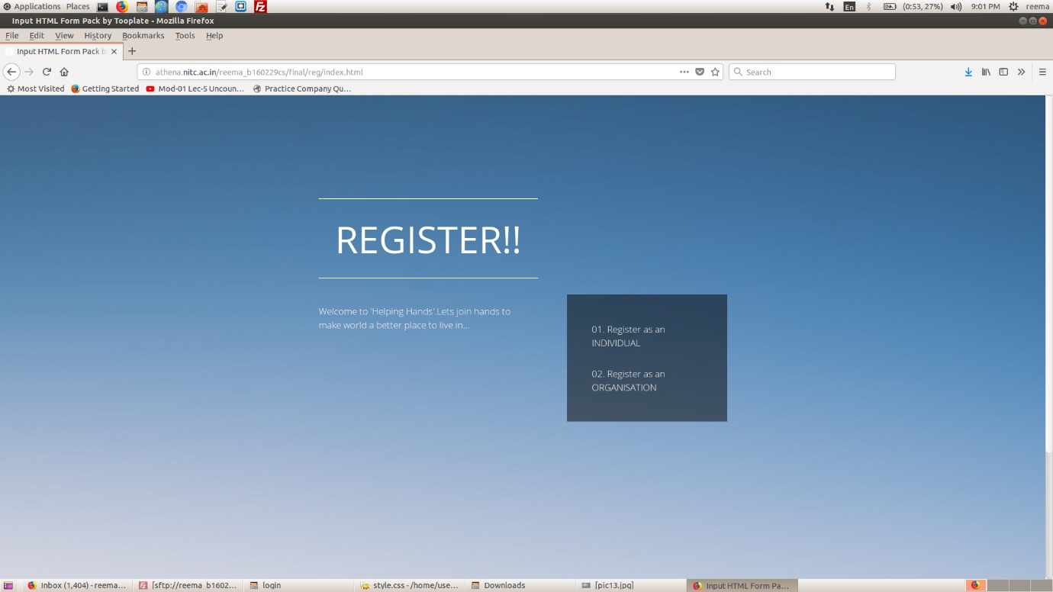

This page has two options –

1. To register as an individual
2. To register as an organisation

Click on which option you choose and you will be redirected to a new and more specific register page.

1. **REGISTER PAGE FOR INDIVIDUAL**

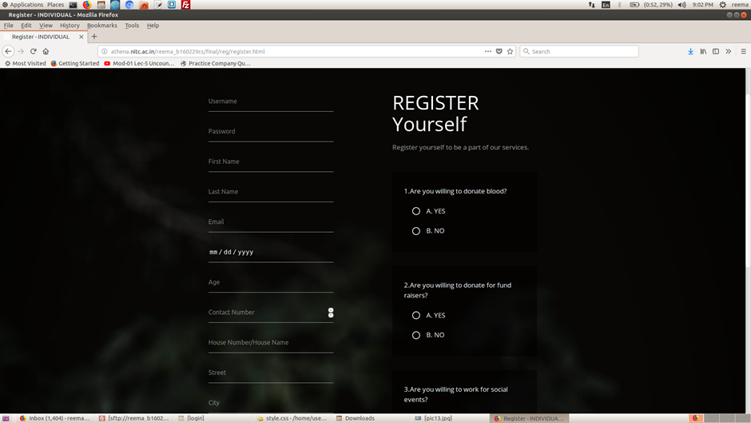

This page has a registration form to fill some necessary details and also some questions are also asked regarding the philanthropic interests of the individual to which the answers are YES/NO. When the button is pressed, the registration will be complete.

1. **REGISTRATION PAGE FOR ORGANISATION**

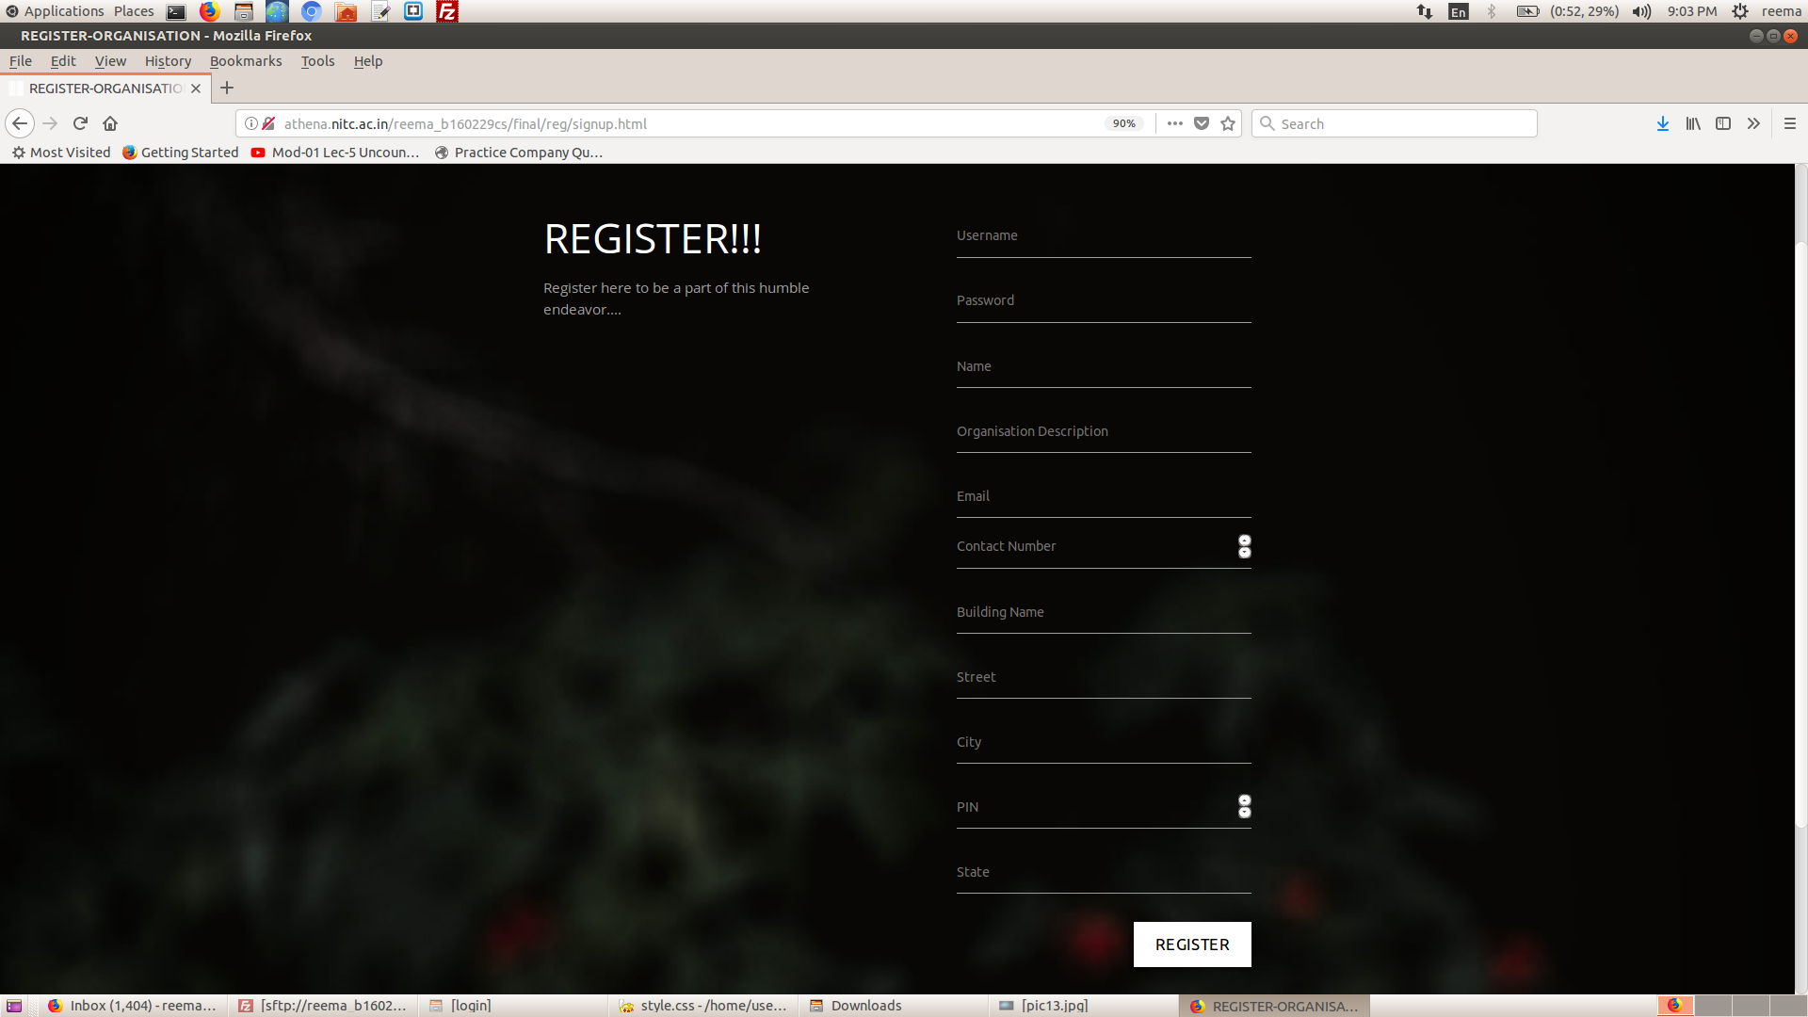

This page is used for registration of a new organisation. There is a form to fill which will ask a few necessary details for the registration. After all the details have been filled, the REGISTER button must be pressed for the registration to be complete.

1. **LOGIN PAGE**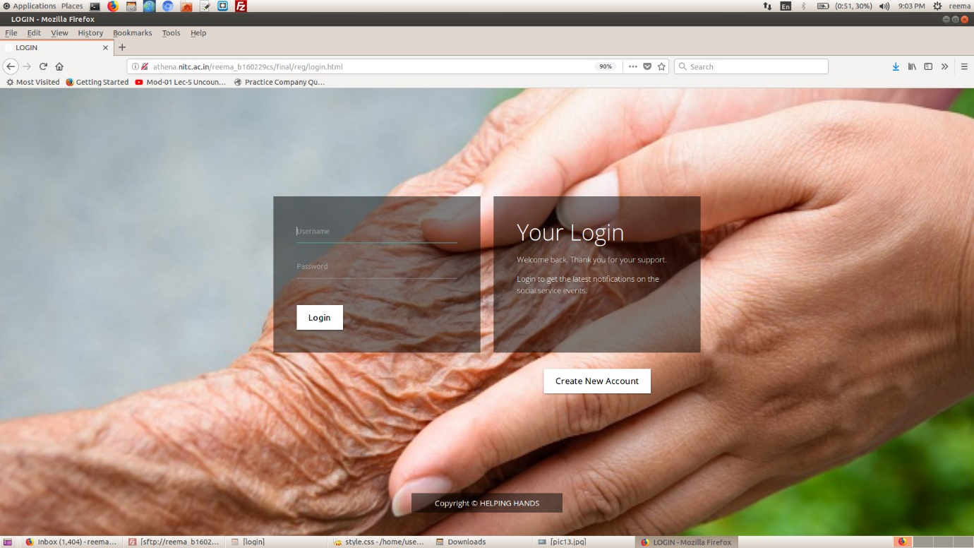

This page contains a form with a username and a password field for login verification. After entering these details, press the LOGIN button to verify login. If you want to create a new account, press the Create New Account button. If your LOGIN is verified, you will be redirected to a logged in page.

1. **LOGGED IN PAGE**

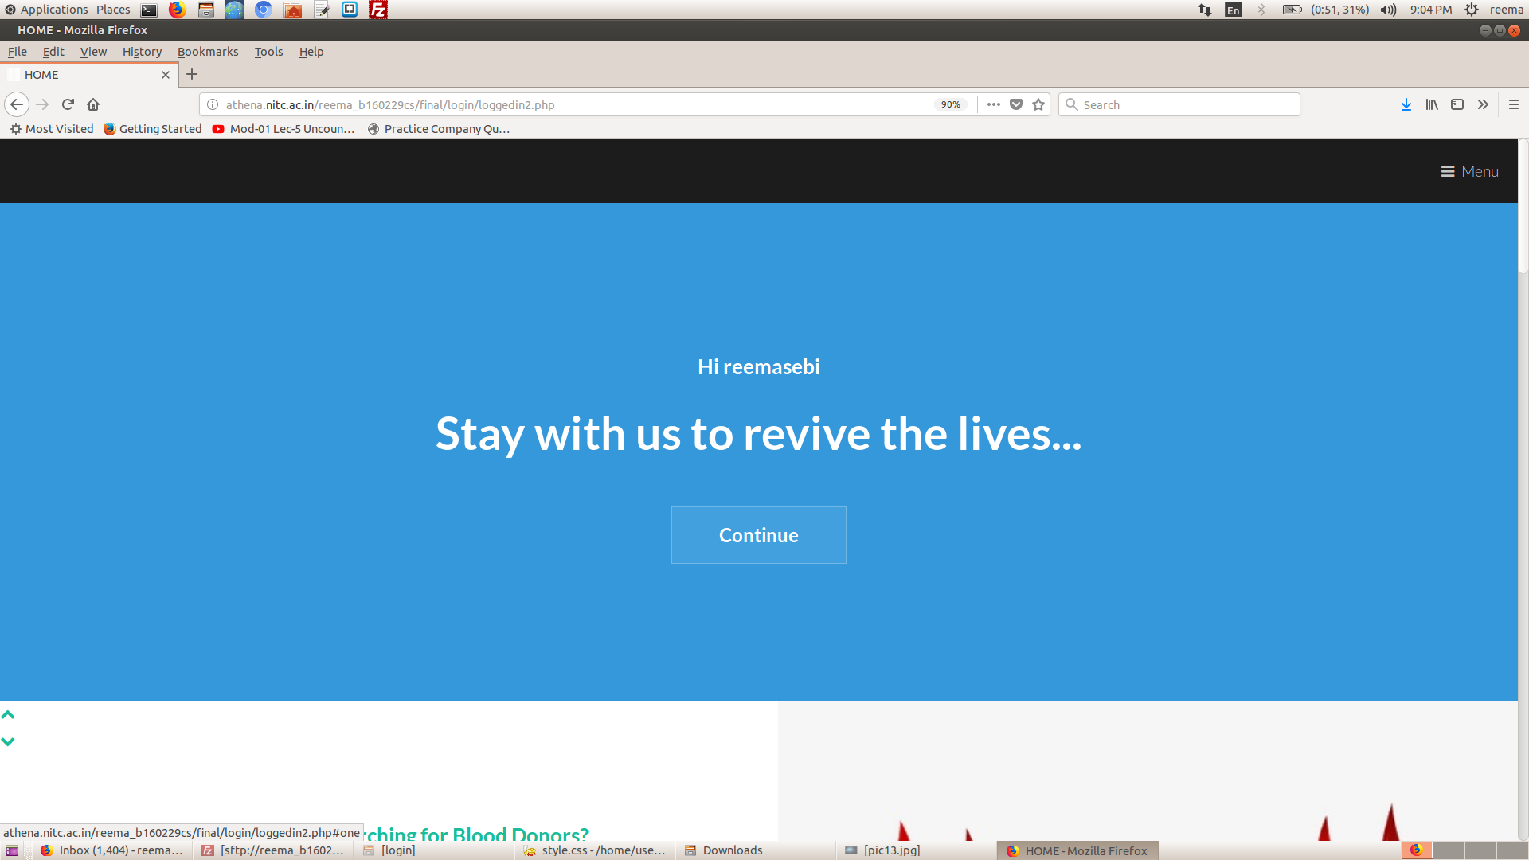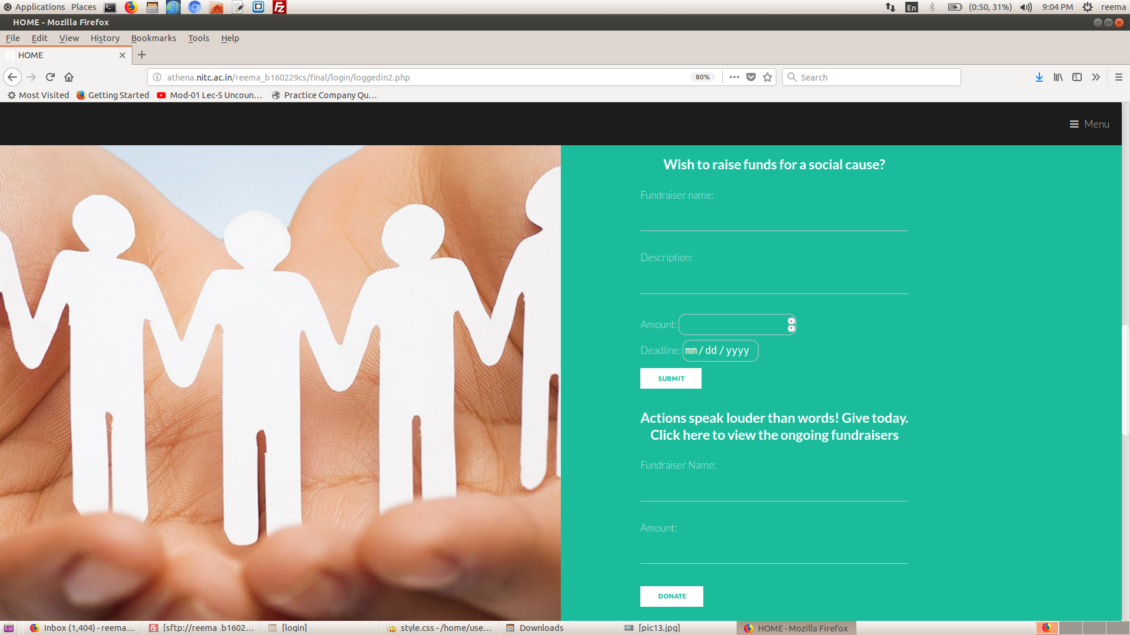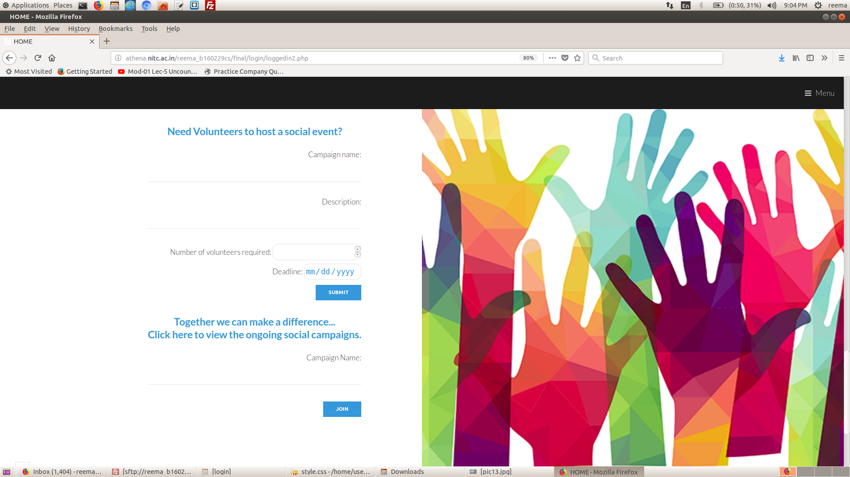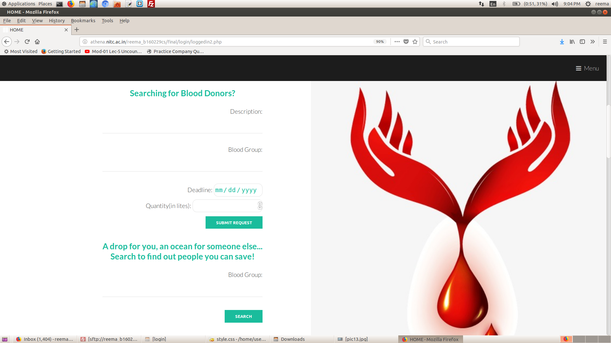

This page contains three different ways in which you can contribute to social campaigns.

There is a section where you can search for blood donors.

There is another section where you can