**Stored Procedures, Views**

View :

Delimiter//

CREATE TRIGGER chnageAddress

before INSERT ON publisher

For each row

Begin

SET new.publisher_officeAddress = "Boston";

END//

Delimiter ;

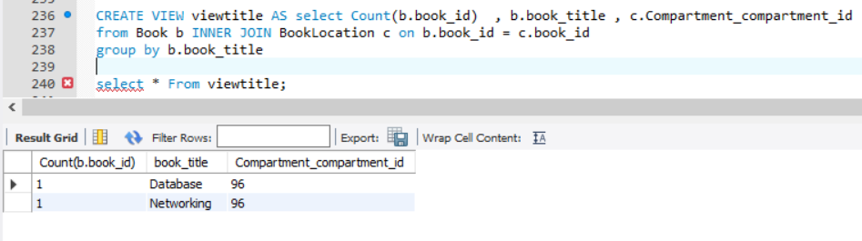

**CREATE VIEW AutDetails** AS

   SELECT

       CONCAT(author_firstName, author_lastName) AS Name,

       author_email

   FROM autdetails

       Author;

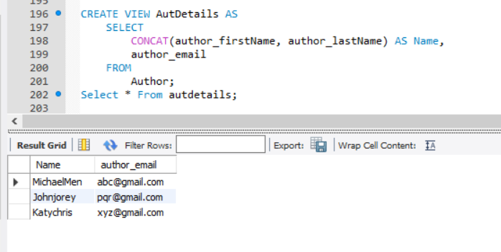

Trigger:

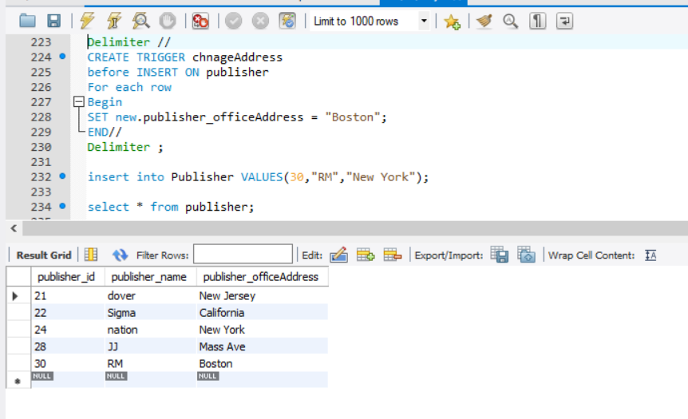

Stored Procedure :

**CREATE PROCEDURE ListStudents()**

 SELECT user_id , user_firstname

 FROM User

 Where user_typeid = 3;

 Call ListStudents()

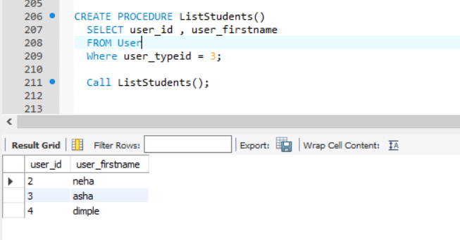

Create , Insert

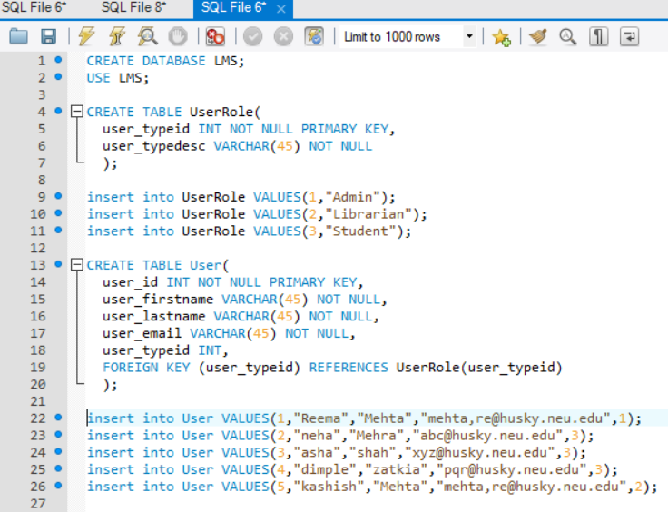

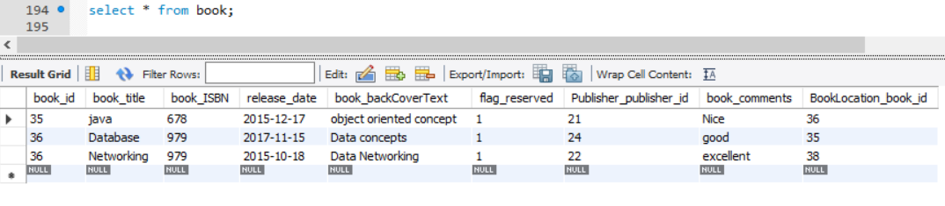

**Update :**

UPDATE book

SET book_id = 40

where book_id = 35;

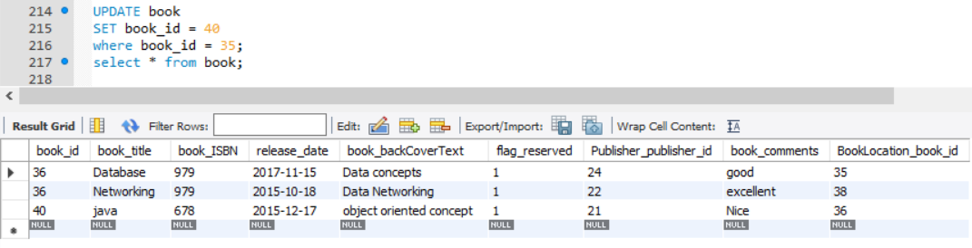

select book.book_id , BorrowerRecord.flag_returned from Book

JOIN BorrowerRecord ON book.book_id = BorrowerRecord.Book_book_id;

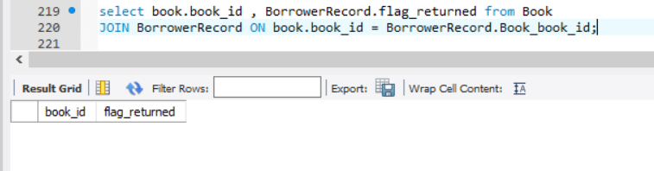

**Index:**

**https://lh5.googleusercontent.com/Zer3dl-kNdA2DIUdbdtWXJYdHnskR0MHXU5XwYXRArZuTIGvJMHNFXkOeHKfMIDcETRkB2gHdBxG37OzxyPcyla6swjPfD1TVy6a38XqDpKVCfgv5TtlkWkAu2UxHNF5bHH60G1i  
https://lh6.googleusercontent.com/kaN4I_bgKk7qYYncUO_ulowxHS1EKEtFl267KMGo1uj3wR7AuQQS4wrUi8UBCMT1uLwCawgN8-VrjYBHhzc1ygWb3IZtU16ppwnCRup9SSlgx0NdznryDFUM3AvTrZOUdHW8qPWs**

**Delimiter//**

**CREATE TRIGGER chnageAddress**

**before INSERT ON publisher**

**For each row**

**Begin**

**SET new.publisher_officeAddress = "Boston";**

**END//**

**Delimiter ;**



**CREATE VIEW viewtitle AS select Count(b.book_id)  , b.book_title , c.Compartment_compartment_id**

**from Book b INNER JOIN BookLocation c on b.book_id = c.book_id**

**group by b.book_title**



**https://lh6.googleusercontent.com/4lObrd8c4zGCJ4LRlIh79gq_5NobE6thJtr-H3jnWTZV0Q65pYNrisV_Bp_DZlO48C9oxYINJqeofozvro4l862b8LffGFdiWQBS_VVEWb8pFHpu7ABYQqN0fJ5bGxe4n0Ca335_**

**https://lh3.googleusercontent.com/tg2Wez_Dj5Lx2L2KZkqJXcjwZoCSQtYvLSugj9tav2CQGO4WIUk8Ikw8n8iDTkgMblyCuriFKdyLALNs6eK4HPHnSIxBYnOSx7u4mmnkt6rT-gwKMX7-by6KDlnXdg00pBtYrvaG**

**Function:**

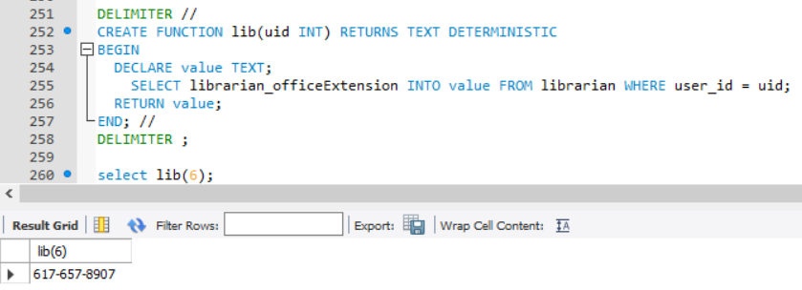

**Information View**

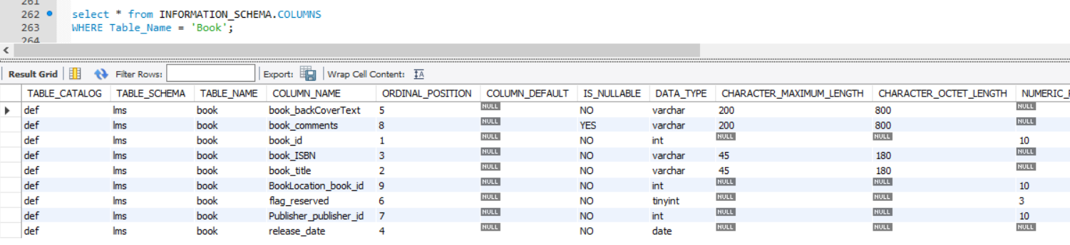

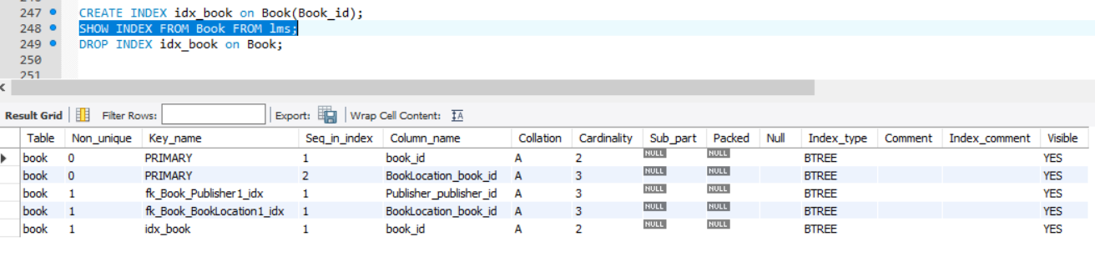

**https://lh3.googleusercontent.com/iekMDUvpSCQxnD7HjmfAkz8KW2VUCLXIrNLVTO8wLg5PVJiYqgjcf8XHrERBpyN7jm-M_v1okhGp-xfFYx16Y7v7jrZhU0Wn7KRc-sw2fnppg-cF0L1mnvHnn5TY45lDd61sjiT4**