**Submitted By,**

**REEMA JAMES-211479.**

1. Create Database project_movie_data and deploy table data according to ER diagram.

create database project_movie_data;

use project_movie_data;

create table actor (act_id int not null,act_fname char(20),act_lname char(20),act_gender char(1),primary key (act_id));

create table director (dir_id int not null,dir_fname varchar(20),dir_lname varchar(20),primary key(dir_id));

create table movie (mov_id int not null,mov_title varchar(50),mov_year int not null,mov_time int not null,mov_lang varchar(50),mov_dt_rel date,mov_rel_country varchar(5),primary key (mov_id));

create table reviewer (rev_id int not null,rev_name varchar(30),primary key (rev_id));

create table genres(gen_id int not null,gen_title varchar(20),primary key(gen_id));

create table movie_cast (act_id int not null, mov_id int not null,role varchar(20),foreign key(act_id) references actor(act_id),foreign key(mov_id) references movie (mov_id));

create table movie_direction (dir_id int not null,mov_id int not null,foreign key(dir_id) references director (dir_id),foreign key(mov_id) references movie (mov_id));

create table movie_genres (mov_id int not null,gen_id int not null,foreign key (mov_id) references movie(mov_id),foreign key (gen_id) references genres (gen_id));

create table rating (mov_id int not null,rev_id int not null,rev_stars int,num_o_rating int ,foreign key (mov_id) references movie (mov_id),foreign key(rev_id) references reviewer (rev_id));

2. Create 9 tables which are presented in ER model and load the data with their foreign key and primary key values.

insert into actor (act_id,act_fname,act_lname,act_gender) values (101,'james','stewart','M'),(102,'Deborah','kerr','F'),(103,'Peter','OToole','M'),

(104,'Robert','De Niro','M'),(105,'F.Murray','Abraham','M'),(106,'Harrison','Ford','M'),(107,'Nicole','Kidman','F'),(108,'Stephen','Baldwin','M'),

(109,'Jack','Nicholson','M'),(110,'Mark','Wahlberg','M'),(111,'Woody','Allen','M'),(112,'Clarie','Danes','F'),(113,'Tim','Robbins','M'),

(114,'Kevin','Spacey','M'),(115,'Kate','Winslet','M'),(116,'Robin','Williams','M'),(117,'Jon','Voight','M'),(118,'Ewan','McGregor','M'),

(119,'Christian','Bale','M'),(120,'Maggie','Gyllenhaal','F'),(121,'Dev','Patel','M'),(122,'Sigourney','Weaver','F'),(123,'David','Aston','M'),

(124,'Ali','Astin','F');

insert into director (dir_id, dir_fname, dir_lname)values (201, 'Alfred', 'Hitchcock'),(202, 'Jack', 'Clayton'),(203, 'David', 'Lean'),(204, 'Michael', 'Cimino'),(205, 'Milos', 'Forman'),(206, 'Ridley', 'Scott'),

(207, 'Stanley', 'Kubrick'),(208, 'Bryan', 'Singer'),(209, 'Roman', 'Polanski'),(210, 'Paul', 'Thomas Anderson'),(211, 'Woody', 'Allen'),(212, 'Hayao', 'Miyazaki'),

(213, 'Frank', 'Darabont'),(214, 'Sam', 'Mendes'),(215, 'James', 'Cameron'),(216, 'Gus', 'Van Sant'),(217, 'John', 'Boorman'),(218, 'Danny', 'Boyle'),

(219, 'Christoph', 'Nolan'),(220, 'Richard', 'Kelly'),(221, 'Kevin', 'Spacey'),(222, 'Andrei','Tarkovsky'),(223, 'Peter', 'Jackson');

insert into genres (gen_id, gen_title) values (1001, 'Action'),(1002, 'Adventure'),(1003, 'Animation'),(1004, 'Biography'),(1005, 'Comedy'),

(1006, 'Crime'),(1007, 'Drama'),(1008, 'Horror'),(1009, 'Music'),(1010, 'Mystery'),(1011, 'Romance'),(1012, 'Thriller'),(1013, 'War');

insert into movie_cast (act_id, mov_id, role) values(101, 901, 'John Scottie Fergus'),(102, 902, 'Miss Giddens'),(103, 903, 'T.E. Lawrence'),(104, 904, 'Michael'),(105, 905, 'Antonio Salieri'),

(106, 906, 'Rick Deckard'),(107, 907, 'Alice Harford'),(108, 908, 'McManus'),(110, 910, 'Eddie Adams'),(111, 911, 'Alvy Singer'),

(112, 912, 'San'),(113, 913, 'Andy Dufresne'),(114, 914, 'Lester Burnham'),(115, 915, 'Rose DeWitt Bukater'),(116, 916, 'Sean Maguire'),

(117, 917, 'Ed'),(118, 918, 'Renton'),(120, 920, 'Elizabeth Darko'),(121, 921, 'Older Jamal'),(122, 922, 'Ripley'),

(114, 923, 'Bobby Darin'),(109, 909, 'J.J. Gittes'),(119, 919, 'Alfred Borden');

insert into movie(mov_id,mov_title,mov_year,mov_time,mov_lang,mov_dt_rel,mov_rel_country)values

(901, 'Vertigo', 1958, 128, ' English ', '1958-08-24', ' UK'),

(902, 'The Innocents', 1961, 100, ' English ', '1962-02-19', ' SW'),

(903, 'Lawrence of Arabia', 1962, 216, ' English ', '1962-12-11', ' UK'),

(904, 'The Deer Hunter', 1978, 183, ' English ', '1979-03-08', ' UK'),

(905, 'Amadeus', 1984, 160, ' English ', '1985-01-07', ' UK'),

(906, 'Blade Runner', 1982, 117, ' English ', '1982-09-09', ' UK'),

(907, 'Eyes Wide Shut', 1999, 159, ' English ', null, ' UK'),

(908, 'The Usual Suspects', 1995, 106, ' English ', '1995-08-25', ' UK'),

(909, 'Chinatown', 1974, 130, ' English ', '1974-08-09', ' UK'),

(910, 'Boogie Nights', 1997, 155, ' English ', '1998-02-16', ' UK'),

(911, 'Annie Hall', 1977, 93, ' English ', '1977-04-20', ' USA'),

(912, 'Princess Mononoke', 1997, 134, ' Japanese ', '2001-10-19', ' UK'),

(913, 'The Shawshank Redem', 1994, 142, ' English ', '1995-02-17', ' UK'),

(914, 'American Beauty', 1999, 122, ' English ', null, ' UK'),

(915, 'Titanic', 1997, 194, ' English ', '1998-01-23', ' UK'),

(916, 'Good Will Hunting', 1997, 126, ' English ', '1998-06-03', ' UK'),

(917, 'Deliverance', 1972, 109, ' English ', '1982-10-05', ' UK'),

(918, 'Trainspotting', 1996, 94, ' English ', '1996-02-23', ' UK'),

(919, 'The Prestige', 2006, 130, ' English ', '2006-11-10', ' UK'),

(920, 'Donnie Darko', 2001, 113, ' English ', null, ' UK'),

(921, 'Slumdog Millionaire', 2008, 120, ' English ', '2009-01-09', ' UK'),

(922, 'Aliens', 1986, 137, ' English ', '1986-08-29', ' UK'),

(923, 'Beyond the Sea', 2004, 118, ' English ', '2004-11-26', ' UK'),

(924, 'Avatar', 2009, 162, ' English ', '2009-12-17', ' UK'),

(925, 'Braveheart', 1995, 178, ' English ', '1995-09-08', ' UK'),

(926, 'Seven Samurai', 1954, 207, ' Japanese ', '1954-04-26', ' JP'),

(927, 'Spirited Away', 2001, 125, ' Japanese ', '2003-09-12', ' UK'),

(928, 'Back to the Future', 1985, 116, ' English ', '1985-12-04', ' UK');

insert into movie_direction (dir_id, mov_id) values

(201, 901),(202, 902),(203, 903),(204, 904),(205, 905),(206, 906),(207, 907),(208, 908),(209, 909),(210, 910),(211, 911),(212, 912),

(213, 913),(214, 914),(215, 915),(216, 916),(217, 917),(218, 918),(219, 919),(220, 920),(218, 921),(215, 922),(221, 923);

insert into movie_genres (mov_id, gen_id) values

(922, 1001),(917, 1002),(903, 1002),(912, 1003),(911, 1005),(908, 1006),(913, 1006),(926, 1007),(928, 1007),

(918, 1007),(921, 1007),(902, 1008),(923, 1009),(907, 1010),(927, 1010),(901, 1010),(914, 1010),(906, 1012),(904, 1013);

insert into rating (mov_id, rev_id, rev_stars, num_o_rating) values

(901, 9001, '8', 263575),(902, 9002, '8', 20207),(903, 9003, '8', 202778),(906, 9005, '8', 484746),(924, 9006, '7',null),(908, 9007, '9', 779489),

(909, 9008,null, 227235),(910, 9009, '3', 195961),(911, 9010, '8', 203875),(912, 9011, '8',null),(914, 9013, '8', 862618),(916, 9014, '4', 642132),

(925, 9015, '8', 81328),(918, 9016,null, 580301),(920, 9017, '8', 609451),(921, 9018, '8', 667758),(922, 9019, '8', 511613),(923, 9020, '7', 13091);

insert into reviewer(rev_id,rev_name)values(9001,'Righty Sock'),(9002,'Jack Malvern'),(9003,'Flagrant Baronessa'),

(9005,null),(9006,'Alec Shaw'),(9007,'Simon Wright'),(9008,'Neal Wruck'),(9009,'Paul Monks'),(9010,'Mike Salvati'),(9011,null),

(9012,'Wesley S.Walker'),(9013,'Sasha Goldshtein'),(9014,'Josh Cates'),(9015,'Krug Stillo'),(9016,'Scott LeBrun'),

(9017,'Hannah Steele'),(9018,'Vincent Cadena'),(9019,'Brandt Sponseller'),(9020,'Richard Adams');

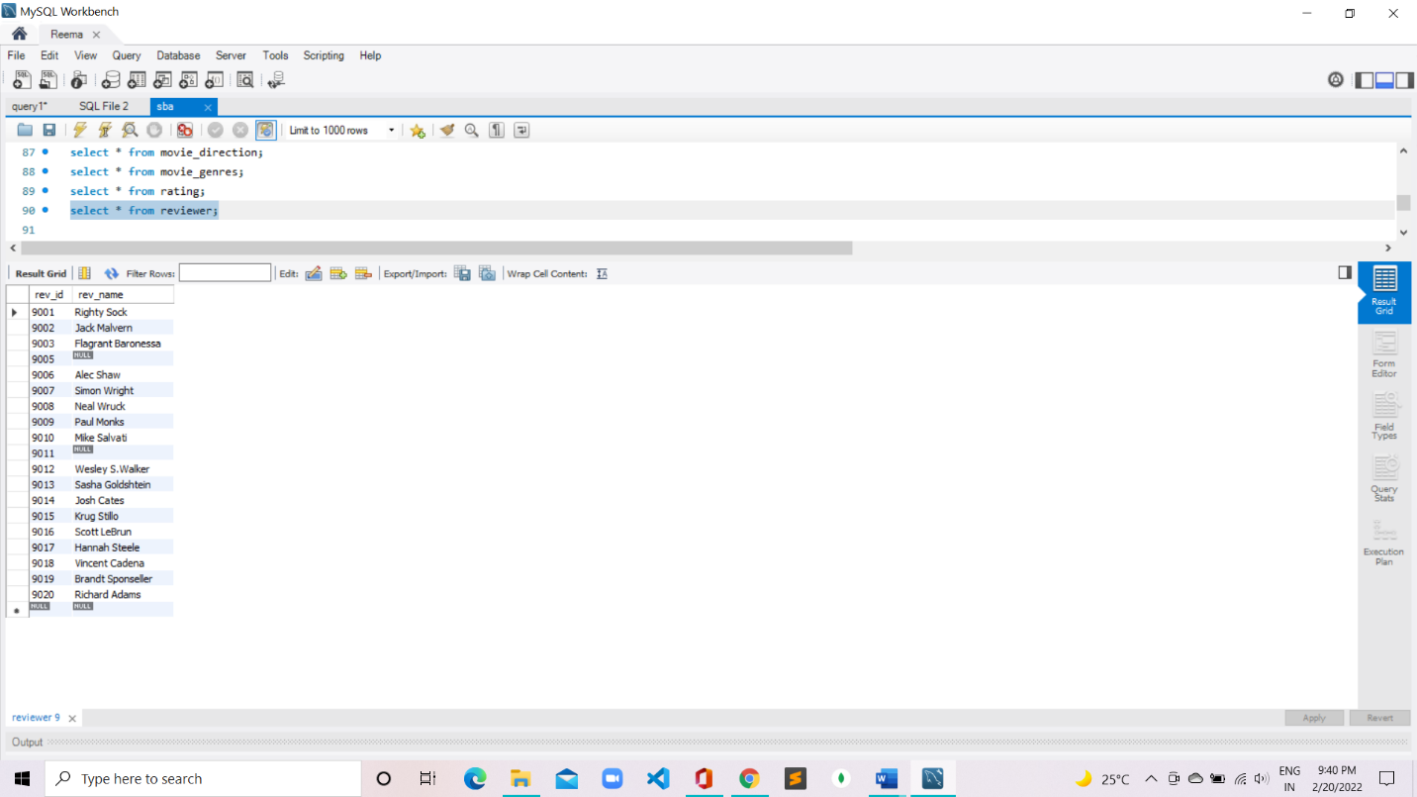

3. Write a query in SQL to list the Horror movies?

select mov_title from movie where mov_id in (select mov_id from movie_genres where gen_id in(select gen_id from genres where gen_title="Horror"));

4. Write a query in SQL to find the name of all reviewers who have rated 8 or more stars?

select reviewer.rev_name

from reviewer, rating

where rating.rev_id = reviewer.rev_id

and rating.rev_stars>=8

and reviewer.rev_name is not null;

5. Write a query in SQL to list all the information of the actors who played a role in the movie ‘Deliverance’

select * from actor

where act_id in( select act_id from movie_cast

where mov_id in (select mov_id from movie

where mov_title='Deliverance'

));

6. Write a query in SQL to find the name of the director (first and last names) who directed a movie that casted a role for ‘Eyes Wide Shut’. (using subquery)

select dir_fname, dir_lname

from director

where dir_id in (

select dir_id

from movie_direction

where mov_id in(

select mov_id

from movie_cast where role = any (

select role

from movie_cast

where mov_id in (

select mov_id

from movie

where mov_title='Eyes Wide Shut'))));

7. Write a query in SQL to find the movie title, year, date of release, director and actor for those movies which reviewer is ‘Neal Wruck’

select mov_title, mov_year, mov_dt_rel, dir_fname, dir_lname, act_fname, act_lname

from movie a, movie_direction b, director c, rating d, reviewer e, actor f, movie_cast g

where a.mov_id=b.mov_id and b.dir_id=c.dir_id and a.mov_id=d.mov_id and d.rev_id=e.rev_id and a.mov_id=g.mov_id and g.act_id=f.act_id and e.rev_name ="Neal Wruck";

