**Exploring Weather Trends**

Extract the data:

1. **SQL query to extract the city level data:**

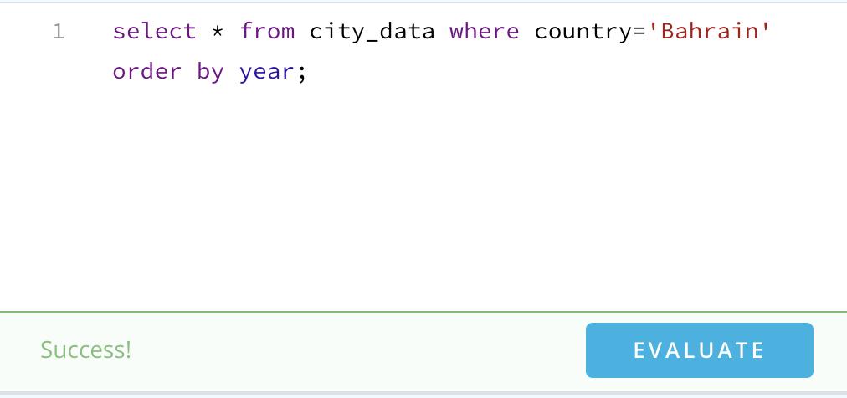

1. **SQL query to extract the global data:**

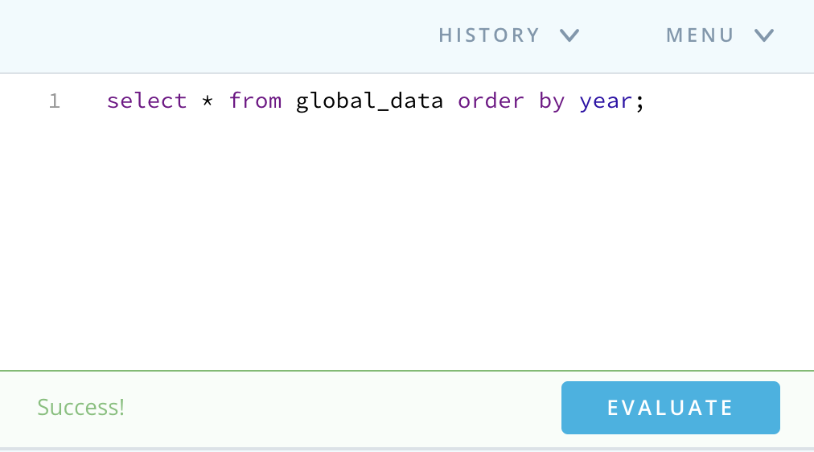

1. **Line charts:**
2. **Global data line chart:**

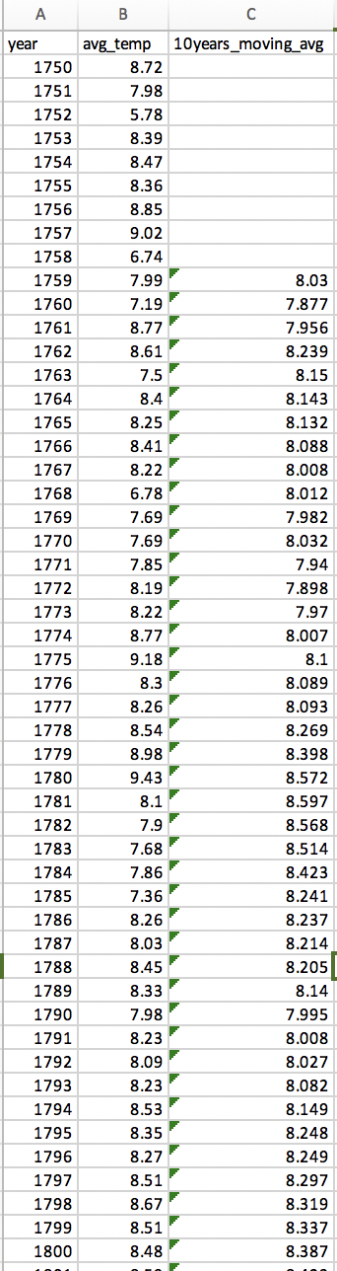

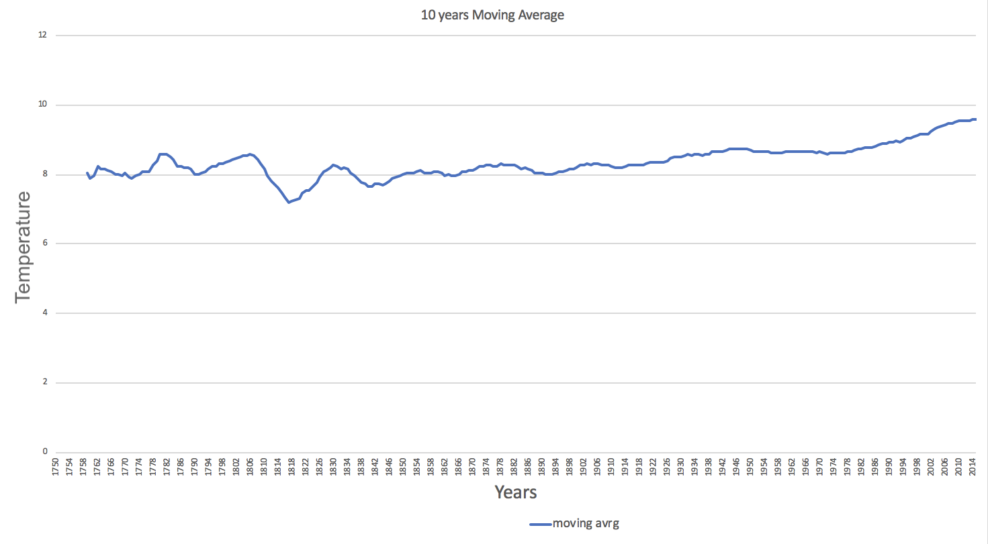

1. Nearest City line chart:

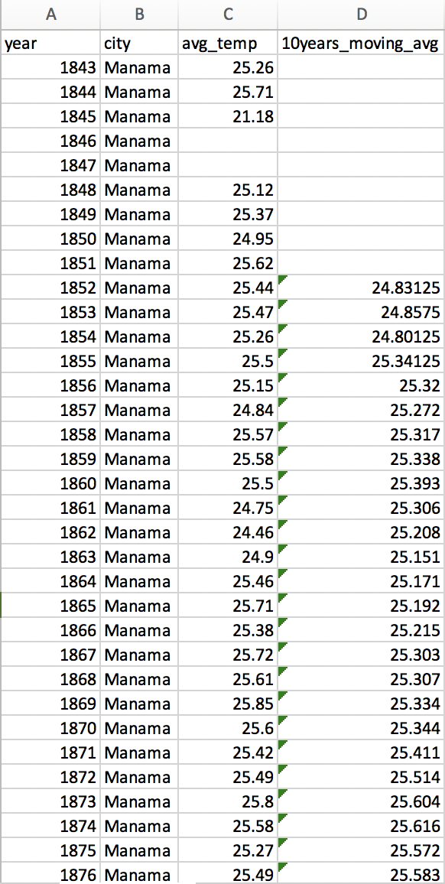

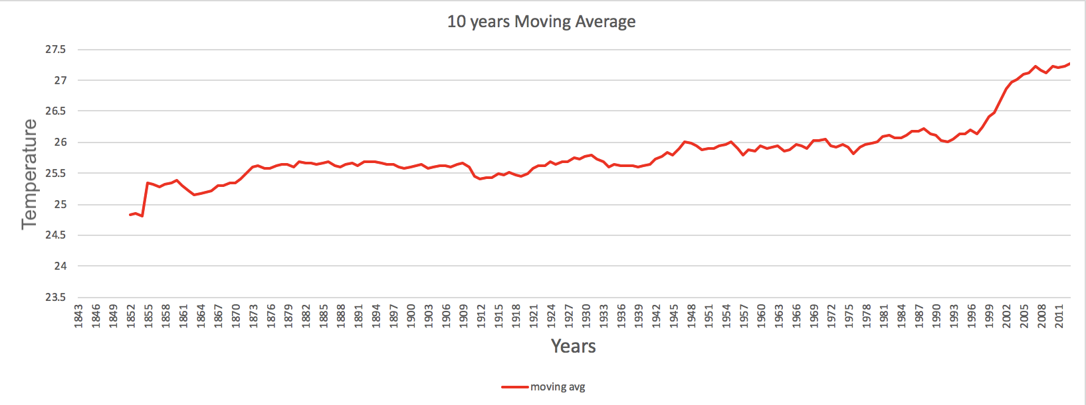

1. **Observations:**

* **“Is your city hotter or cooler on average compared to the global average? Has the difference been consistent over time?**

Manama is hotter than the global average

**The Manama graph**, it can clearly be seen that there has been a large increase in weather temperature from the year 1997

* **“How do the changes in your city’s temperatures over time compare to the changes in the global average?”**

Both my city temperature and the global temperature are getting hotter over time which means increasing in the number of temperatures.

**What does the overall trend look like? Is the world getting hotter or cooler? Has the trend been consistent over the last few hundred years?**

**The global graph** shows that the temperature almost remains constant then it shows a slightly increase in the temperature.

The minimum temperature is almost 5.7 in the year 1752.

The maximum temperature is almost 9.8 in the year 2015.

**The Manama graph** shows that the temperature shows a slightly increase from the year 1853 then it shows slightly differences tell the year 1997 which show a clear increase in the temperature.

The minimum temperature is almost 21.1 in the year 1845.

The maximum temperature is almost 27.8 in the year 2010.