CSC 120 Lab 03

* (+15) **Install VirtualBox on your system.**

In this exerise you will be installing Virtual Box on your system. (Windows or Mac). After installing VirtualBox you will be using it for installing a linux operating system by creating a Virtual Machine in Virtual Box. (Read online about what a virtual machine is).

**VirtualBox Download link** <https://www.virtualbox.org/wiki/Downloads>

* (+15) **Explain what a Virtual Machine is**. Virtual Machine is like any program that is working on a computer, but it is different than the others app because it is working as an independent computer.

Why and how is are virtual machines used today? It used today in case if the programmers want to try setting or program that they worry to use it on their physical computer, or flash memory that has a virus, but they want to take the folders from it, or they might want to use different operating systems on the same computer. It acts just like computer inside another computer. It gives the ability of using the same laptop with different users because it provides whole computer system. It is easy to fix as well.

How does VirtualBox help you create Virtual Machine? VirtualBox runs on different OS such as Windows10, Linux, and Mac, and became as a base to Virtual Machine that can make other operating systems run that are differ than the OS of the physical computer to run on the same computer.

What is the Host Operating System. How is it different from a Guest Operating System? Host Operating System is the operating system that works on the physical computer. While Guest OS is the virtual OS that work on the physical computer. Host OS which is like mother carrying a baby which represents by Virtual OS.

(**You can refer online** but **do not copy paste text** from blogs. It is very easy to detect and will undo the whole purpose of this assignment. I am not looking for a super technical answer but a general understanding of VM's. Write your own explanation here)

* (+20) **Install Ubuntu 20.04 as a virtual machine using VirtualBox.**

**Step 0:** Open VirtualBox on your machine.

**Step 1:** Download the ISO for Ubuntu 20.04 to install it using Virtual Box.**Ubuntu 20.04 ISO Download Link** [**https://ubuntu.com/download/desktop**](https://ubuntu.com/download/desktop)

**Step 2:** Read more about what an ISO is below. **Note:** You just need to download an ISO for this exercise and not burn or mount one,The links provided give a lot more details about ISO which may not be relevant for this assignment,*]*

**Reading :** [**https://www.lifewire.com/iso-file-2625923**](https://www.lifewire.com/iso-file-2625923)

**Step 3:** Follow the steps provided in the tutorial below to install Ubuntu 20.04 using VirtuallBox.

**Ubuntu installation Video link:** [**https://youtu.be/3qcK_Bwa0sU**](https://youtu.be/3qcK_Bwa0sU)

**Ubuntu Installation Screenshotslink:** [**https://itsfoss.com/install-linux-in-virtualbox/**](https://itsfoss.com/install-linux-in-virtualbox/)

**Note:** Although the above tutorial is for installating Ubuntu 17.04, the steps are still the same.

* (+10) **Open the terminal and type whoami. Paste the screenshot of the command and the output below.** 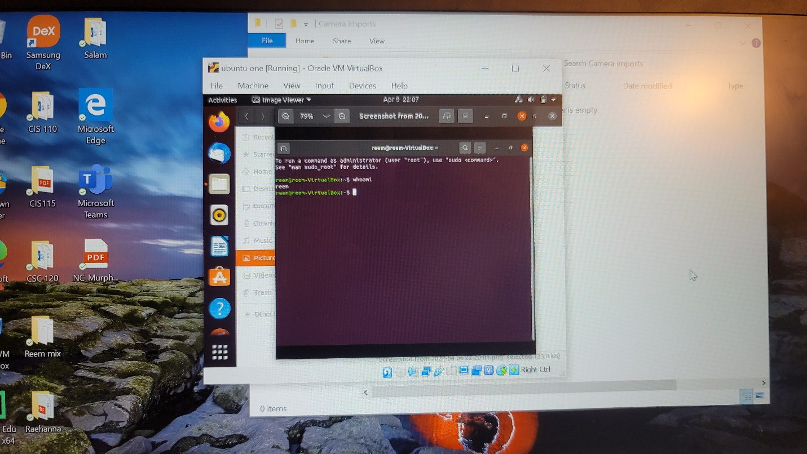
* **Conceptual Question**
* (+5) Explain the concept of a process. What is the difference between a process that is ready vs waiting? The process in computing means an operation that contains many stages and the process stored in the main memory. The ready and waiting process are two kinds of process stages. Ready process means that the process is ready to go to the CPU, while waiting means that the process wait for instructions or input.
* (+5) What is the distinction between application software and system software. Give an example of each. Application software is the applications that designed for many reasons such as Facebook, translator, maps apps. Meanwhile system software is considered as a base for apps to work on, because it mimics the hardware language, so it links the apps to the hardware. For example, about system software, Windows10, Linux, Mac, Android.
* (+5) What is the difference between main memory and virtual memory? Main memory is located in the physical computer, but virtual memory considered as a file located in the main memory and it created by paging.
* (+5) What are pages in virtual memory? Explain the concept of page size. Pages in virtual memory translate the address in virtual to address in physical memory. page size is (8 byte) the same in virtual and physical memory but the address in virtual memory is smaller (16 byte) than the physical memory (20 byte).
* (+5) Summarize the booting process. The booting process is that the OS loads from the hard drive to the RAM.
* What is the difference between an IO-bound process vs a compute-bound process? The difference between an IO-bound process and a compute-bound process is that when the program execution correlated to the CPU called compute-bound process, such as math problems. While an IO-bound process is program that its performance correlated to subsystem such as word processor.
* (+5) If both IO bound and compute bound process are waiting for a time slice which (+5) process should be given priority? Why? The IO bound process will be given the higher priority because compute bound take longer and more space in CPU.
* (+5) What problem arises when the lengths of time slices in a multiprogramming system are made smaller and smaller? What happens when they are made longer and longer? The program will do the next operation before the previous operation finished since the time slices in smaller that it supposed to be done. If it is made longer the program will finish the operation and wait for the time of other operation so the program will take longer.
* (+5) Explain the relationship between **semaphore**, **critical region** and **mutual exclusion. The semaphore acts like wait and go. While critical region is the process time it takes to process to finish and mutual exclusion make other operations away till the one in critical region finished.**

**Instructions: Upload the file with the screenshot on Blackboard with youyr firstname_lastname.docx**