WASL

classDiagram:

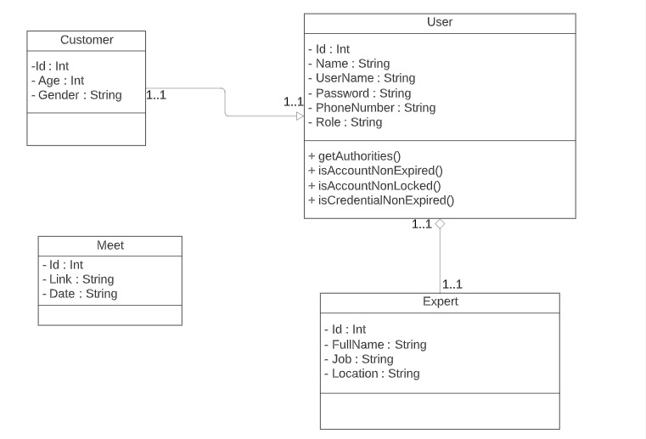

Introduction:

WASL It is a project that provides to students the assistance in solving the most important problems they face after graduation, such as preparing for and practicing for the job interview and helping them to get an idea of ​​the questions that can be asked during the interview, as well as reviewing their resume and addressing the most important points that should be available and urging them to avoid The problems that other students encounter while writing their resume, and one of the most important points provided by the project is to suggest the most important courses they need based on their specialization and their level of knowledge, and all of this, of course, under the supervision of human resources staff, each according to his specialization, as the project provides HR staff In all sectors such as the banking and health sector, and the employees have a freelance license,we use Spring Boot(intellij IDEA)and use for the Database (DATAGrip).