Activity 8: Intrusion Detection — Log Analysis

Name: Reemas Aleid
Student ID: 2240006097
Course: CYS 313

- Screenshot of Room Completion
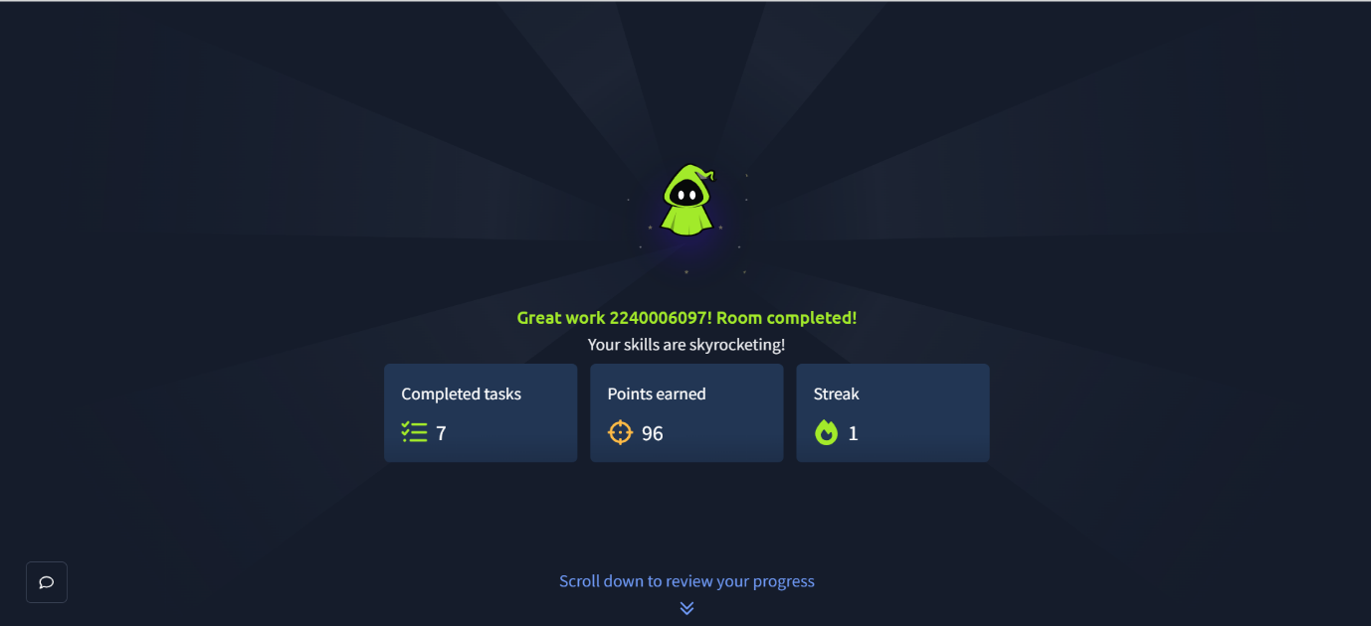

- rsyslog Configuration
# Configured by Reemas Aleid - 2240006097
$FileCreateMode 0644
:programname, isequal, "sshd" /var/log/websrv-02/rsyslog_sshd.log
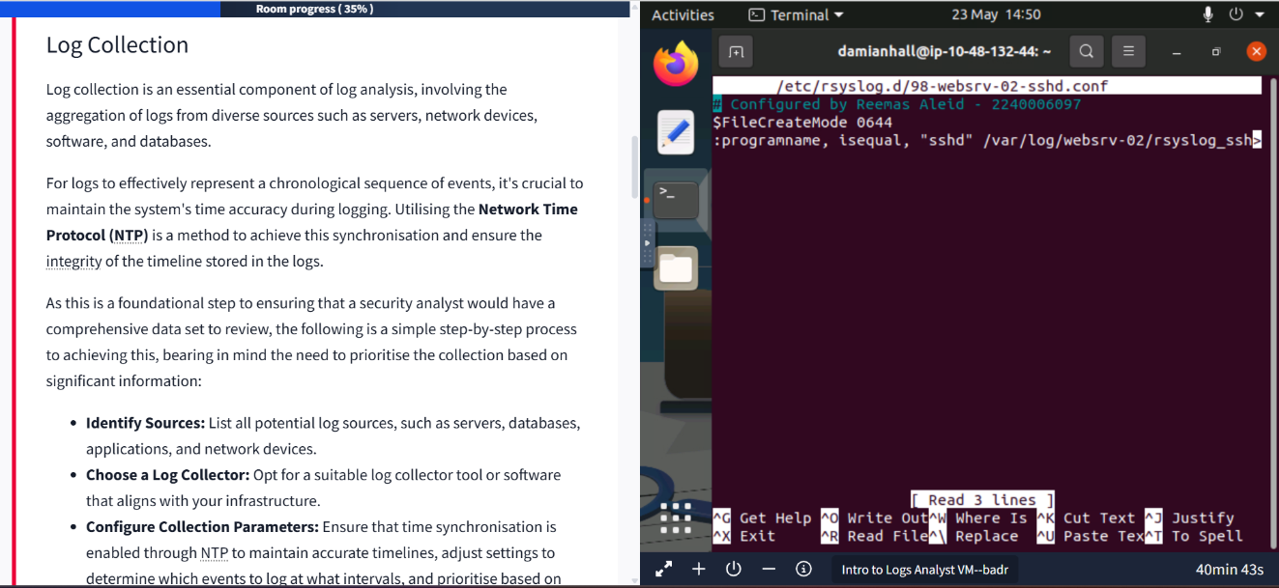

- Challenges

Challenge 1: SSH Authentication Failure

Cause:
The correct password was unknown during the SSH login attempt.

Solution:
The SSH connection was tested by entering passwords until the failed login attempts were recorded in the logs.
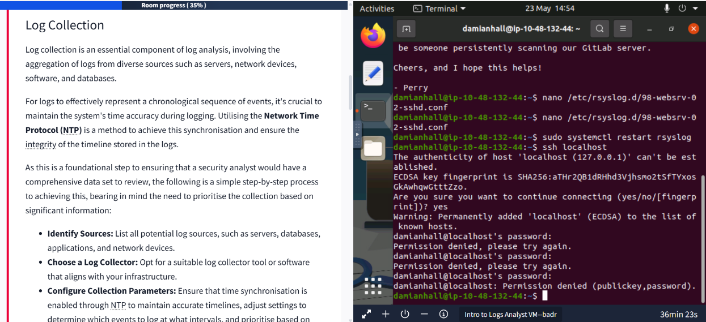
Challenge 2: Incorrect File Path
Cause:
An incorrect directory or filename was entered while searching for the log file.
Solution:
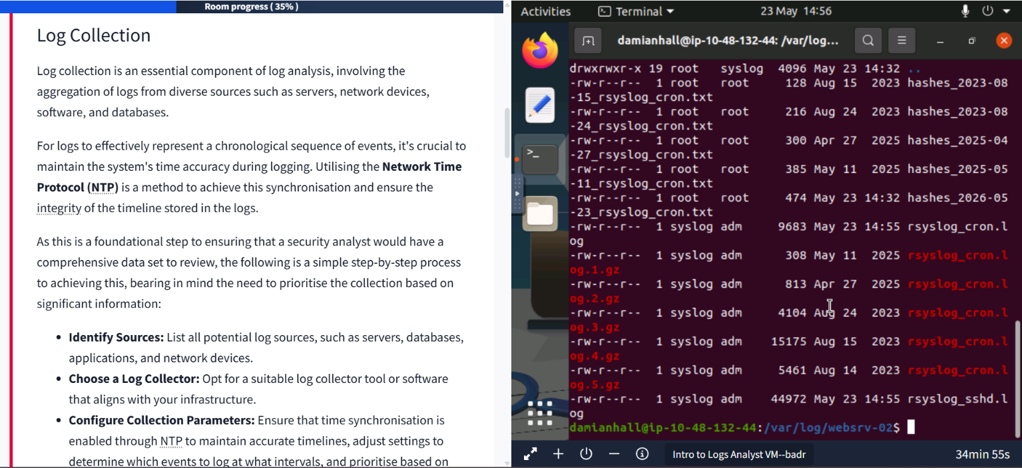
The correct path /var/log/websrv-02/ was used to access the generated logs.
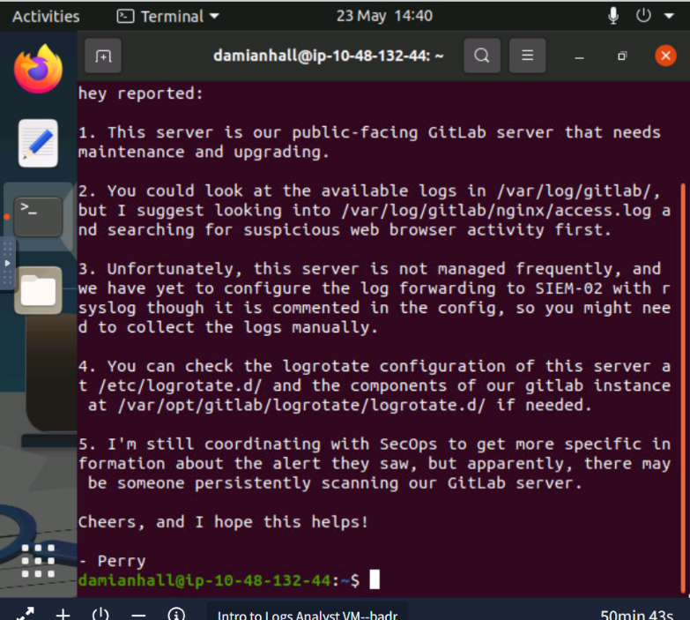

Challenge 3: rsyslog Configuration
Cause:
The rsyslog configuration file initially contained incomplete settings.
Solution:
The configuration file was corrected and rsyslog was restarted successfully.

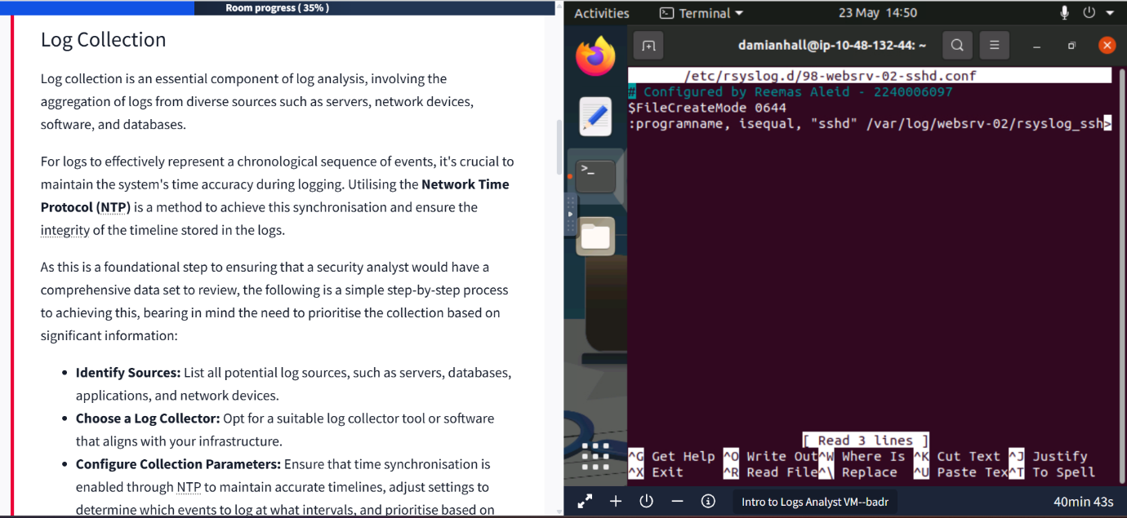
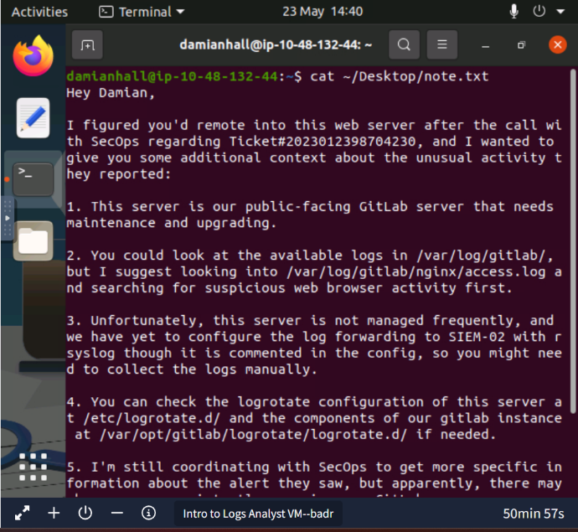

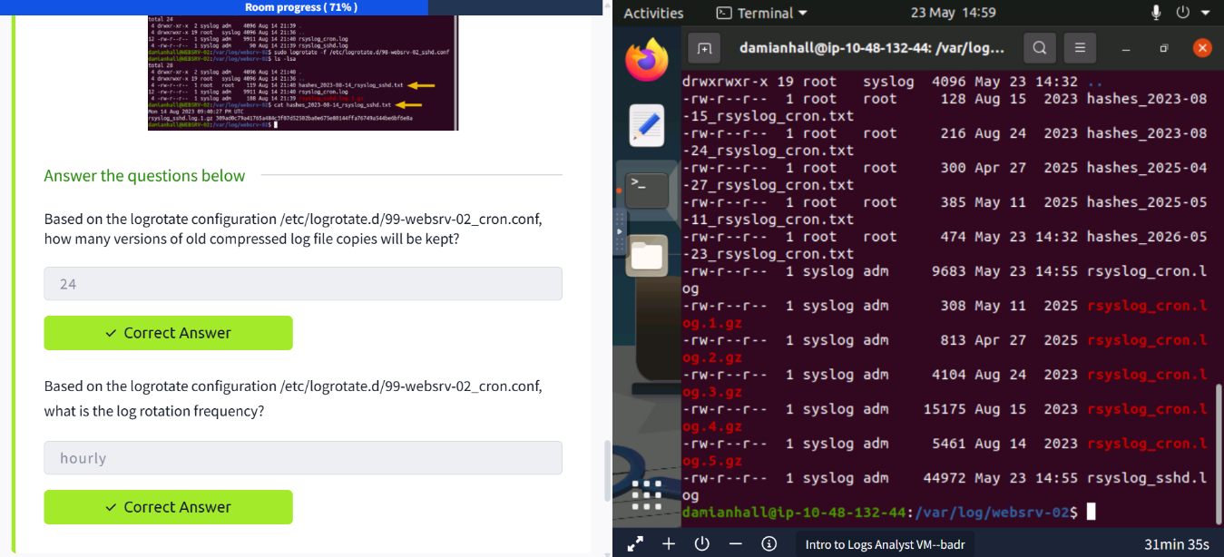

- Conclusion
In this activity, I learned how logs are collected, monitored, and analyzed using Linux and rsyslog. I configured log collection for SSH and cron services, investigated suspicious activities, and verified that log files were successfully generated. I also gained practical experience in identifying failed login attempts, reviewing important log files, and understanding the role of log rotation and normalization in cybersecurity. Overall, this lab improved my understanding of how security analysts use logs for monitoring, investigation, and incident response.

