

SUPERVISOR CERTIFICATION
I certify that the preparation of this project, entitled
“Project Title,”
prepared by
“Students’ Names,”
was carried out under my supervision at the Faculty of Artificial Intelligence Engineering in partial fulfillment of the requirements for the degree of B.Sc. in the Department of Artificial Intelligence Engineering and Data Science.
Name:
Date:
Signature:

كلمة شكر وتقدير

الملخص
تُعدّ شبكات المركبات المخصّصة (VANETs) من التقنيات المحورية في أنظمة النقل الذكية، إذ تتيح تبادل المعلومات الحيوية بين المركبات، وبين المركبات والبنية التحتية للطريق، في الزمن الحقيقي، كتحذيرات الحوادث وحالة الطرق. غير أنّ الطبيعة اللاسلكية المفتوحة لهذه الشبكات وتبدّل بنيتها المستمر بفعل حركة المركبات يجعلانها عرضة لهجمات أمنية مثل انتحال الهوية وهجوم الثقب الأسود والتشويش، لا يقتصر أثرها على موثوقية المعلومات بل يمتد إلى سلامة السائقين والركاب. ويكمن التحدي في فهم أثر هذه الهجمات في أداء الشبكة، وفي إيجاد آليات حماية تحقق توازناً بين الأمان وزمن الاستجابة وكفاءة الاتصال.
يقترح هذا المشروع بناء بيئة محاكاة لشبكات المركبات باستخدام المحاكي NS-3 لنمذجة الاتصالات اللاسلكية والبرنامج SUMO لتوليد حركة المركبات، وتضم 40 مركبة ووحدتين على جانب الطريق (RSUs) وبروتوكول التوجيه AODV، ثم تنفيذ هجمات مختارة داخلها وقياس أثرها بمؤشرات أداء محددة هي نسبة تسليم الحزم (PDR) وفقد الحزم ومعدل نقل البيانات والتأخير. وقد نُفّذ هجوم انتحال الهوية مع آلية كشف تعتمد على القواعد تقارن هوية المرسل بالهوية المُعلنة في الرسالة، كما نُفّذت المرحلة الأولى من هجوم الثقب الأسود بتعديل بروتوكول AODV في NS-3 لإسقاط الحزم العابرة عبر عقدة خبيثة. وتتمثل نقاط قوة الحل في اعتماد سيناريو مرجعي دون هجمات مثبّت العشوائية ومتطابق النتائج عند التكرار، مما يتيح مقارنة موثوقة، وفي بناء الهجمات على مراحل قابلة للقياس.
أظهرت المقارنة مع السيناريو الطبيعي أنّ إسقاط الحزم خفّض نسبة تسليم الحزم من 85.7143% إلى 59.5238% أي بمقدار 26.19 نقطة مئوية، ورفع عدد الحزم المفقودة من 6 إلى 17، وخفّض معدل نقل البيانات الناجح بنحو 31.5% (من 0.6588 إلى 0.451 كيلوبت/ث)، أما الانخفاض الطفيف في متوسط التأخير فلا يُعدّ تحسناً لأنه يُحسب من الحزم المستلمة فقط. وسجّلت آلية كشف انتحال الهوية في تجربة أولية نسبة كشف بلغت 14.2857% (رسالة واحدة من أصل سبع رسائل منتحلة)، وهي مؤشر أولي لا يمثل دقة تصنيف شاملة. ويستلزم العمل اللاحق استكمال هجوم الثقب الأسود بردود RREP مضللة، ومحاكاة هجوم التشويش، وتصميم آلية كشف مناسبة وتقييمها على عدة تشغيلات.
كلمات مفتاحية: شبكات المركبات (VANET)، أمن الشبكات، انتحال الهوية، هجوم الثقب الأسود، المحاكاة (NS-3 وSUMO)

Abstract
Vehicular Ad Hoc Networks (VANETs) are a key technology in intelligent transportation systems, as they enable the real-time exchange of vital information between vehicles, and between vehicles and roadside infrastructure, such as accident warnings and road conditions. However, the open wireless nature of these networks and their constantly changing topology, caused by vehicle movement, make them vulnerable to security attacks such as identity spoofing, black hole, and jamming attacks, whose impact extends from the reliability of information to the safety of drivers and passengers. The challenge lies in understanding the effect of these attacks on network performance and in finding protection mechanisms that balance security, response time, and communication efficiency.
This project proposes building a VANET simulation environment that uses NS-3 to model wireless communication and SUMO to generate vehicle mobility, with 40 vehicles, two roadside units (RSUs), and the AODV routing protocol, and then implementing selected attacks inside it and measuring their impact with defined performance indicators: packet delivery ratio (PDR), packet loss, throughput, and delay. An identity spoofing attack was implemented together with a rule-based detection mechanism that compares the sender identity with the identity declared in the message, and the first stage of the black hole attack was implemented by modifying the AODV protocol in NS-3 so that a malicious node drops the packets passing through it. The strengths of the solution are a no-attack baseline scenario with fixed randomness that gives identical results when repeated, which allows reliable comparison, and the staged construction of attacks that can be measured.
Compared with the normal scenario, packet dropping reduced the packet delivery ratio from 85.7143% to 59.5238%, a decrease of 26.19 percentage points, increased the number of lost packets from 6 to 17, and reduced the successful data rate by about 31.5% (from 0.6588 to 0.451 Kbps). The slight decrease in average delay is not an improvement, because it is calculated only from the packets that were received. In a preliminary experiment, the identity spoofing detection mechanism reached a detection ratio of 14.2857% (one of seven spoofed messages), which is an initial indicator and does not represent a comprehensive classification accuracy. Future work includes completing the black hole attack with misleading RREP replies, simulating the jamming attack, and designing and evaluating a suitable detection mechanism over several runs.
Keywords: VANET, Network Security, Identity Spoofing, Black Hole Attack, Simulation (NS-3, SUMO)

فهرس المحتويات
فهرس المحتويات V
فهرس الجداول VII
فهرس الأشكال VIII
فهرس المعادلات IX
فهرس المصطلحات والرموز X
Introduction 1
Scientific Problem 2
Research Objective 3
State of the Art 3
Comparative Analysis of Research Trends 9
Related Work Table 9
Detailed Related Work Table 11
Chapter One: Theoretical Studies 13
Mechanism of VANET Networks 13
VANET Architecture Layers and Protocol Stack 18
Weaknesses of VANET Networks 22
Security Mechanisms in VANET Networks 24
Security Challenges in VANET Networks 26
Security Attacks in VANET Networks and Their Mechanisms 30
Chapter Two: Practical Implementation and Experimental Setup 32
2.0 Chapter Overview 32
2.1 Simulation Environment 32
2.2 Network Configuration 33
2.3 Mobility Model and Traffic Simulation 33
2.4 Application-Level Message Design 34
2.5 Attack Scenario: Identity Spoofing 35
2.6 Detection Mechanism 35
2.7 Prevention and Mitigation Mechanism 36
2.8 Randomized Attack Parameters 36
2.9 Security Output and Attack Field Analysis 36
2.10 Performance Evaluation Metrics 37
2.11 Integration with SUMO Visualization 37
2.12 Visual Emphasis of Accident Scene 38
2.13 Experimental Observations 38
2.14 Reference Study for the Black Hole Attack Mechanism 39
2.15 Baseline Multi-hop Scenario 39
2.16 Black Hole Attack Implementation (Stage 1: Malicious Packet Dropping) 40
2.17 Impact of Packet Dropping on Network Performance 41
2.18 Black Hole Detection Status 41
2.19 Remaining Work 42
2.20 Chapter Summary 42
Chapter Three: Results and Performance Evaluation 43
3.0 Chapter Overview 43
3.1 Evaluation Metrics 43
3.2 Attack Impact Analysis (Before Detection) 44
3.3 Detection Performance Analysis 45
3.4 Mitigation Effectiveness 46
3.5 Network Performance Analysis (After Protection) 47
3.6 Comparative Analysis 47
Chapter Four: Discussion and Comparative Analysis 50
4.0 Chapter Overview 50
4.1 Discussion of Results 50
4.2 Comparison with Existing Studies 51
4.3 Strengths of the Proposed System 53
4.4 Limitations 53
4.5 Summary 54
Chapter Five: Conclusion and Future Work 55
5.0 Chapter Overview 55
5.1 Conclusion 55
5.2 Future Work 56
References 58

فهرس الجداول
Table 1.1: Related work table: research stages and focus 10
Table 1.2: Detailed related work table 11
Table 1.3: Main VANET protocol layers, associated technologies, potential attacks, vulnerabilities, and impact 28
Table 1.4: Application-level message fields used in the project 18
Table 1.5: Standard UDP header fields 19
Table 1.6: Main fields of an AODV Route Request (RREQ) 20
Table 2.1: Baseline scenario results (no attack) 40
Table 2.2: Network performance without attack and with packet dropping 41
Table 3.1: Comparison of system performance before and after detection 48

فهرس الأشكال
Figure 1.1: VANET architecture diagram 16
Figure 1.2: Illustrative VANET network topology showing V2V and V2I communication 17
Figure 1.3: Chapter One flowchart summarizing the theoretical framework, research gap, attacks, and defenses 32

فهرس المعادلات
Equation [2.1]: Detection accuracy = (Detected / Sent) × 100 37
Equation [2.2]: Mitigation rate = (Blocked / Sent) × 100 37
Equation [3.1]: Detection accuracy = (Spoofed messages detected / Spoofed messages sent) × 100 46
Equation [3.2]: Mitigation rate = (Blocked spoofed messages / Spoofed messages sent) × 100 47

فهرس المصطلحات والرموز
المصطلح | المقابل بالإنكليزية | الرمز / الاختصار
الاتصال بين المركبات | Vehicle-to-Vehicle | V2V
الاتصال بين المركبة والبنية التحتية | Vehicle-to-Infrastructure | V2I
الاتصال بين المركبة وكل شيء | Vehicle-to-Everything | V2X
الاتصالات المخصصة قصيرة المدى | Dedicated Short-Range Communications | DSRC
الارتجاف (تباين التأخير) | Jitter
اكتشاف الشذوذ | Anomaly Detection
الإنتاجية (معدل نقل البيانات) | Throughput
انتحال الهوية | Identity Spoofing
أنظمة النقل الذكية | Intelligent Transportation Systems | ITS
بروتوكول التحكم بالنقل | Transmission Control Protocol | TCP
بروتوكول التوجيه بالمتجه المسافي عند الطلب | Ad hoc On-demand Distance Vector | AODV
بروتوكول بيانات المستخدم | User Datagram Protocol | UDP
التأخير من طرف إلى طرف | End-to-End Delay
التحكم بالوصول إلى الوسط | Medium Access Control | MAC
التعلم الاتحادي | Federated Learning | FL
التعلم الآلي | Machine Learning | ML
جودة الخدمة | Quality of Service | QoS
حجب الخدمة | Denial of Service | DoS
حجب الخدمة الموزع | Distributed Denial of Service | DDoS
دقة الكشف | Detection Accuracy
رد مسار | Route Reply | RREP
رسالة الإشارة الدورية | Beacon Message | BEACON
رقم تسلسل الوجهة | Destination Sequence Number
سلسلة الكتل | Blockchain
السيناريو المرجعي | Baseline Scenario
الشبكة السيّارة | Vehicular Ad Hoc Network | VANET
الطبقة الفيزيائية | Physical Layer | PHY
طلب مسار | Route Request | RREQ
فقد الحزم | Packet Loss
الكشف القائم على القواعد | Rule-Based Detection
كيلوبت في الثانية | Kilobits per second | Kbps
متعدد القفزات | Multi-hop
محاكاة التنقل الحضري | Simulation of Urban Mobility | SUMO
المحاكي NS-3 | Network Simulator 3 | NS-3
المرسل | Sender | sender
معدل التخفيف | Mitigation Rate
المعيار IEEE 802.11a | IEEE 802.11a Standard | 802.11a
المعيار IEEE 802.11p | IEEE 802.11p Standard | 802.11p
ميلي ثانية | Millisecond | ms
نسبة تسليم الحزم | Packet Delivery Ratio | PDR
نظام تحديد المواقع العالمي | Global Positioning System | GPS
نظام كشف التسلل | Intrusion Detection System | IDS
هجوم التشويش | Jamming Attack
هجوم الثقب الأسود | Black Hole Attack
هجوم الثقب الدودي | Wormhole Attack
الهوية المُعلنة | Claimed Identity | claimedId
واجهة التحكم بالمرور | Traffic Control Interface | TraCI
وحدة على جانب الطريق | Road Side Unit | RSU
وحدة على متن المركبة | On-Board Unit | OBU
النسبة المئوية | Percent | %
الضرب | Multiplication | ×
عدم التساوي | Not Equal | ≠

Chapter one

Introduction:
Over the past two decades, the world has witnessed rapid developments in wireless communication technologies and intelligent systems, which have contributed to the emergence of Intelligent Transportation Systems (ITS) as one of the most important technological solutions for addressing contemporary traffic challenges. This trend is part of the broader digital transformation that aims to integrate communication and information technologies into transportation infrastructure in order to achieve higher levels of efficiency, safety, and sustainability.
One of the most prominent technologies that emerged from this development is the Vehicular Ad Hoc Network (VANET), which is a dynamic wireless network that enables vehicles to communicate with each other (Vehicle-to-Vehicle – V2V) or with roadside infrastructure (Vehicle-to-Infrastructure – V2I) without requiring a fixed centralized architecture.
These networks enable the real-time exchange of vital information such as speed data, accident notifications, road conditions, and traffic signals, which contributes to reducing accidents, improving traffic management, and supporting autonomous vehicle applications. As reliance on this type of network increases, VANET has become a fundamental component of modern transportation systems.
However, the open nature of these networks, the rapid changes in their structure due to continuous vehicle movement, and their dependence on wireless communication make them vulnerable to a wide range of cyber threats and attacks. The possibility of new nodes joining the network instantly, along with data exchange without permanent centralized supervision, creates opportunities for attackers to inject false messages, launch denial-of-service attacks, or intercept transmitted data.
The seriousness of these threats lies in the fact that their impact is not limited to the informational aspect only, but may directly affect the safety of drivers and passengers, as well as critical transportation infrastructure. Sending false traffic information or disrupting warning systems may lead to serious accidents and human and material losses.
Accordingly, there is a clear need for an in-depth study of the security aspects of VANETs, an analysis of the potential vulnerabilities in their architecture and communication protocols, and an evaluation of the effectiveness of current protection mechanisms. This project aims to provide a scientific and analytical framework for studying security threats in VANETs by building a simulation environment, implementing selected attacks, and analyzing their impact on network performance, ultimately proposing defense solutions that enhance the reliability and security of these networks within modern intelligent transportation environments.

Scientific Problem :
With the significant development of intelligent transportation systems, Vehicular Ad Hoc Networks (VANETs) have become an important part of modern transportation infrastructure. These networks rely on direct wireless communication between vehicles and infrastructure and operate in a highly dynamic environment that continuously changes due to vehicle mobility and high speed.
The problem lies in the fact that the open nature of VANETs and the rapid exchange of data make them vulnerable to multiple cyberattacks such as identity spoofing, dissemination of false messages, and denial-of-service attacks. At the same time, applying strong security mechanisms may negatively affect network performance and response time, which is extremely critical in an environment that depends on instantaneous decisions related to traffic safety.
Therefore, the scientific problem is the need to study and analyze security vulnerabilities in VANETs, understand the impact of cyberattacks on network performance, and investigate protection mechanisms that can achieve a balance between security and performance efficiency.

Research Objective :
This research aims to study the security aspects of Vehicular Ad Hoc Networks (VANETs) by analyzing their architecture and communication patterns and identifying the most prominent vulnerabilities and attacks that may target them.
It also aims to build a suitable simulation environment to represent vehicle mobility and network communication, and to implement selected cyberattacks in order to study their impact on network performance indicators such as delay, packet loss, and throughput.
In addition, the research seeks to evaluate selected proposed protection mechanisms and attempt to reach solutions that achieve a balance between enhancing security and maintaining efficient network performance, thereby contributing to improving the reliability of VANETs within intelligent transportation systems.

State of the Art :
In the Field of VANET and V2X Security and Privacy
Vehicular Ad Hoc Networks (VANETs) have received increasing research attention in recent years due to their central role in Intelligent Transportation Systems (ITS) and autonomous vehicle applications. With the expansion of V2V, V2I, and V2X applications, security and privacy challenges have become a major focus of research.
First: Authentication and Privacy Enhancement Stage (2024)
Soujanya & Azam (2024):
This study presented an updated review of authentication mechanisms in VANETs, focusing on:
Authentication in V2V, V2I, and V2X
Blockchain technologies
Integration with 5G/6G networks
Resistance to attacks with computational cost analysis

Strength: Detailed comparison of authentication algorithms with performance analysis.
Gap: It remained within the scope of theoretical survey studies without a practical simulation environment.
Venkatasamy et al. (2024):
This study proposed an intrusion detection system, ML-CPIDS, that integrates:
Modern cryptographic protocols
Machine learning techniques for threat detection
Improved response time and reduced latency
Reported results: 98.2% privacy, 92% average threat detection rate, and 95.7% accuracy

Strength: Integration of cryptography with artificial intelligence.
Gap: It relies on pre-trained data, which may not fully reflect highly dynamic VANET environments.
Second: Recent Trends (2025)
Artificial Intelligence, Federated Learning, Anomaly Detection, and Simulation-Based Attack Evaluation
Borah & Paranjothi (2025):
This study proposed a false information attack detection model using unsupervised learning.
Its main advantages include:
No dependence on historical data
Reducing processing time by 30%
Lowering the false alarm rate by 17%

Strength: Real-time detection based on instantaneous network characteristics.
Gap: It focuses only on one type of attack, namely the False Information Attack.
Borah & Ganga (2025):
This study evaluated how different propagation models affect the performance of AODV-based VANETs in real traffic scenarios of Guwahati city, using SUMO and NS-3.
Main features include:
Comparison of the FRIIS, ITU-R P.1411, and Nakagami fading models
Metrics: throughput, end-to-end delay, jitter, packet delivery ratio, routing goodput, and MAC/PHY overhead
ITU-R P.1411 gave better throughput, delay, jitter, and MAC/PHY overhead, while FRIIS gave better packet delivery ratio and routing goodput

Strength: Realistic city scenario built with SUMO and NS-3 and a clear set of performance indicators that matches the project's baseline (no-attack) measurements.
Gap: It evaluates normal network behavior only and does not implement any attack.
Almansour et al. (2025):
This study proposed the APFed model for personalized federated learning using a lightweight LDwCBN network to detect intrusions in an Internet of Vehicles (IoV) environment.
Main features include:
Privacy preservation
Handling non-IID data issues
Improving accuracy by up to 5% compared with FedAvg

Strength: Suitable for dynamic IoV environments.
Gap: It requires distributed computing resources and supporting infrastructure.
Zghair et al. (2025):
This study proposed an adaptive mechanism for detecting complex jamming attacks in VANETs, combining Generative Adversarial Networks (GANs) to generate adversarial and zero-day jamming samples, a hybrid CNN–Random Forest classifier, and online learning with concept drift adaptation.
Main features include:
F1-score of 93.4%
Inference latency reduced by 44.7%
Accuracy of 92.3% under more than 10% concept drift, tested on a real-world DSRC vehicular dataset

Strength: Robust against new and evolving jamming patterns thanks to adversarial training and online learning.
Gap: The evaluation focuses on detection metrics on a pre-collected dataset rather than network indicators such as delay and packet loss in a simulated traffic scenario.
Muktar et al. (2025):
This study proposed a machine learning framework for detecting DDoS attacks on emergency vehicle communication in highway VANETs, using a dataset generated with NS-3 and SUMO and enriched with real mobility traces from Germany's A81 highway.
Main features include:
Scenario of 10 malicious vehicles flooding a target vehicle with UDP traffic to disrupt the communication of an emergency vehicle
Network indicators collected with FlowMonitor: throughput, mean delay, and packet loss
Comparison of eleven classifiers, where XGBoost and CatBoost reached the best F1-score of 96%

Strength: Realistic highway scenario built with NS-3 and SUMO, and measurement of the same delay and packet loss indicators used in the project.
Gap: The dataset is synthetic, the scenario covers only a highway with a DDoS attack, and the study focuses on detection without addressing jamming or black hole attacks.
Alfarizi et al. (2025):
This study evaluated the impact of black hole and wormhole attacks on VANET quality of service, using SUMO to generate a real map of Yogyakarta city and NS-3 to simulate AODV-based communication over IEEE 802.11p.
Main features include:
QoS metrics based on the TIPHON standard: throughput, end-to-end delay, jitter, and packet loss ratio
Attack scenarios with 1 to 8 malicious nodes
Black hole attack raised the packet loss ratio from 29% to 59% and reduced throughput from 57.75 to 31.03 bps, while wormhole attack mainly increased delay and jitter

Strength: Closest match to the project: a realistic SUMO city map with NS-3, and a clear comparison showing that each attack affects different QoS indicators.
Gap: It covers only two routing attacks, does not include physical-layer attacks such as jamming, and does not propose a detection or mitigation mechanism (left as future work).
Ghute & Suryawanshi (2025):
This study proposed a cryptography-based authentication approach (CBAA) that protects AODV routing against black hole attacks by verifying the real destination during route discovery.
Main features include:
RREQ and RREP packets are extended with RSA-encrypted fields, so the black hole, which replies immediately and ignores these fields, is rejected
Simulated in NS-2.35 with 40, 60, 80, and 100 nodes and one black hole node; without the scheme, no packets reached the destination under attack
Packet delivery ratio between 57.5% and 81.82%, higher than the 23%–45% of a compared IDS-based scheme, with lower protocol energy consumption than normal AODV

Strength: Proactive early-stage prevention of the black hole attack with low overhead, performing better in dense networks (80 nodes or more).
Gap: It was evaluated with a single black hole and random waypoint mobility in NS-2 rather than a SUMO city map, it adds extra fields to the packets, and it shows higher delay in low-density networks.
Srinivas T et al. (2025):
This study proposed DenseNet-ABiLSTM, a hybrid deep learning model with Divine Religions Algorithm (DRA) feature selection, to detect jamming attacks in VANETs using the DSRC Vehicle Communication Dataset.
Main features include:
Binary classification accuracy of 98.7% (F1-score 0.986), compared with 94.7% for LSTM and 95.3% for XGBoost
Multiclass accuracy of 96.8% across No-Jamming, Mild-Jamming, and Severe-Jamming
Compact feature set of 24 features selected by DRA

Strength: High detection accuracy for different jamming levels with an efficient feature subset.
Gap: It relies on a pre-collected dataset, focuses on detection only, and has slightly higher latency (12.4 ms) and energy use (3.2 W) than lighter models.
Comparative Analysis of Research Trends :
The development of this field can be summarized into two main stages.
There is a gradual shift from traditional security solutions based mainly on cryptography toward intelligent solutions based on artificial intelligence.
However, there are still research gaps in:
Integrated performance evaluation under multiple attacks
Realistic simulation in highly dynamic VANET environments
Balancing security with response time and latency
Therefore, this project should address these research gaps through:
Combining the analysis of multiple attacks
Proposing an enhanced defense mechanism
Conducting practical testing within a simulation environment
Evaluating performance in terms of response time, attack detection rate, and resource consumption

This gives the project practical value that goes beyond purely theoretical survey studies.

Related Work Table :
Table 1.1: Related work table: research stages and focus
Stage | Research Focus
2024 | Authentication enhancement, use of blockchain and cryptography, and machine learning-based intrusion detection
2025 | Unsupervised and federated learning, deep learning-based jamming detection, machine learning-based DDoS detection, cryptographic black hole prevention, and simulation-based evaluation of attack impact on VANET performance

There is a clear gradual shift from traditional security solutions based on cryptography toward intelligent solutions based on artificial intelligence. However, several research gaps still remain, particularly in the following areas:
integrated performance evaluation under multiple attacks
realistic simulation in highly dynamic VANET environments
balancing security with response time and latency.

Therefore, this project aims to address these research gaps by:
combining the analysis of multiple attacks
proposing an enhanced defense mechanism
conducting practical testing within a simulation environment
evaluating performance in terms of response time, attack detection rate, and resource consumption.

This gives the project practical value that goes beyond purely theoretical survey studies.

Detailed Related Work Table :
Table 1.2: Detailed related work table
Relation to the Project | Results | Topic | Year | Article
Provides a reference for developing an improved authentication mechanism | Detailed comparison of authentication mechanisms and efficiency analysis | Review of authentication mechanisms and integration of Blockchain and 5G/6G | 2024 | Ensuring Security and Privacy in VANET: Authentication Approaches
Supports the design of an intelligent defense mechanism and serves as a reference for project performance evaluation | Reported 98.2% privacy, 92% average threat detection rate, and 95.7% accuracy, with lower latency than existing methods | Machine learning-based intrusion detection model supported by cryptographic protocols for V2X communication | 2024 | Intrusion Detection System for V2X Communication in VANET Networks Using ML-based Cryptographic Protocols (ML-CPIDS)
Can be utilized in the simulation phase | Reduced processing time and false alarm rate | Detection of false information attacks using unsupervised learning | 2025 | Enhancing VANET Security: Unsupervised Learning Approach
Provides a baseline (no-attack) performance reference built with SUMO and NS-3 for the normal-case scenario of the project | ITU-R P.1411 gave better throughput, delay, jitter, and MAC/PHY overhead, while FRIIS gave better packet delivery ratio and routing goodput | Performance analysis of AODV-based VANETs in Guwahati city using different propagation models | 2025 | Performance Analysis of AODV-Based VANETs in Guwahati City: A Comparative Study of Propagation Models
Supports the development of a distributed defense model | Improved accuracy compared with traditional methods | Federated learning-based intrusion detection system | 2025 | Adaptive Personalized Federated Learning for IDS in IoV
Supports the jamming attack stage of the project and its detection-based defense | 93.4% F1-score, 44.7% lower inference latency, and 92.3% accuracy under more than 10% concept drift | GAN-augmented adversarial training with a hybrid CNN–Random Forest classifier for detecting complex jamming attacks | 2025 | GAN-Augmented Adversarial Training for Robust Detection of Complex Jamming Attacks in VANET Intelligent Systems
Supports the network disruption attack scenarios and the choice of delay and packet loss as performance indicators | XGBoost and CatBoost reached a 96% F1-score in detecting DDoS traffic | Machine learning-based detection of DDoS attacks on emergency vehicle communication in highway VANETs | 2025 | Machine Learning-Based Detection of DDoS Attacks in VANETs for Emergency Vehicle Communication
Main reference for the black hole attack stage and the SUMO + NS-3 simulation setup of the project | Black hole raised packet loss from 29% to 59% and cut throughput; wormhole mainly increased delay and jitter; average QoS was Medium for both (2.6 and 2.65) | Impact of black hole and wormhole attacks on VANET quality of service | 2025 | Performance Evaluation of Vehicular Ad Hoc Networks Considering Malicious Node Impact on Quality of Services Metrics
Provides a prevention-based defense reference for the black hole attack stage and its comparison metrics (PDR and delay) | PDR of 57.5%–81.82% with 40–100 nodes, higher than an IDS-based scheme (23%–45%); no packets were delivered under attack without it | Cryptography-based authentication of RREQ/RREP packets in AODV to prevent black hole attacks | 2025 | Discovering Authentic Routes Using a Cryptographic Approach Against Blackhole Attack
Supports the jamming attack stage and offers a deep learning detection method for later comparison | 98.7% binary and 96.8% multiclass accuracy, outperforming LSTM (94.7%) and XGBoost (95.3%) | Hybrid DenseNet-ABiLSTM model with DRA feature selection for jamming attack detection | 2025 | Leveraging DenseNet-ABiLSTM for Effective Jamming Attack Detection in VANETs

Theoretical Studies

Mechanism of VANET Networks
Vehicular Ad Hoc Networks (VANETs) are considered one of the advanced types of wireless networks, specifically designed to support Intelligent Transportation Systems (ITS). These networks aim to enhance road safety, reduce traffic accidents, and improve transportation efficiency by enabling real-time communication between vehicles and their surrounding environment [1], [2].
The working mechanism of VANETs is based on the concept of ad hoc networking, where no fixed centralized infrastructure is required. Instead, each vehicle acts as an intelligent node within the network. These nodes are capable of sending, receiving, and forwarding data to other vehicles, forming a highly dynamic and continuously changing network [1], [2].
- Components of VANET
VANETs consist of several key components that work together to ensure efficient communication [1], [2]:
Vehicles:
Vehicles represent the main nodes in the network. Each vehicle is equipped with wireless communication devices and sensors such as GPS, enabling it to determine its location and share relevant information [1], [2].
Road Side Units (RSUs):
These are fixed devices installed along roads or at intersections. RSUs act as intermediaries between vehicles and infrastructure, and they help extend the network coverage [1], [2].
On-Board Unit (OBU):
This unit is responsible for processing data within the vehicle and managing communication operations [1], [2].
- Types of Communication in VANET
VANET supports different communication types, including [1], [2]:
Vehicle-to-Vehicle (V2V):
In this type, vehicles communicate directly with each other without the need for an intermediary. It is mainly used for safety applications such as collision warnings or sudden braking alerts [1], [2].
Vehicle-to-Infrastructure (V2I):
Vehicles communicate with infrastructure components such as RSUs or smart traffic signals to obtain information about road conditions or traffic congestion [1], [2].
Vehicle-to-Everything (V2X):
This is a broader concept that includes communication with vehicles, infrastructure, pedestrians, and smart devices [2].
- Data Exchange Mechanism
Vehicles in VANET exchange two main types of messages [1], [2]:
Periodic Messages:
These are sent continuously and include information such as position, speed, and direction [1], [2].
Event-driven Messages:
These are generated when a specific event occurs, such as an accident or sudden traffic congestion [1], [2].
In deployed vehicular communication systems, technologies such as Dedicated Short-Range Communications (DSRC) and IEEE 802.11p have been associated with vehicular communications. However, these standards should not be interpreted as the wireless configuration used in the present simulation, which uses IEEE 802.11a in ad hoc mode [14].
- Routing in VANET
Due to the highly dynamic nature of VANET, routing is considered one of the major challenges. Specialized routing protocols are used to handle the frequent changes in network topology [2], [6], [13].
These protocols include:
- Geographic-based routing protocols
- Topology-based routing protocols
The selection of the best path depends on factors such as vehicle location and current network conditions [6], [13].
- Role of Positioning Technologies
VANET heavily relies on positioning systems such as GPS. These systems play a critical role in [1], [2]:
- Improving routing efficiency
- Reducing data loss
- Supporting real-time applications
- Characteristics of VANET Operation
The operation of VANET is characterized by several key features [1], [2]:
- Highly dynamic network topology
- Lack of fixed infrastructure
- Real-time communication requirements
- Strong dependence on geographic location
VANET Architecture Diagram
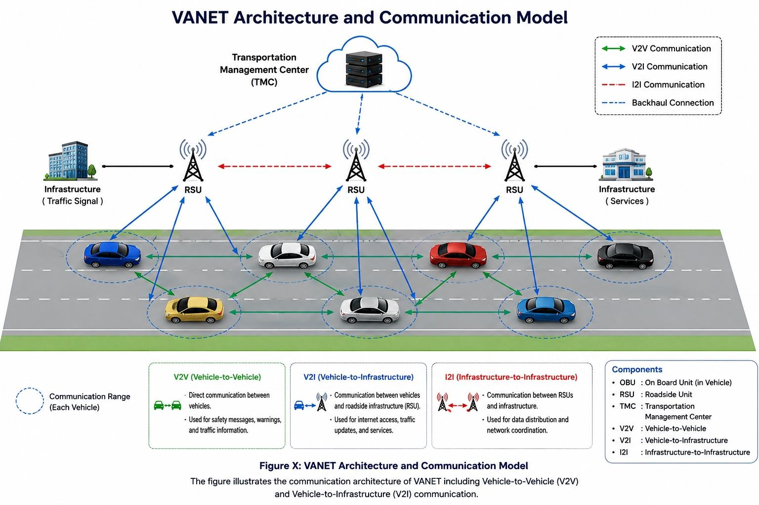
Figure 1.1: VANET architecture diagram
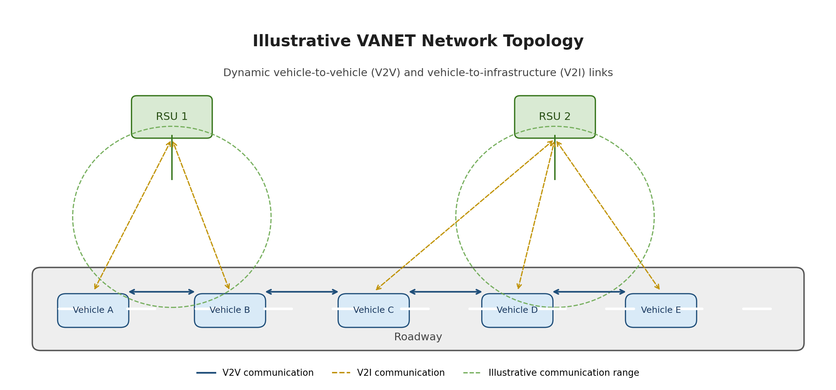
Figure 1.2: Illustrative VANET network topology showing V2V and V2I communication.
Figure 1.2 illustrates a representative topology in which vehicles communicate directly with nearby vehicles and exchange information with roadside units. Because vehicles move continuously, the available links and neighborhood relationships may change over time; the diagram is conceptual and does not represent a measured simulation snapshot [1], [2].
VANET Architecture Layers and Protocol Stack:
Vehicular Ad Hoc Networks (VANETs) rely on a layered communication architecture similar to the TCP/IP and IEEE communication models. Each layer is responsible for specific communication functions and utilizes dedicated protocols to ensure efficient and reliable data exchange between vehicles and infrastructure [1], [2].
The proposed project adopts a practical VANET protocol stack implemented within the NS-3 simulation environment [12], [13], [14].
- Application Layer
The Application Layer is responsible for generating and processing vehicular communication messages related to road safety and traffic management [1], [2].
In this project, customized application messages were implemented, including:
- BEACON messages
- SAFETY_ALERT messages
- TRAFFIC_STATUS messages
- SPEED_REPORT messages
These messages support real-time traffic awareness and attack simulation scenarios such as identity spoofing [1], [2].
Application-Level Message Structure
Application-level messages carry the information required for traffic awareness and safety applications. In this project, the following fields are used in customized application messages; these are project-specific application fields, not fields defined by UDP or AODV standards [1], [2].
Table 1.4: Application-level message fields used in the project

Field | Description
sender | Identifier of the node that actually sends the message in the simulation.
claimedId | Vehicle identity declared inside the application message.
speed | Reported vehicle speed.
posX | Vehicle position coordinate on the X-axis.
posY | Vehicle position coordinate on the Y-axis.
event | Type of traffic or safety event reported.
priority | Priority assigned to the message.
status | Status information associated with the vehicle or reported event.
The sender and claimedId fields are particularly relevant to the identity-spoofing scenario because the detection logic checks whether the declared identity is consistent with the sending node. The remaining fields provide traffic context for the simulated messages.
- Transport Layer
The Transport Layer is responsible for end-to-end communication between nodes and packet delivery management [12].
The project uses:
- UDP (User Datagram Protocol)
UDP was selected because VANET applications require:
- Low latency
- Fast message transmission
- Real-time communication
Although UDP does not guarantee reliable delivery, it is widely used in VANET safety applications due to its lightweight nature and minimal delay [12].
UDP Header Fields
A UDP datagram begins with a fixed 8-byte header containing four 16-bit fields: source port, destination port, length, and checksum. These are transport-layer header fields and are separate from the customized application-message fields listed in Table 1.4 [12].
Table 1.5: Standard UDP header fields
Field | Size | Purpose
Source Port | 16 bits | Identifies the sending application port; may be zero when unused.
Destination Port | 16 bits | Identifies the receiving application port.
Length | 16 bits | Length of the UDP header and data in bytes; minimum value is 8.
Checksum | 16 bits | Provides error detection for the UDP header and data, with IPv4/IPv6-specific rules.
The project uses UDP sockets to carry application messages. The table above describes the standard UDP header, not a custom header created by the project [12].
- Network Layer
The Network Layer manages routing and packet forwarding between vehicles and infrastructure nodes [13].
The routing protocol implemented in this project is:
- AODV (Ad hoc On-Demand Distance Vector)
AODV is a reactive routing protocol that dynamically discovers routes only when needed, making it suitable for highly dynamic VANET environments [13].
The protocol supports:
- Dynamic route discovery
- Route maintenance
- Efficient packet forwarding in mobile environments
AODV Route Request (RREQ) Message Fields
During route discovery, AODV uses control messages including Route Request (RREQ), Route Reply (RREP), and Route Error (RERR). The standard RREQ format includes fields that identify the request, destination, and originator. These protocol fields are distinct from the application-level message fields used in this project [13].
Table 1.6: Main fields of an AODV Route Request (RREQ)
Field | Purpose
Type | Identifies the control-message type; RREQ uses type value 1.
Flags | Control options, including join, repair, gratuitous reply, destination-only, and unknown-sequence-number flags.
Hop Count | Number of hops traversed from the originator to the node processing the request.
RREQ ID | Identifies a particular request when combined with the originator IP address.
Destination IP Address | IP address of the destination for which a route is requested.
Destination Sequence Number | Sequence number representing the freshness of destination-route information.
Originator IP Address | IP address of the node that initiated the route request.
Originator Sequence Number | Sequence number associated with the originator's route information.
This table summarizes the principal RREQ fields for theoretical explanation. It does not imply that the application messages defined by the project use the RREQ format.
- MAC and Physical Layer
The MAC and Physical Layers are responsible for wireless channel access and physical data transmission [14].
The project uses:
- IEEE 802.11-based wireless communication
- Wi-Fi Ad Hoc Mode
- IEEE 802.11a in the current simulation (IEEE 802.11p is not used)
These technologies provide:
- Short-range wireless communication
- Fast channel access
- Support for high vehicle mobility
The physical communication environment was configured inside NS-3 to simulate realistic VANET wireless behavior [14].
Weaknesses of VANET Networks
Despite the significant advantages of Vehicular Ad Hoc Networks (VANETs), these networks suffer from several weaknesses and limitations that affect their performance, reliability, and security. These weaknesses mainly arise from the unique characteristics of VANETs, such as high mobility, dynamic topology, and the use of open wireless communication channels [1], [2].
- High Mobility of Nodes
One of the primary weaknesses of VANETs is the high speed and continuous movement of vehicles. This leads to:
- Frequent disconnections between nodes
- Short communication durations
- Difficulty in maintaining stable communication links
As a result, data transmission may be interrupted or delayed, which negatively impacts network reliability [1], [2].
- Rapidly Changing Network Topology
The network topology in VANET changes continuously due to the movement of vehicles. This makes it difficult to:
- Maintain consistent routing paths
- Ensure stable communication links
- Predict network behavior accurately
This dynamic environment increases the complexity of designing efficient routing protocols [2], [6].
- Limited Communication Range
VANET relies on short-range wireless communication technologies such as Dedicated Short Range Communication (DSRC). This results in [1], [14]:
- Limited network coverage
- The need for a high density of vehicles or Road Side Units (RSUs)
- Possible communication loss in low-traffic areas
- Security Vulnerabilities
Due to the open nature of wireless communication, VANET is highly vulnerable to various security threats, including:
- Message tampering
- Eavesdropping
- Impersonation attacks
- Denial of Service (DoS) attacks
These vulnerabilities can have serious consequences, especially in safety-critical applications [1], [2].
- Privacy Issues
Vehicles in VANET continuously broadcast sensitive information such as location, speed, and identity. This creates several privacy concerns, including:
- Tracking of vehicle movements
- Exposure of user identity
- Misuse of personal data
Ensuring user privacy while maintaining efficient communication remains a significant challenge [1], [2].
- Scalability Challenges
As the number of vehicles increases, VANET faces scalability issues such as:
- Increased network congestion
- Higher packet collision rates
- Reduced communication efficiency
These issues are particularly critical in densely populated urban environments [2], [6].
- Dependence on External Systems
VANET depends heavily on external technologies such as GPS and RSUs. Any failure in these systems may lead to [1], [2]:
- Inaccurate location information
- Communication disruption
- Degradation of overall network performance
- Lack of Standardization
Despite ongoing research and development, VANET still suffers from [1], [2]:
- Lack of unified communication standards
- Variations in protocols and technologies
- Difficulty in interoperability between different systems.
Security Mechanisms in VANET Networks
Ensuring security in Vehicular Ad Hoc Networks (VANETs) is a critical requirement due to the open wireless communication environment and the safety-critical nature of the applications. Various security mechanisms have been developed to protect VANETs from potential attacks and to ensure reliable and trustworthy communication between vehicles [1], [2].
- Authentication Mechanisms
Authentication is one of the fundamental security requirements in VANET. It ensures that only legitimate vehicles are allowed to participate in the network.
In VANET, authentication is typically achieved using digital certificates and cryptographic techniques. Each vehicle is assigned a unique identity and a corresponding cryptographic key, which is used to verify its authenticity [1], [2].
This mechanism helps prevent attacks such as impersonation, where a malicious node attempts to act as a legitimate vehicle [1], [2].
- Data Integrity
Data integrity ensures that the transmitted messages are not altered during transmission.
This is usually achieved using cryptographic hash functions and digital signatures. When a message is sent, a hash value is generated and attached to it. The receiver recalculates the hash and compares it with the received one to verify that the message has not been modified [1], [2].
Maintaining data integrity is essential in VANET, especially for safety-related messages [1], [2].
- Confidentiality
Confidentiality ensures that sensitive information is only accessible to authorized entities.
Encryption techniques are used to protect data from unauthorized access. Even if an attacker intercepts the message, they will not be able to understand its content without the correct decryption key [1], [2].
- Non-Repudiation
Non-repudiation ensures that a sender cannot deny sending a message.
This is achieved using digital signatures, which provide proof of the origin of the message. This mechanism is important for accountability, especially in scenarios involving accidents or disputes [1], [2].
- Privacy Preservation
Protecting user privacy is a major concern in VANET. Mechanisms such as pseudonyms are used to hide the real identity of vehicles [1], [2].
Vehicles can use temporary identities that change periodically, making it difficult to track them while still allowing secure communication.
- Intrusion Detection Systems (IDS)
Intrusion Detection Systems are used to monitor network activity and detect suspicious behavior [4], [7], [11].
IDS can identify anomalies such as:
- Unusual message patterns
- Multiple identities used by a single node
- Inconsistent location information
Once detected, appropriate actions can be taken, such as isolating the malicious node.
- Trust Management Systems
Trust-based mechanisms evaluate the behavior of nodes and assign trust levels accordingly [1], [2].
Nodes with low trust values may be ignored or excluded from the network. This helps in identifying and mitigating malicious behavior over time.
- Secure Routing Protocols
To enhance security, secure versions of routing protocols have been developed, such as Secure AODV (SAODV) [10], [13].
These protocols incorporate security features like authentication and digital signatures to ensure that routing information is not manipulated by malicious nodes.
Security Challenges in VANET Networks
Vehicular Ad Hoc Networks (VANETs) face a unique set of security challenges due to their dynamic nature, open wireless environment, and critical applications. These challenges complicate the design of secure communication mechanisms and make VANETs vulnerable to a variety of attacks [1], [2].
- High Mobility and Dynamic Topology
- Vehicles move at high speeds, causing frequent network disconnections.
- Rapidly changing network topology makes it difficult to establish and maintain secure routing paths [1], [2].
- Attackers can exploit temporary communication gaps to inject malicious messages.
- Open Wireless Communication
- VANET relies on open wireless channels, which are easily accessible by attackers.
- This exposes the network to eavesdropping, message tampering, and replay attacks [1], [2].
- Securing wireless communication without impacting performance is challenging.
- Scalability and Large Network Size
- VANET can consist of thousands of vehicles in urban environments.
- Maintaining security at scale is difficult due to the large number of nodes.
- Cryptographic operations may introduce delays, affecting real-time communication [1], [2].
- Authentication and Identity Management
- Ensuring the authenticity of every vehicle is challenging.
- Lack of proper identity management enables impersonation and Sybil attacks [1], [2].
- Managing digital certificates for all vehicles requires a robust infrastructure.
- Privacy Preservation
- Vehicles continuously broadcast location and behavioral information.
- Protecting user privacy while maintaining accountability is difficult.
- Attackers can track vehicles if pseudonyms or anonymization techniques are not implemented properly [1], [2].
- Real-Time Communication Requirements
- Safety applications demand real-time data delivery.
- Security mechanisms like encryption and authentication may introduce delays.
- Balancing security and low-latency performance is a major challenge [1], [2].
- Vulnerability to Insider Attacks
- Compromised or malicious vehicles can bypass external security mechanisms.
- Insider attackers are harder to detect than external threats [1], [2].
- Trust and reputation-based mechanisms must be implemented to mitigate insider attacks [1], [2].
- Resource Constraints
- Vehicles have limited computational power and memory.
- Intensive cryptographic operations may impact performance.
- Designing lightweight security mechanisms without compromising effectiveness is essential [1], [2].
- Dependence on Infrastructure
- VANET often relies on Road Side Units (RSUs) and central authorities.
- Any compromise or failure of these components can weaken network security [1], [2].
- Ensuring distributed security without relying too heavily on infrastructure is a challenge.
- Heterogeneity and Standardization Issues
- Different vehicle manufacturers may use different communication technologies.
- Lack of standardized protocols complicates secure interoperability [1], [2].
- Ensuring consistent security across heterogeneous systems is difficult.
- Denial of Service (DoS) and Resource Exhaustion
- Attackers can flood the network with fake messages to overload nodes.
- This disrupts both safety and non-safety applications.
- Detecting and mitigating DoS attacks in a highly dynamic network is challenging [1], [2], [8]
- Integration with Emerging Technologies
- VANETs are evolving to include V2X, autonomous vehicles, and IoT devices.
- Integrating new technologies while maintaining security introduces additional risks [1], [2].
- New attack vectors appear as complexity increases.
The following table summarizes the main VANET protocol layers, their associated technologies, potential attacks, existing vulnerabilities, and their impact on network performance and security.
Table 1.3: Main VANET protocol layers, associated technologies, potential attacks, vulnerabilities, and impact
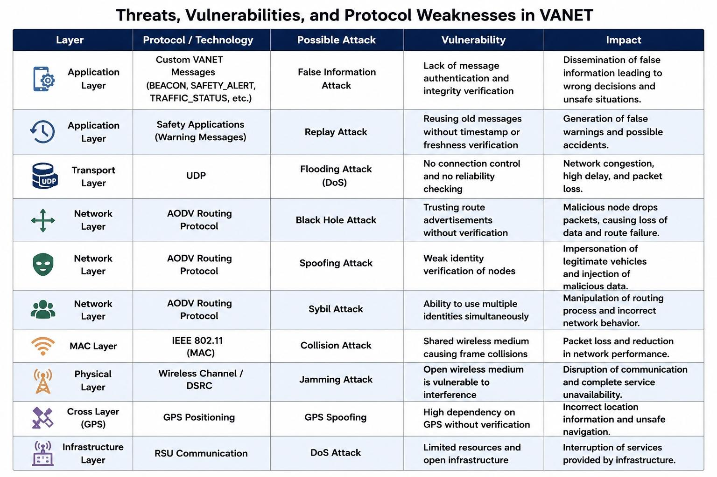
Security Attacks in VANET Networks and Their Mechanisms
Vehicular Ad Hoc Networks (VANETs) are essential technologies in intelligent transportation systems, as they allow data exchange between vehicles (V2V) and between vehicles and roadside infrastructure (V2I). However, the wireless and dynamic nature of these networks makes them vulnerable to security attacks that target the reliability of information, the continuity of communication, and the efficiency of packet routing [1], [2].
This project focuses on identity spoofing and black hole attacks, and also studies the jamming attack as one of the attacks that disrupt wireless communication.
Identity Spoofing Attack
An identity spoofing attack occurs when a malicious node tries to appear with the identity of another vehicle in the network, in order to send incorrect information or to influence the trust of vehicles in the exchanged messages [1], [2].
The attacker can create messages that appear to come from a trusted vehicle, such as accident warnings or traffic information, which may lead the receiving vehicles to make incorrect decisions [1], [2].
The attack passes through the following stages:
- The malicious node selects the identity of another vehicle.
- It creates a message containing a declared identity that does not match the identity of the sender used in the scenario.
- It sends misleading traffic information or warning messages.
- The target node receives the message, and the verification mechanism tries to detect the inconsistency in the identity fields.
Black Hole Attack
The black hole attack is a routing attack that targets the network layer in VANET, especially the AODV routing protocol.
AODV discovers routes on demand through route request (RREQ) and route reply (RREP) messages. The attacker exploits this mechanism by claiming to own a fresh and short route to the destination [13].
The attack works as follows:
- The source vehicle sends an RREQ message to search for a route to the destination.
- The malicious node receives the route request.
- The attacker can send a misleading RREP message containing information that suggests a better route, such as a high destination sequence number.
- If the source adopts this route, the packets are sent toward the malicious node [10], [13].
- The malicious node drops the packets instead of forwarding them, which lowers the packet delivery ratio and the throughput and increases packet loss.
Alfarizi et al. (2025) studied the impact of this attack on quality-of-service indicators using NS-3, SUMO, and the AODV routing protocol [9].
Jamming Attack
The jamming attack targets the physical layer of the wireless network. It is based on generating interference or signals that affect the ability of nodes to receive data correctly [7], [11].
This attack can cause frame reception failures, more retransmissions, a lower packet delivery ratio, and possibly a loss of communication between some vehicles [7], [11].
This attack is included in the theoretical scope of the project, and the details of its simulation and its practical results will be added after the jamming scenario is implemented.
Attack Detection Mechanisms
Detection mechanisms depend on the type of attack and the targeted layer [1], [2], [4].
- Identity spoofing: checking the consistency of the sender information with the declared identity, together with identity authentication techniques and message verification.
- Black hole: inferring malicious behavior by monitoring routing paths, analyzing abnormal RREP replies, and comparing the number of packets received and forwarded by intermediate nodes.
- Jamming: studying changes in interference levels, reception failure rates, and retransmission rates to identify possible jamming behavior.
The ability to detect attacks differs according to the available information and the monitoring mechanism. Therefore, a drop in network performance alone is not conclusive evidence of the type of attack [1], [2], [4].

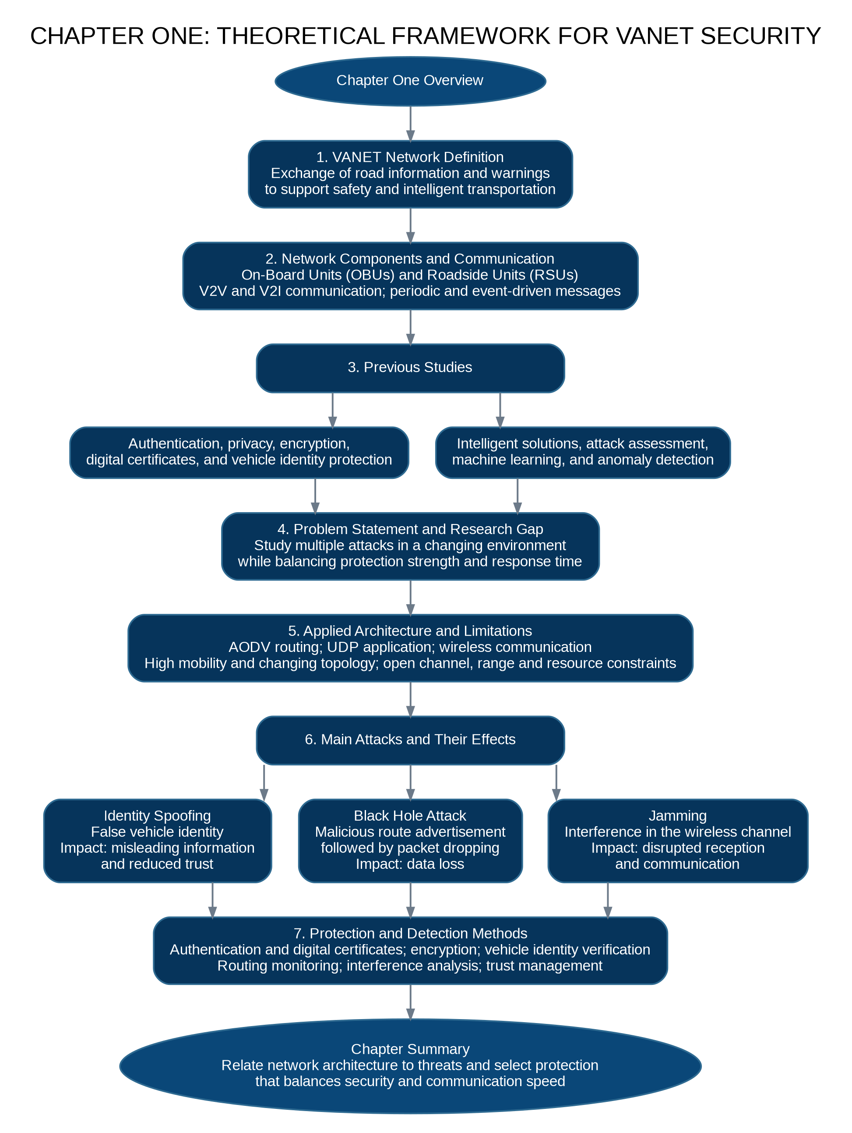
Figure 1.3: Chapter One flowchart summarizing the theoretical framework, research gap, attacks, and defenses.
References

[1] “Ensuring Security and Privacy in VANET: Authentication Approaches,” Wireless Communications and Mobile Computing, 2024.

[2] “State-of-the-Art Authentication and Verification Schemes in VANETs: A Survey,” Internet of Things Elsevier, 2024.

[3] “A Secure and Efficient Blockchain Enabled Federated Q-Learning Model for Vehicular Ad-hoc Networks,” Scientific Reports, Nature, 2024.

[4] T. K. Venkatasamy, M. J. Hossen, G. Ramasamy, and N. H. B. Abdul Aziz, “Intrusion Detection System for V2X Communication in VANET Networks Using Machine Learning-Based Cryptographic Protocols,” Scientific Reports, vol. 14, Art. no. 31780, 2024, doi: 10.1038/s41598-024-82313-x.

[5] “Enhancing VANET Security: An Unsupervised Learning Approach for Mitigating False Information Attacks in VANETs,” Electronics, vol. 14, no. 1, 2025.

[6] R. J. Borah and D. Ganga, “Performance analysis of AODV-based VANETs in Guwahati city: a comparative study of propagation models,” Int. J. Vehicle Information and Communication Systems, vol. 10, no. 1, pp. 61–84, 2025, doi: 10.1504/IJVICS.2024.10066105.

[7] N. A. K. Zghair, W. K. Jawad, J. J. Alwash, M. A. Almaiah, and R. Shehab, “GAN-augmented adversarial training for robust detection of complex jamming attacks in VANET intelligent systems,” Int. J. Innovative Research and Scientific Studies, vol. 8, no. 3, pp. 4304–4314, 2025.

[8] B. Muktar, V. Fono, and O. A. Nouboukpo, “Machine Learning-Based Detection of DDoS Attacks in VANETs for Emergency Vehicle Communication,” arXiv preprint arXiv:2505.08810, 2025.

[9] N. F. Alfarizi, M. T. Nuruzzaman, S. Uyun, B. Sugiantoro, and M. F. A. bin Abdullah, “Performance Evaluation of Vehicular Ad Hoc Networks Considering Malicious Node Impact on Quality of Services Metrics,” Jurnal Online Informatika, vol. 10, no. 2, pp. 299–307, 2025, doi: 10.15575/join.v10i2.1568.

[10] M. Ghute and Y. Suryawanshi, “Discovering authentic routes using a cryptographic approach against blackhole attack,” EURASIP Journal on Wireless Communications and Networking, vol. 2025, Art. no. 86, 2025, doi: 10.1186/s13638-025-02494-5.

[11] A. S. Srinivas T, K. J. Prasanna Venkatesan, R. Garladinne, G. Vallathan, K. V. Balaramakrishna, and L. Sahukar, “Leveraging DenseNet-ABiLSTM for Effective Jamming Attack Detection in VANETs: A Hybrid Model with DRA-driven Feature Optimization,” Int. J. Intelligent Engineering and Systems, vol. 18, no. 11, 2025, doi: 10.22266/ijies2025.1231.18.
[12] J. Postel, “User Datagram Protocol,” RFC 768, Internet Engineering Task Force, Aug. 1980. Available: https://www.rfc-editor.org/rfc/rfc768.html.
[13] C. Perkins, E. Belding-Royer, and S. Das, “Ad hoc On-Demand Distance Vector (AODV) Routing,” RFC 3561, Internet Engineering Task Force, Jul. 2003. Available: https://www.rfc-editor.org/rfc/rfc3561.html.
[14] IEEE 802.11 Working Group, “IEEE 802.11 Wireless LAN Standards,” IEEE. Available: https://www.ieee802.org/11/.

