Full Stack Development with MERN
Project Documentation
1. Introduction
ShopEZ is your one-stop destination for effortless online shopping. With a user-friendly interface and a comprehensive product catalog, finding the perfect items has never been easier. Seamlessly navigate through detailed product descriptions, customer reviews, and available discounts to make informed decisions. Enjoy a secure checkout process and receive instant order confirmation. For sellers, our robust dashboard provides efficient order management and insightful analytics to drive business growth. Experience the future of online shopping with ShopEZ today.
Project Title: SHOPEZ: E-commerce Application

2. Project Overview
Purpose:
The purpose of this project is to build a dynamic e-commerce application using the MERN stack that simulates a real shopping platform. It aims to provide product listing, detailed product pages with image carousels, and a checkout flow backed by MongoDB for data persistence. The goal is to demonstrate how frontend and backend communicate through RESTful APIs to render data dynamically. It also showcases how structured product documents can enhance user experience with fields like mainImg and carousel. Overall, the project establishes a scalable foundation for future enhancements such as authentication, payments, and order tracking.

Features:
- Comprehensive product catalog: Wide range of items with descriptions, reviews, pricing, and discounts.
- Shop Now button: Quick access to start purchasing directly from product listings.
- Order details page: Enter shipping address, payment method, and product requirements.
- Secure and efficient checkout: Safe handling of personal information with a smooth process.
- Order confirmation and details: Instant confirmation plus a page to review shipping, payment, and requests.

3. Architecture
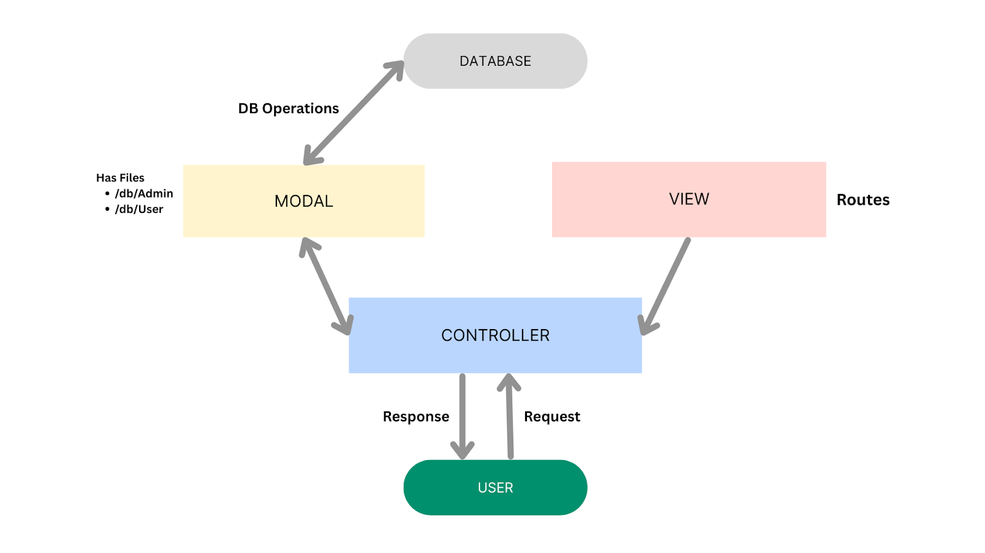
Frontend:
1. Setup React Application:
• Create a React app in the client folder.
• Install required libraries
• Create required pages and components and add routes.
2.Design UI components:
• Create Components.
• Implement layout and styling.
• Add navigation.
3.Implement frontend logic:
• Integration with API endpoints.
• Implement data binding.

Backend:
1.Setup Express Server
- Create index.js file
- Start server on chosen port
- Define APIs
2.Database Configuration
- Set up MongoDB (local or Atlas)
- Create database and collections (admin, users, products, orders)
3.Express.js Server Setup
- Handle HTTP requests and endpoints
- Configure middleware (body-parser, cors)
4.Define API Routes
- Separate route files (users, orders, auth)
- Implement product listing, user registration/login, order management
5.Implement Data Models
- Define Mongoose schemas (products, users, orders)
- Create models and CRUD operations
6.User Authentication
- Routes for register, login, logout
- Middleware to protect authenticated routes
7.Handle Products & Orders
- Routes/controllers for product listings
- Implement order functionality with validation and DB updates
8.Admin Functionality
- Routes/controllers for admin tasks (add products, manage orders)
- Authentication/authorization for admin access
9.Error Handling
- Middleware for catching errors
- Return proper error messages and status codes
Database:
1.Install Mongoose
- In your Node.js project directory, run:
- npm install mongoose
Now, make sure the database is connected before performing any of the actions through the backend. The connection code looks similar to the one provided below.
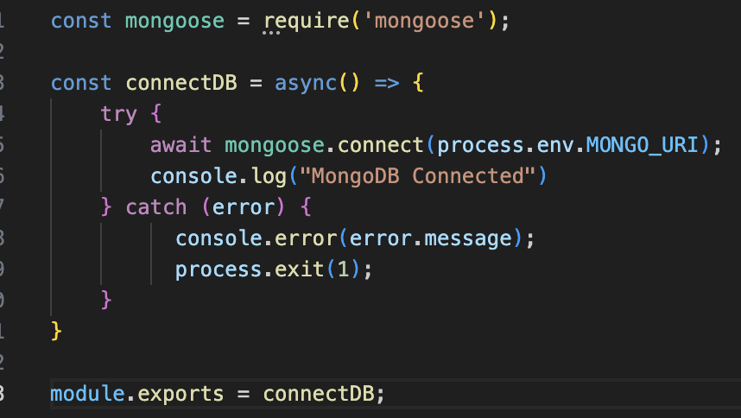
Schemas: Now let us define the required schemas
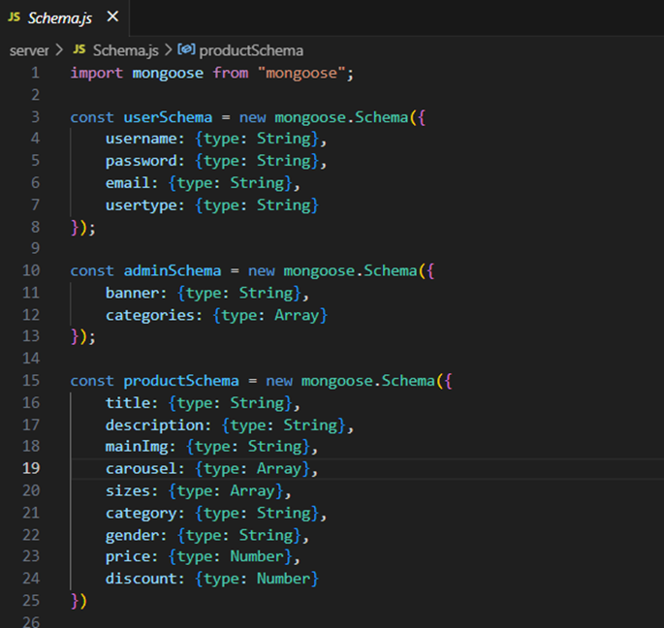
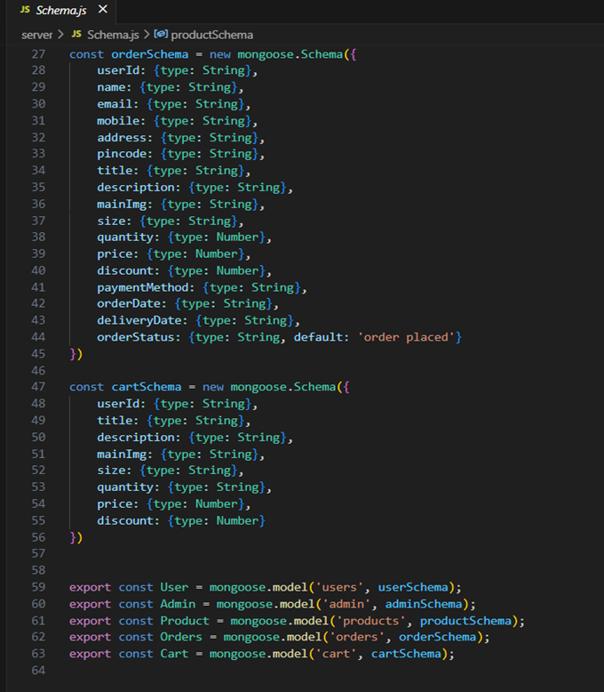

4. Setup Instructions:
- Create a new folder with your project name.
- Inside that folder create two new folders.
- Name one as Client.
- Name another one as Server.
- Now open that folder in VS Code.
- Open the Client folder in the terminal of VScode.
- npm create vite@latest. -- --templates react
- Select React framework from the given options.
- Select a framework:
- │ React
- Select JavaScript variant from the given options.
- Select a variant:
- │ JavaScript
- Now let’s navigate to the client folder by giving the following command.
- cd client
- To install all the packages, run the following command.
- npm install
- To start the React server type the following command.
- npm run dev
- Open Server folder in terminal of VScode.
- npm init -y
- Create files:
- server.js
- Create folders:
- Models
- Controllers
- Routes

Prerequisites:
Software Requirements:
- Operating System: Windows 10/11, macOS, or Linux
- Node.js v16 or above: Runtime for server and frontend logic
- npm v8 or above: Package manager for dependencies
- React.js: Library for building dynamic user interfaces
- Browser: Latest Google Chrome or Firefox for testing UI
- Express.js: Web framework for RESTful APIs
- MongoDB: NoSQL database for storing application data
- Postman: API testing tool
- Visual Studio Code: Preferred editor with Git and terminal support Git & GitHub: Version control and collaboration

Hardware Requirements:
- Processor: Intel Core i5 (8th Gen or above) / AMD Ryzen 5 or better
- RAM: Minimum 8 GB, recommended 16 GB
- Storage: At least 1 GB free space
- Display: 1366x768 resolution or higher

5. Folder Structure:
Client: Describe the structure of the React frontend.
Server: Explain the organization of the Node.js backend.

6. Running the Application:
Step 1: Set Up the Frontend (React App):
a) Open a terminal and navigate into the client folder:
cd client
b) Once installation is done, start the React development server:
npm run dev
c) The app should now be running on:
http://localhost:5173
Step 2: Set Up the Backend (Express Server)
a) Open a new terminal tab/window or split the terminal.
b) Navigate into the server folder:
cd ../server
Step 3: Configure Environment Variables
Inside the server folder, create a new file named .env (no file extension).
In that .env file, add your MongoDB connection string:
MONGO_URI=mongodb://localhost:27017/<— dbname—>
Step 4: Start the Backend Server:
Inside the same server folder, run the backend server using:
nodemon index.js
The server should start on:
http://localhost:8000

9. User Interface:
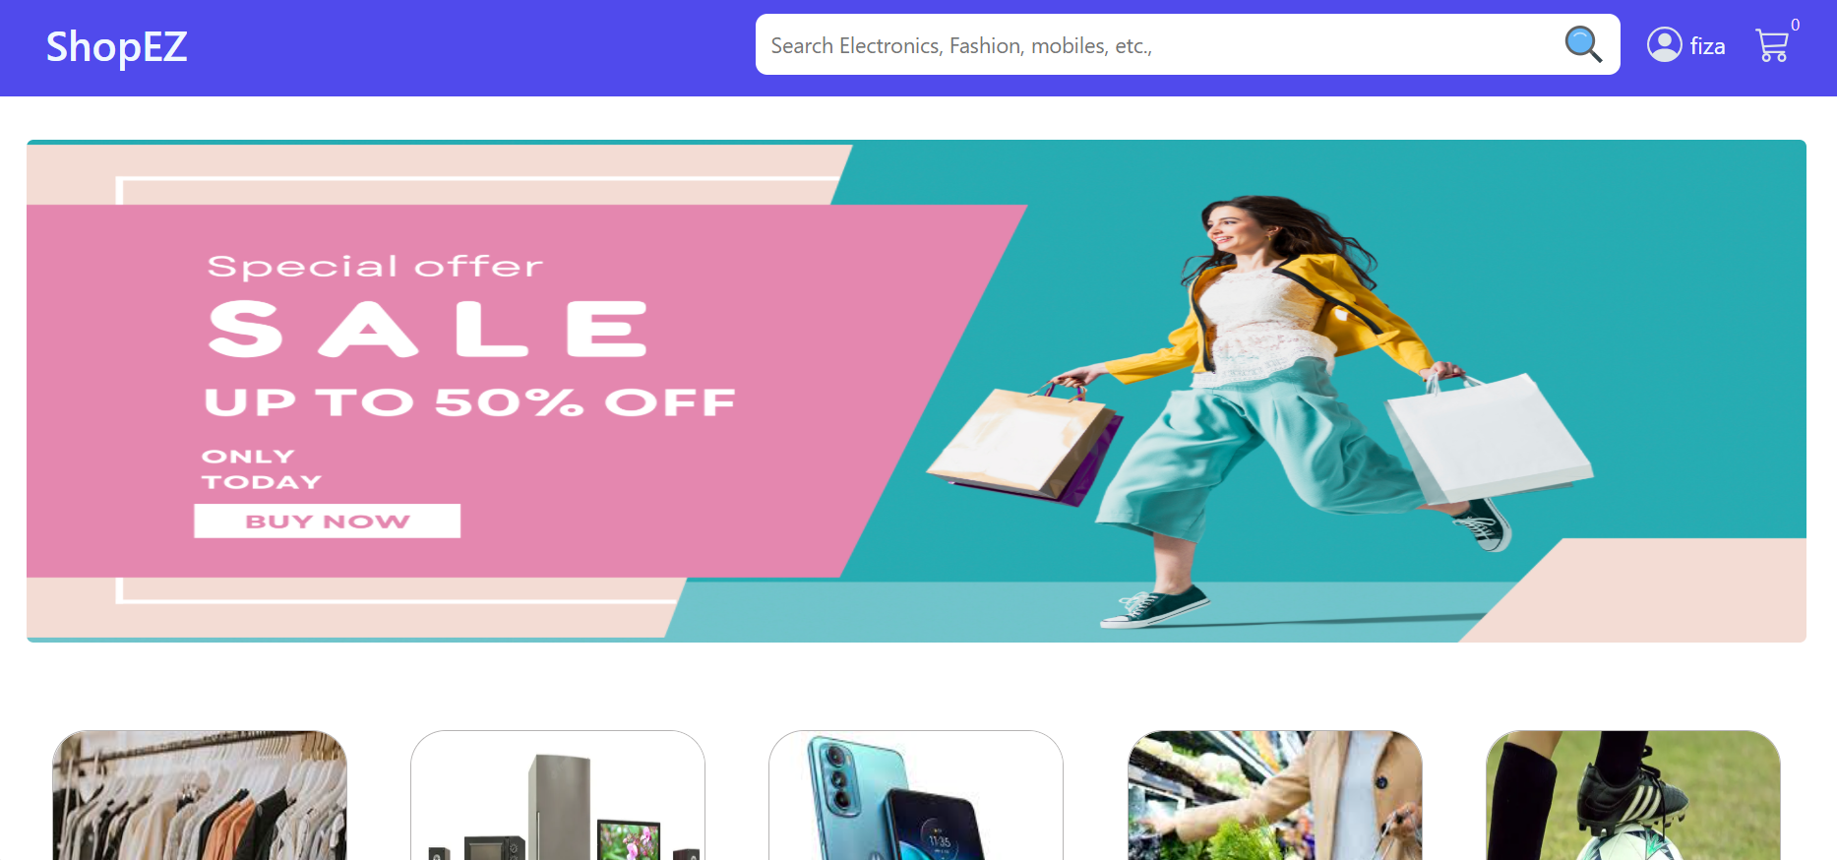

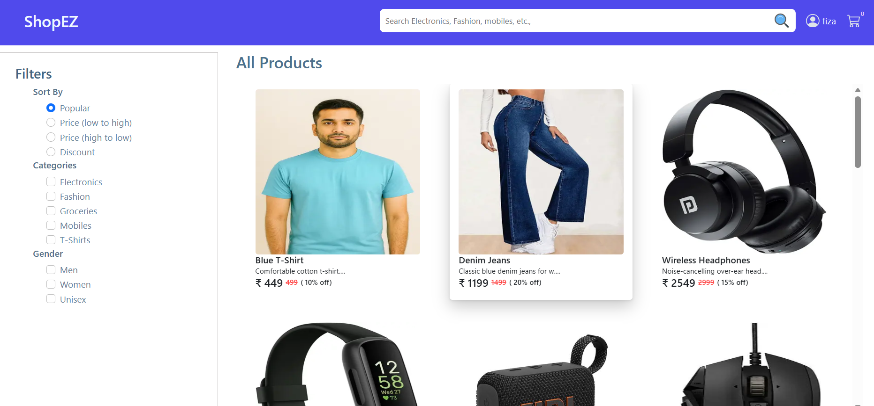

DEMO LINK:
https://drive.google.com/file/d/17ZgPKzJOYVkZfDkIyroGy9MhAPb5u6rh/view?usp=sharing

13. Future Enhancements:
- Add user authentication and role-based access (admin vs customer).
- Integrate payment gateway APIs for real transactions.
- Implement order management with tracking and history.
- Build advanced search and filtering for products.

