MEDIA STREAMING IN IBM CLOUD VIDEO STREAMING

1. Sign in to your IBM Cloud account.

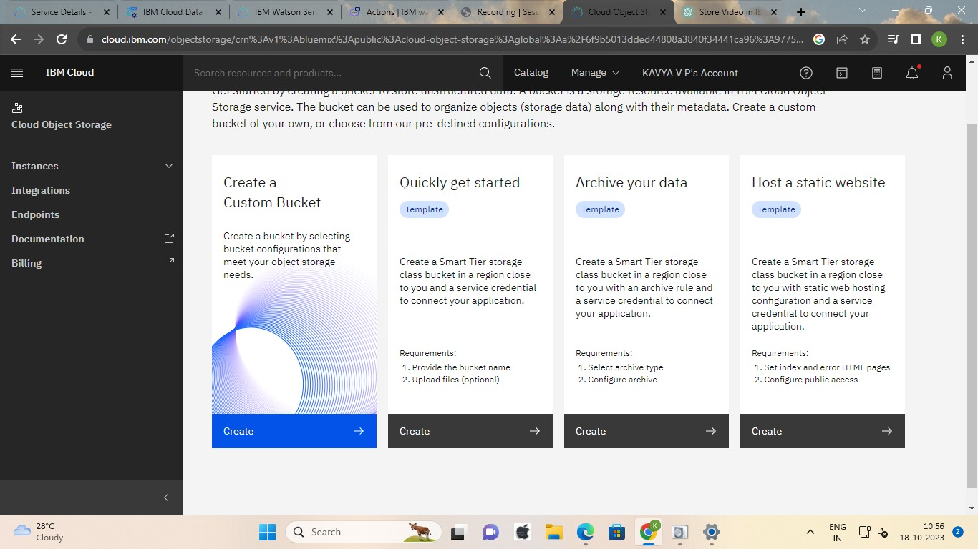

2. Click on "Upload" or "Create" to start the upload process.

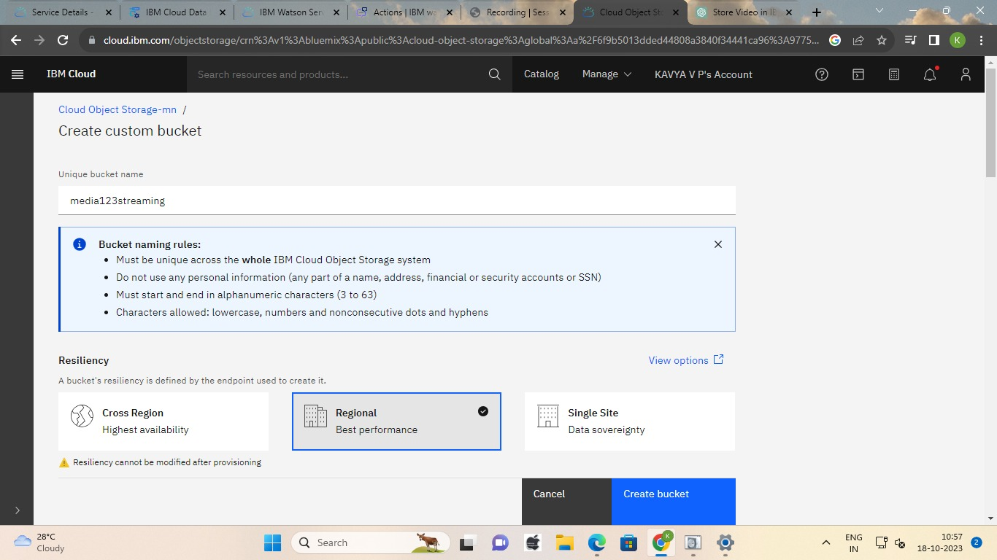

3. Select the video file you want to upload from your computer.

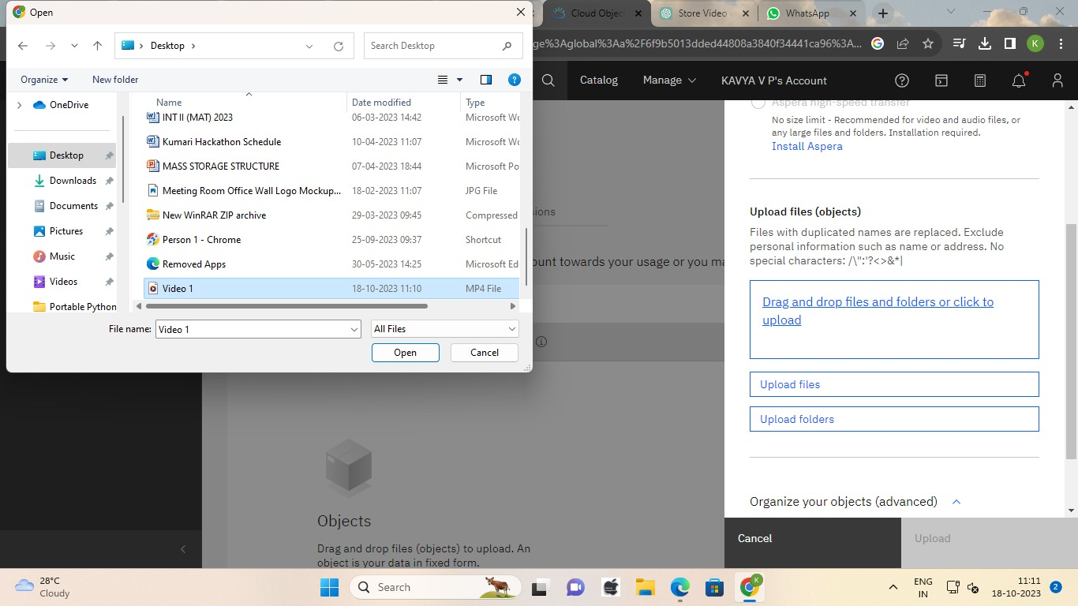

4.Once you've selected the settings, click on "Upload" or "Start" to begin the upload process.

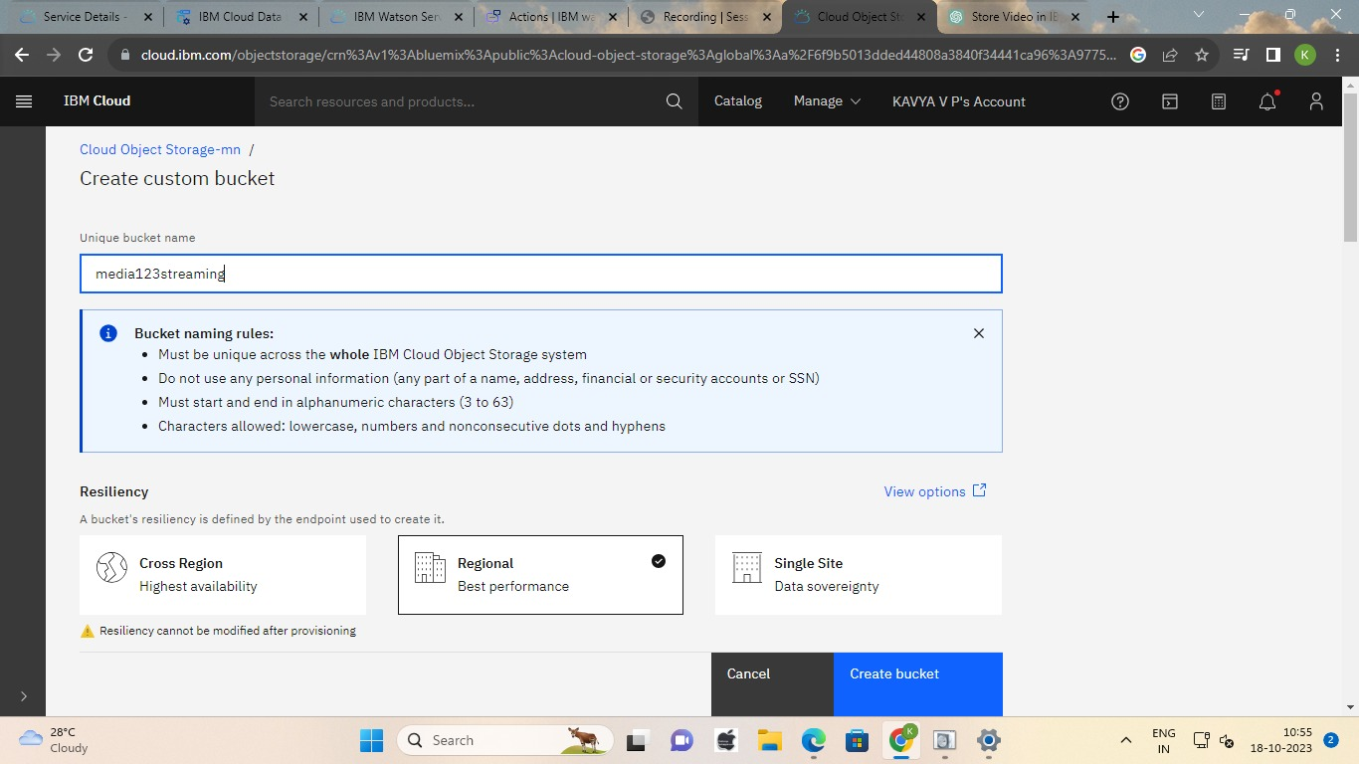

5. Wait for the video to finish uploading. The time it takes will depend on the size of the video and your internet connection.

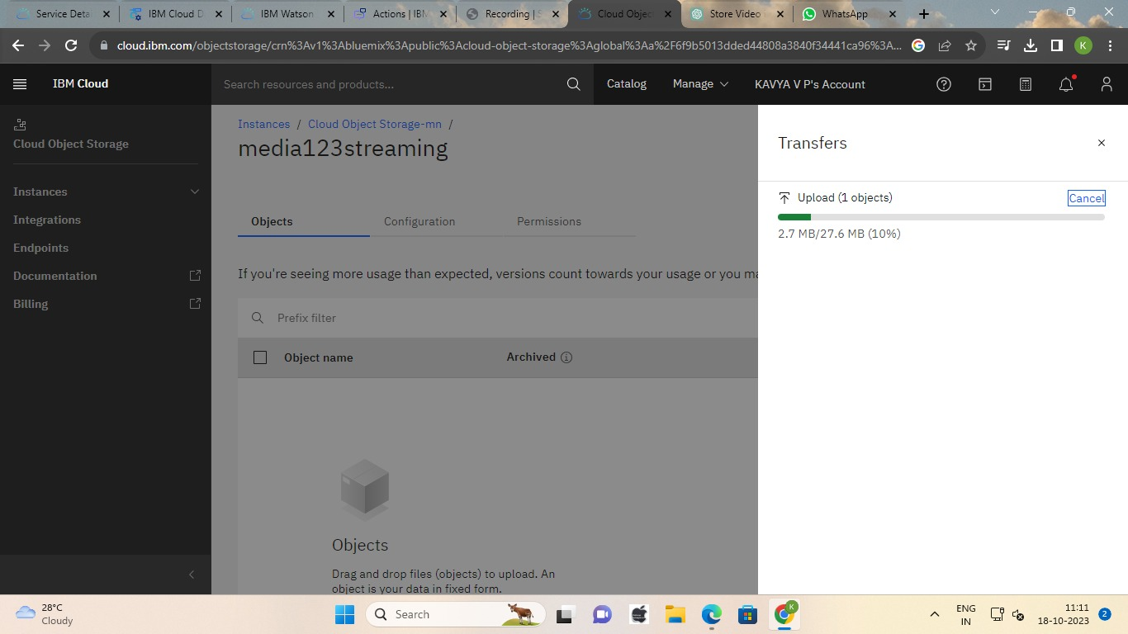

6. Once the upload is complete, you'll be able to access and manage your video in IBM Cloud Video Streaming.

