FASTAPI
Fast API is web framework of Python, is a backend framework.
FIVE REASONS WHY FASTAPI IS THE BEST PYTHON FRAMEWORK:
- Fastest Performance - Faster than Django, Flask, and other Python frameworks. Perfect for handling complex requests and microservices architecture.
- Automatic Data Validation - Built on top of Pydantic, FastAPI provides automatic data validation and parsing. No need to write validation code manually!
- Easy to Learn - The easiest Python web framework to learn. If you want to quickly master backend development, FastAPI is your best choice.
- Asynchronous Programming - FastAPI supports async/await, allowing your application to handle multiple requests simultaneously for better performance.
- High Demand Jobs - FastAPI has amazing job openings compared to other frameworks. Companies are actively hiring FastAPI developers in 2024.

CREATE YOUR FIRST FASTAPI SEVER ANG HANDLE GET REQ:
from fastapi import FastAPI
here FastAPI is the class, for which we need to create an object to access.
app = FastAPI() //here, we create a object for the class FastAPI. This line also starts the server.
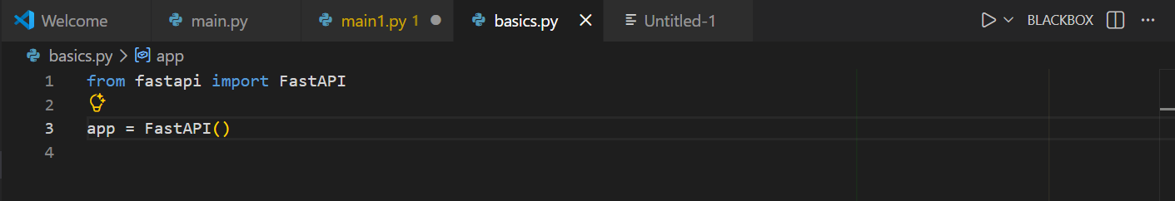
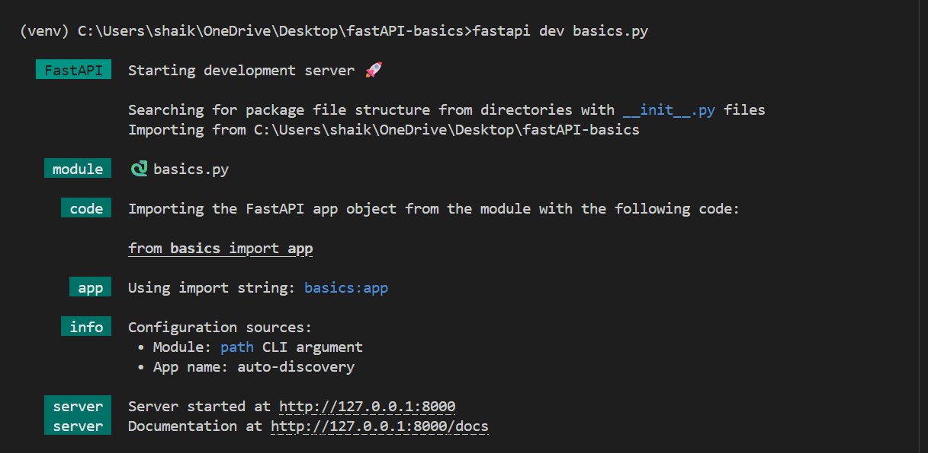
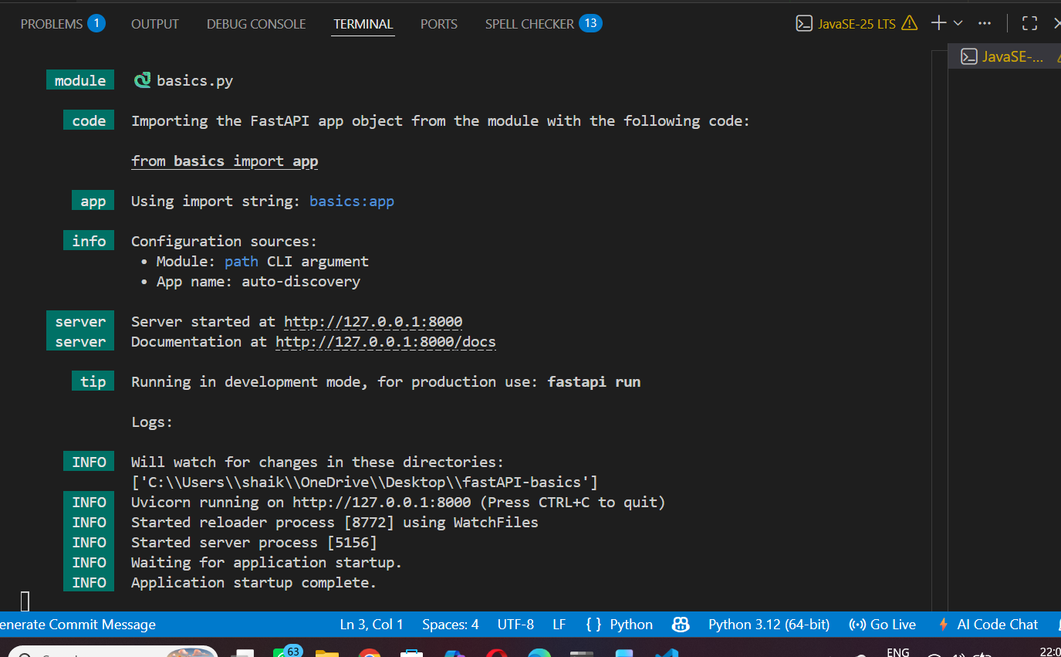

The line server started at http://127.0.0.1:8000 says that server has started.
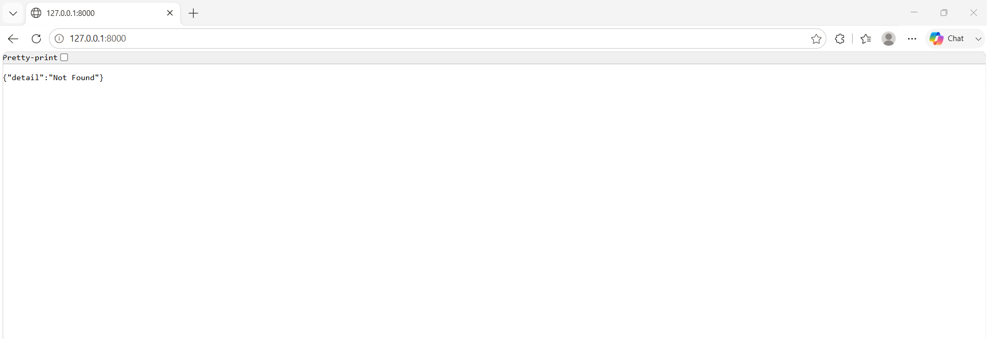

Details not found, means we can say, fastapi server is running, but we haven’t configured anything.
Creating an End Point:
Endpoint decides what data to be displayed. Developer might have configured that for this particular API, saying for this end point or URL display a particular data.
Example:
In an e-commerce website, when we said https://www.amazon.com/shoes here, this URL shoes the Shoes products.

How to create an End Point:
We have to define a method, to identify it as a fastapi method we use @app.get(“<endpointpath>”) and normal method. @app.get(“<endpointpath>”) also known as route.
We can different https method based on the requirement.
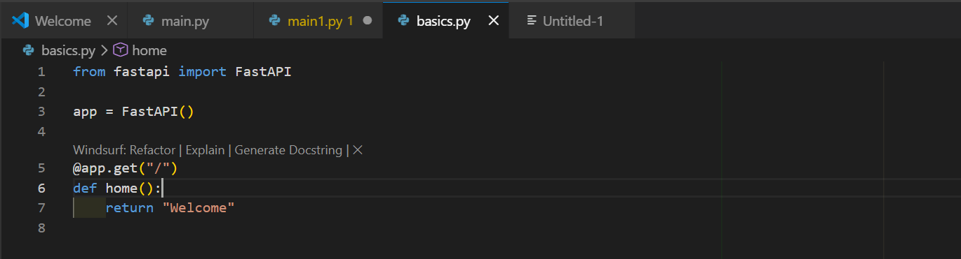
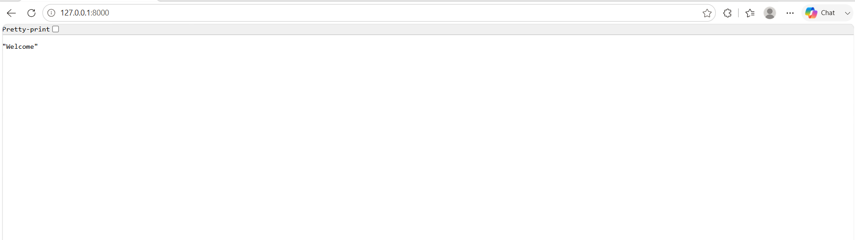
Note: we cannot use same route again, as ambiguity might occurs.
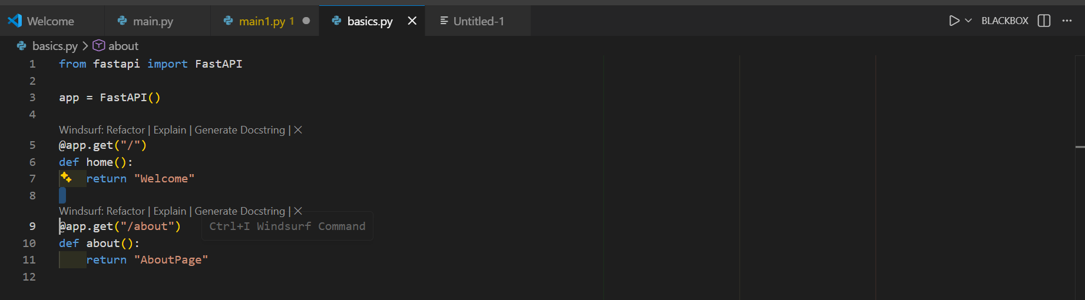
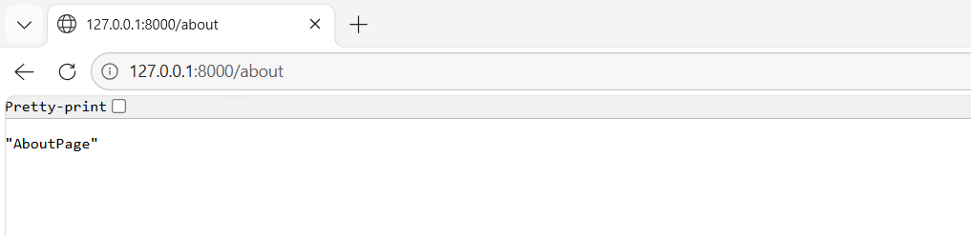

QUERY PARAMETERS AND PATH PARAMETERS:
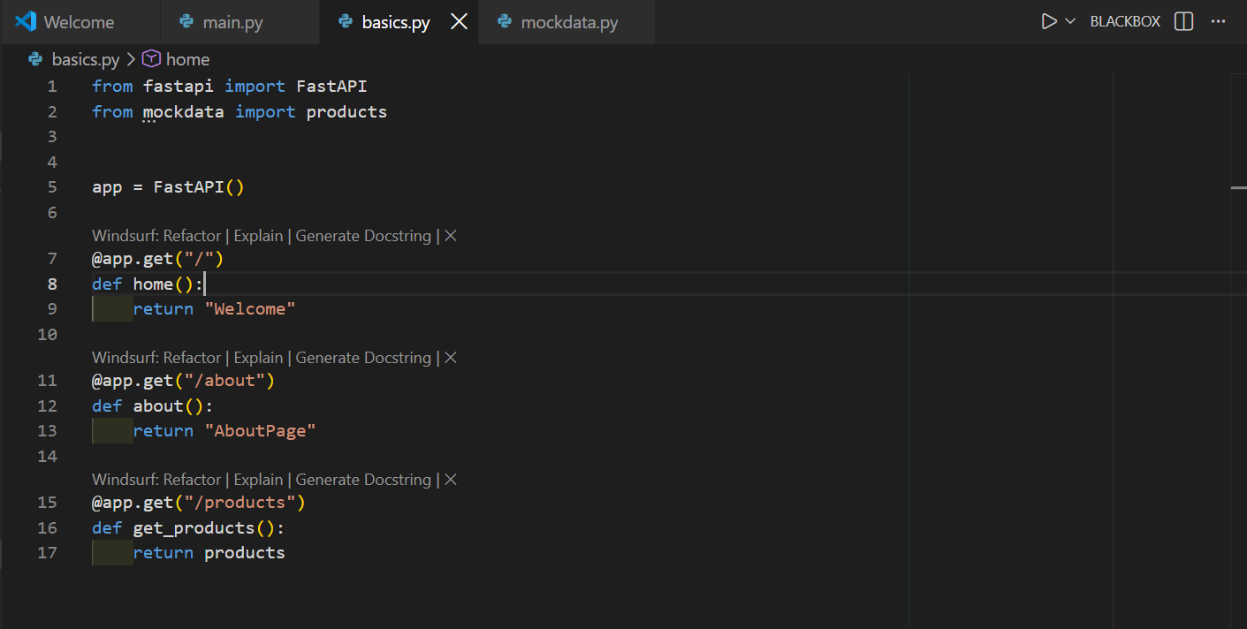
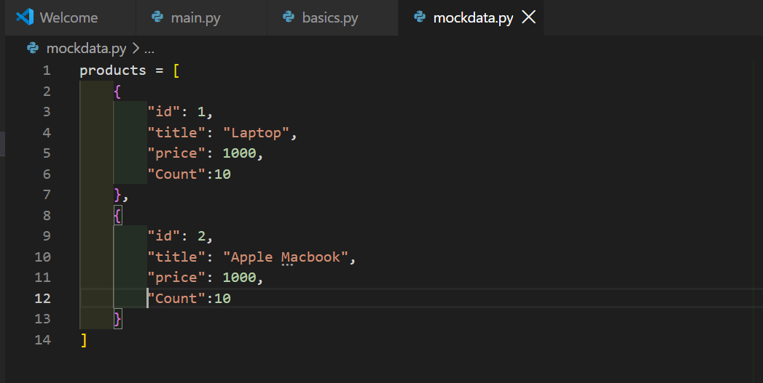
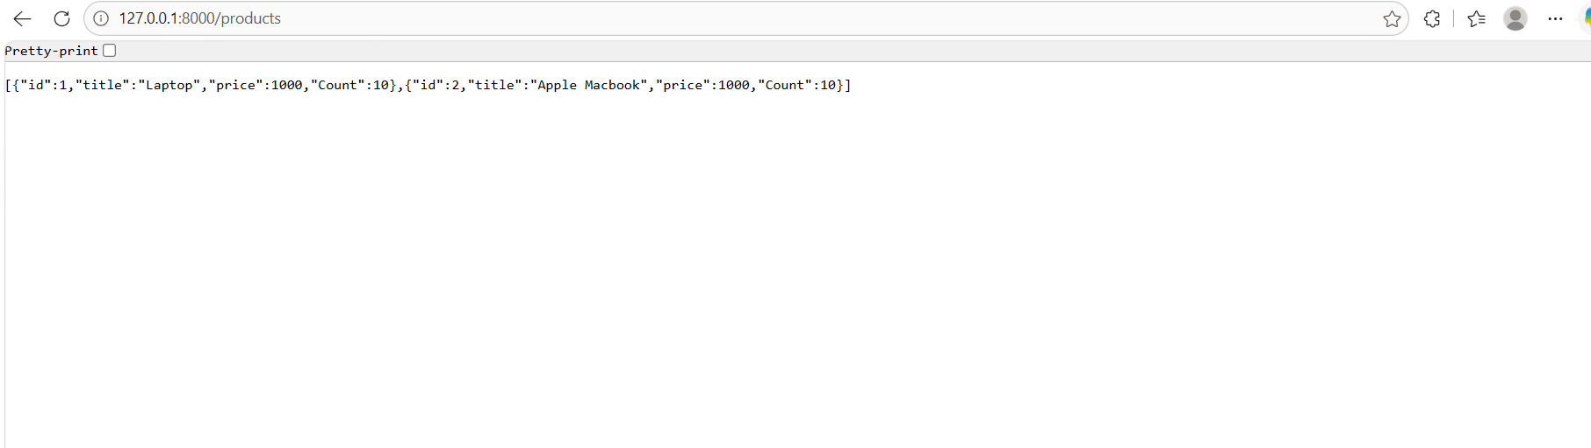
we had created a mock data and also products named end point.

path parameters are variable segments embedded directly inside a URL path to uniquely identify a specific resource. They are declared using curly braces {} within the route decorator and must match the function's argument names exactly.

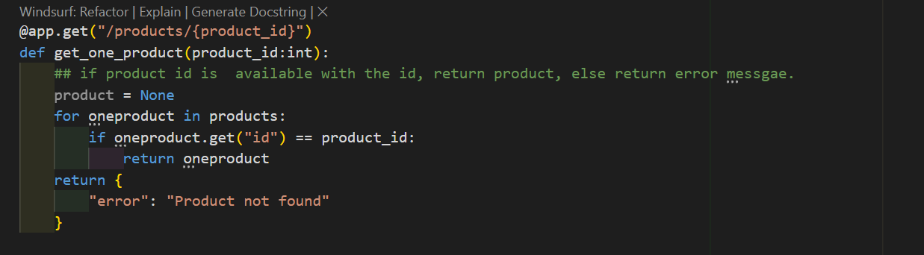

Here, product_id is the path parameter.
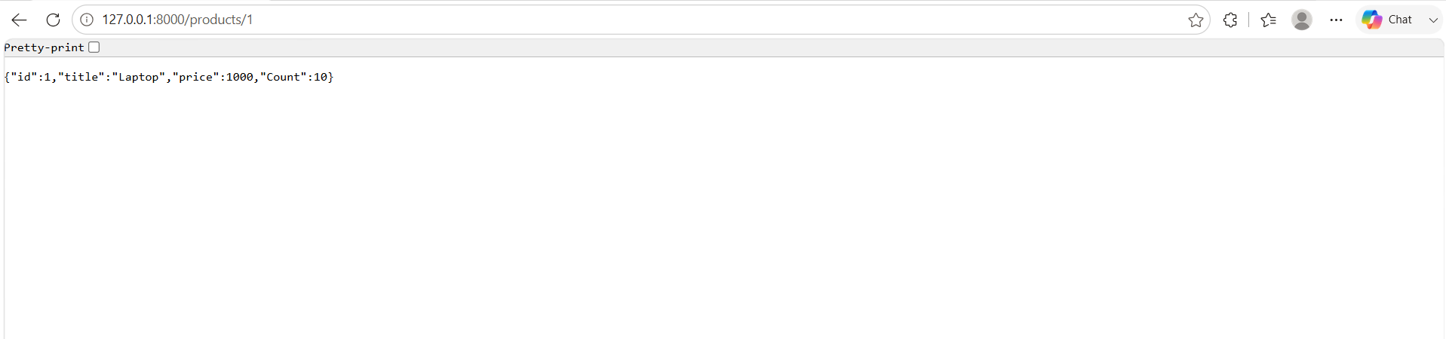
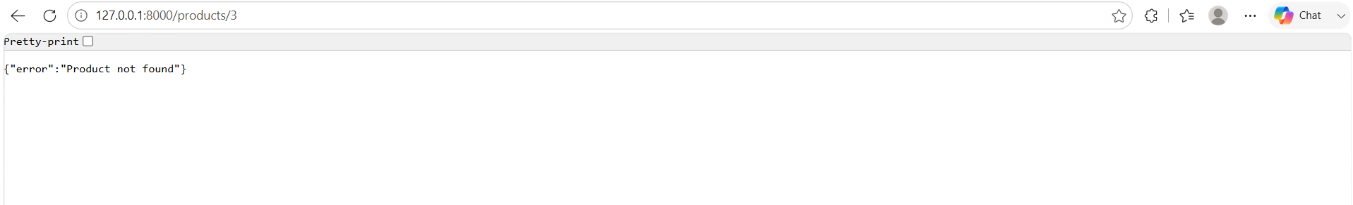
Query parameter is so simple to define than Path parameter, fastAPI is so smart that, if we havenot given any path parameter, it will finds out simply that it is a query parameter.
query parameters are key-value pairs appended after the ? in a URL (e.g., /items/?skip=0&limit=10) used primarily for filtering, sorting, or paginating data. Any function argument in your path operation that is not part of the URL path is automatically interpreted by FastAPI as a query parameter.
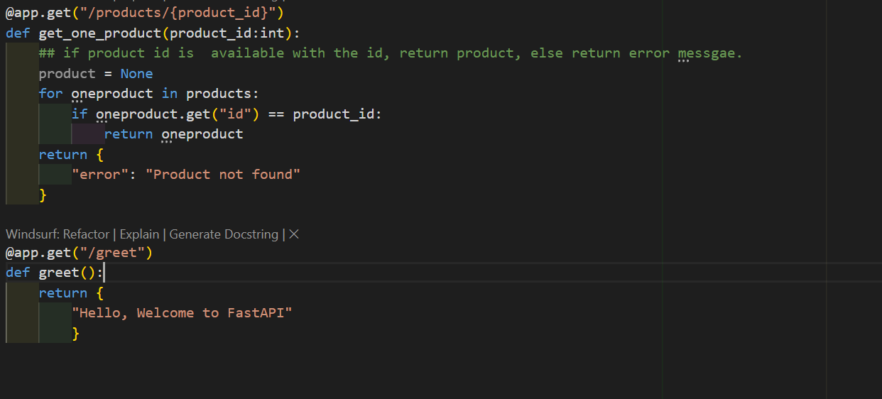
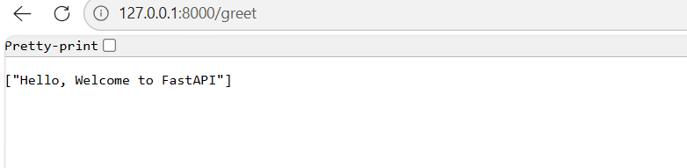
If we have add a query parameter means ?<name> after greet and observe the output.
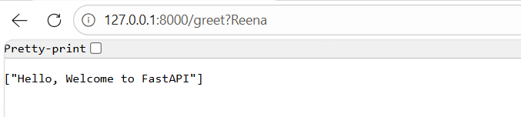
No change is seen and name is not included anywhere there, as we haven’t added anything in the parameters.
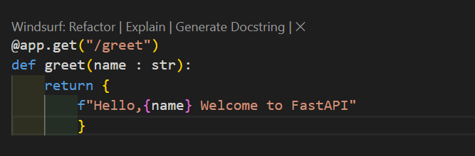
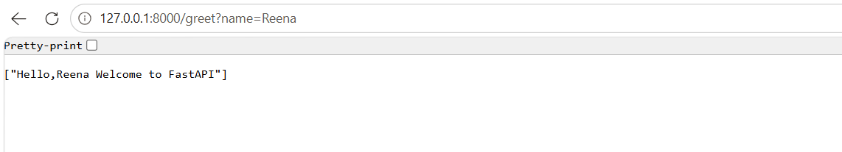
Think:
PATH = Which thing?
QUERY = How do I want it?
1. Path parameter → "Which specific resource?"
Suppose you have users:
/users/101
/users/102
/users/103
Here 101 tells the API which user you want.
@app.get("/users/{user_id}")
def get_user(user_id: int):
return {"user_id": user_id}
Request:
/users/101
👉 101 = path parameter
Think of it like an address 🏠
India → Hyderabad → Kokapet → House 25
↑
specific thing
The path identifies exactly what you're looking for.
2. Query parameter → "How/which way do I want it?"
Suppose you want users, but you want to filter or sort them.
/users?age=25
/users?city=Hyderabad
/users?sort=name
/users?limit=10
Here /users is still the same resource.
The query tells the server how you want the result.
@app.get("/users")
def get_users(age: int = None):
return {"age": age}
Request:
/users?age=25
👉 age=25 = query parameter
Feature | Path Parameter | Query Parameter
Purpose | Identifies a specific resource | Filters/customizes the result
Location | Inside the URL path | After ?
Syntax | /users/{id} | /users?id=10
Example | /users/10 | /users?id=10
Usually used for | Specific item | Search, filter, sort, pagination
Required? | Usually required | Often optional
Can have multiple? | Yes | Yes
Changes the resource being requested? | Yes | Usually no

HTTPS Methods:
There are 4 methods:
- Get – to fetch data
- Post – to add data in the database
- Put – to update the data
- Delete – to delete the data from database.
When we use post method, we can send data from client(postman) to server using body(using post or put), headers (request headers), query params.
while using post, we can use all body, headers, query params.
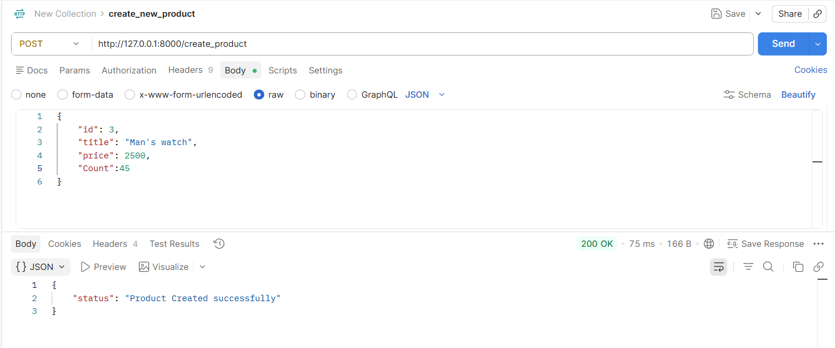
We have posted the data using body and sent it from client to server, but it does not reach the backend or fastAPI code, now the question is how fastAPI will receive this data.
we will be sending this through a variable in the code as given in the picture below:
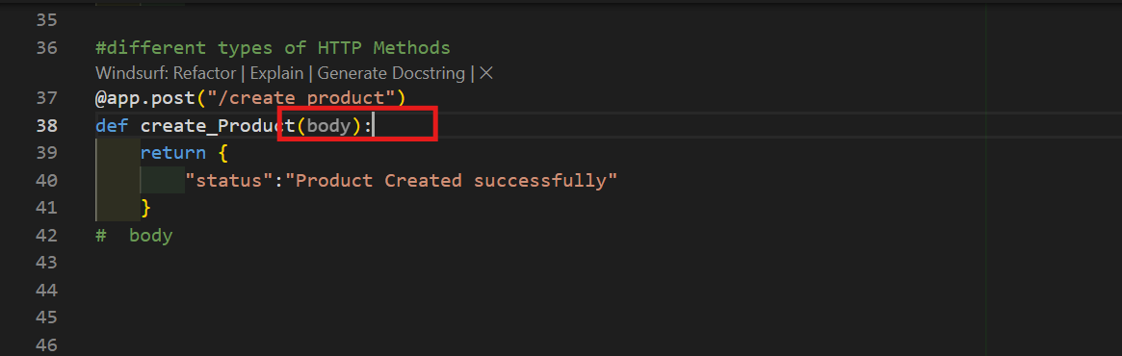
Here, the product that created in Postman using Post method is given as the parameter to the function. The variable body represents { id:3………………….}, variable name can be anything, not only body. Donot misunderstood that as we gave input in the form of body so we took the parameter or sends data to backend using body variable.
Now the body = {id :3, product:mens watch, …….}. How fastAPI validates the data?
This happened using pydentic library. Using this library we can validate the data.
FastAPI Project SetUP:
A simple project can look like:
fastAPI-basics/
│
├── .venv/
│
├── basics.py
├── mockdata.py
├── dtos.py
└── requirements.txt
What each file does
File/Folder | Purpose
.venv/ | Isolated Python environment
basics.py | Main FastAPI application
mockdata.py | Sample/mock data
dtos.py | Pydantic models / DTOs
requirements.txt | Project dependencies

