Linux
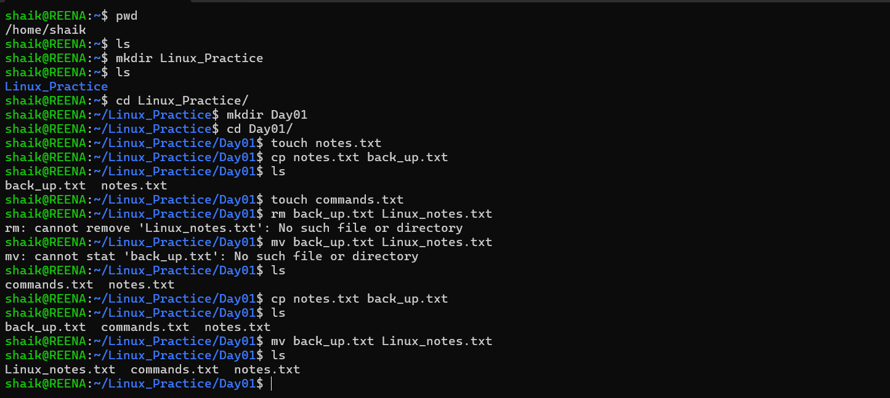
Directory | Purpose
/ | Root directory
/home | User home directories
/etc | Configuration files
/var | Logs and variable data
/tmp | Temporary files
/bin | Essential user commands
/usr | Installed applications
/opt | Optional software
/dev | Device files
S.no | Command | Reason
1 | pwd | To know the Present working Directory
2 | ls | To list the items (files, folders, etc) in the current directory.
3 | ls-l | To list the items (files, folders, etc) in the current directory. (long form)
4 | ls-la | To list all the hidden files, folders in the current directory
5 | Cd <file, folder, directory name> | To change the directory or to enter the given file, folder, directory

