**ADVANCE PYTHON PROGRAMMING**

**LAB-8(ELA)**

**ERRORS**

**G REENA SRI**

**22MID0009**

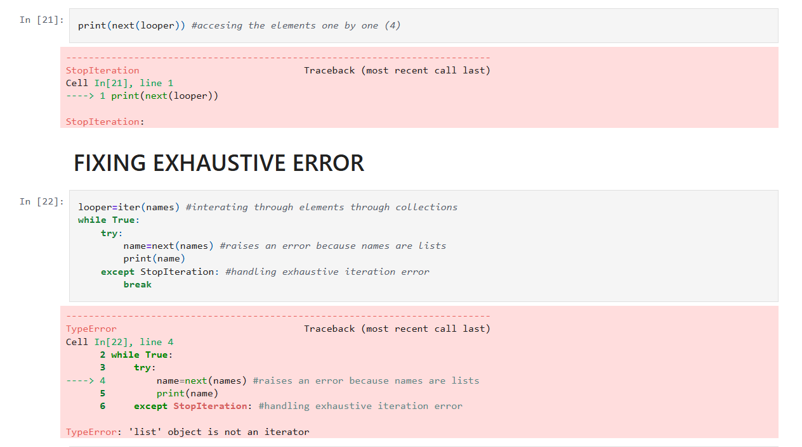

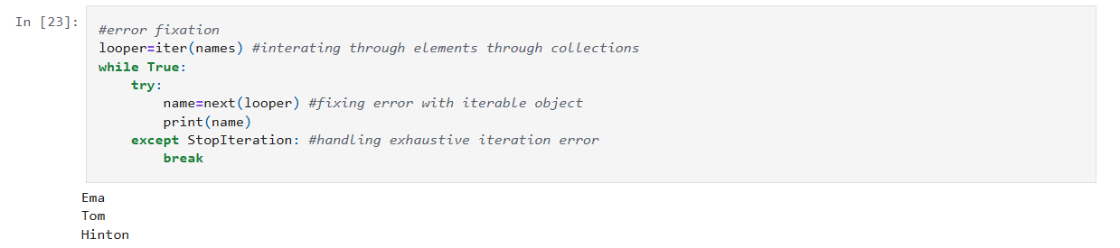

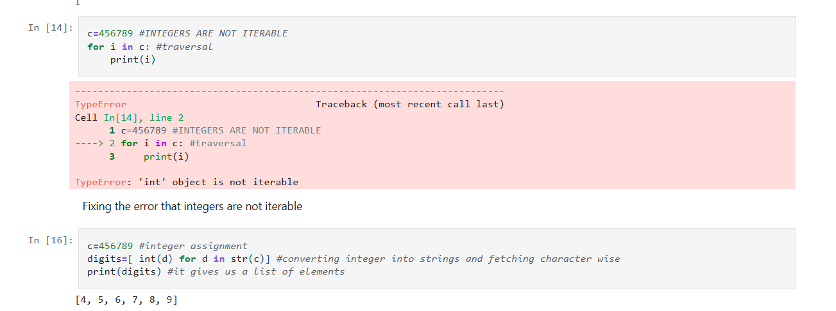

**Errors and their fixation are coded and attached in the pictures**