**G REENA SRI**

**22MID0009**

**Lab 5 - Dictionary - 01.08.2025 - Due 04.08.2025**

**1. Dictionary Logic (6)**

**2. Creating a Dictionary based Database with the storage, specific retrieval logic (3)**

**3.1 Geek for Geeks 30 Interview Questions on Python Dictionary (No submission required for this)**

**3.2 Identify one extra feature from the 30 Interview Questions that you can add your Project (Highlight this in your project through comment)**

**IDEA OF IMPLEMENTATION:** nested dictionaries can be accessed through different levels.

**EG:**

print("\n Appending New Client ")

lawyers["Lawyer 2"]["Client 2"] = ["CaseID108", "2025-08-05", "Family", "Open"]

print(f"Updated Lawyer 2: {lawyers['Lawyer 2']}")

**3.3 Team's Score (screenshot) Geek for Geeks Quiz with Team Details**

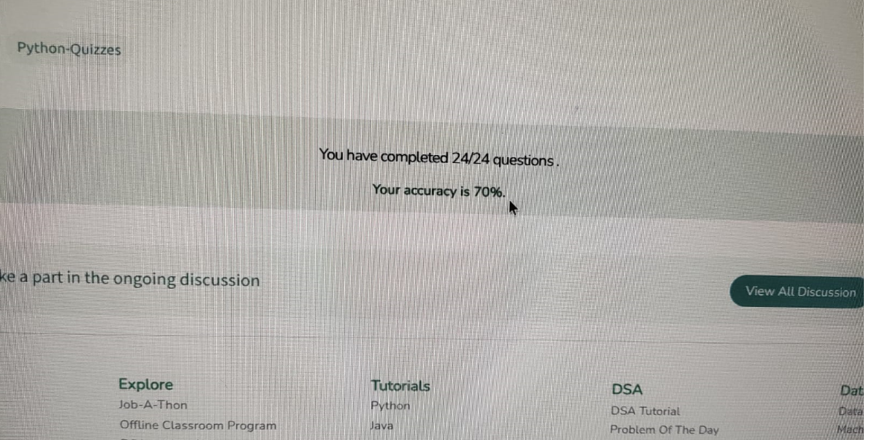

**Team details:**

* G Reena Sri
* Gokulesh
* Dharshan Raj
* Riyas
* Dev nandhan