Reena Sri g (22MID0009)

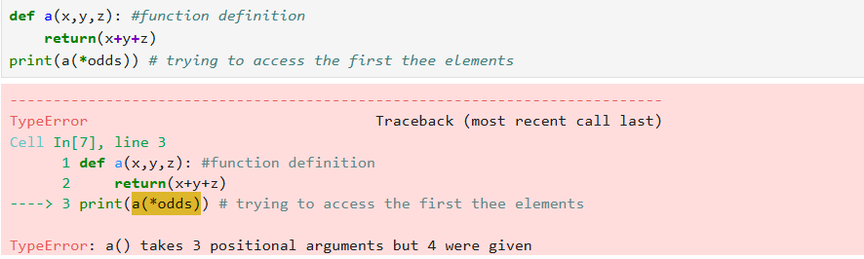

Error 1: length of the lists didn’t match

Fix: length has been changed to 3

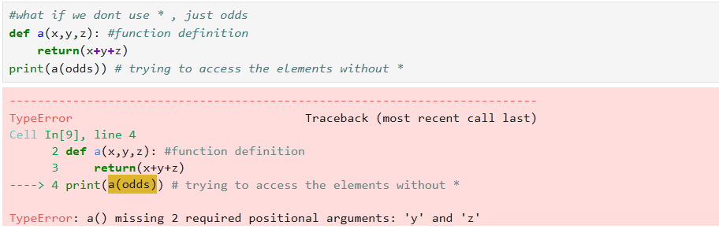

Error 2: sequence unpacking failed, odds has be considered as single argument

Fix : use \*odds to assign respective values

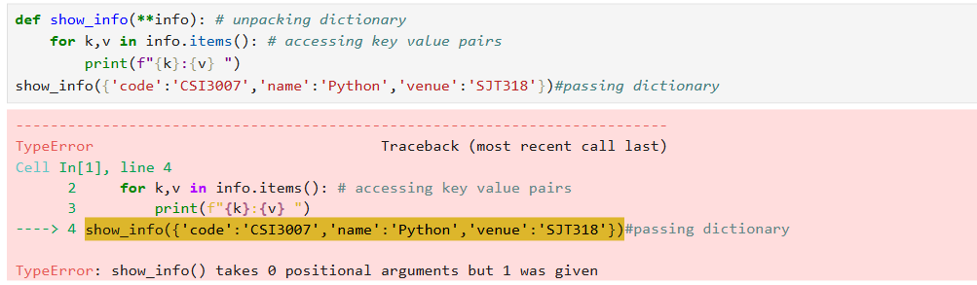

Error 3: trying to pass the whole dictionary

Fix : passing dictionary using sequence unpacking