**CSI3007- Advanced Python Programming(ELA)**

**G.REENA SRI DATE: 11-07-25**

**22MID0009**

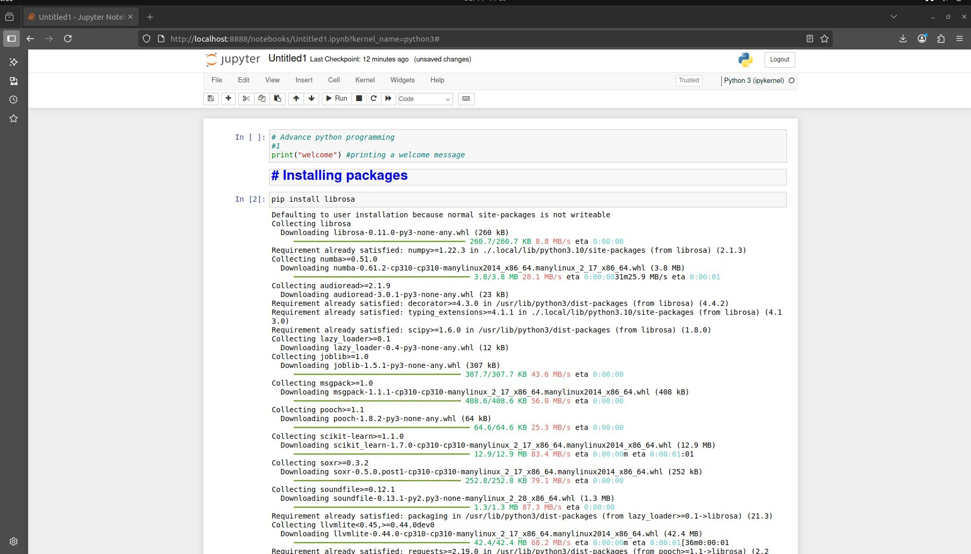

Pic.1

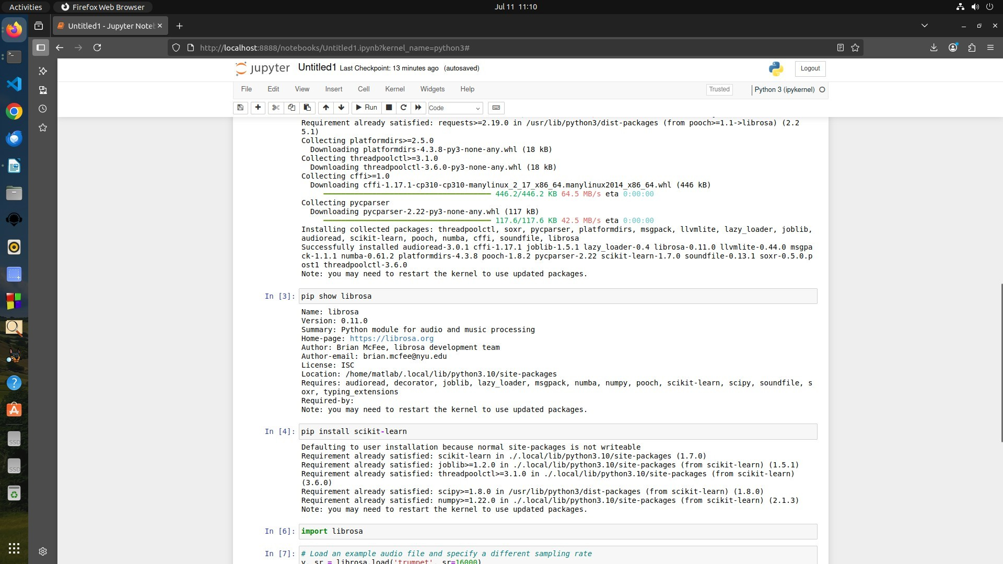

Pic. 2

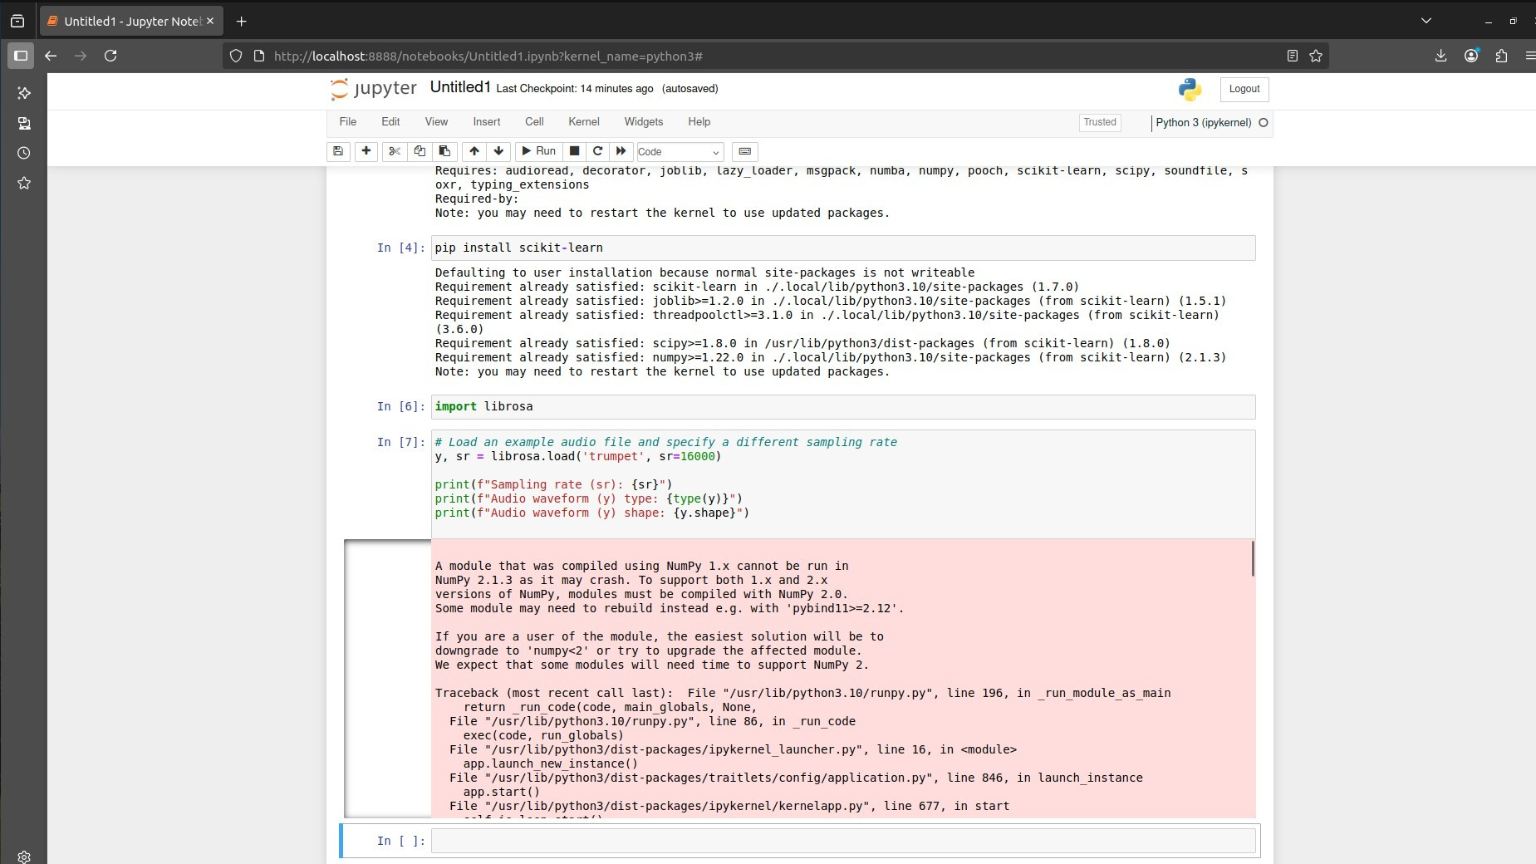

Pic.3

Error 1: Librosa required numpy<2, but the installed version was incompatible.

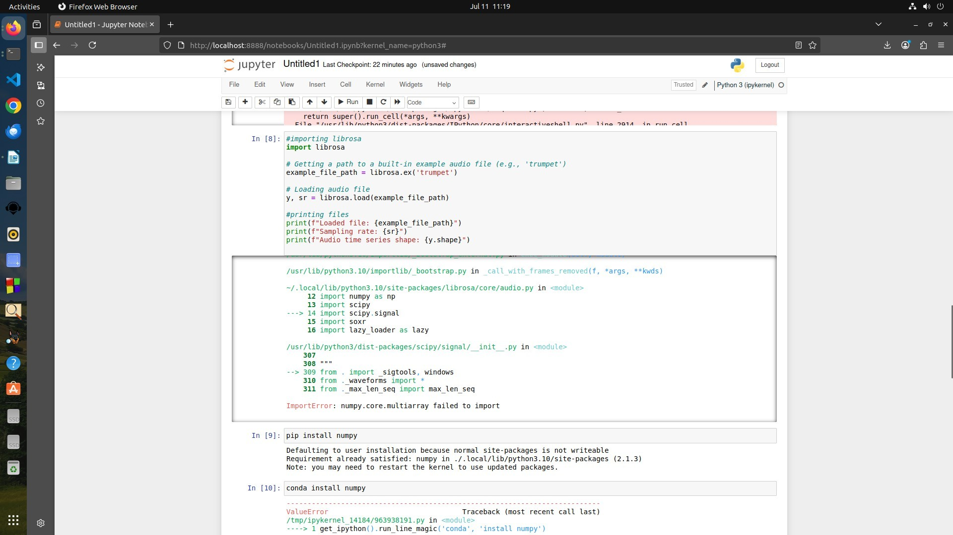

Pic.4

Error 2 : Even after installation, version mismatch persisted due to existing base numpy version.

**Action Taken:**

Attempted to install the compatible version (numpy<2) and update numpy accordingly.

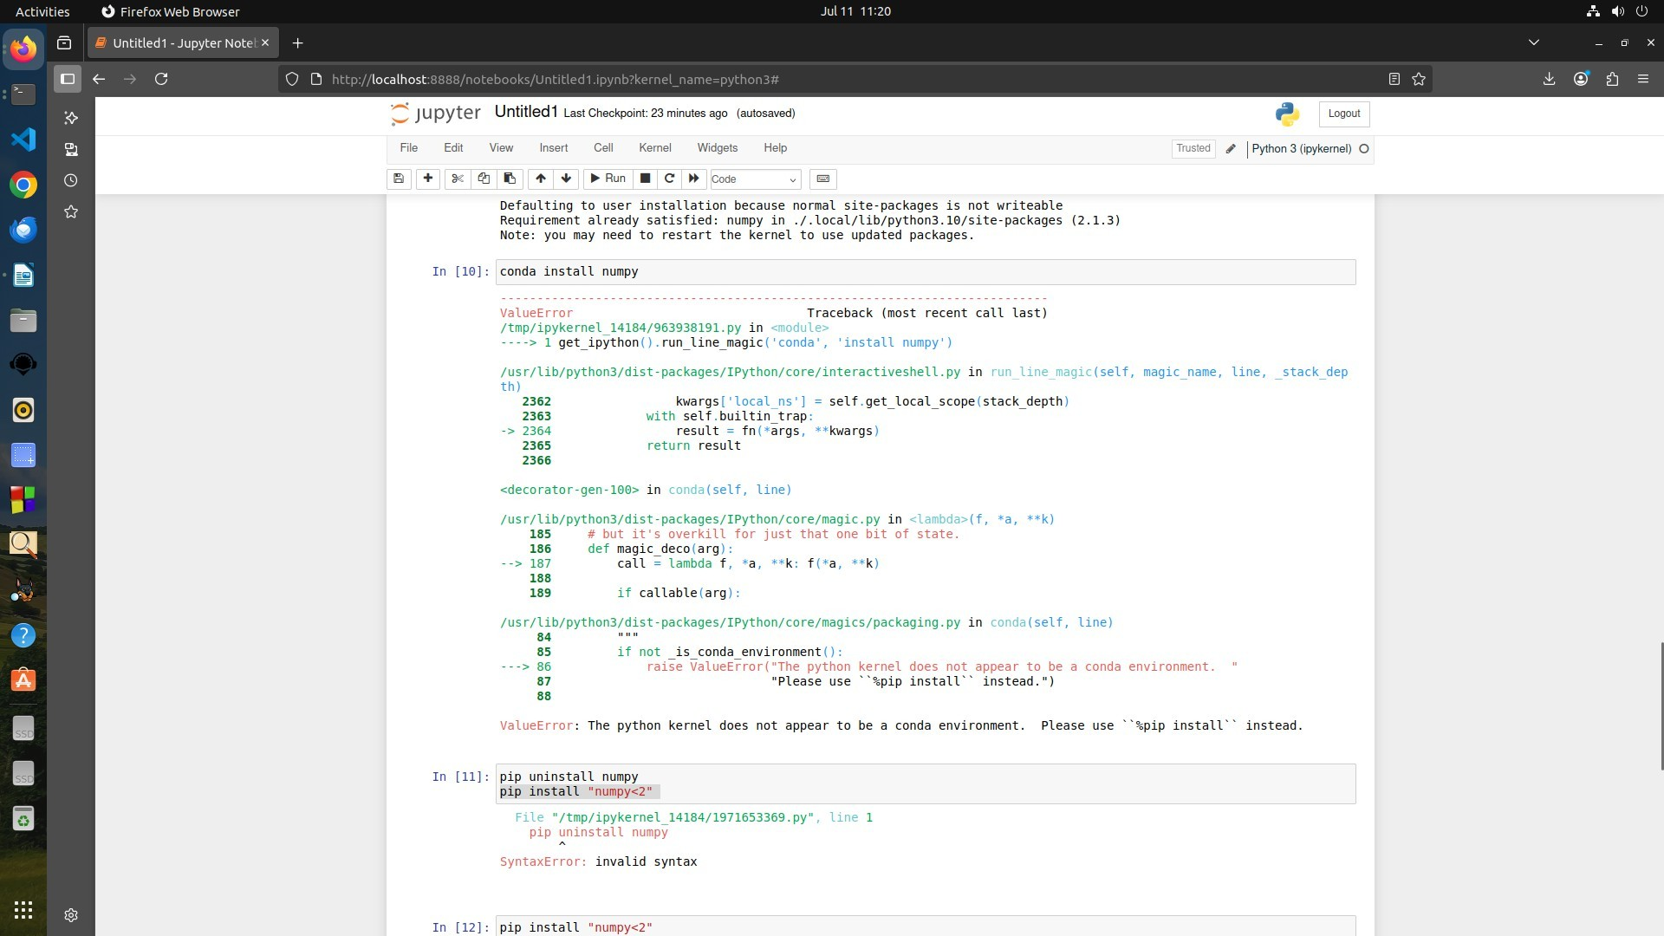

Pic.5

Error 3: Conda commands were ineffective within Jupyter environment; switched to pip-based installation instead.

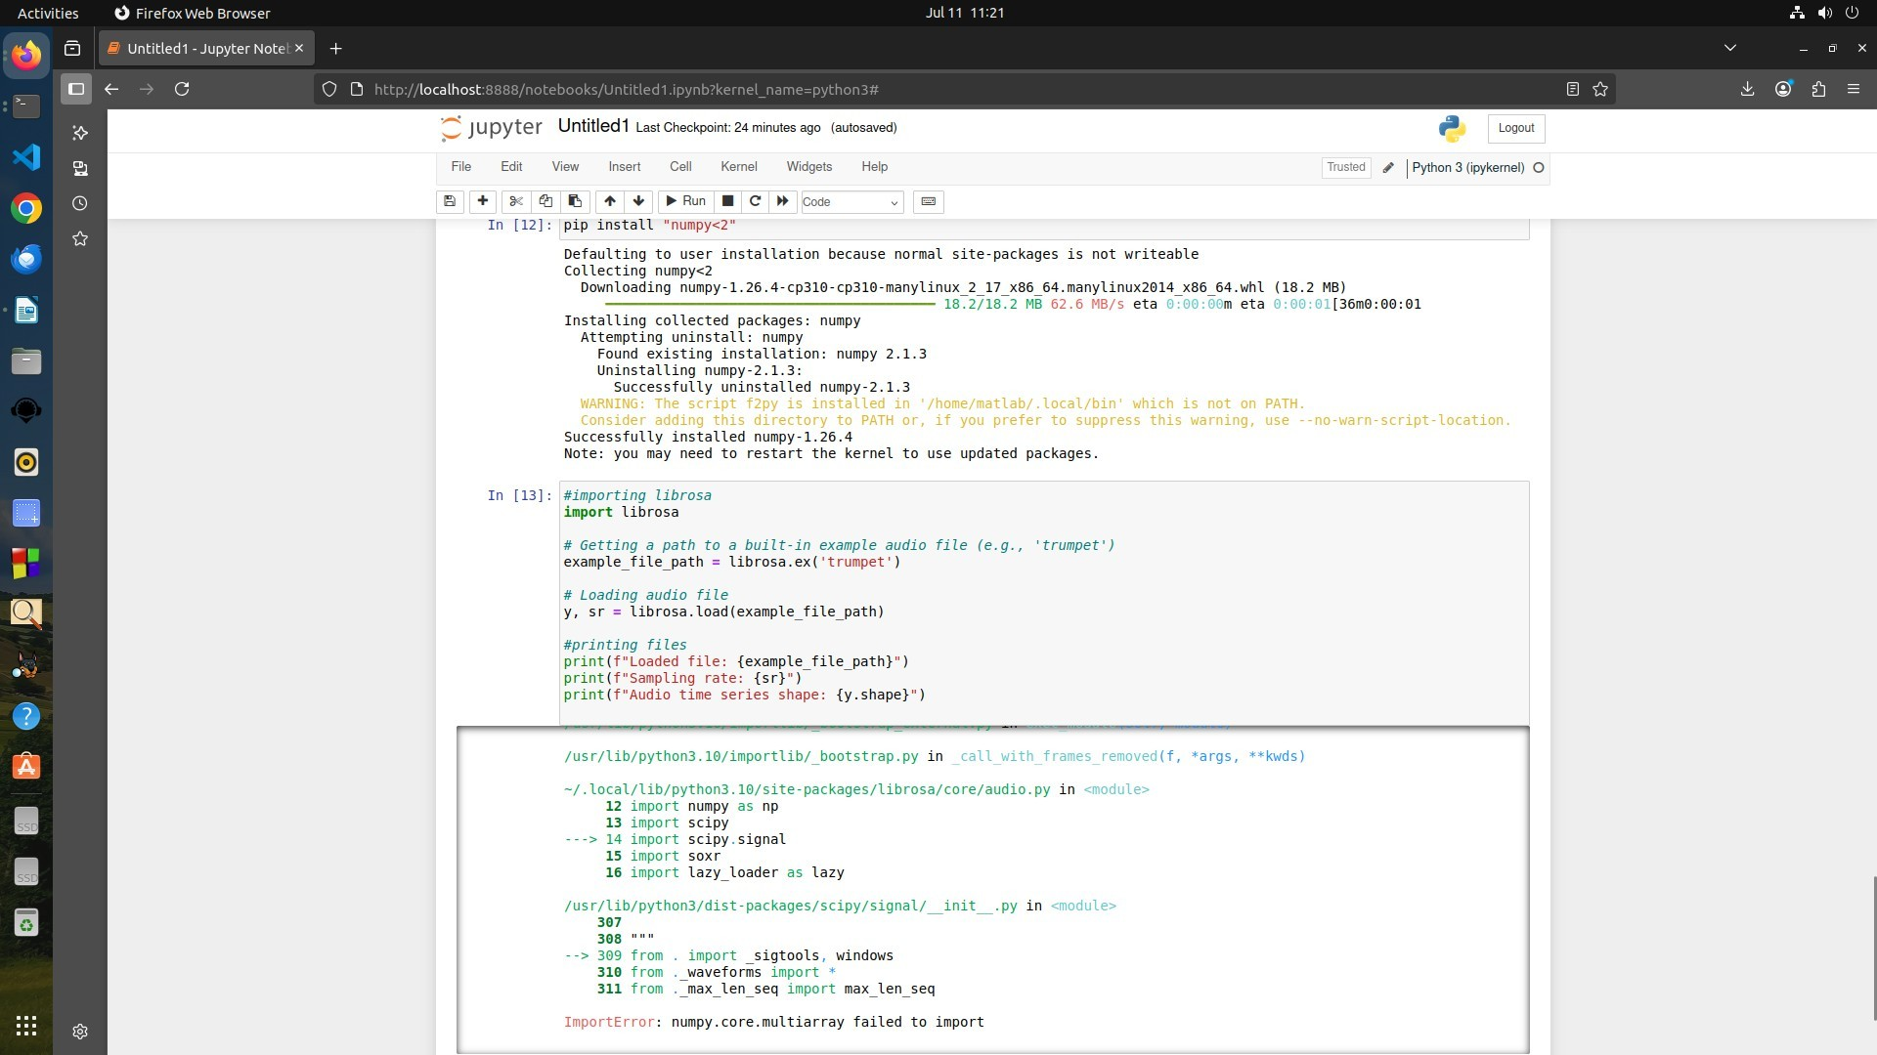

Pic.6

Numpy<2 has been succesfully installed . Uninstallation of base packages is restricted, hence unable to downgrade or replace existing numpy properly.

Error 4: While using librosa.load() with the default argument "trumpet" (as seen in Pic.3), an error was encountered.

Therefore, Replaced with librosa.ex() function to access built-in sample data (Pic.4), but issue remained unresolved.

Since Librosa-related errors couldn’t be fully resolved, shifted focus to Matplotlib.

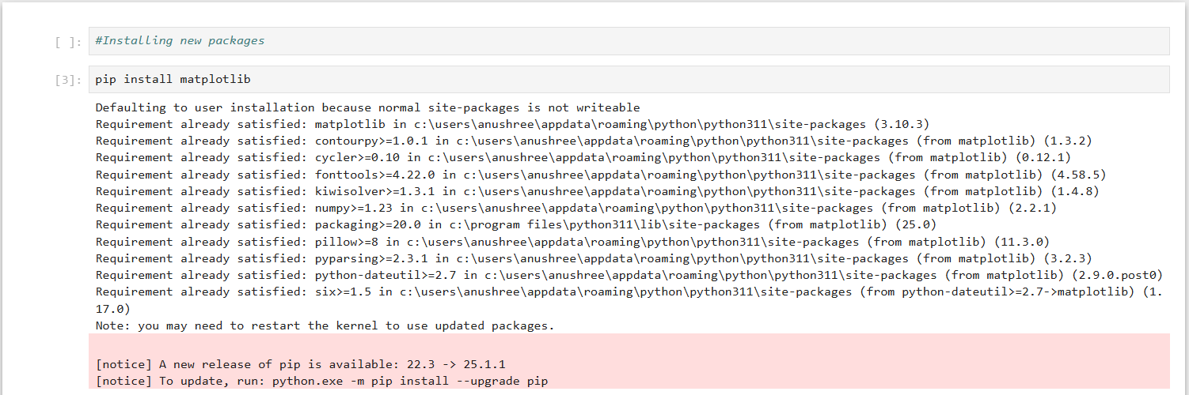

Pic 7

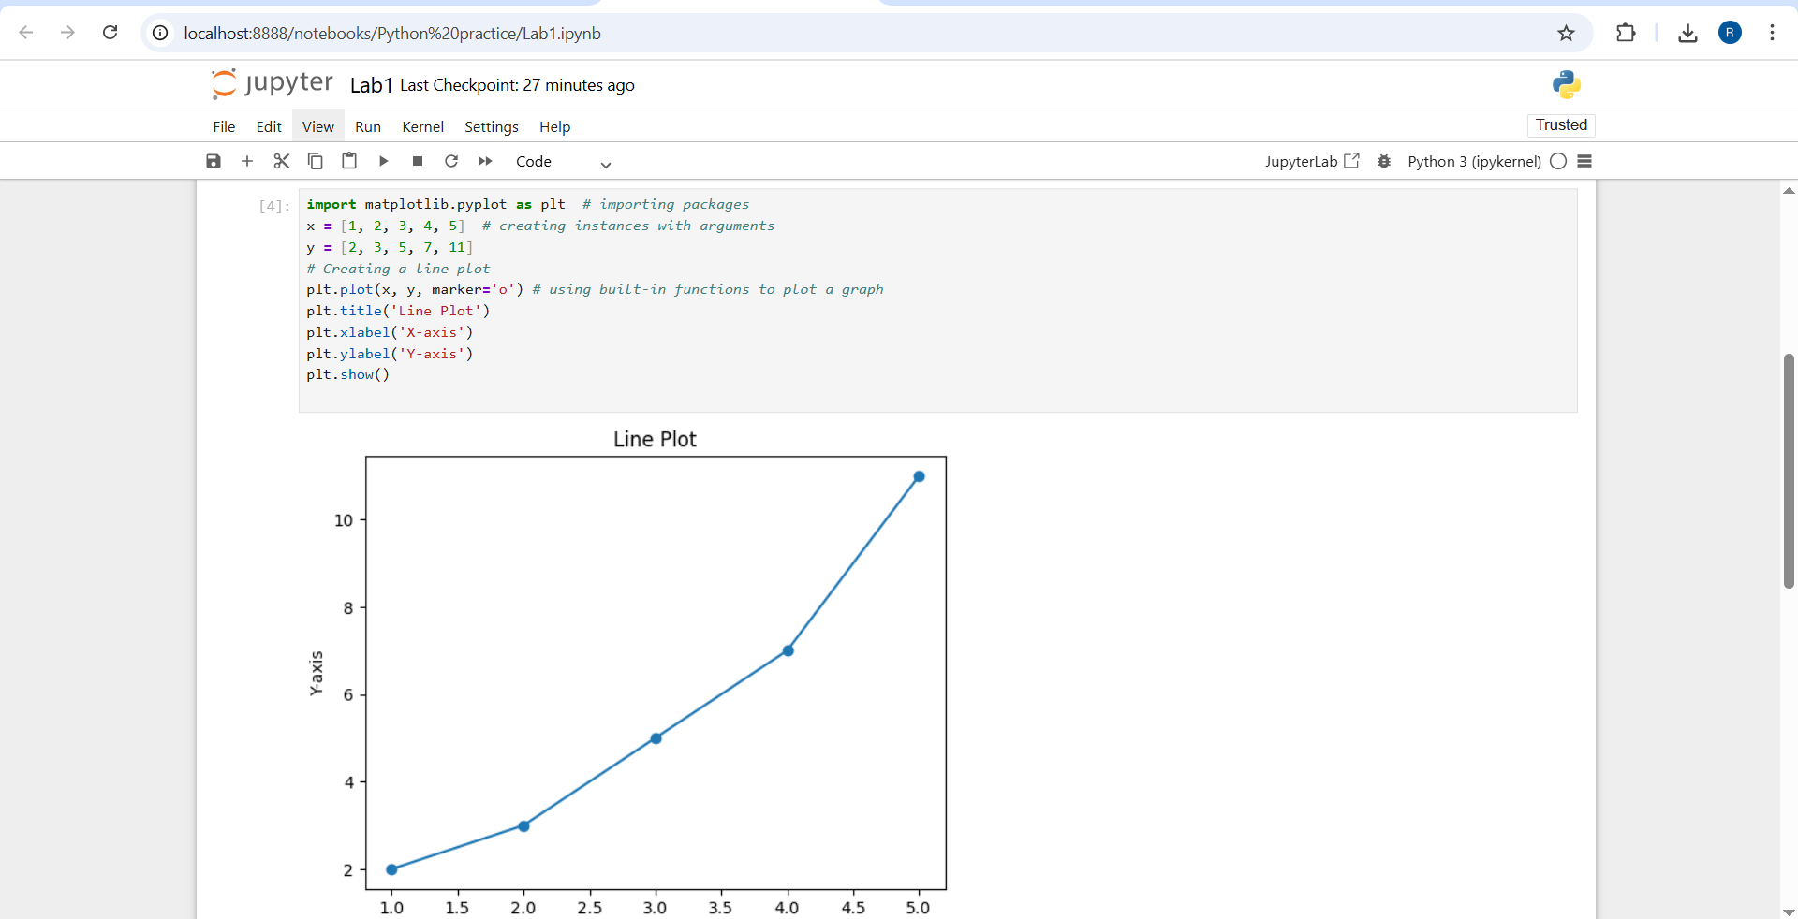

Pic 8

* Verified that Matplotlib was already installed (Pic.7 & Pic.8).
* Imported the package and demonstrated its basic functionalities.
* Created instances using relevant arguments and built-in functions to generate sample plots.

**Summary :**

Matplotlib is a powerful library for static, animated, and interactive visualizations in Python. It supports a wide variety of 2D plots (line, scatter, bar, histogram, pie charts) and allows extensive customization including titles, labels, legends, and colors. It integrates seamlessly with other packages such as NumPy and Pandas for data manipulation and analysis.