**ADVANCE PYTHON PROGRAMMING(ELA)**

**TRAVELLING AGENCY USING LISTS OPERATIONS**

**REENA SRI G 22-07-25**

**22MID0009**

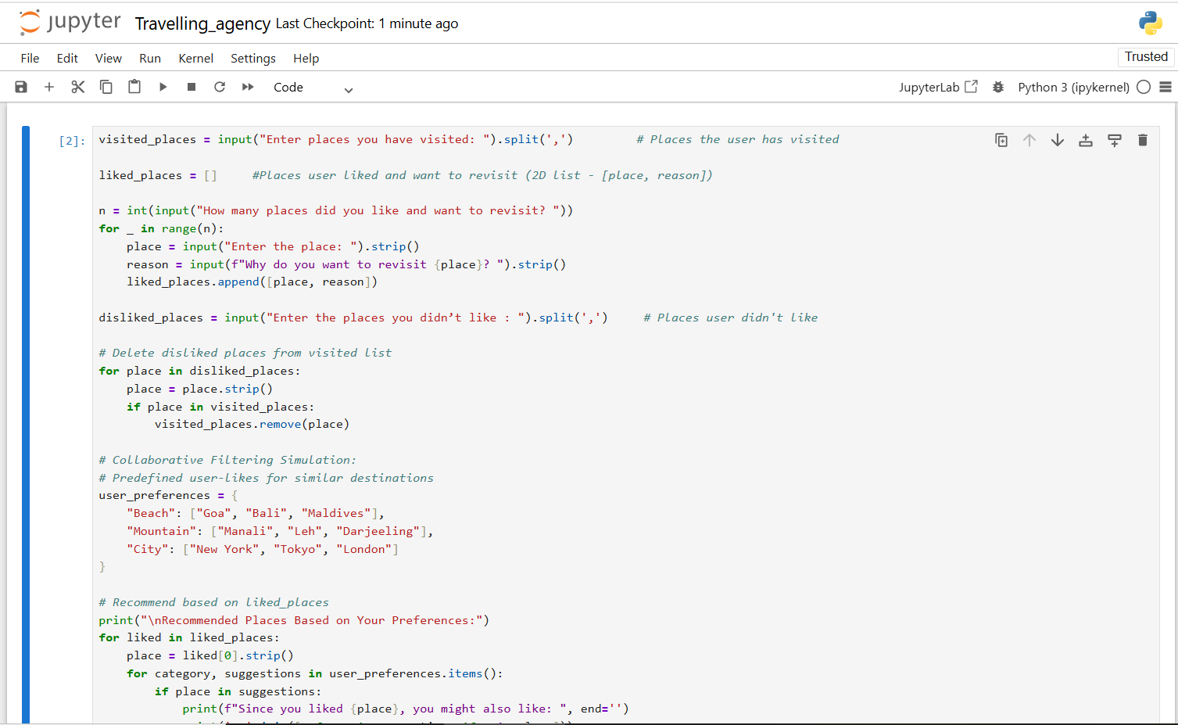

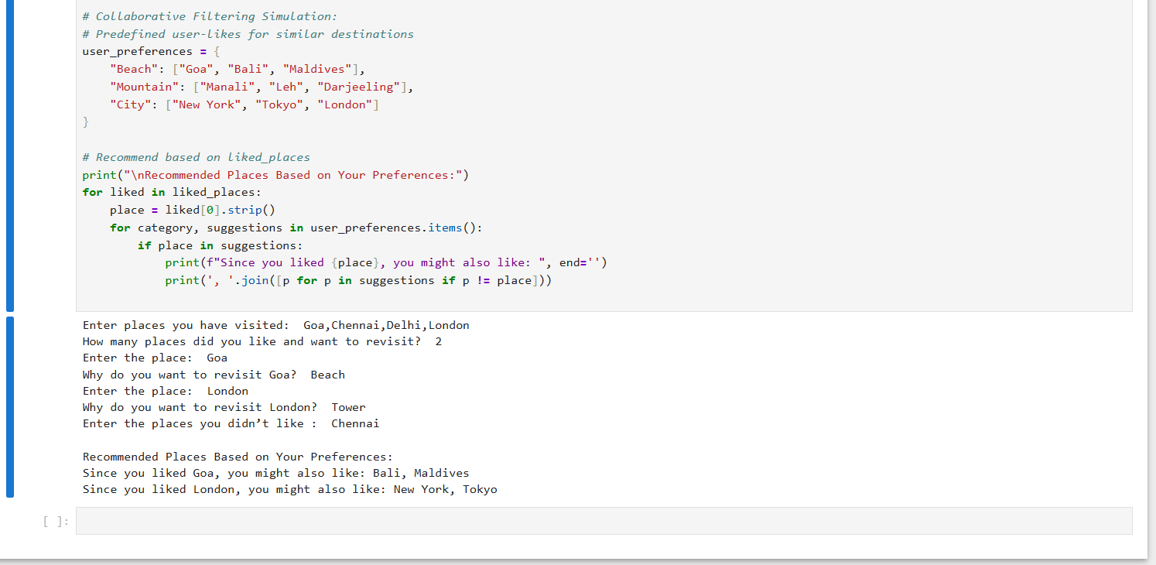

**LIST OPERATIONS USED :**

* **Creating Lists:** visited_places = input(...).split(',')
* **Appending :** liked_places.append([place, reason])
* **Accessing Elements :** liked[0], suggestions[i]
* **Removing Elements :** visited_places.remove(place)
* **2D Lists :** liked_places = [[place, reason]]
* **Membership Testing :** if place in visited_places:
* **Nested Iteration (for 2D) :** for liked in liked_places:
* **String Splitting (list input) :** input().split(',')

**COLLABORATIVE FILTERING USED :** simplified item-based collaborative filtering approach**.**

user_preferences = { "Beach": ["Goa", "Bali", "Maldives"],

"Mountain": ["Manali", "Leh", "Darjeeling"],

"City": ["New York", "Tokyo", "London"] }

**COMPARISION WITH GT HOLIDAYS:**

|  |  |  |
| --- | --- | --- |
| **ASPECT** | **TRAVEL AGENCY** | **GT HOLIDAYS** |
| **Data Source** | **Uses input from a *single user* only (manual list entries).** | **Collects data from *thousands of users*, including bookings, searches, and reviews.** |
| **Type of Collaborative Filtering** | **Uses *basic item-based filtering* with hardcoded categories like "Beach" or "Mountain".** | **Likely uses *user-based filtering* or *hybrid filtering* with advanced algorithms based on similar user behavior.** |
| **Personalization** | **Provides *generalized suggestions* based on one-time input.** | **Offers *dynamic and personalized recommendations* based on your past trips, interests, and travel patterns.** |
| **Feedback & Adaptability** | **No learning or feedback loop; recommendations stay static** | **Continuously adapts based on *user feedback*, reviews, bookings, and seasonal trends.** |
| **Output** | **Print suggestions** | **Shows deals, discounts, trending spots in UI** |