**ADVANCE PYTHON PROGRAMMING**

**REENA SRI G**

**22MID0009**

**LAB(29-07-25)**

**ERRORS:**

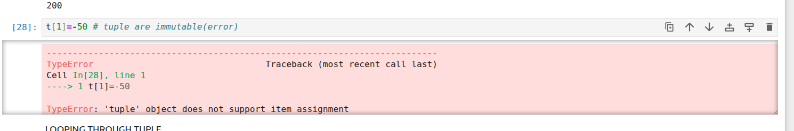

ERROR: TUPLES ARE IMMUTABLE

SOLUTION: RE-ASSIGN THE TUPLE