Assessmenttitle:  **AT1 Project management documentation portfolio**

# Assessment method: Portfolio Unitinformation

Course name: **22603VIC Certificate IV in Cyber Security**

Unit[s] of competency: **VU23220 Develop and carry out a cyber security industry project**

# Assessment information for student

Task number: **1** Of **3**

Due date: Click or tap to enter a date. If date in Gordon Online, check box: ☒

Where assessment will take place: in classroom

Time available to complete this assessment: 9 weeks

If Questioning, state number of questions: N/A

# Requirements of this assessment task

The following documents should be included in the project management documentation portfolio. Use the document templates provided. Zip all the documents and include the assessment coversheet.

Please refer to our GitHub repository for all the attachments and documentation.

**Github repository**  [2024CyberProject](https://github.com/Reenhaider/2024CyberProject).

1. Attach project scope document including: business problem definition and clarification questions; a list of team members identifying the team leader.

Refer :[**Attachment 1**](https://github.com/Reenhaider/2024CyberProject/blob/main/ProjectManagement/README.md)

1. Attach dated Trello screenshots and a link to Trello board

<https://trello.com/b/WAbXQ07O/cyber-project>

10:09 25/6/2024

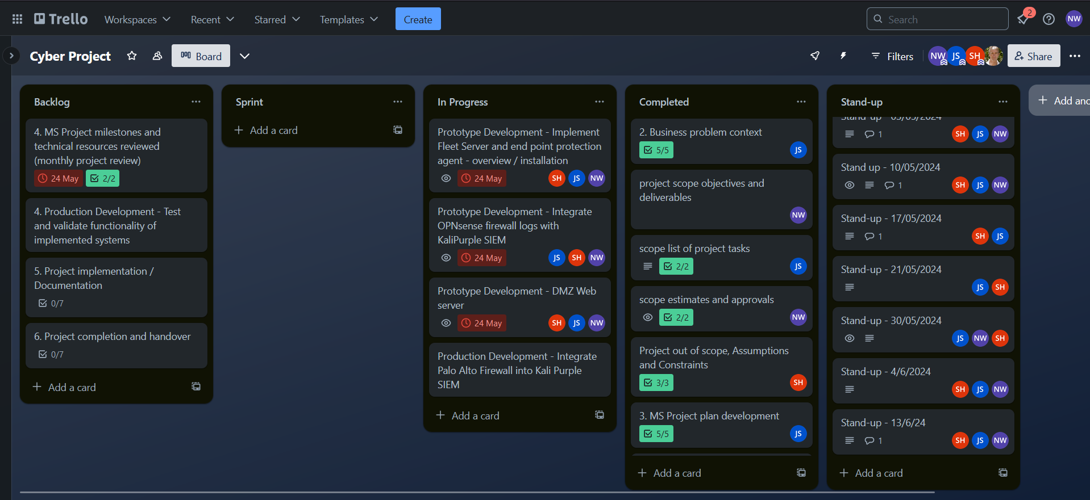

1. Attach weekly stand-up meeting minutes

Our weekly meeting minutes are on the trello (<https://trello.com/b/WAbXQ07O/cyber-project>).

Here are a couple examples of our meetings.

**10/05/2024**

**everyone**

* completed Configure kali Purple - for remote management - ssh, rdp, console
* completed Set up configure and interconnect Virtual environment, firewall , servers and client

**individual progress:**

‌

**Nicholas**

What you’re working on

* 4.1 Install Elasticsearch

Any blockers

* trouble with kibarna and elastic (resolved)

Next Steps

* try to get to 5.0 Implement Fleet Server and end point protection agent - overview / installation

‌

**Shehreen**

What you’re working on

* project documentation

Any blockers

* trouble with kibana and elastic (resolved)

Next Steps

* working on the project document

‌

**Jarna**

What you’re working on

* fleet installation

Any blockers

* PC didn't have enough ram to run virtual machines

Next Steps

* completing fleet installation and setup

**30/05/2024**

**Everyone:**

* Review product backlog and re prioritise, add tasks etc.
* Review task due dates

**Nick**

* Completed prototype to SEIM integration with client and server
* Completing DMZ Production

**Shehreen**

* Completing DMZ Production
* Shared learning and investigation

**Jarna**

* Completing DMZ Production
* Shared workload to achieve our progress

**Actions**

* Preparation for testing
* Preparation for presentation
* Documentation and procedures

1. Attach Monthly project reports to milestones including risk management strategy

Each attach when uploading your submission : Refer: [**Attachment 2**](https://github.com/Reenhaider/2024CyberProject/tree/main/ProjectManagement/Monthly%20project%20progress%20reports)

1. Attach project closing (monthly) report : Refer: [**Attachment 3**](https://github.com/Reenhaider/2024CyberProject/tree/main/ProjectManagement/Monthly%20project%20progress%20reports)
2. Attach MS-Project file inclusive of the following: Refer: [**Attachment 4**](https://github.com/Reenhaider/2024CyberProject/blob/main/ProjectManagement/MsProject%20File.docx)
   1. WBS for all project tasks with predecessors
   2. Working time for each task
   3. Gant Chart
   4. Milestones / dates
   5. Resources allocated to tasks
   6. Costs
   7. Baseline
   8. WBS includes end user training