COVID-19 India Analysis and Risk Assessment Using EDA and Feature Engineering

Abstract
The COVID-19 pandemic had a significant impact on India, affecting millions of people across different states and union territories. This project aims to analyze COVID-19 cases, testing statistics, and vaccination progress using Exploratory Data Analysis (EDA) and Feature Engineering techniques. Three datasets were used: COVID-19 India case data, state-wise vaccination data, and state-wise testing data. Various statistical and visualization techniques were applied to identify trends, state-wise differences, growth patterns, and risk levels. A custom COVID Risk Score and K-Means clustering approach were developed to classify states into different risk categories.

1. Introduction
COVID-19 emerged as a global pandemic and posed major challenges to public health systems worldwide. India experienced multiple waves of infection with significant variations across states. Data analytics can help identify patterns in disease spread, recovery, mortality, testing efficiency, and vaccination effectiveness.
The objective of this project is to perform comprehensive Exploratory Data Analysis (EDA), generate meaningful features, and identify high-risk and low-risk states using data-driven approaches.

2. Objectives
- Analyze COVID-19 trends across Indian states.
- Study confirmed cases, recoveries, and deaths.
- Examine testing and vaccination statistics.
- Identify states with better recovery performance.
- Analyze growth patterns during Wave 1 and Wave 2.
- Develop new features for deeper insights.
- Create a COVID Risk Score.
- Cluster states into risk categories using machine learning.

3. Datasets Used
Dataset 1: COVID-19 India
Attributes:
- Date
- State/Union Territory
- Confirmed Cases
- Cured Cases
- Deaths

Dataset 2: COVID Vaccination State-wise
Attributes:
- State
- Total Doses Administered
- First Dose Administered
- Second Dose Administered

Dataset 3: State-wise Testing Details
Attributes:
- State
- Total Samples Tested
- Positive Cases
- Negative Cases

4. Data Preprocessing
The following preprocessing steps were performed:
Date Conversion
Date columns were converted into datetime format for time-series analysis.
Missing Value Handling
Missing numerical values were replaced using suitable methods such as zero imputation.
State Name Standardization
Inconsistent state names such as:
- Telengana → Telangana
- Karanataka → Karnataka
- Himanchal Pradesh → Himachal Pradesh
were corrected.
Removal of Invalid Categories
The following categories were removed:
- Unassigned
- Cases being reassigned to states

5. Exploratory Data Analysis
Univariate Analysis
The distribution of confirmed cases showed a highly right-skewed pattern, indicating that a small number of states contributed a large proportion of total cases.
Deaths also exhibited significant outliers, suggesting large variations in mortality across states.
Vaccination distributions indicated unequal vaccine administration among states.
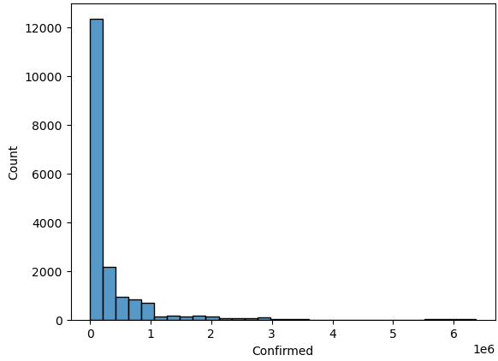
Bivariate Analysis
Confirmed cases showed a strong positive relationship with deaths and recoveries.
Testing data revealed that states conducting more tests generally identified more positive cases.
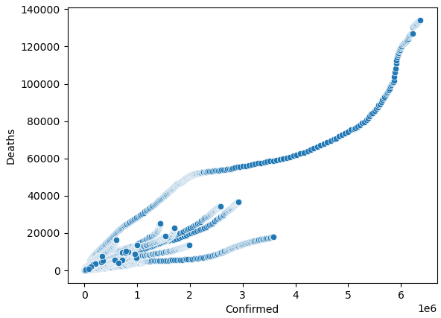
Time-Series Analysis
National trends showed two major infection waves:
- Wave 1 (2020)
- Wave 2 (2021)
The second wave displayed a much sharper rise in cases and deaths compared to the first wave.
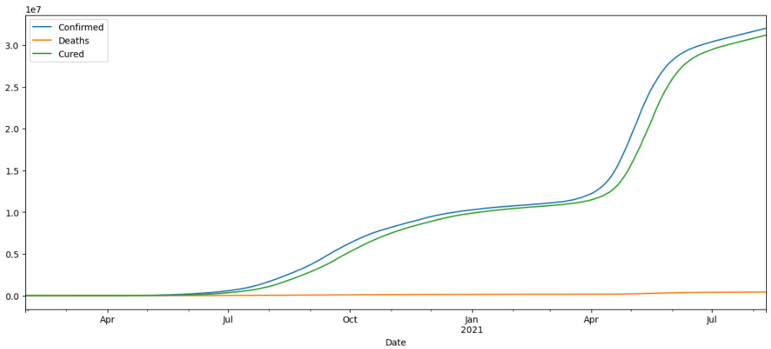
State-wise Analysis
Top states were identified based on:
- Confirmed Cases
- Deaths
- Recovery Rates
- Death Rates
This highlighted significant regional differences in pandemic impact.
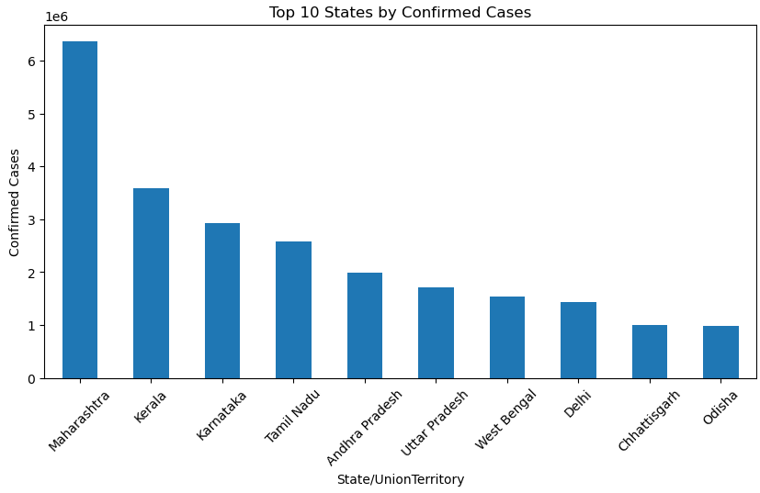

6. Feature Engineering
Several new features were created:
Active Cases
Active Cases = Confirmed − Cured − Deaths
Recovery Rate
Recovery Rate = (Cured / Confirmed) × 100
Death Rate
Death Rate = (Deaths / Confirmed) × 100
Positivity Rate
Positivity Rate = (Positive Cases / Total Samples Tested) × 100
Active Case Ratio
Active Case Ratio = (Active Cases / Confirmed Cases) × 100
Daily New Cases
Calculated using differences in cumulative confirmed cases.
Daily New Deaths
Calculated using differences in cumulative death counts.
Daily Recoveries
Calculated using differences in cumulative recovery counts.

7. Growth Rate Analysis
Growth Rate Analysis was performed to identify states that experienced the fastest increase in COVID-19 cases.
Wave 1 Analysis
States such as Maharashtra and Karnataka showed high average daily increases in confirmed cases.
Wave 2 Analysis
Wave 2 displayed significantly larger daily increases, indicating more aggressive disease spread compared to Wave 1.
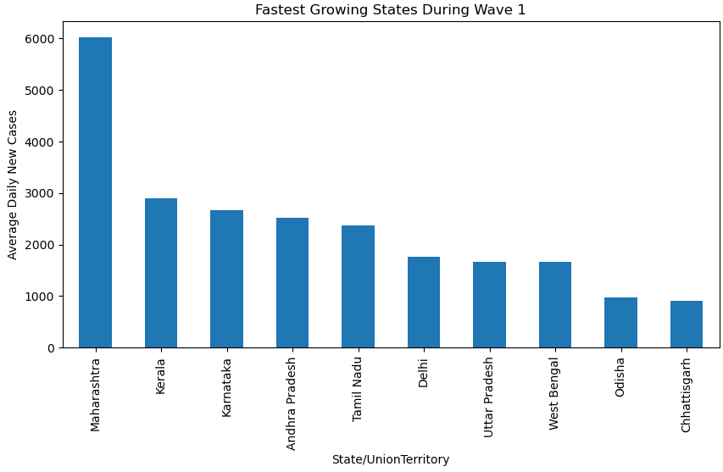
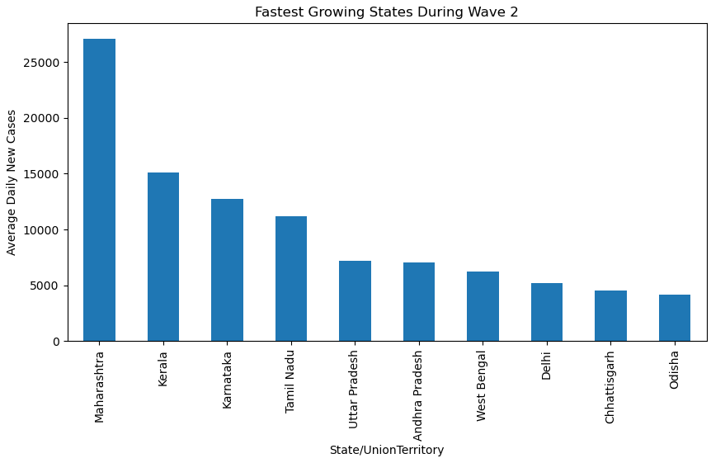

8. COVID Risk Score Development
A custom risk metric was developed:
Risk Score = (Death Rate × 0.5) + (Active Case Ratio × 0.3) + (Positivity Rate × 0.2)
This metric incorporates:
- Mortality impact
- Current active burden
- Testing effectiveness
States were ranked based on their Risk Score.
Higher scores indicate greater COVID-related risk.
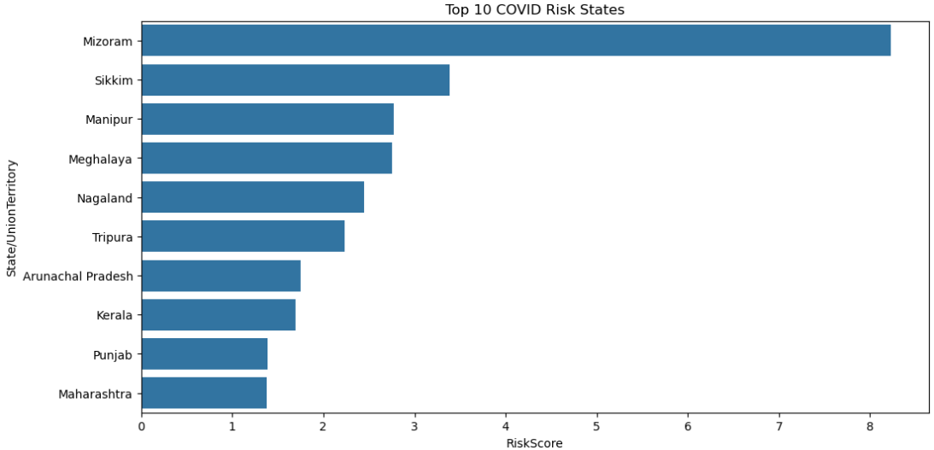
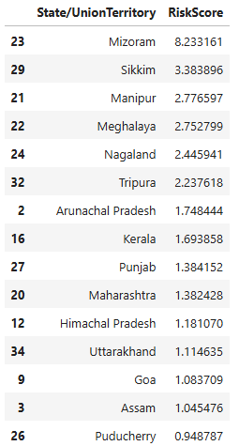

9. State Clustering Using K-Means
K-Means clustering was applied using:
- Confirmed Cases
- Deaths
- Recovery Rate
- Death Rate
States were classified into:
- High Risk
- Moderate Risk
- Low Risk
This approach helped identify groups of states with similar COVID characteristics.
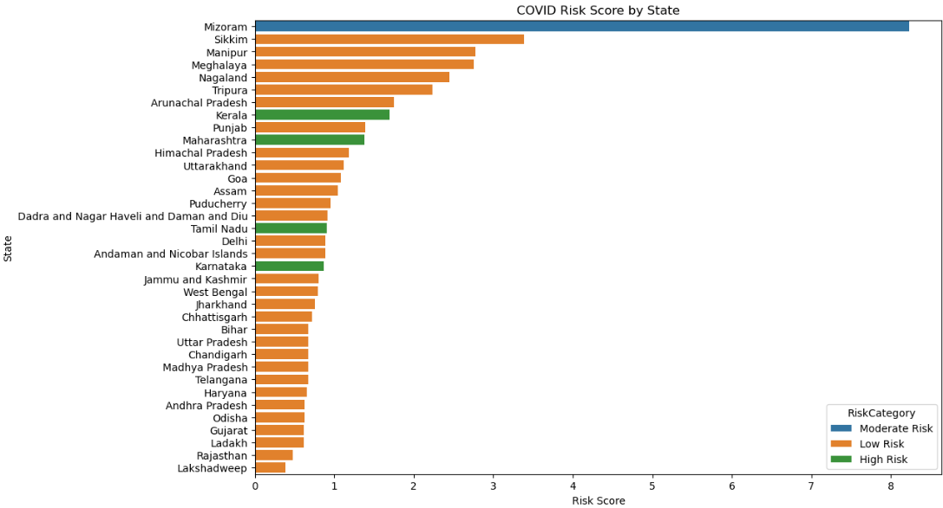

10. Key Findings
- COVID spread was highly concentrated in a few states.
- Recovery rates improved significantly over time.
- Wave 2 was considerably more severe than Wave 1.
- Testing levels strongly influenced positive case detection.
- States differed substantially in mortality and recovery performance.
- The custom Risk Score successfully identified vulnerable states.
- Clustering revealed distinct risk categories among Indian states.

11. Conclusion
This project demonstrated how Exploratory Data Analysis and Feature Engineering can be used to understand pandemic trends and regional variations in disease impact. By combining COVID case data, testing statistics, and vaccination records, meaningful insights were generated regarding disease spread, recovery patterns, mortality rates, and risk assessment. The custom COVID Risk Score and clustering approach provided a comprehensive framework for evaluating state-level pandemic risk.

12. Future Scope
- Predict future COVID cases using Machine Learning models.
- Forecast infection trends using Time Series models.
- Build interactive dashboards using Power BI or Tableau.
- Incorporate demographic and healthcare infrastructure data for improved risk assessment.

