IPL PERFORMANCE ANALYSIS

Executive Summary
This IPL analysis explored match-level and ball-by-ball data spanning 17 seasons (2008–2024). The objective was to identify trends in team performance, batting success, toss decisions, venue influence, and death-over scoring patterns.
The analysis reveals that batting has become increasingly aggressive over the years, with average runs per match rising from approximately 309 runs in the inaugural season to nearly 366 runs in 2024. Teams choosing to field first after winning the toss achieved a higher match-winning percentage than teams choosing to bat first, suggesting a strategic advantage while chasing targets.
Among individual performers, Virat Kohli emerged as the highest run-scorer in IPL history with more than 8,000 runs. At the team level, Mumbai Indians, Chennai Super Kings, and Kolkata Knight Riders consistently demonstrated strong performances across seasons. Death-over analysis showed that Chennai Super Kings and Mumbai Indians were among the most effective teams in maximizing runs during the final overs.
Overall, the findings highlight the growing importance of aggressive batting, tactical toss decisions, and efficient death-over execution in achieving success in the IPL.

17  Seasons Analyzed | 8,014  Kohli's Career Runs | 53.55%  Win Rate Fielding First | 309 → 366  Avg. Runs/Match Growth | CSK / MI  Death-Over Leaders

Key Insights

1. Virat Kohli is the Leading Run Scorer in IPL History
Virat Kohli scored 8,014 runs, making him the highest run-scorer across all IPL seasons analyzed. His consistency over multiple seasons demonstrates exceptional longevity and batting performance.
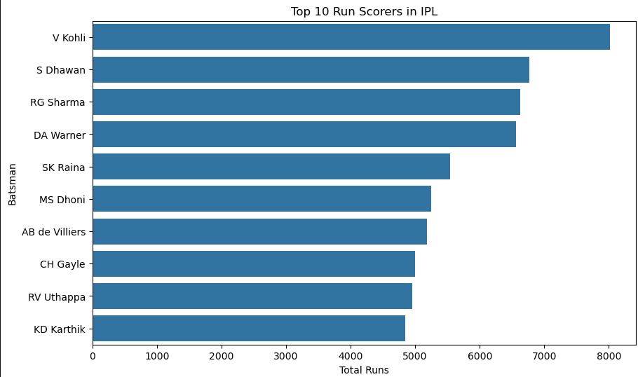

2. Fielding First Provides a Higher Winning Probability
Teams that chose to field first after winning the toss won approximately 53.55% of matches, compared to 45.27% for teams choosing to bat first.
This suggests that chasing targets often provides a strategic advantage, allowing teams to adapt their batting approach based on the required score.
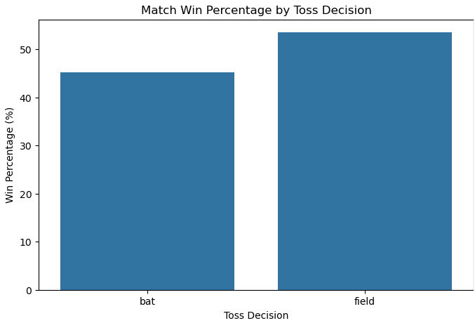

3. IPL Has Become Significantly More High-Scoring
Average runs per match increased from around 309 runs in the early seasons to approximately 366 runs in 2024.
The upward trend indicates increasingly aggressive batting strategies, improved power-hitting capabilities, and batting-friendly playing conditions.
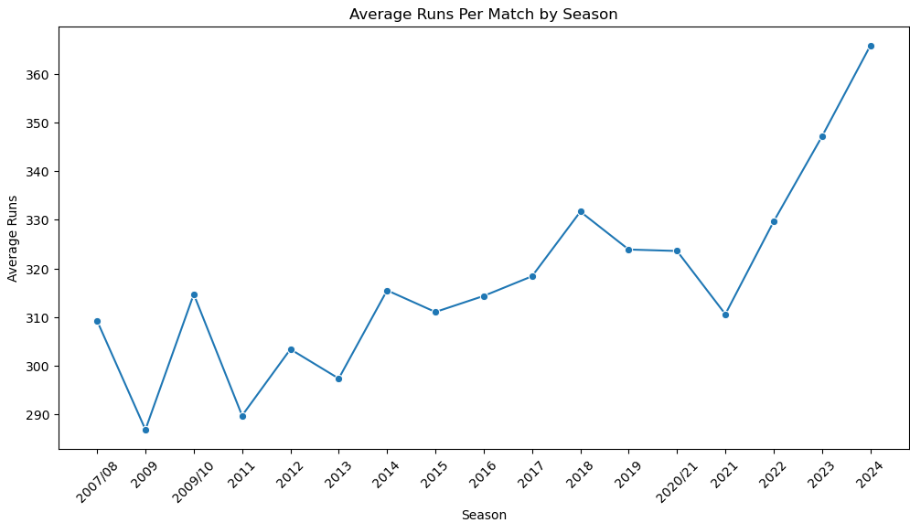

4. Mumbai Indians Have Been One of the Most Dominant Franchises
Mumbai Indians achieved the highest seasonal win percentage multiple times (2009/10, 2013, 2017, 2019, and 2020/21).
Their consistent presence among the top-performing teams demonstrates strong squad management and adaptability across different IPL eras.

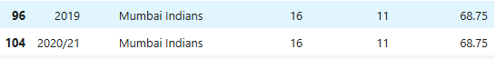

5. Chennai Super Kings and Mumbai Indians Excel in Death Overs
Death-over analysis revealed that Chennai Super Kings and Mumbai Indians maintained the highest median runs scored during overs 16–20.
This indicates strong finishing ability and effective utilization of power hitters during the most crucial phase of an innings.
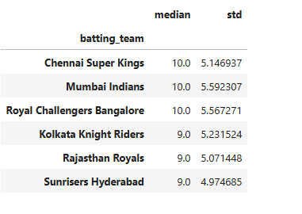

Strongest Findings Summary
The table below consolidates the five most statistically significant findings from this analysis.

# | Finding | Key Figure | Category
1 | Virat Kohli is the all-time highest run scorer in IPL history | 8,014 runs | Individual Batting
2 | Fielding first after winning the toss yields a higher win rate | 53.55% vs 45.27% | Toss Strategy
3 | Average runs per match rose substantially across seasons | 309 → 366 runs | Scoring Trend
4 | Mumbai Indians repeatedly posted the highest seasonal win % | 5 seasons led | Team Dominance
5 | CSK and MI are the strongest death-over (16–20) batting teams | Highest median runs | Death-Over Execution

Recommendation for Team Strategy
Based on the analysis, IPL teams should prefer to field first after winning the toss whenever pitch and weather conditions are favorable.
The data shows that teams choosing to field first achieved a higher match-winning percentage than teams choosing to bat first. Chasing allows teams to adjust their scoring rate according to the target and make more informed tactical decisions throughout the innings.
Additionally, teams should invest in specialist finishers capable of accelerating scoring during overs 16–20. Death-over performance emerged as a key differentiator between successful and average teams. Strong finishing can significantly increase the probability of winning close matches.

- Prefer fielding first after winning the toss when conditions allow it.
- Build squads around proven death-over finishers (overs 16–20).
- Continue to prioritize aggressive, power-hitting batting depth given the league-wide scoring trend.
- Use historical toss and venue data as inputs to pre-match tactical planning.

Self-Reflection
One limitation of the dataset is the lack of contextual information such as player fitness, pitch conditions, weather, and player roles. While the dataset captures ball-by-ball events and match outcomes, it does not explain why certain performances occurred.
Additional information that would enhance the analysis includes:
- Pitch characteristics (batting-friendly, spin-friendly, pace-friendly)
- Weather conditions during matches
- Player fitness and injury records
- Batting position and player role information
- Detailed field placement and bowling strategy data
Incorporating these variables would enable deeper predictive analysis and provide a more comprehensive understanding of factors influencing IPL match outcomes.

