Mini Project 4: Exploratory Data Analysis (EDA) on Netflix Dataset

1. Introduction
Exploratory Data Analysis (EDA) is an essential step in the data analysis process that helps in understanding the characteristics of a dataset before applying machine learning or statistical models. It involves summarizing the main features of the data using statistical methods and visualizations to identify patterns, trends, relationships, missing values, and outliers.
In this project, the Netflix dataset is analyzed to understand the platform's content distribution based on content type, country, release year, ratings, genres, and duration. Feature engineering and multivariate analysis are also performed to generate meaningful business insights.

2. Objective
The objectives of this project are:
- To understand the structure of the Netflix dataset.
- To clean and preprocess the data.
- To perform exploratory data analysis using statistical techniques and visualizations.
- To analyze trends in Netflix content over time.
- To identify popular genres, ratings, and countries.
- To detect outliers using statistical methods.
- To create new features through feature engineering.
- To generate business insights based on the analysis.

3. Dataset Description
The dataset contains information about movies and TV shows available on Netflix.
Dataset Summary
Attribute | Value
Number of Records | 7,787
Number of Features | 12
Content Types | Movies and TV Shows
Numerical Features | Release Year, Duration
Categorical Features | Type, Country, Rating, Genres, Director, Cast
Dataset Columns
- Show ID
- Type
- Title
- Director
- Cast
- Country
- Date Added
- Release Year
- Rating
- Duration
- Genres
- Description

4. Dataset Understanding
The dataset was explored using the following functions:
- head()
- info()
- describe()
- describe(include='object')
- shape
- columns
- isnull()
- duplicated()

Findings
- Total records: 7787
- Total columns: 12
- Missing values were present in Director, Cast, Country, Date Added, and Rating.
- Both numerical and categorical variables were available for analysis.

5. Task 2: Data Cleaning
The following preprocessing steps were performed:
- Created a copy of the dataset.
- Filled missing values in categorical columns.
- Filled missing ratings using the mode.
- Filled missing dates using the mode.
- Converted the Date Added column into datetime format.
- Removed duplicate records.
- Standardized text fields.
- Created additional date-related features.
Result
The dataset became clean, consistent, and ready for analysis.

6. Content Type Analysis
Results
Content Type | Count
Movies | 5377
TV Shows | 2410
Observation
Movies constitute approximately 69% of the Netflix library, while TV Shows account for 31%.
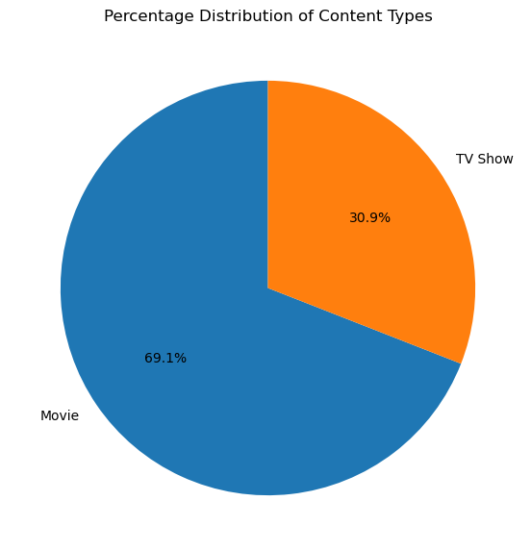
Interpretation
Netflix focuses more heavily on Movies than TV Shows, indicating a strategy of maintaining a larger movie catalog.

7. Country Analysis
Top Content Producing Countries

Country | Titles
United States | 2883
India | 956
United Kingdom | 577
Canada | 259
Japan | 237
France | 196
South Korea | 194
Spain | 168
Mexico | 123

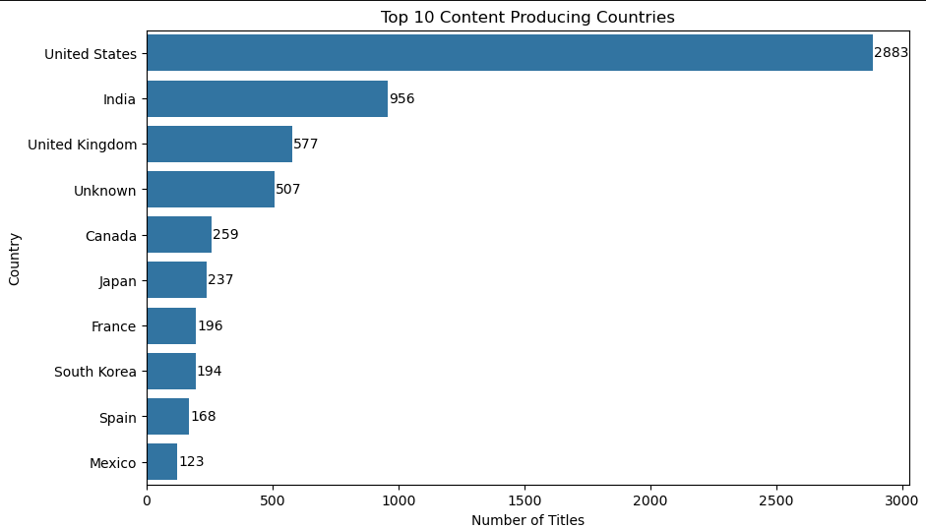
Observation
The United States dominates Netflix's content library, followed by India.
Interpretation
Netflix invests significantly in North American content while continuously expanding regional and international productions.

8. Yearly Trend Analysis
Peak Production Year
- 2018
- 1121 Titles Released
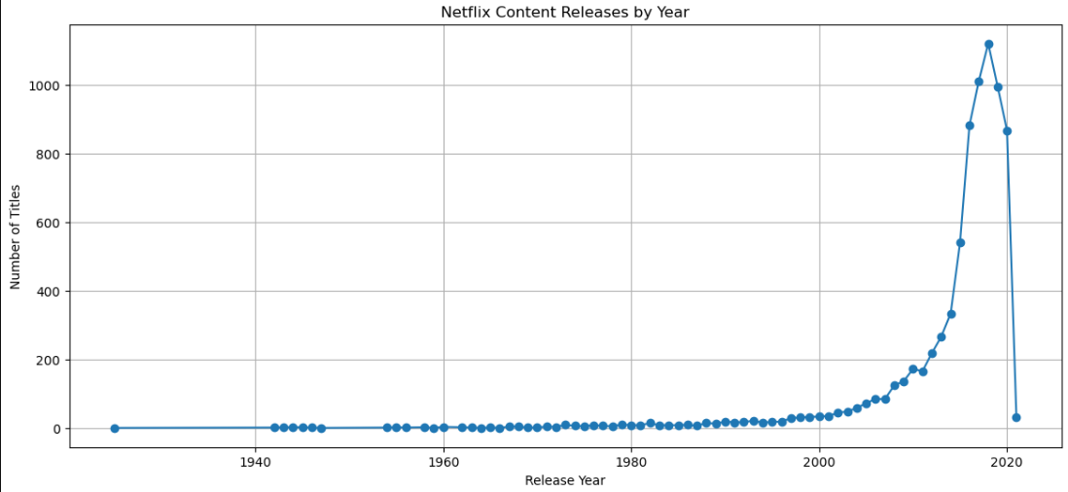
Observation
The number of releases increased steadily from 2007 and reached its maximum in 2018 before declining slightly in later years.
Interpretation
The rapid increase during 2015–2018 reflects Netflix's aggressive global expansion strategy.

9. Rating Analysis
Most Common Ratings
Rating | Count
TV-MA | 2870
TV-14 | 1931
TV-PG | 806
R | 665

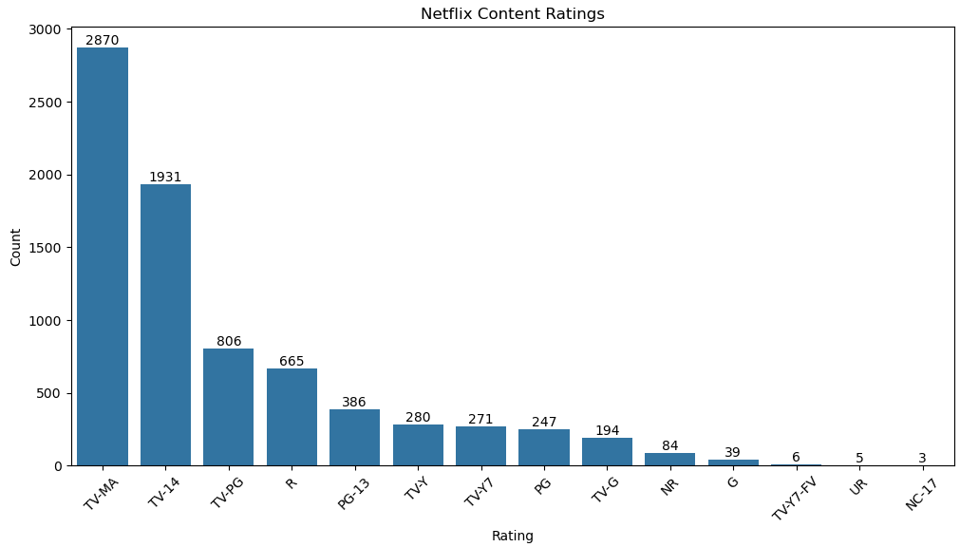
Observation
TV-MA is the most common content rating.
Interpretation
Netflix primarily targets adult and young adult audiences.

10. Genre Analysis
Top Genres

Genre | Titles
International Movies | 2437
Dramas | 2106
Comedies | 1471
International TV Shows | 1199
Documentaries | 786
Action & Adventure | 721
TV Dramas | 704
Independent Movies | 673
Children & Family Movies | 532
Romantic Movies | 531

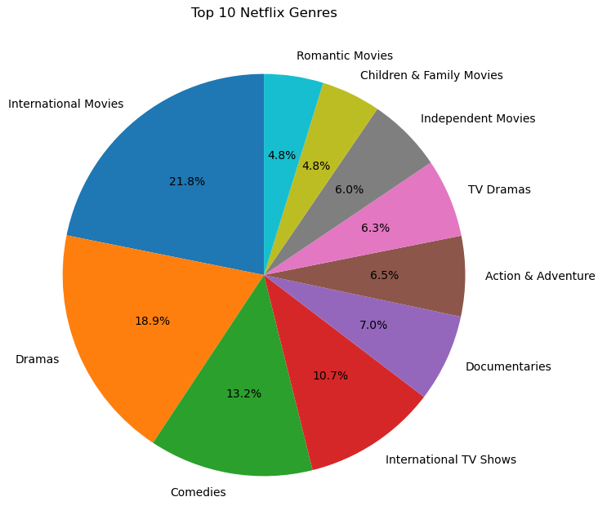
Observation
International Movies and Dramas dominate the platform.
Interpretation
Netflix's strategy focuses on delivering diverse content to audiences across multiple countries and cultures.

11. Duration Analysis
Results
Metric | Value
Average Movie Duration | 99.31 Minutes
Longest Movie | Black Mirror: Bandersnatch (312 Minutes)
Shortest Movie | Silent (3 Minutes)

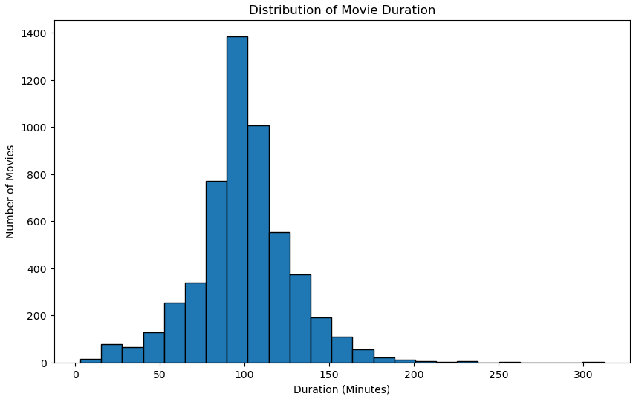
Observation
Most movies have durations close to the average feature film length.
Interpretation
Netflix maintains a balanced catalog of feature-length movies while also offering a few experimental short and long-duration titles.

12. Outlier Detection
IQR Method
Outliers Detected: 337
Z-Score Method
Outliers Detected: 45
Interpretation
The IQR method detected more outliers because it is more sensitive to variations in duration, whereas the Z-score method identified only the most extreme values.

13. Feature Engineering
The following new features were created:
- Release Decade
- Content Age
- Duration Category

Release Decade Distribution
Decade | Titles
1980s | 106
1990s | 225
2000s | 728
2010s | 5711
2020s | 899
Duration Categories
Category | Count
Medium | 3920
Short | 2856
Long | 1011

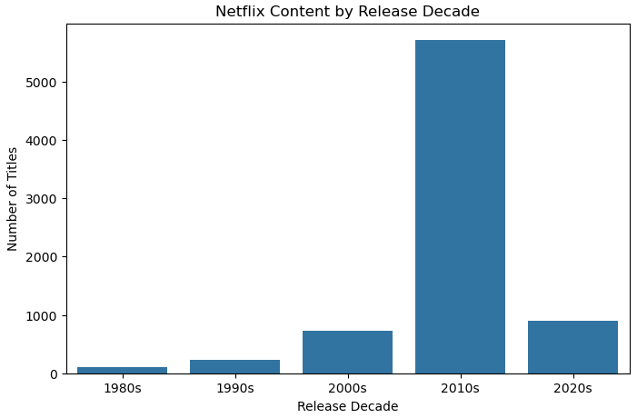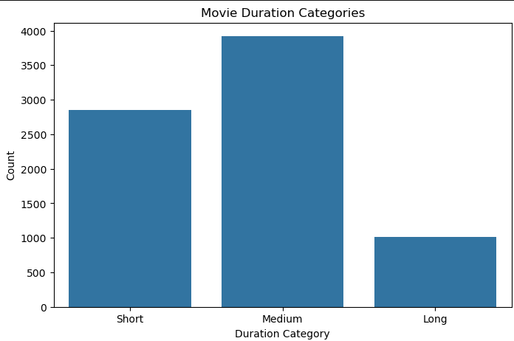

Interpretation
Most Netflix content belongs to the 2010s and falls under the Medium duration category.

14. Multivariate Analysis
The following relationships were analyzed:
- Rating vs Content Type
- Country vs Content Type
- Release Decade vs Content Type
- Correlation between numerical variables
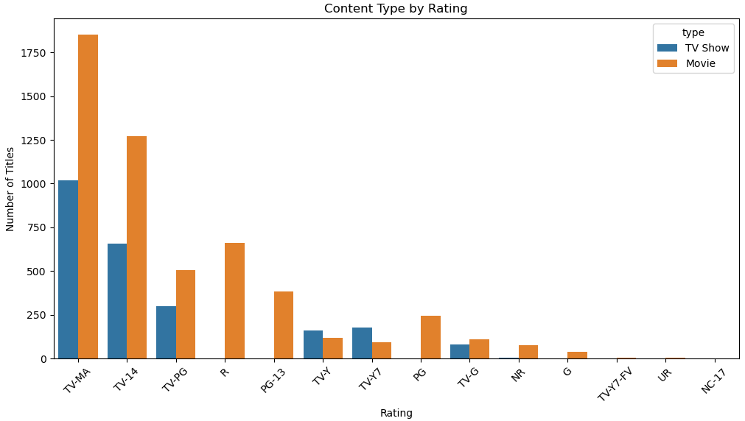
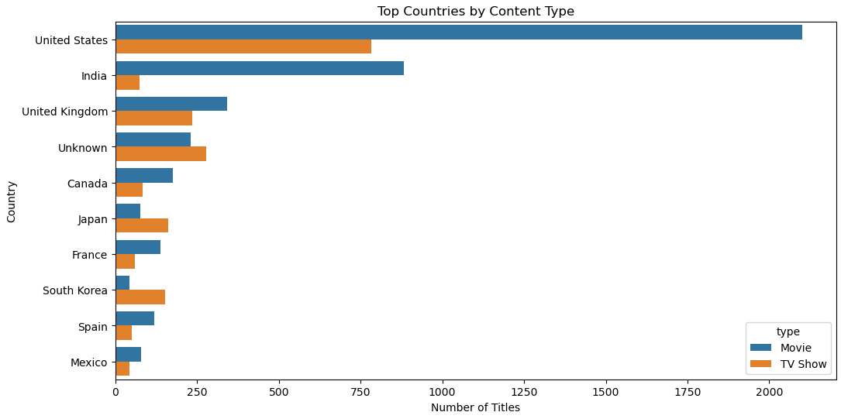
Findings
- Movies dominate almost every rating category.
- The United States produces more Movies than TV Shows.
- Most content was released during the 2010s.
- Numerical features showed weak correlation with each other.

15. Business Insights
- Movies represent approximately 69% of Netflix's catalog.
- The United States is the largest contributor to Netflix content.
- India is the second-largest content-producing country.
- International Movies are the platform's most popular genre.
- The largest number of releases occurred in 2018.
- Most Netflix content belongs to the 2010s.
- TV-MA is the most common maturity rating.
- The average movie duration is approximately 99 minutes.
- Most titles belong to the Medium duration category.
- Netflix demonstrates a strong focus on international and regional content.

16. Conclusion
The Exploratory Data Analysis of the Netflix dataset provided valuable insights into the platform's content library. The analysis revealed that Netflix primarily focuses on movies, with a significant portion of its content originating from the United States and India. International Movies, Dramas, and Comedies dominate the catalog, reflecting Netflix's global expansion strategy. Most titles were released during the 2010s, highlighting rapid growth in that decade. The average movie duration is approximately 99 minutes, and the majority of titles target mature audiences through TV-MA and TV-14 ratings. Overall, the project demonstrates how EDA techniques can effectively uncover trends, patterns, and business insights from real-world datasets.

17. Recommendations
- Continue investing in international and regional content.
- Increase production of family-friendly and children's programming.
- Expand collaborations with emerging entertainment markets.
- Maintain a balance between original productions and licensed content.
- Use audience analytics to optimize genre and rating distribution.
- Continue focusing on medium-duration movies while experimenting with diverse content formats.

18. Technologies Used
- Python
- Pandas
- NumPy
- Matplotlib
- Seaborn
- Jupyter Notebook

19. References
- Netflix Dataset
- Pandas Documentation
- NumPy Documentation
- Matplotlib Documentation
- Seaborn Documentation

