Washington State University

School of Electrical Engineering and Computer Science Fall 2019

CptS 440/540 Artificial Intelligence

**Homework 1**

Due: August 29, 2019 (11:59pm)

**General Instructions**: Put your answers to the following problems into a PDF document and submit as an attachment under Content → Homework 1 for the course CptS 440 Pullman (all sections of CptS 440 and 540 are merged under the CptS 440 Pullman section) on the Blackboard Learn system by the above deadline. Note that you may submit multiple times, but we will only grade the most recent entry submitted before the above deadline.

1. Go to [www.rong-chang.com/tutor_mike.htm](http://www.rong-chang.com/tutor_mike.htm) and click on “Tutor Mike” to engage the chatbot in a conversation. Enter at least 10 comments/questions and copy the entire conversation into your homework. Based on this conversation explain why you think Tutor Mike does or does not pass the Turing Test.

Answer: The conversation is as follows:

1. YOU: My name is Reet Barik

Mike: Hi! My name is Mike, nice to meet you!

2. YOU: What's my last name?

Mike: I have no idea.

3. YOU: Tell me about yourself.

Mike: I'm a professor. My name is Mike. My major is English Literature, but I teach English as a Second Language. I like my students, who are from different parts of the world.

4. YOU: What do you like about your students?

Mike: A student is a learner who is enrolled in an educational institution.

5. YOU: what's 437437403740374 multiplied by 3343284382

Mike: I'm thinking... 437437403740374 * 3343284382 . It's 1.4624776400278207e+24

6. YOU: what is the multiplication answer I asked a while back?

Mike: What do you mean by multiplication answer I asked a while back?

7. YOU: Choose between a cat, a dog, a goat and a sheep

Mike: I would've chosen the same thing.

8. YOU: what?

Mike: You said, " Choose between a cat, a dog, a goat and a sheep" I replied, " I would've chosen the same thing.".

9. YOU: what's your wife's name?

Mike: I'm not married yet. I have a girlfriend. Her name is Maria.

10. YOU: What's her mother's name

Mike: Honestly, I don't know.

11. YOU: What's your girlfriend's mother's name?

Mike: The name of my girlfriend s mother is Chris.

12. YOU: My name is RB

Mike: Hi! My name is Mike, nice to meet you!

13. YOU: what's your girlfriend's name and does she have a pet dog?

Mike: A girlfriend is a young woman with whom a man is romantically involved.

14. YOU: Can't a woman have a girlfriend?

Mike: I'm sorry to hear that.

15. YOU: What's my name?

Mike: You are RB, right?

16. YOU: What's your girlfriend's mother's name?

Mike: The name of my girlfriend s mother is Casey.

A Turing test is the test proposed by Alan Turing to differentiate between a human and an artificial agent based on the responses of the same conversation with both. Based on the conversation with Tutor Mike, I think it doesn’t pass the test. My arguments are as follows:

* From 1 and 2, it can be observed that Tutor Mike doesn’t understand the concept of first and last name. The same isn’t expected from a human.
* From 4 and 13, it’s seen that Tutor Mike gives an answer that doesn’t go with the question asked. A reason might be that it’s a pre-decided response based on the presence of some keywords ({‘student’, ‘girlfriend’} maybe?) in the conversation.
* Tutor Mike seems to be able to do HUGE multiplications in a duration which is inhumanely fast as seen in 5. And as seen in 6, it seems to be unaware of the multiplication operation it did in 5 which wouldn’t be expected from a human.
* From 7 and 8, it is observed that Tutor Mike isn’t able to make choices based on free will which is a characteristic of human beings.
* In 11, it is established that Tutor Mike’s girlfriend’s mother’s name is Chris. In 16, that changes to Casey. A likely explanation is that the conversation resets in 12 and the context of the previous conversation is lost. [Note: Another explanation might be that Tutor Mike’s girlfriend has 2 mothers, namely Chris and Casey which is unlikely given Tutor Mike’s views on same sex relationships as seen in his response to 14]

I feel the above points cumulatively point towards the conclusion that Tutor Mike is indeed not a human being and hence fails the Turing test.

1. Consider an intelligent aerial drone whose task is to patrol major cities looking for people on the FBI’s most wanted list and informing the FBI of any hits.
   1. What are typical sensors, actuators and performance measures for this task? Include a brief explanation with each.
   2. For each of the following task environment properties, choose which option is most appropriate for this task. Include a brief explanation for each.
      1. Fully observable or partially observable?
      2. Single agent or multi-agent?
      3. Deterministic or stochastic?
      4. Episodic or sequential?
      5. Static or dynamic?
      6. Discrete or continuous?
   3. Which agent type is most appropriate for this task: simple reflex, model-based reflex, goal-based, or utility-based? Include a brief justification for your choice.

Answer: a)

1. Typical sensors:

* Altimeter: To measure altitude.
* GPS: To track it’s route.
* Proximity sensors: To avoid running into obstacles.
* Camera: To scan and click pictures at regular intervals.
* Remote control receptor: To receive commands from FBI headquarters.

2. Typical actuators:

* Gyroscope: To maintain steady hover.
* Rotor blades/Propeller: To maintain altitude and speed.
* Rudder: To change direction.
* Processor: To process the images captured and execute orders coming through receptor.
* Storage: To store the database containing images of wanted criminals to compare against.
* Battery operated motor: To fly.
* Security/Encryption system: To prevent malicious attack or interception of communication from unauthorized third party.

3. Performance measures:

* Hit rate: Frequency of criminals correctly identified.
* Relative increase in arrest rate of wanted criminals from open streets after introduction of drones (here, relative increase is considered and not the absolute value because the aim is to improve the identification and subsequent arrest of individuals in the wanted list).
* False positive rate: This needs to be as close to zero as possible so as to not misclassify innocent civilians as criminals.

b) Task environment properties:

1. Fully observable or partially observable? – The city is the environment here. Hence, this requires it to be **partially observable** because for one drone to cover the whole city at any given time (fully observable) would result in the resolution of the pictures captured to be too low for them to be useful for facial recognition.
2. Single agent or multi-agent? – Given that the question implies that there is only one drone assigned for the whole city, it seems to be a case of **single agent**.
3. Deterministic or stochastic? – The better option would be making it a **stochastic** environment because the output in the form of a probability figure of it being a match should give better actionable intelligence than a deterministic output which will disregard any match which is less than 100%.
4. Episodic or sequential? – **Sequential** because the drone needs to have an optimal explore policy in order to be maximally effective. Moreover, following a successful identification, it needs to update its knowledge base which will affect its subsequent behavior.
5. Static or dynamic? – The city is ever changing with new people emerging on to the streets and a fraction of them going indoors. Hence, **dynamic**.
6. Discrete or continuous? – The number of observable states are practically infinite. Hence, **continuous**.

c) The environment here is analogous to the Wumpus environment described in class where the goal of the agent is to locate/identify the wumpus. The only difference here is that there might be more than one wumpus and their positions might keep changing. Given the complexity of the environment, simple reflex agents are ruled out. Model-based reflex agents are inadequate because it takes into account and keeps track of the current state of the environment and isn’t equipped with to deal with the additional information of goals. It would appear that the agent described in the question is a Goal-based one, but as mentioned in Section 2.4.5 on Page 53 of ‘Artificial Intelligence: A Modern Approach’ By Stuart Russell and Peter Norvig,”*when there are several goals that the agent can aim for, none of which can be achieved with certainty, utility provides a way in which the likelihood of success can be weighed against the importance of the goals”*. Based on the above statement, an **Utitlity-based agent** seems to be the most suited to the task in question.

1. Consider the following initial and goal states for the 8-puzzle problem.

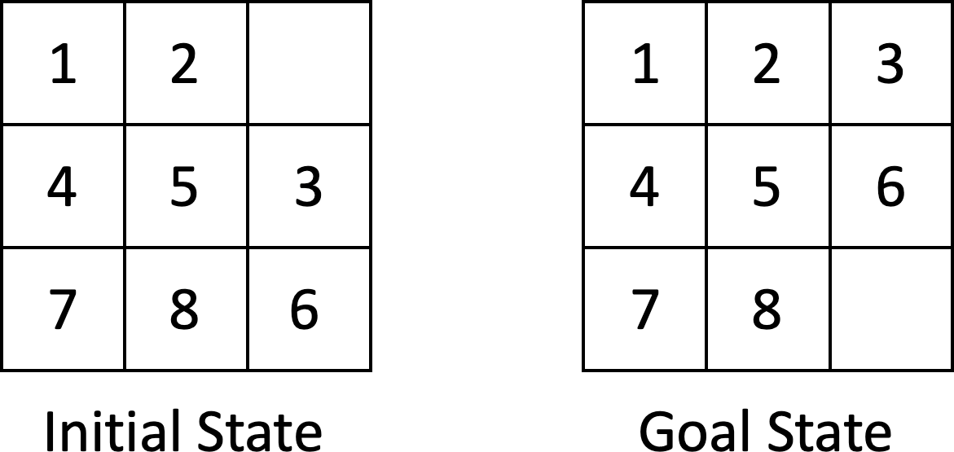

* 1. Draw the entire search tree to a depth of 2. As you draw child nodes from left to right, consider actions (moving blank tile) in the order: left (L), right (R), up (U), down (D). Duplicate states should still be shown, but illegal actions (attempting to move the blank tile off the 3x3 grid) should not be attempted.
  2. Draw the search tree again, as in part (a), but this time, consider the actions in the opposite order: down (D), up (U), right (R), left (L).

Answer: [Note: The goal state is indicated by the state with colored lettering.]

d)

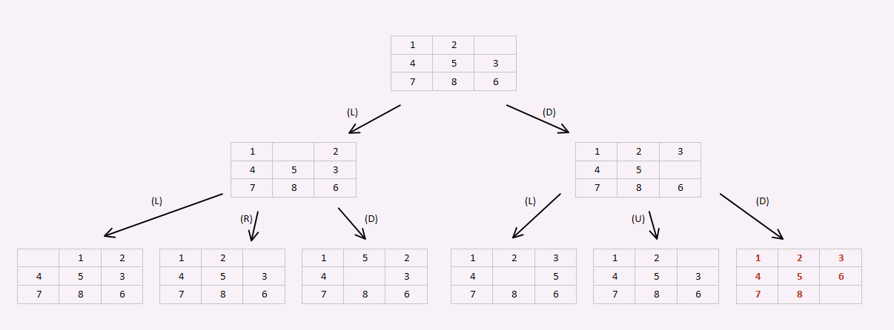

e)

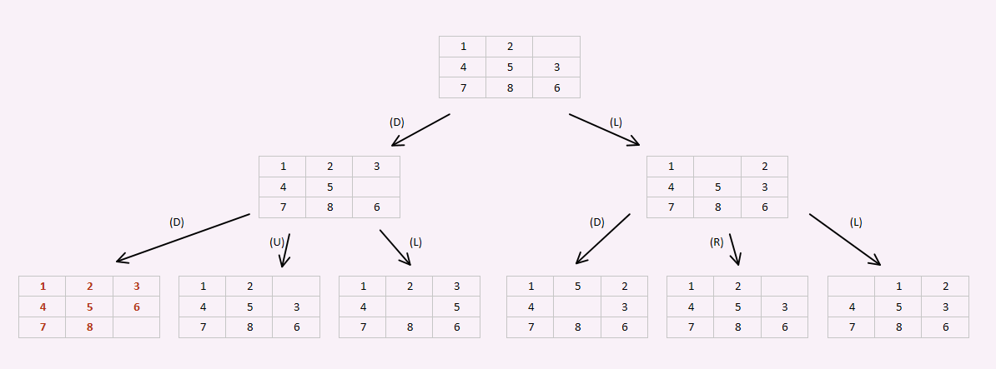

1. *CPTS 540 Students Only*: Consider a variant to the 8-puzzle problem in which an additional four actions (L2, R2, U2, D2) are available that can move two tiles at once. For example, in the Goal State above, L2 and U2 are available, but R2 and D2 are not. Redo problem 3a above using the action order: L, L2, R, R2, U, U2, D, D2.

Answer: [Note: The goal state is indicated by the state with colored lettering.]

