Washington State University

School of Electrical Engineering and Computer Science

Fall 2019

CptS 440/540 Artificial Intelligence

**Homework 8**

Due: October 24, 2019 (11:59pm)

**General Instructions**: Put your answers to the following problems into a PDF document and submit as an attachment under Content à Homework 8 for the course CptS 440 Pullman (all sections of CptS 440 and 540 are merged under the CptS 440 Pullman section) on the Blackboard Learn system by the above deadline. Note that you may submit multiple times, but we will only grade the most recent entry submitted before the above deadline.

1. Suppose your agent is playing a 4x4 Wumpus world game and has visited locations (1,1), (1,2), (1,3), (2,3) and (3,3). The agent observes a breeze in (3,3), but no breeze in the other visited locations. Given this information, we want to compute the probability of a pit in (3,4). You may use px,y and ¬px,y as shorthand notation for Pitx,y=true and Pitx,y=false, respectively. Similarly, you may use bx,y and ¬bx,y as shorthand notation for Breezex,y=true and Breezex,y=false, respectively. Specifically:

a. Define the sets: *breeze*, *known*, *frontier* and *other*.

*breeze* : ¬b1,1 ^ ¬b1,2 ^ ¬b1,3 ^ ¬b2,3 ^ b3,3

*known* : ¬p1,1 ^ ¬p1,2 ^ ¬p1,3 ^ ¬p2,3 ^ ¬p3,3

*frontier* : {p2,1 , p2,2 , p3,2 , p4,2 , p4,3, p2,4 , p1,4}

*other* : {p3,1 , p4,1, p4,4 }

b. Following the method in the textbook and lecture, compute the probability *distribution*

**P**(Pit3,4 | *breeze*, *known*). Show your work.

**P**(Pit3,4 | *breeze*, *known*) = α’ **P**(Pit3,4) ∑frontier **P** (breeze | known, Pit3,4, frontier) P(frontier)

The term **P** (breeze | known, Pit3,4, frontier) is 1 if the frontier is consistent with the breeze observations and 0 otherwise. Now, the logical models for the frontier variables that are consistent with the known facts are as follows (figure in next page):

**P**(Pit3,4 | *breeze*, *known*) = α’ < 0.2( 0.04 + 0.16 + 0.16 + 0.64) , 0.8( 0.04 + 0.16 + 0.16 )>

= α’ < 0.2 , 0.288 >

≈ < 0.41, 0.59 >

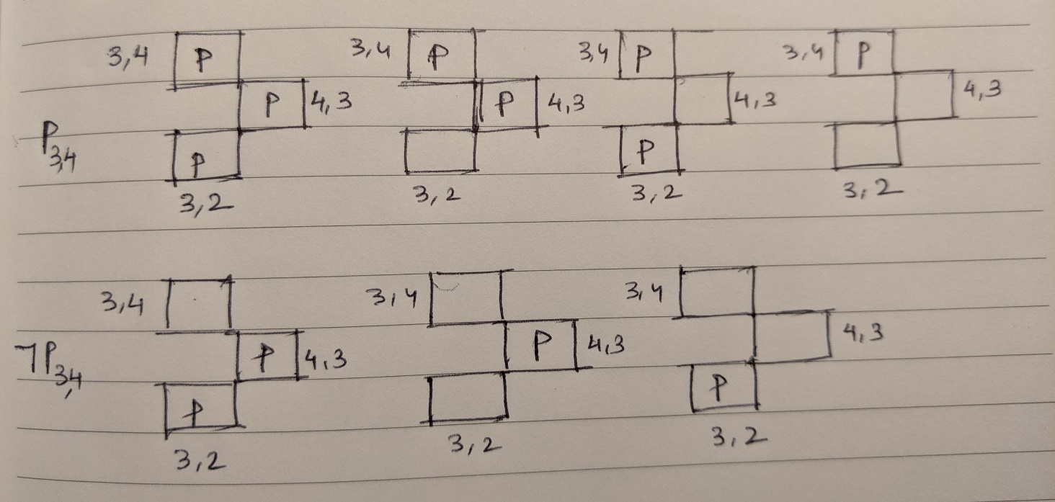

2. Recall the Halloween World from Homework 7. The full joint probability distribution for Halloween World is reproduced below. We are also given that Weather and Costume are independent of each other, and that Party depends on both Weather and Costume. Show a Bayesian network consistent with this information. Be sure to show all nodes, links and conditional probability tables (CPTs).

*Weather*: clear cloudy rain

*Costume*: yes no yes no yes no

*Party*: yes 0.084 0.032 0.18 0.06 0.09 0.024 no 0.036 0.048 0.12 0.14 0.09 0.096

Bayesian Network is as follows:

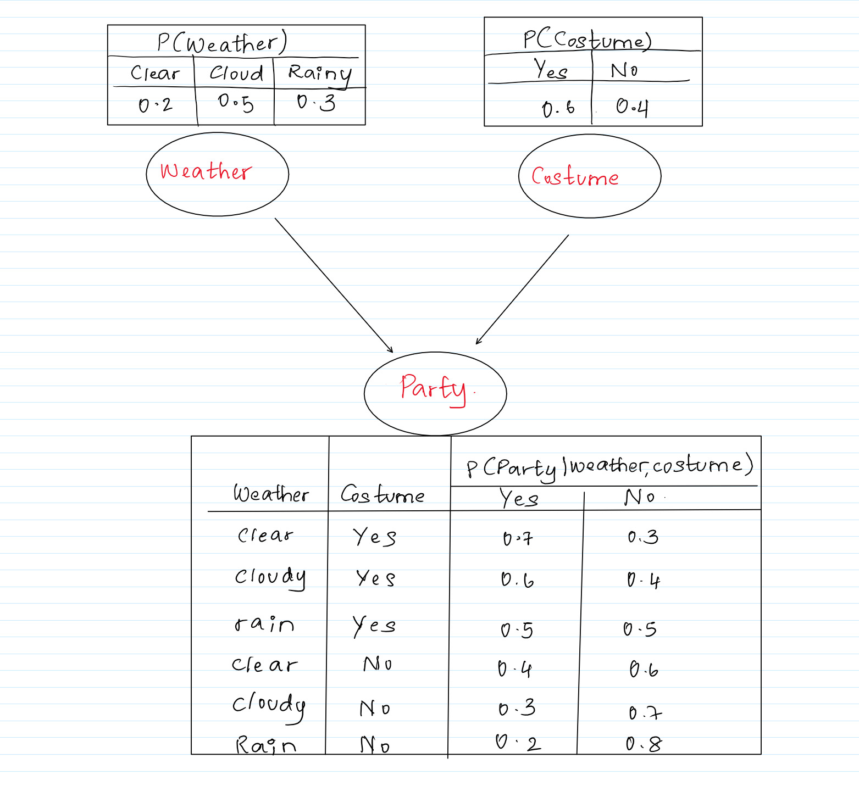

3. Using the Bayesian network in Figure 1 below, compute the following probabilities. Show your work.

a. P(AIDone = true, Costume = false, Party = true, HaveFun = true, MakeFriends = true)

= P(AIDone = true) * P(Costume = false) * P(Party = true | AIDone = true, Costume = false) * P(HaveFun = true | Party = true) * P(MakeFriends = true | Party = true)

= 0.4 * 0.7 * 0.5 * 0.6 * 0.7

= 0.058

b. P(HaveFun = true | AIDone = false, Costume = true)

= α P(HaveFun = true , AIDone = false, Costume = true)

= α < ∑Party P(HaveFun = true , AIDone = false, Costume = true, Party) , ∑Party P(HaveFun = false , AIDone = false, Costume = true, Party) >

= α < ∑Party P(AIDone = false) * P(Costume = true) * P(Party | AIDone = false, Costume = true) * P(HaveFun = true | Party) , ∑Party P(AIDone = false) * P(Costume = true) * P(Party | AIDone = false, Costume = true) * P(HaveFun = false | Party) >

= α < P(AIDone = false) * P(Costume = true) * ∑Party P(Party | AIDone = false, Costume = true) * P(HaveFun = true | Party) , P(AIDone = false) * P(Costume = true) * ∑Party P(Party | AIDone = false, Costume = true) * P(HaveFun = false | Party) >

= α < 0.6 * 0.3 * [P(Party = true | AIDone = false, Costume = true) * P(HaveFun = true | Party = true) + P(Party = false | AIDone = false, Costume = true) * P(HaveFun = true | Party = false) , 0.6 * 0.3 * [P(Party = true | AIDone = false, Costume = true) * P(HaveFun = false | Party = true) + P(Party = false | AIDone = false, Costume = true) * P(HaveFun = false | Party = false) >

= α < 0.6 * 0.3 * [ 0.4 * 0.6 + 0.6 * 0.2 ] , 0.6 * 0.3 * [ 0.4 * 0.4 + 0.6 * 0.8 ] >

= α < 0.06, 0.11>

= < 0.35, 0.65 >

Therefore, P(HaveFun = true | AIDone = false, Costume = true) = 0.35

c. P(AIDone = true | HaveFun = true, MakeFriends = true)

For brevity,

a : AIDone

c : Costume

p : Party

h : HaveFun

m : MakeFriends

**P**(a | h, m)

**=** α < P(a, h, m) , P(¬a, h, m) >

= α < $\sum_{c}{\sum_{p}{P(a,h,m,p,c)}}$ , $\sum_{c}{\sum_{p}{P(¬a,h,m,p,c)}}$ >

= α < $\sum_{C}{\sum_{P}{P\left(a\right)P\left(c\right)P\left(p | a,c\right)P\left(h | p\right)P\left(m | p\right)}}$, $\sum_{C}{\sum_{P}{P\left(¬a\right)P\left(c\right)P\left(p | ¬a,c\right)P\left(h | p\right)P\left(m | p\right)}}$ >

= α < P(a) { P(c)[P(p|a,c)P(h|p)P(m|p) + P($¬$ p|a,c)P(h|p)P(m|p)] + P($¬$ c)[P(p|a, $¬$ c)P(h|p)P(m|p) + P($¬$ p|a, $¬$ c)P(h|p)P(m|p)] ,

P($¬$ a) { P(c)[P(p|a,c)P(h|p)P(m|p) + P($¬$ p|a,c)P(h|p)P(m|p)] + P($¬$ c)[P(p|a, $¬$ c)P(h|p)P(m|p) + P($¬$ p|a, $¬$ c)P(h|p)P(m|p)] >

= α < (0.4) { (0.3)[(0.9)(0.6)(0.7) + (0.1)(0.2)(0.4)] + (0.7)[(0.5)(0.6)(0.7)+(0.5)(0.2)(0.4)]} ,

(0.6) { (0.3)[(0.4)(0.6)(0.7) + (0.6)(0.2)(0.4)] + (0.7)[(0.2)(0.6)(0.7)+(0.8)(0.2)(0.4)]}>

= α < 0.11632 , 0.10104 >

= < 0.53 , 0.47 >

Therefore, P(AIDone = true | HaveFun = true, MakeFriends = true) = 0.53

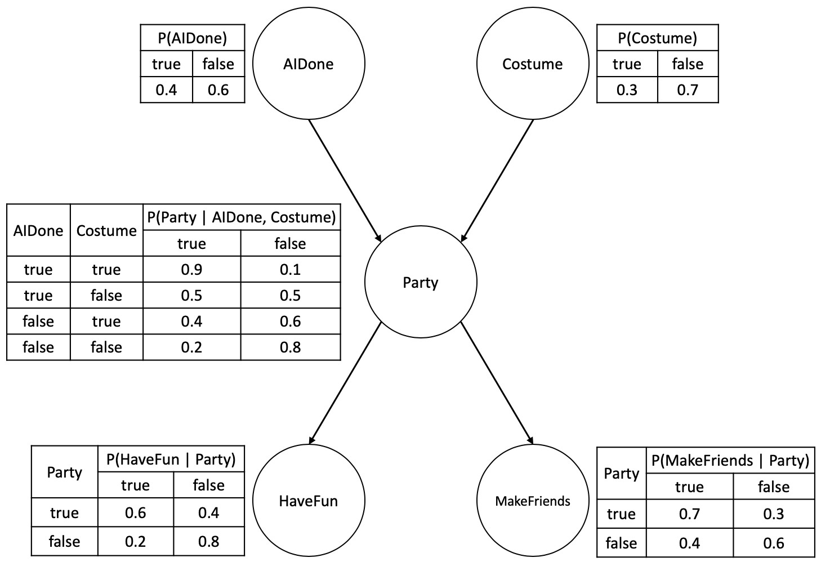

*Figure 1. Bayesian Network.*

2