Cpt S 411 Assignment Cover Sheet

(To be turned in along with each homework and program project submission)

Assignment #

For individual assignments:

Student name (Last, First): Barik, Reet

For team projects:

List of all students (Last, First): Barik, Reet

List of collaborative personnel (excluding team participants):

I certify that I have listed above all the sources that I consulted regarding this assignment, and that I have not received or given any assistance that is contrary to the letter or the spirit of the collaboration guidelines for this assignment. I also certify that I have not referred to online solutions that may be available on the web or sought the help of other students outside the class, in preparing my solution. I attest that the solution is my own and if evidence is found to the contrary, I understand that I will be subject to the academic dishonesty policy as outlined in the course syllabus.

Please print your names.

Assignment Project Participant(s): Barik, Reet

Today’s Date: 13 September 2020
It is observed that after a certain message size, the cost in terms of communication size breaks even. That message size is identified as the point where the time to send and receive are almost equal for a given message size. That message size is approximately equal to the Network Buffer Size. This is so because any message of size bigger than the Network Buffer Size will be sent as multiple packets. For message sizes less than the Network Buffer Size, the ‘Send’s will “Recv’ sooner while for bigger message sizes, it has to wait for the packets to get flushed from the buffer before returning (this trend is observed in the plots).

The region after the break-even point is linear which is used for calculating the Bandwidth and Latency.

Blocking Test:

The plots are shown in the figure below:

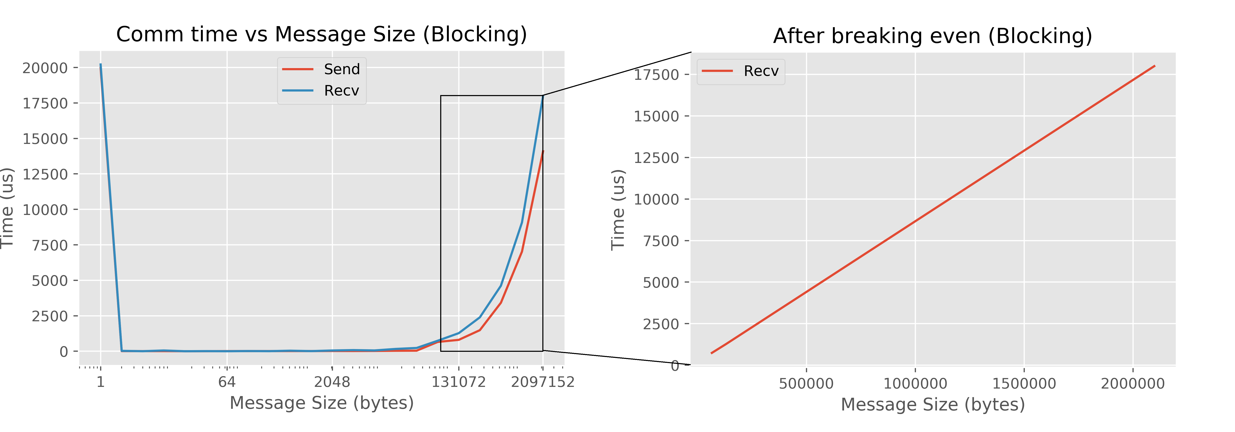

Network Buffer Size = 65536 Bytes
The linear plot has the following line equation: y = 0.0082x + 205.6
Now, Bandwidth = 1 / slope = 121.9 bytes per microseconds.
Latency = Y-intercept = 205.6 microseconds

RESULTS:

Network Buffer Size ≈ 65536 Bytes, Bandwidth = 121.9 bytes/microseconds, and Latency = 205.6 microseconds

Non-Blocking Test:

The plots are shown in the figure below:

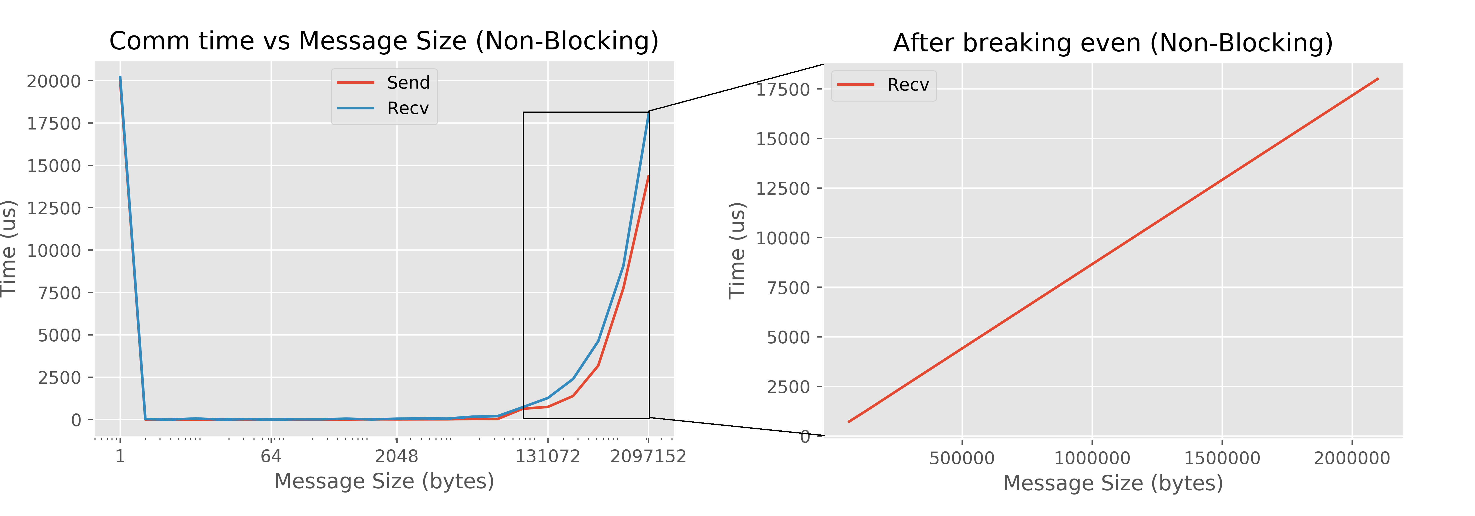

Network Buffer Size = 65536 Bytes
The linear plot has the following line equation: y = 0.0083x + 189
Now, Bandwidth = 1 / slope = 120.48 bytes per microseconds.
Latency = Y-intercept = 189 microseconds

RESULTS:

Network Buffer Size ≈ 65536 Bytes, Bandwidth = 120.48 bytes/microseconds, and Latency = 189 microseconds

If you worked as a team, then the word “I” includes yourself and your team members.

