Cpt S 411 Assignment Cover Sheet

(To be turned in along with each homework and program project submission)

Assignment # 4

For individual assignments:

Student name (Last, First): Barik, Reet

For team projects:

List of all students (Last, First): Barik, Reet

List of collaborative personnel (excluding team participants):

I certify that I have listed above all the sources that I consulted regarding this assignment, and that I have not received or given any assistance that is contrary to the letter or the spirit of the collaboration guidelines for this assignment. I also certify that I have not referred to online solutions that may be available on the web or sought the help of other students outside the class, in preparing my solution. I attest that the solution is my own and if evidence is found to the contrary, I understand that I will be subject to the academic dishonesty policy as outlined in the course syllabus.

Please print your names.

Assignment Project Participant(s): Barik, Reet

Today’s Date: 14 November2020
The following are the results:

- Parallel runtime (in milliseconds)

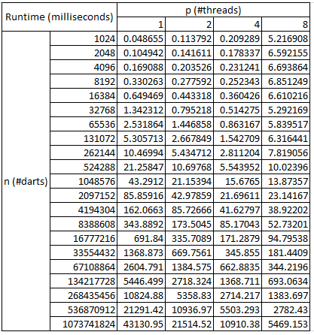

Only the results for n ≥ 1M is shown in the plot below:
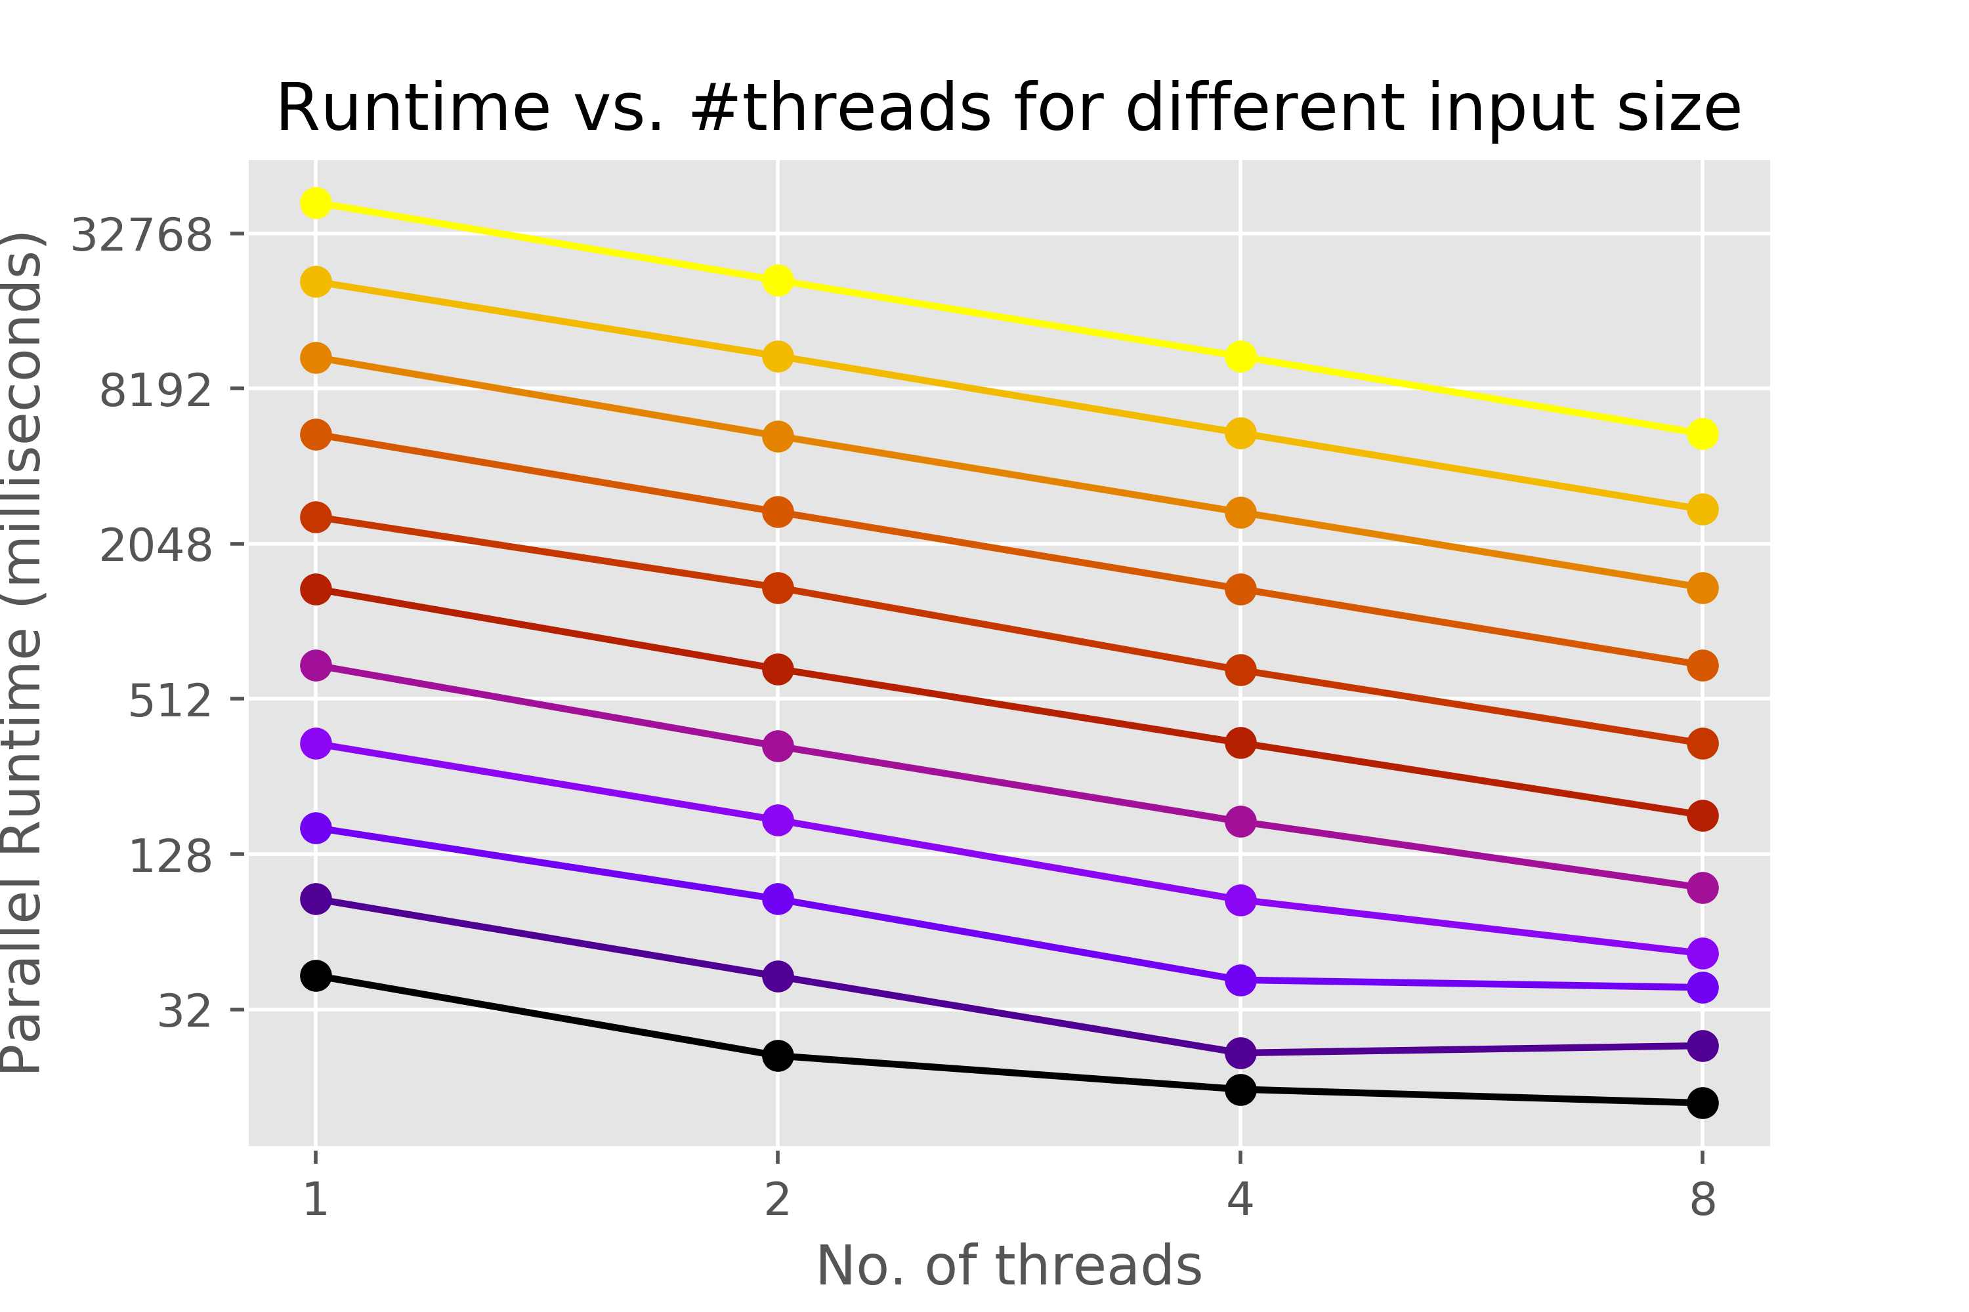
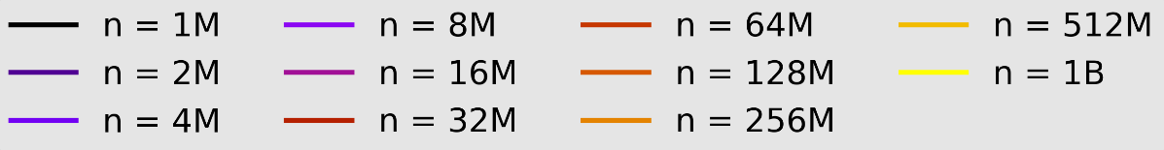
- Speedup

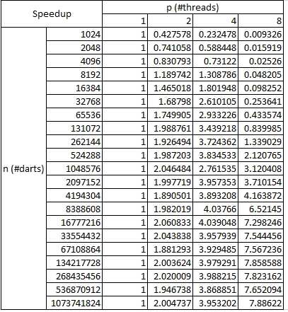

Only the results for n ≥ 1M is shown in the plot below:
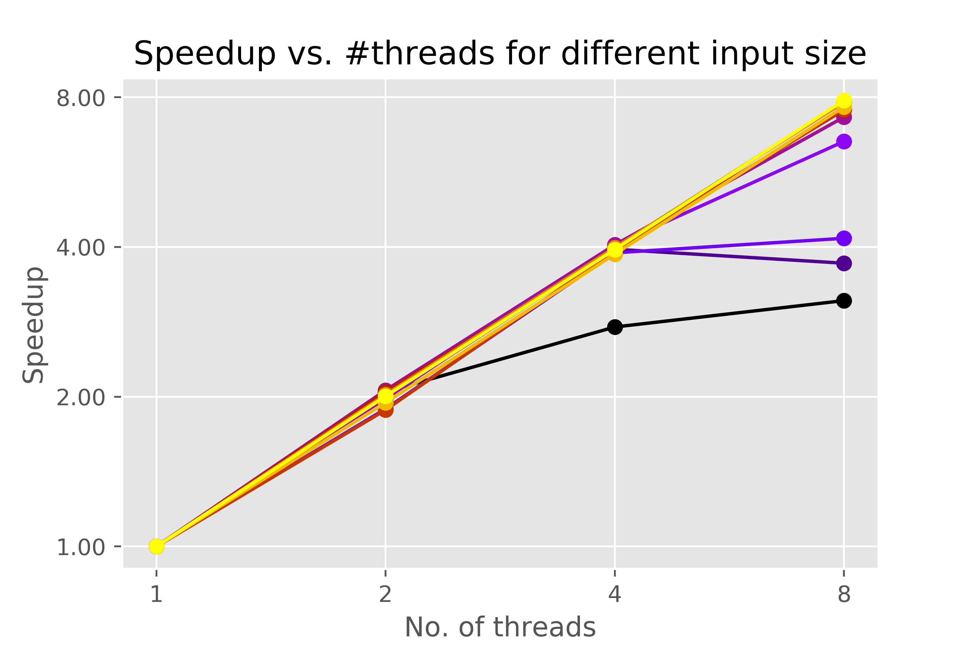

- Precision (obtained by keeping p = 8 and increasing n)

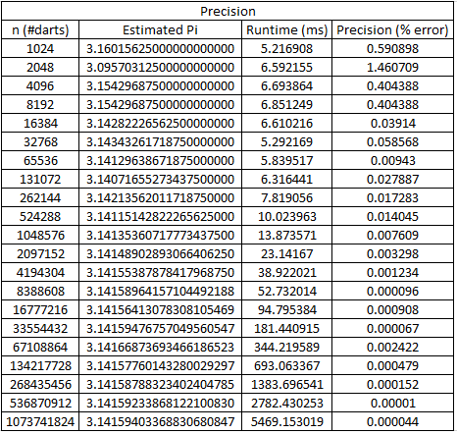

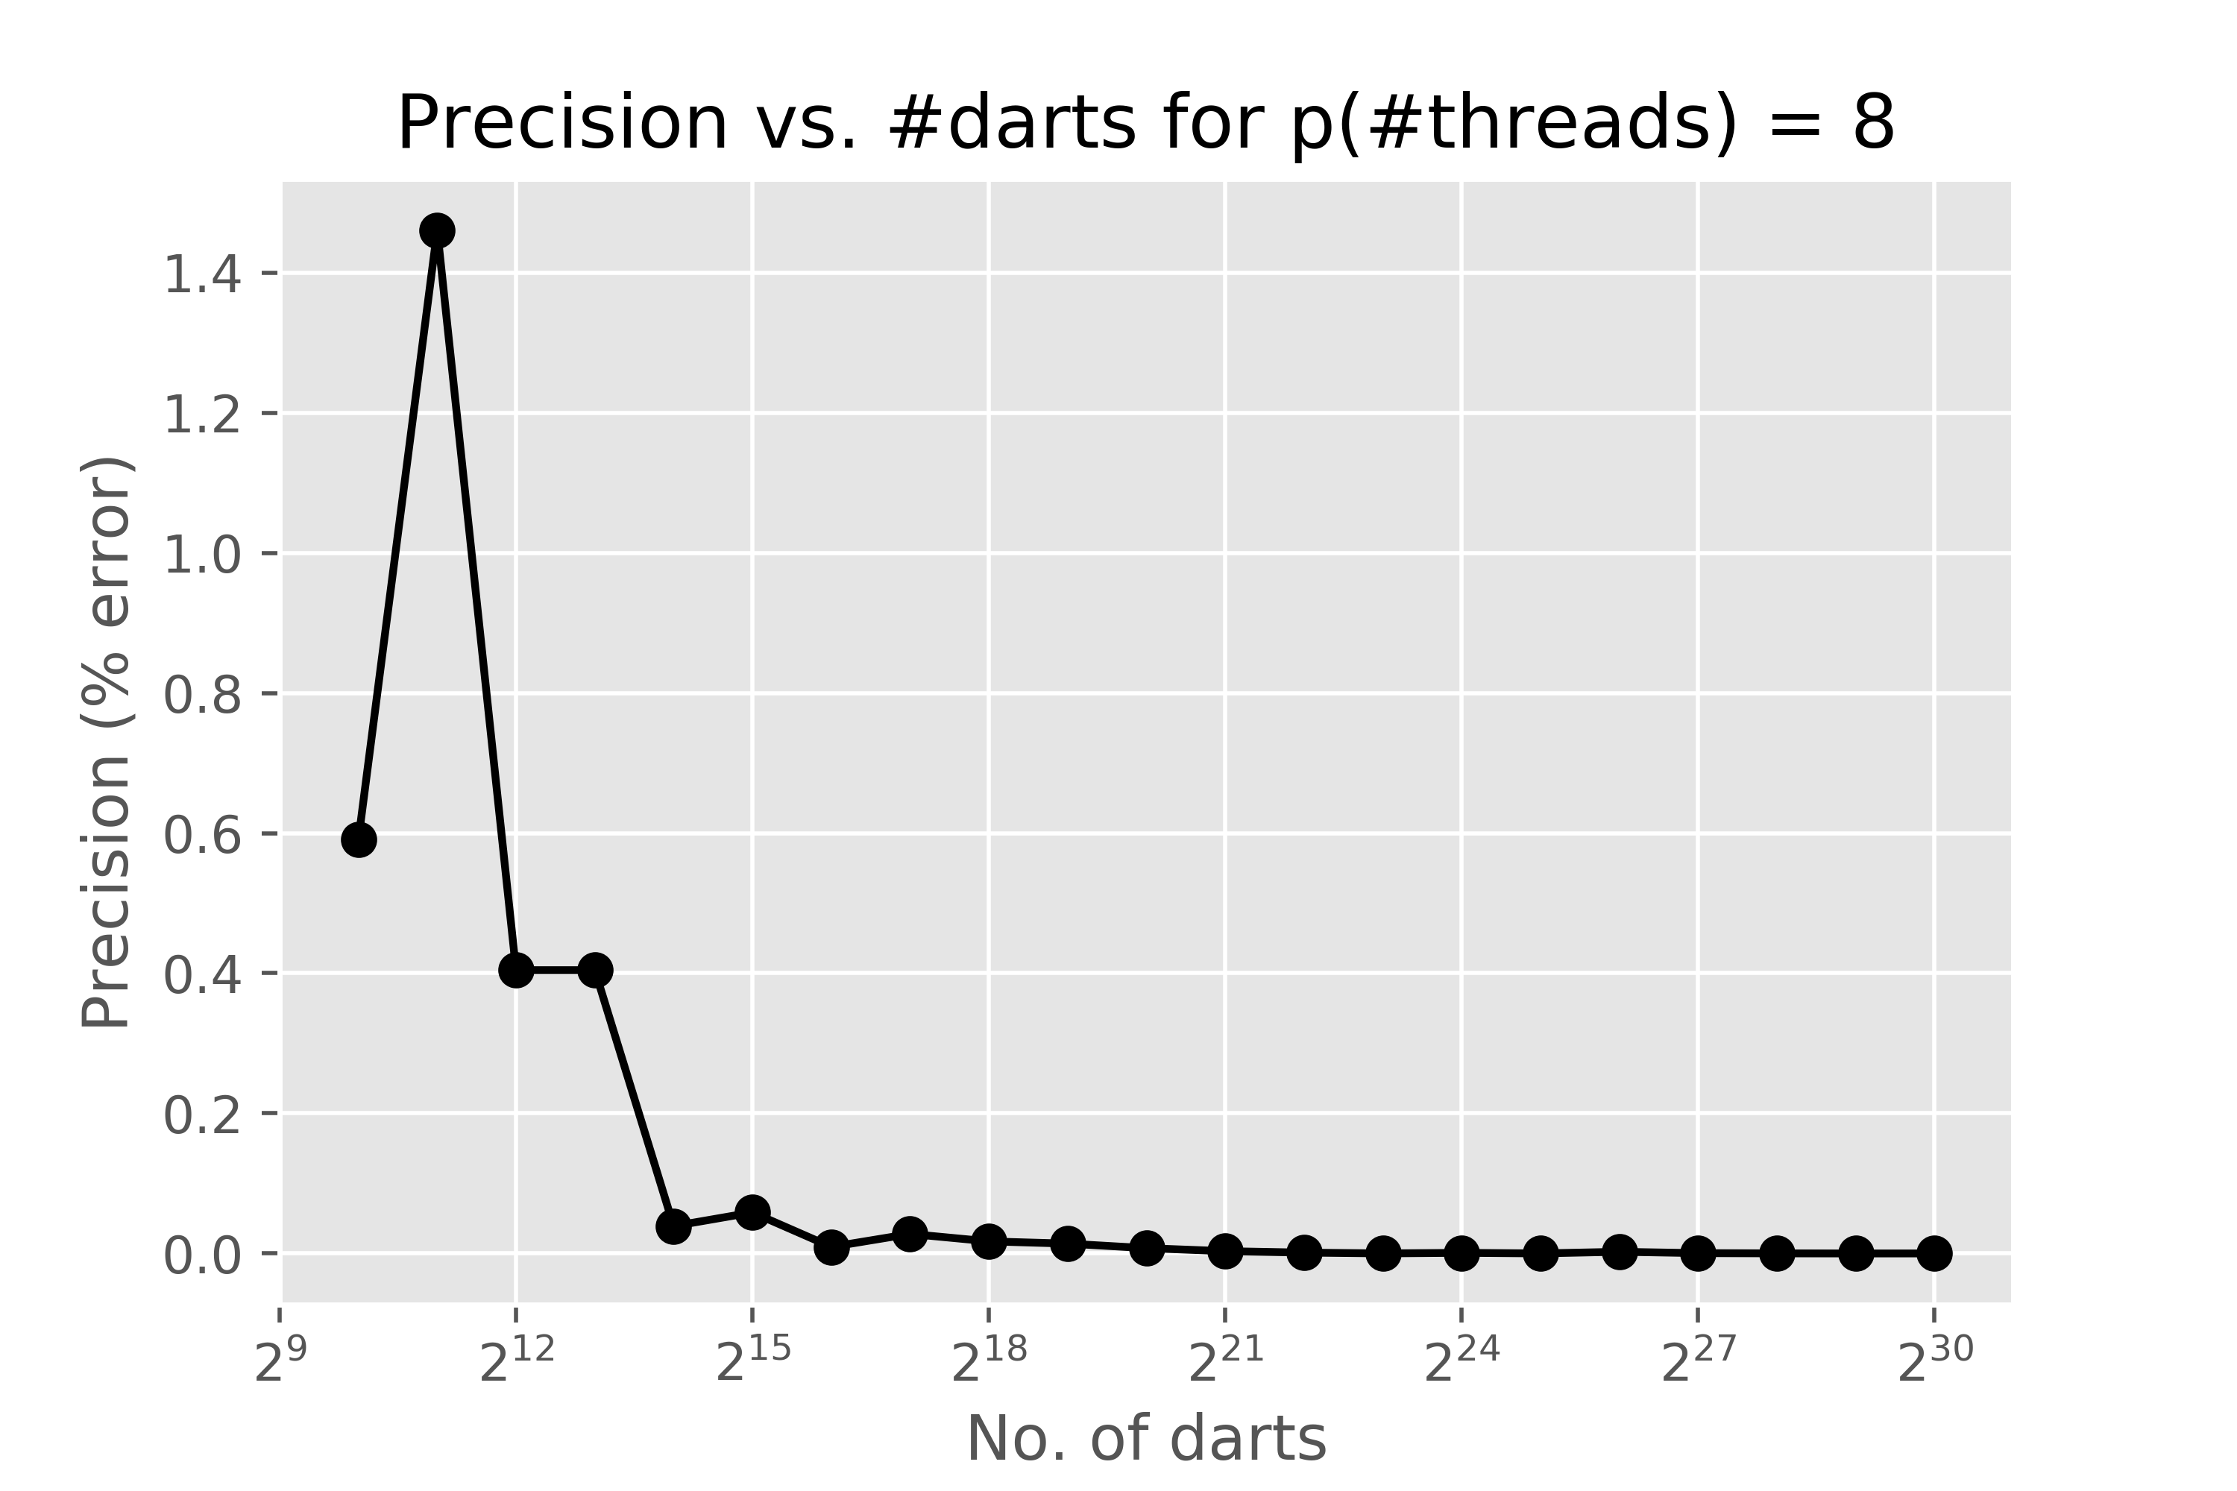

As we can see, ignoring the smaller values of ‘n’ (≤ 2¹²), there is a general decrease in the percentage error in estimating the value of Pi. The ground truth value of Pi used (accurate up to 20 decimal places) is as follows: 3.14159265358979323846.

Observations:
- Significant decrease in runtime and consequent increase in Speedup is observed for n ≥ 1M. Mixed results for smaller values of n shows that parallelization is an overkill for those cases and might result in net slowdown.
- The decrease in runtime and increase in speedup becomes more and more linear as one increases n. For example, for 1M ≤ n ≤ 8M, the speedup is clearly sub-linear whereas it is very close to linear for n = 1B.
- As is expected, we observe a general trend of the percentage error in estimating Pi decreasing as one increases the number of darts thrown (ignoring the smaller values where n ≤ 2¹²).

If you worked as a team, then the word “I” includes yourself and your team members.

