Cpt S 411 Assignment Cover Sheet

(To be turned in along with each homework and program project submission)

Assignment # 2

For individual assignments:

Student name (Last, First): Barik, Reet

For team projects:

List of all students (Last, First): Barik, Reet

List of collaborative personnel (excluding team participants):

I certify that I have listed above all the sources that I consulted regarding this assignment, and that I have not received or given any assistance that is contrary to the letter or the spirit of the collaboration guidelines for this assignment. I also certify that I have not referred to online solutions that may be available on the web or sought the help of other students outside the class, in preparing my solution. I attest that the solution is my own and if evidence is found to the contrary, I understand that I will be subject to the academic dishonesty policy as outlined in the course syllabus.

Please print your names.

Assignment Project Participant(s): Barik, Reet

Today’s Date: 8 October 2020
The required plots are as follows:

- Speedup:
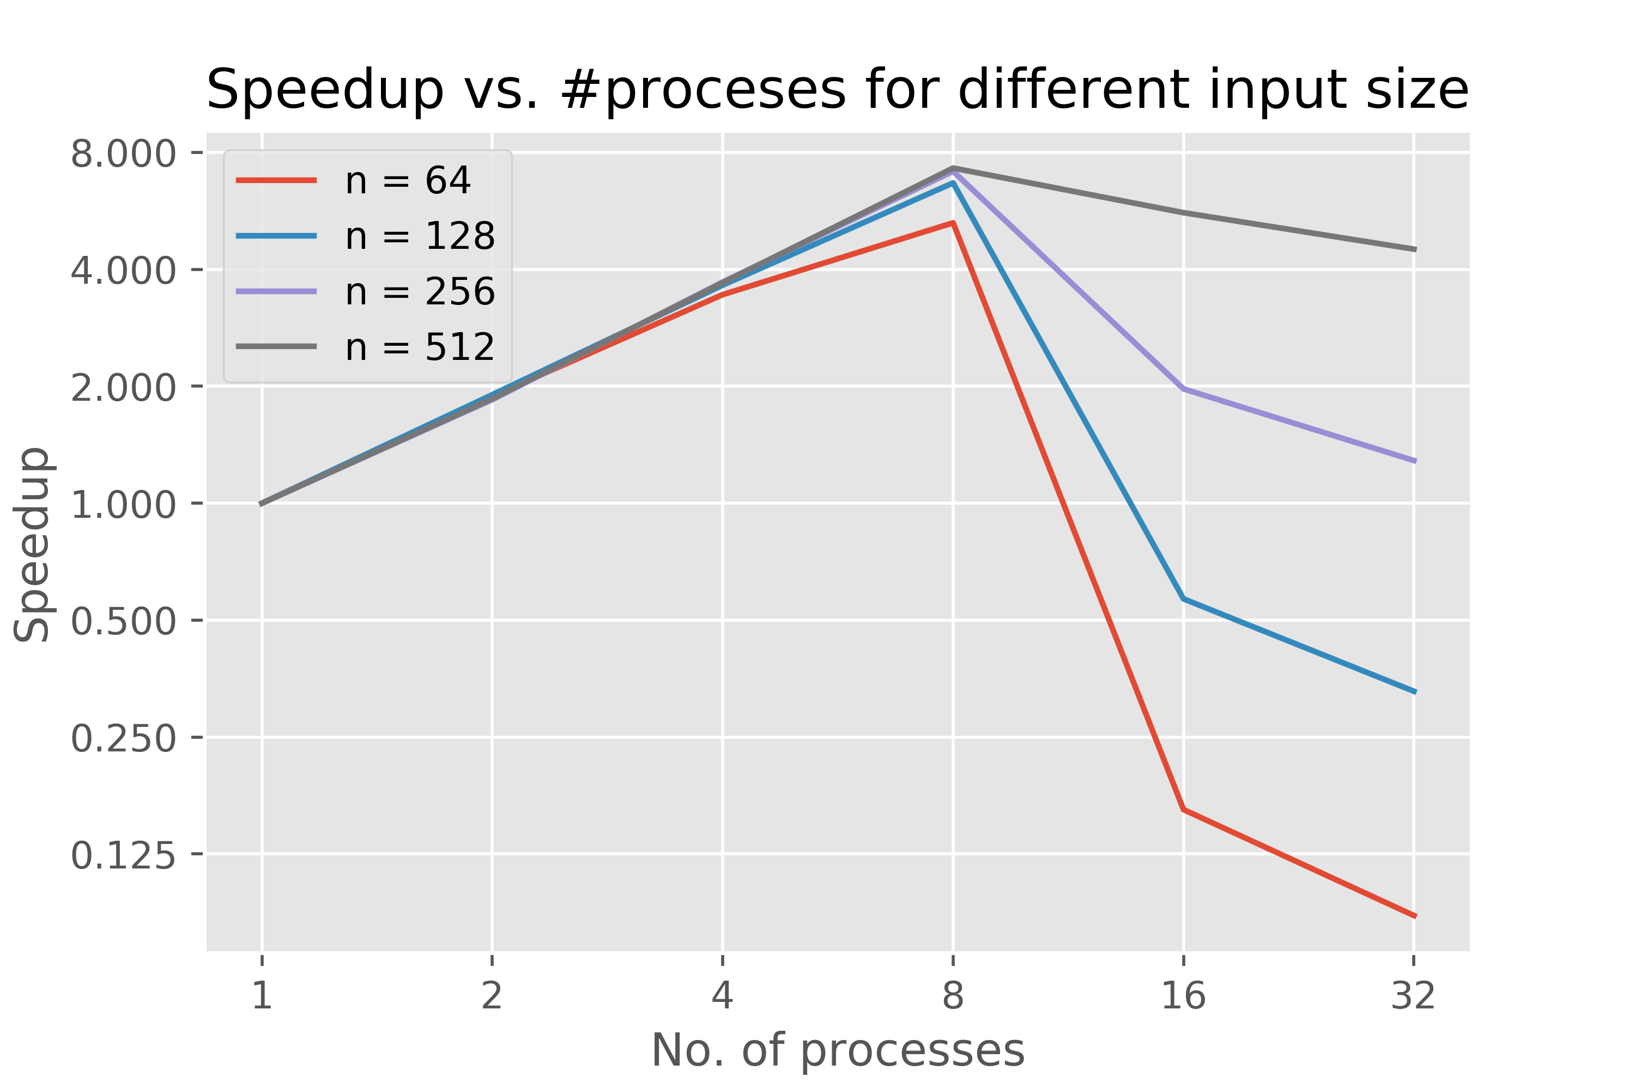

- Efficiency:

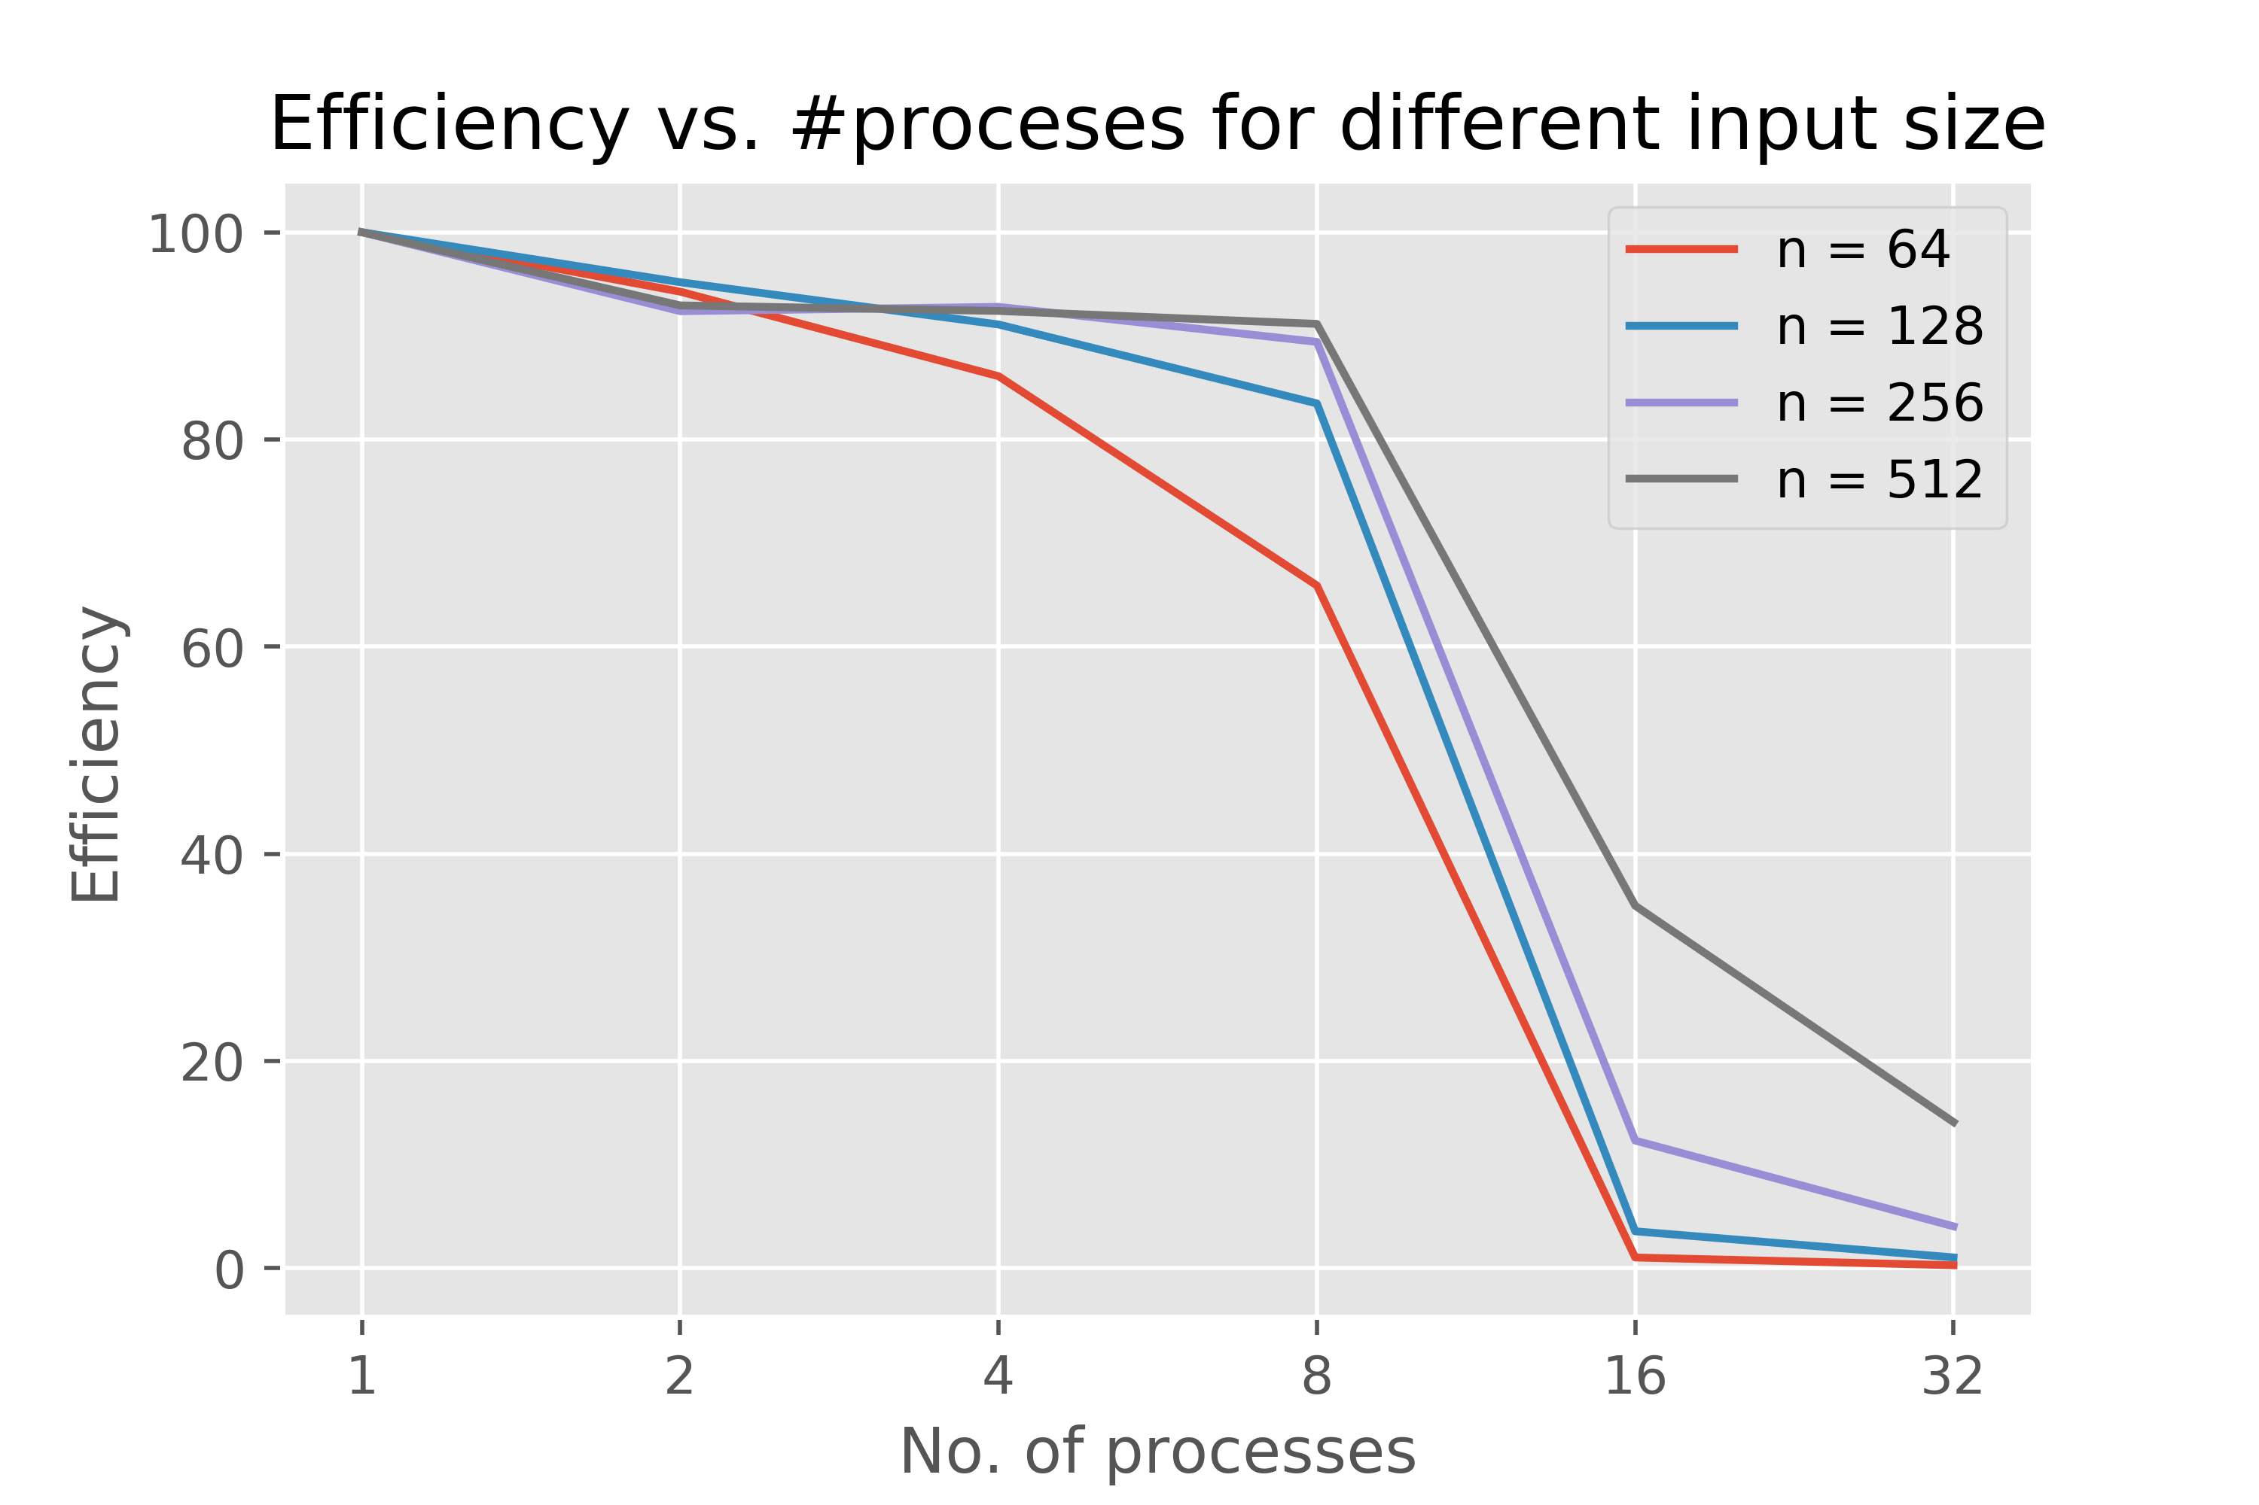

- Breakup of Communication and Computation time in the total runtime

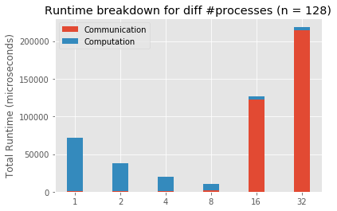

Interpretation:

I ran the code using the command ‘sbatch -n <#processes> sub.sh’.
This results in my code scaling well till #processes = 8. This is because each node has 8 processors and hence can run at most 8 processes without incurring significant slowdown due to communication. As soon as #processes go above 8, it requires at least 2 nodes. Which is where communication becomes a bottleneck (as can be seen from the chart showing the breakup between communication and computation time).

If I had run my code using the command ‘sbatch -N <#nodes> -n <#processes> sub.sh’, then I definitely would have had the communication bottleneck from #processes = 2 onwards. And I would not have seen any speedup.

Possible fix:
- I am using ‘int’ as the datatype to store the matrices. I should use ‘bool’ instead and hence the communication load should ideally be reduced to 25% of what it is right now.
- Also, the way my code is set up right now, I am adding up the values of all the neighboring cells and then checking whether the current cell should live or die based on the sum. The 4 byte integer additions might be done away with if we are using bool and bring down the computation time further: have an 8 bit array for each cell we are considering (each position corresponding to the 8 neighbors). The number of ones in the array (Hamming Weight) can be calculated by bitwise operations (a combination of bitwise AND and right shift). This is significantly cheaper than integer additions.

If you worked as a team, then the word “I” includes yourself and your team members.

