Attendance Management System
Comprehensive Project Report
By: Reet Goyal(11401032024,IT 2)

1. Project Overview
The Attendance Management System is a full-featured, role-based web application built using Python and Streamlit with an SQLite database backend. It is designed specifically for the IGDTUW DevOps Batch and provides a unified platform for tracking student attendance, managing assignments, and posting notices.
The system enforces strict role separation: students can mark their own attendance and view academic content, while administrators have complete control over all records, students, and communications.

Attribute | Detail
Framework | Streamlit (Python)
Roles | Student, Administrator
File Storage | Local uploads/ directory
Default Admin | admin / admin123 (seed on first run)

2. System Architecture
The application is structured across four Python modules, each with a distinct responsibility:

Module | Role
main.py | Streamlit UI — all pages, routing, and session management (930 lines)
db.py | SQLite data layer — all CRUD operations for users, attendance, assignments, notices
auth.py | Authentication logic — hashing, validation, login, signup, logout
admin.py | One-time seed script — creates or resets the admin account

3. Authentication & Access Control

3.1 Login Page
The login page is the entry point for all users. It features a centered card layout with the IGDTUW branding and uses the DM Serif Display typeface for the heading "Welcome back".
- Role selector: Users must explicitly choose Student or Administrator before submitting credentials. This is enforced — if the selected role does not match the account's stored role, login is rejected even with correct credentials.
- Form fields: Username/email input and masked password field.
- "Remember for 30 days" checkbox (UI element).
- "Forgot password?" link (UI element).
- Validation: Empty-field checks, role mismatch error, and wrong-credential error (both return the same generic message to prevent username enumeration).
- Navigation: A "Create account" button leads to the signup page.

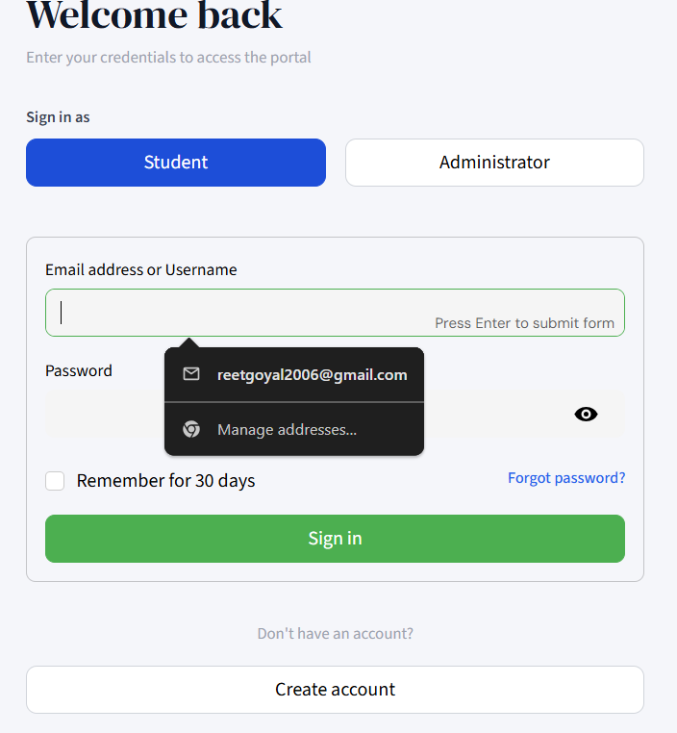

3.2 Signup Page
Student self-registration is available from the login page. Admin accounts cannot be created here — only administrators can create new admin accounts from within the portal.
- Fields: Username (3–20 characters, alphanumeric/underscores), Email (regex-validated), Password (min 6 characters), Confirm Password.
- All validation runs server-side via auth.py before the database write.
- On success, the user is redirected to the login page with a success message.
- Duplicate username or email detection: SQLite IntegrityError is caught and surfaced as a friendly message.
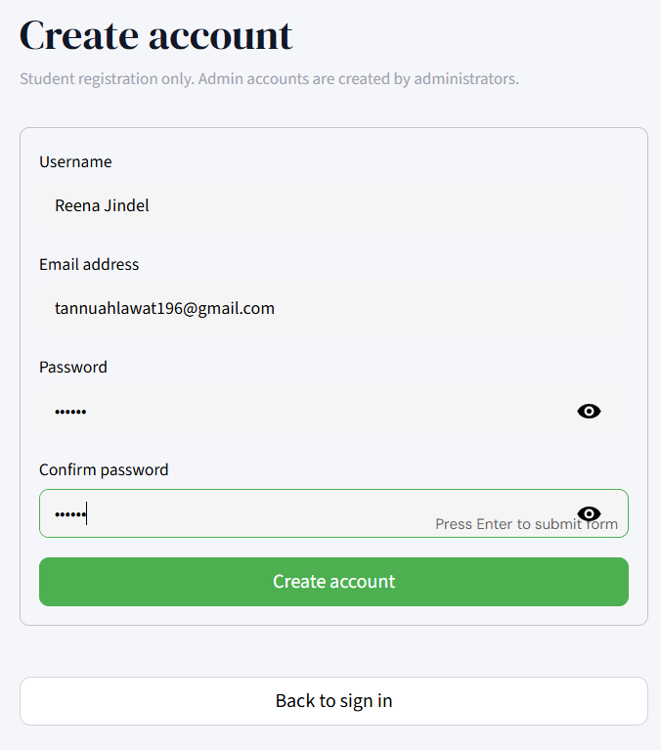

3.3 Password Security
- All passwords are hashed with SHA-256 before storage. Plain-text passwords are never persisted.
- Verification uses constant-time hash comparison.
- Students can change their password from their Profile page after verifying their current password.

3.4 Session Management
Streamlit's session_state object is used to maintain authentication status across page navigations. Session variables include: authenticated, user_id, username, email, role, page, and login_role. Logout clears all session variables and returns the user to the login page.

4. Student Portal
Once logged in as a Student, the user sees a left sidebar with their avatar (initials), email, a colour-coded attendance progress bar, and the navigation menu. All student pages are accessible from this sidebar.

4.1 Student Sidebar
- Profile: Initials shown on a blue-to-purple gradient badge.
- Live attendance bar: A coloured progress bar (green ≥75%, amber ≥50%, red <50%) with the exact count of present days out of total days.
- Navigation links: Overview, Mark Attendance, My Records, Assignments, Notices, Profile, Sign Out.
- Active page is highlighted with a blue tint.
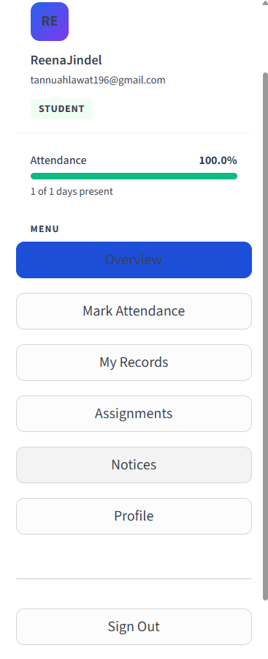

4.2 Overview Dashboard
The student dashboard is the first page shown after login. It aggregates all key information into one view.
Stat Cards
- Total Days — total calendar days with any attendance record.
- Days Present — count of days marked Present.
- Attendance Rate — percentage, with a label: "Good standing" (≥75%), "Below minimum" (50–74%), or "At risk — below 75%" (<50%).
Today's Status Banner
- If attendance has already been marked today: a green banner displays the exact time it was marked.
- If not yet marked: an amber banner with a "Mark Attendance Now" quick-action button that marks attendance instantly and triggers a balloon animation on success.
Attendance Trend Chart
- A line chart of the past 30 days' attendance, rendered using Streamlit's native chart component with blue colour.
Recent Activity Table
- A compact table showing the 6 most recent attendance records (Date, Time, Status).
Latest Assignment & Notice
- Side-by-side cards at the bottom showing the most recently posted assignment (blue left border) and most recent notice (amber left border with warm yellow background) as quick previews.
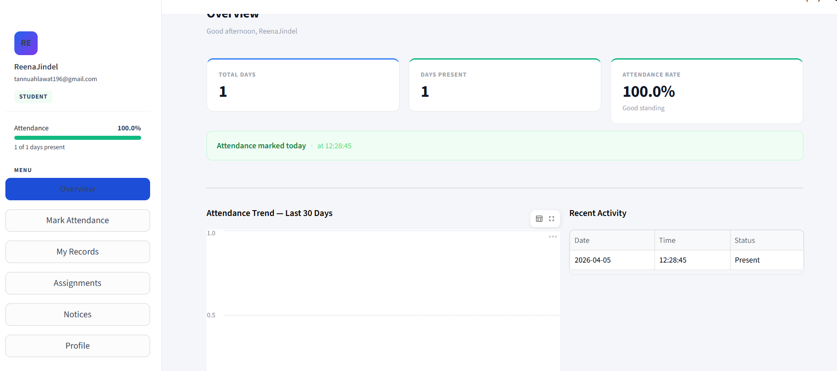

4.3 Mark Attendance
A focused, centred card page for marking attendance for the current day.
- Displays the current date (e.g., "April 05, 2026") and time prominently.
- If not yet marked: a "Mark Present" button records the attendance immediately with the exact timestamp.
- If already marked: a success confirmation shows the time of marking — no duplicate marking is possible (enforced by UNIQUE(user_id, date) constraint at the database level).
- This Month section below shows two stat cards: Present This Month count and Monthly Rate percentage.
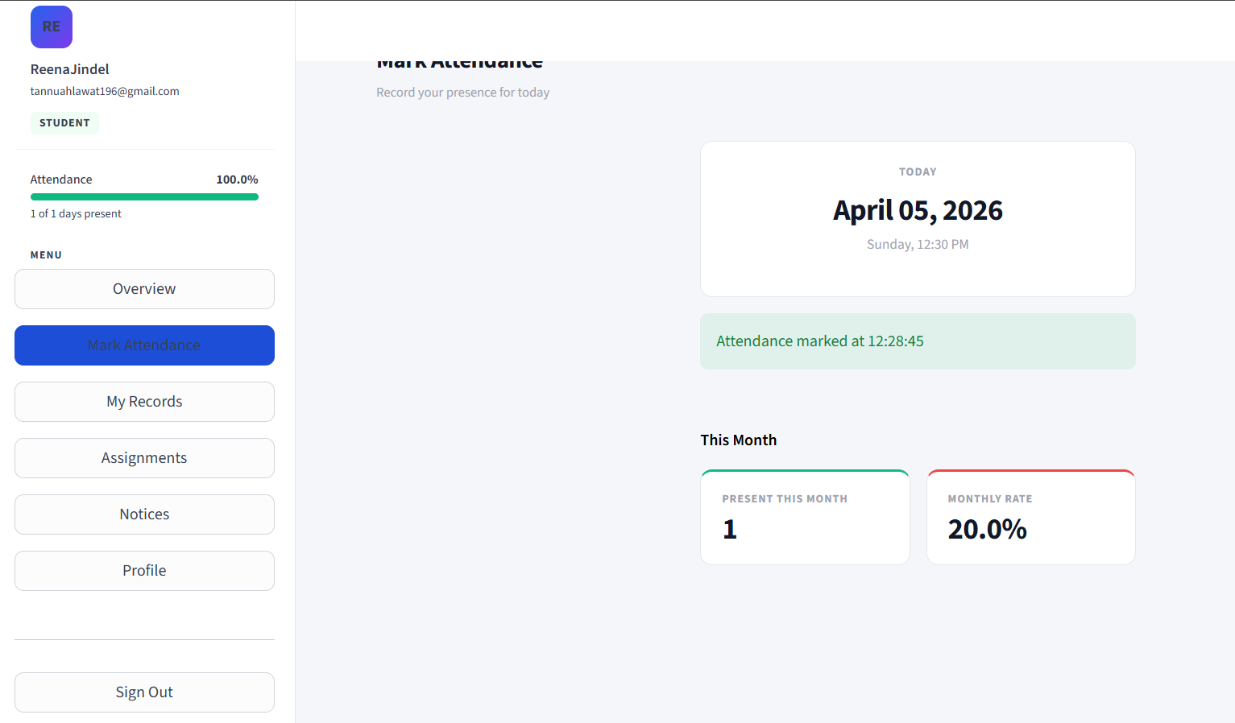

4.4 My Records
A filterable, exportable view of the student's full attendance history.
- Three summary stat cards at the top: Total Days, Days Present, Overall Rate.
- Date range filter: "From" and "To" date pickers (default: last 30 days to today).
- Filtered data table with columns: Date, Time, Status, Marked By.
- Record count shown above the table.
- Download as CSV button: exports the filtered view as a file named attendance_STARTDATE_to_ENDDATE.csv.
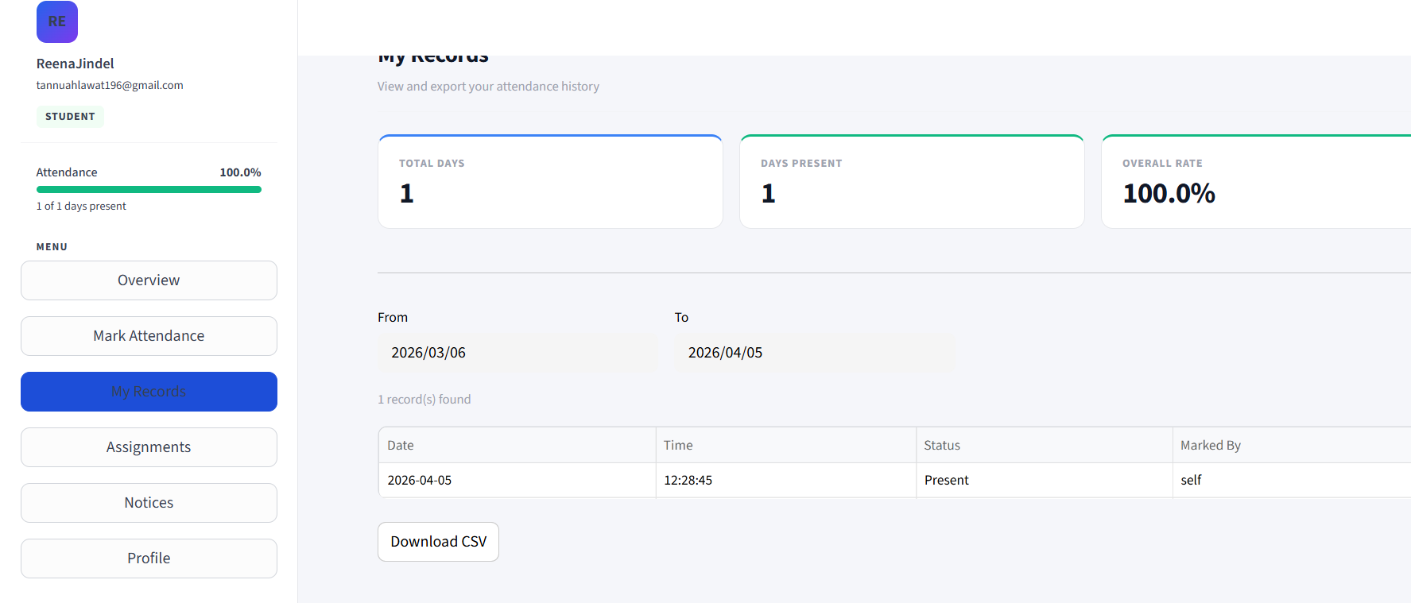

4.5 Assignments
Displays all assignments posted by the admin, ordered newest first.
- Each assignment is shown as a styled card with a blue left border.
- Card content: Title, Due date, Posted-by name, Post date, Description.
- Due-soon alert: If the due date is within 3 days, the card border turns red and a "DUE SOON" badge appears in red next to the title.
- File download: If the admin attached a file, a "Download Attachment" button appears below the card.
- Students cannot create, edit, or delete assignments.
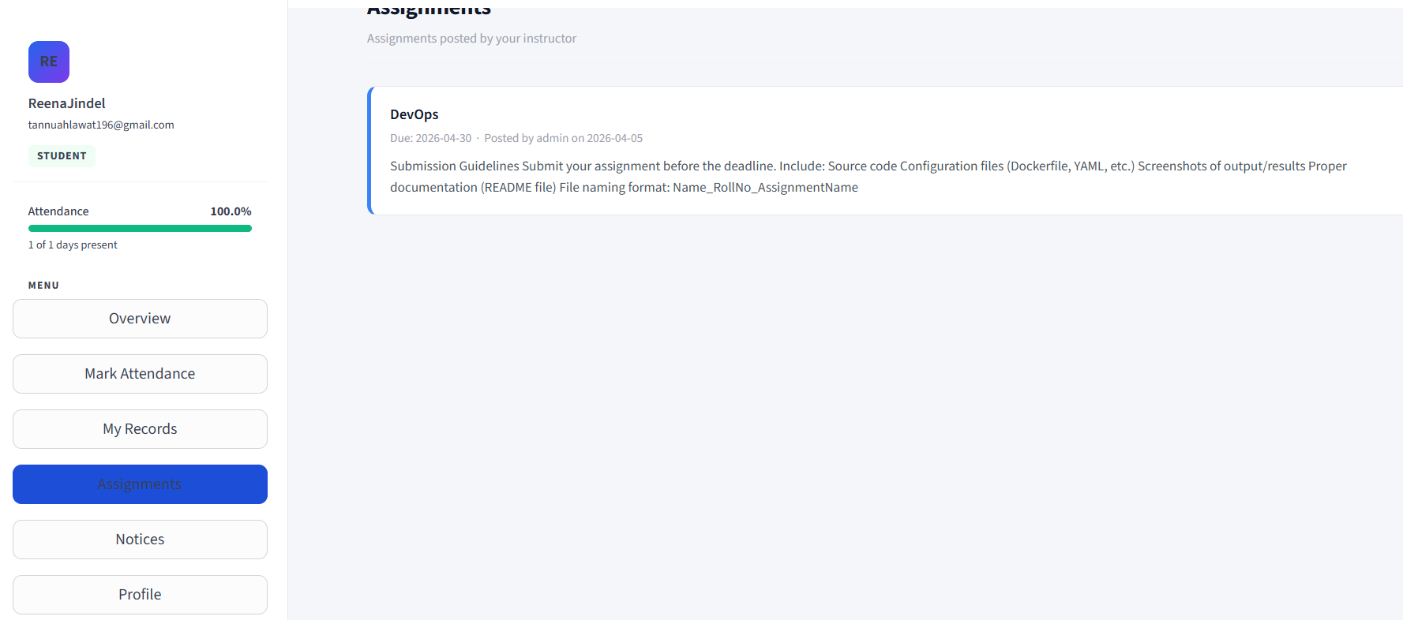

4.6 Notices
Displays all notices posted by the admin, ordered newest first.
- Each notice is rendered as a warm yellow card with an amber left border.
- Card content: Title, Posted date, Posted-by name, Full notice body.
- Students cannot create or delete notices.
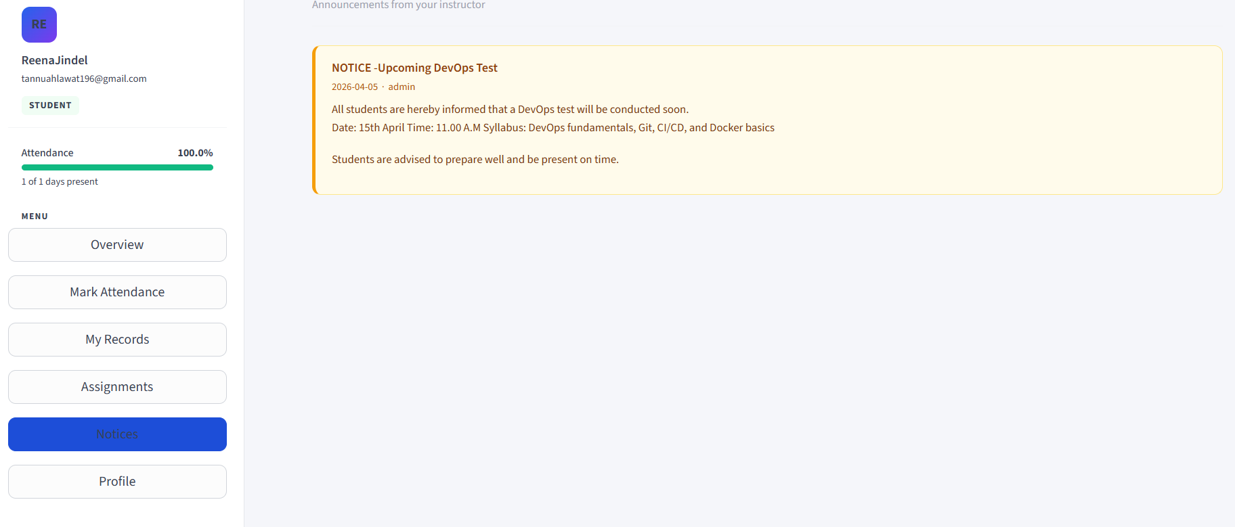

4.7 Profile
The student's account information and password management page.
- Avatar card: Initials badge, username, email, Student role pill, and "Member since" date.
- Change Password form: requires Current Password (verified against stored hash), New Password, Confirm New Password. Updates the hash in the database on success.
- Right-side stat column: Total Days, Present count, Attendance Rate — a compact read-only view.

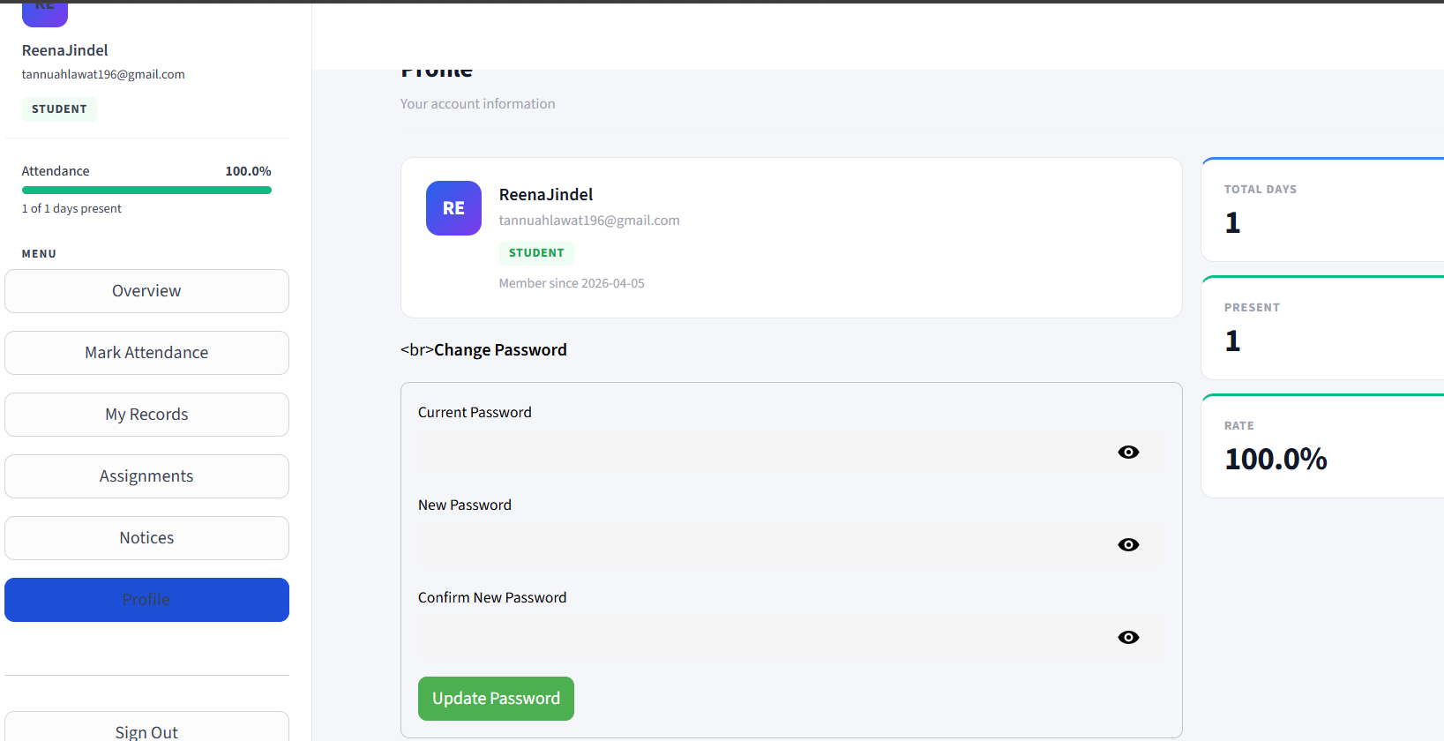

5. Administrator Portal
Administrators access a completely separate set of pages via their own sidebar. The admin avatar uses a red gradient badge and displays an "Administrator" red role pill. Admins have full read/write access to all data.
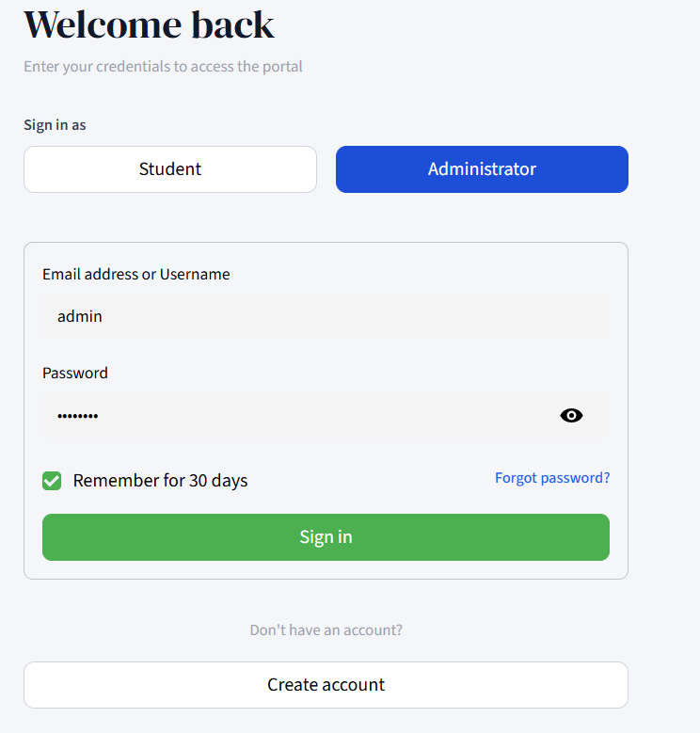

5.1 Admin Sidebar
- Navigation links: Dashboard, Students, Attendance Records, Mark Attendance, Assignments, Notices, Manage Admins, Sign Out.
- Red avatar gradient distinguishes admin accounts visually from student accounts.
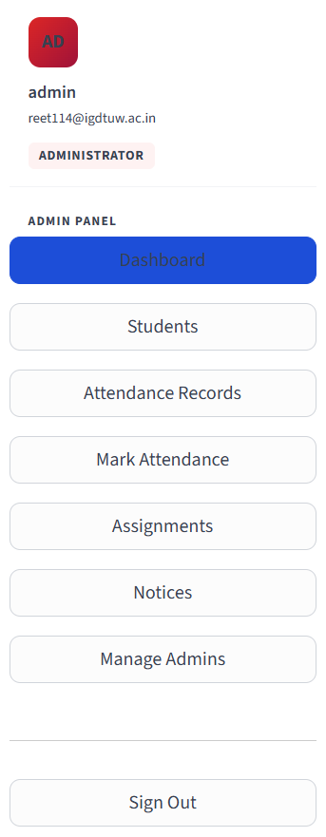

5.2 Admin Dashboard
The main overview page for administrators, showing the state of the entire system at a glance.
Summary Stat Cards (4 across)
- Total Students — count of all registered student accounts.
- Present Today — count of students who have marked attendance today, with a sub-label showing the total.
- Today's Rate — today's attendance percentage (colour-coded green/amber/red).
- Assignments — total number of assignments currently in the system.
Absent Today Panel
- A red-tinted box listing the names of all students who have NOT marked attendance today, showing up to 12 names with an overflow count.
Student Attendance Summary Table
- A full table of all students with columns: Username, Email, Total Days, Present, Attendance %. The Attendance % column is colour-coded inline (green/amber/red) for quick visual scanning.

5.3 Students
A searchable directory of all registered students with per-student detail expansion.
- Search bar: Filters students by name or email in real time.
- Student count shown above the list.
- Each student is an expandable row showing: three stat cards (Total Days, Present, Rate), a colour-coded attendance bar, and a full attendance history table (Date, Time, Status, Marked By).
- Download CSV button: exports that student's full attendance record as USERNAME_attendance.csv.
- Remove student button: permanently deletes the student account and all their attendance records from the database.
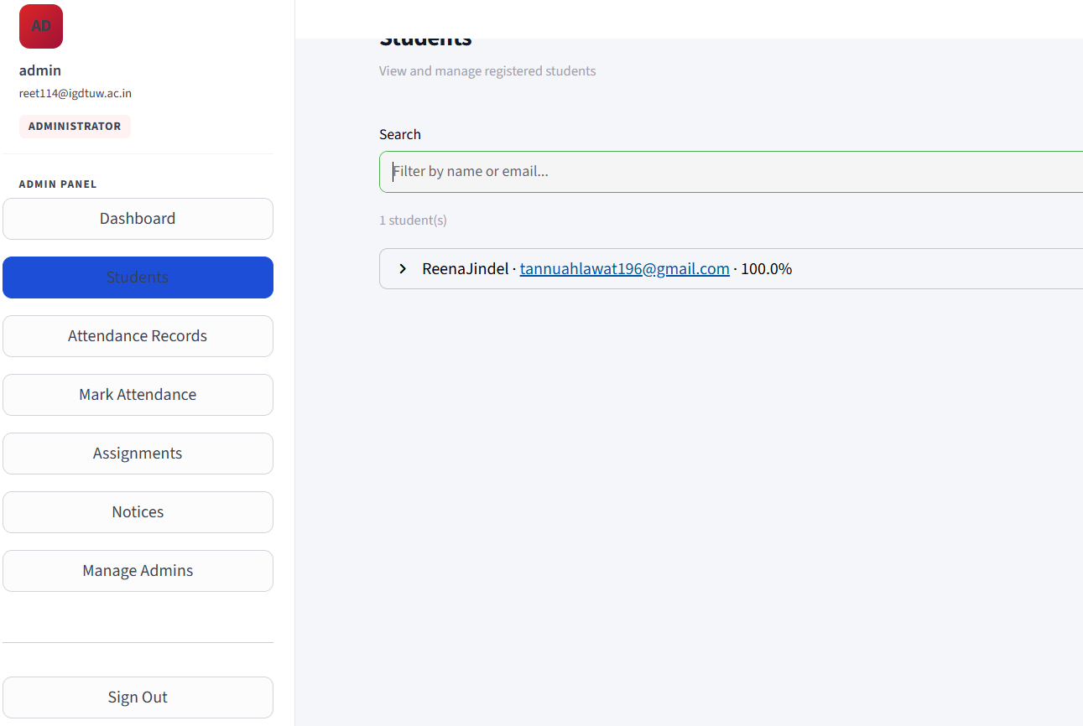

5.4 Attendance Records
A complete, filterable, exportable log of every attendance record across all students.
- Three filter controls: Student dropdown (All or specific username), Date picker, Month dropdown (All or 01–12).
- Filters are combinable — e.g., filter by student AND month.
- Record count shown dynamically as filters change.
- Full data table: Username, Email, Date, Time, Status, Marked By.
- Download CSV button: exports the full filtered dataset as attendance_export.csv.

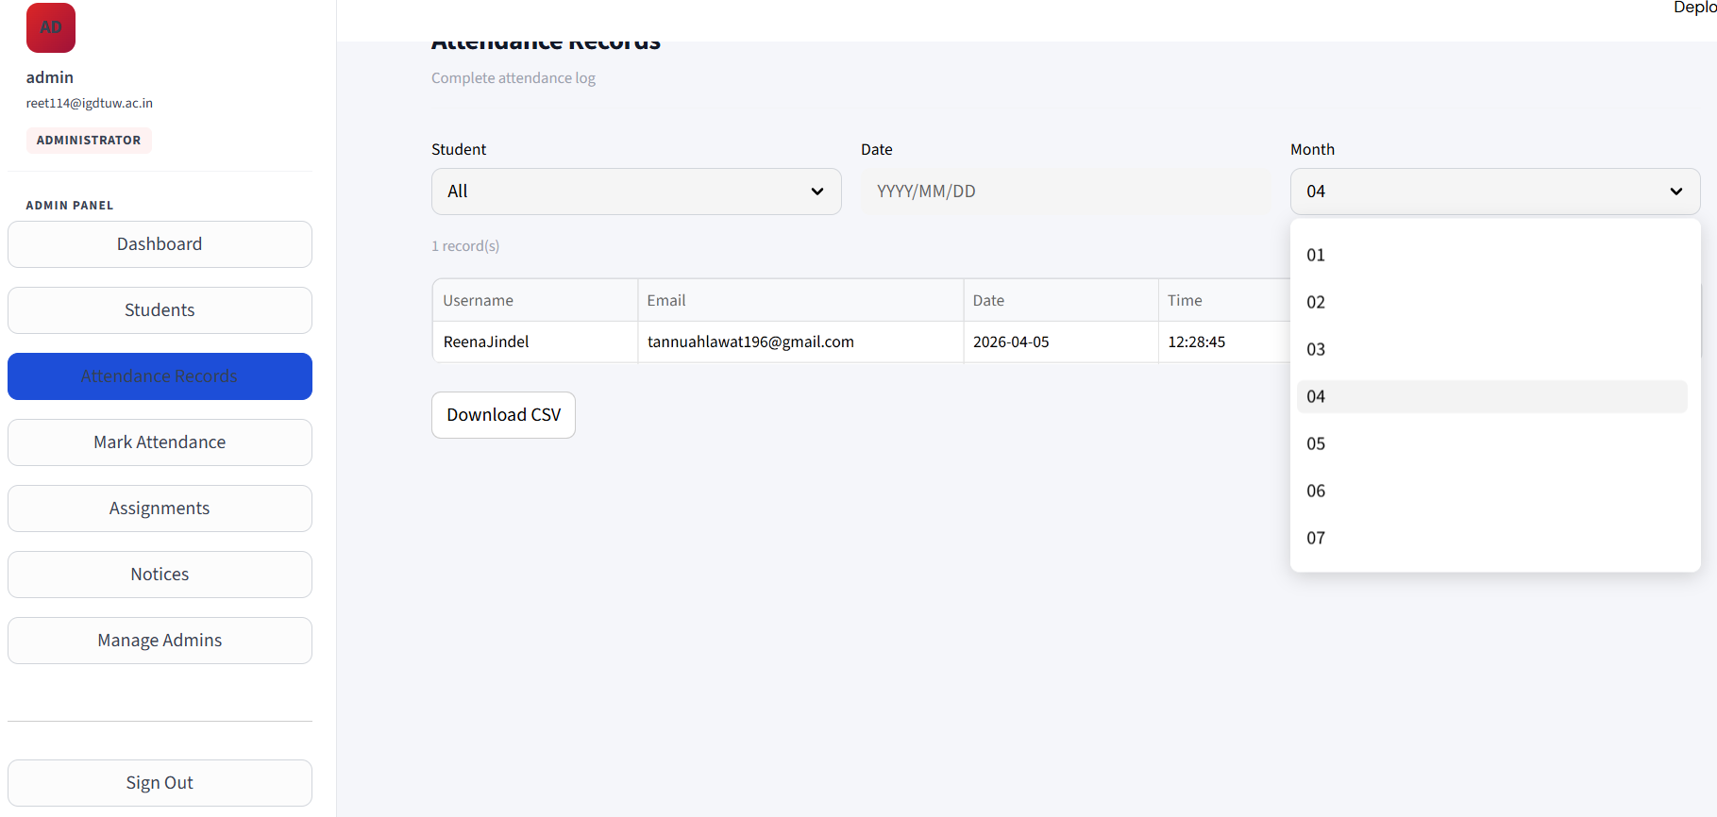

5.5 Mark Attendance (Admin)
Allows an administrator to record attendance on behalf of any student, for any past or current date.
- Student selector: Dropdown of all registered student usernames.
- Date picker: Defaults to today; maximum date is today (cannot mark future attendance).
- Mark as Present button: Inserts the attendance record with marked_by set to the admin's username.
- Recent records table: Shows the selected student's last 15 attendance records immediately below, updating after marking.
- Duplicate protection: The UNIQUE(user_id, date) constraint prevents double-marking; a warning is shown if a record already exists.

5.6 Assignments (Admin)
A two-tab interface for creating and managing assignments.
Upload Assignment tab
- Form fields: Title (required), Description/Instructions (text area), Due Date (date picker), File attachment (optional, any file type).
- Attached files are saved to the local uploads/ directory.
- On submission, the assignment is saved to the database and the page refreshes.
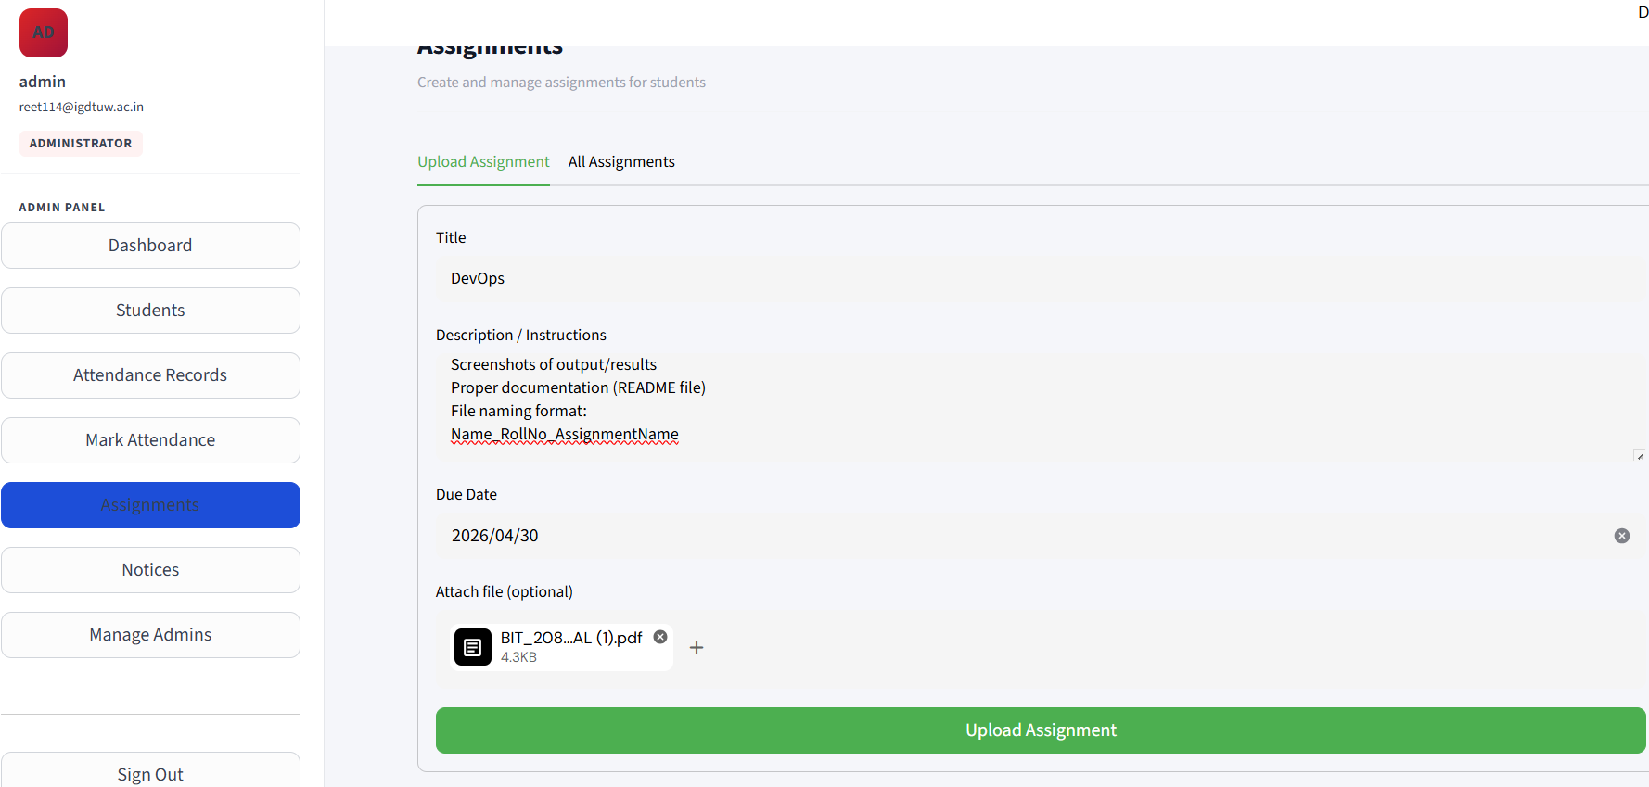
All Assignments tab
- Lists every assignment in an expandable accordion showing title, due date, creation date, description, poster name, and a Download button if a file was attached.
- Delete button: Removes the assignment record and deletes the file from disk if it exists.
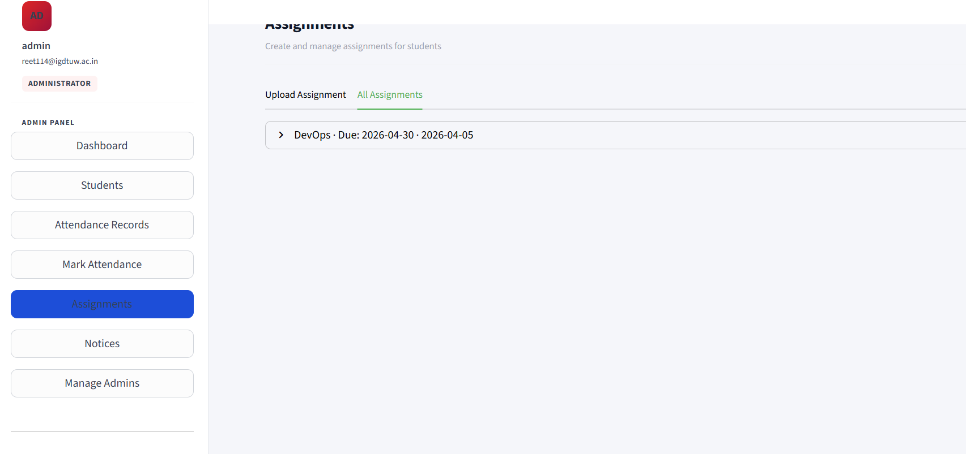

5.7 Notices (Admin)
A two-tab interface for posting and managing notices.
Post Notice tab
- Form fields: Title (required), Content body (required, text area).
- Posted notice is attributed to the admin's username.
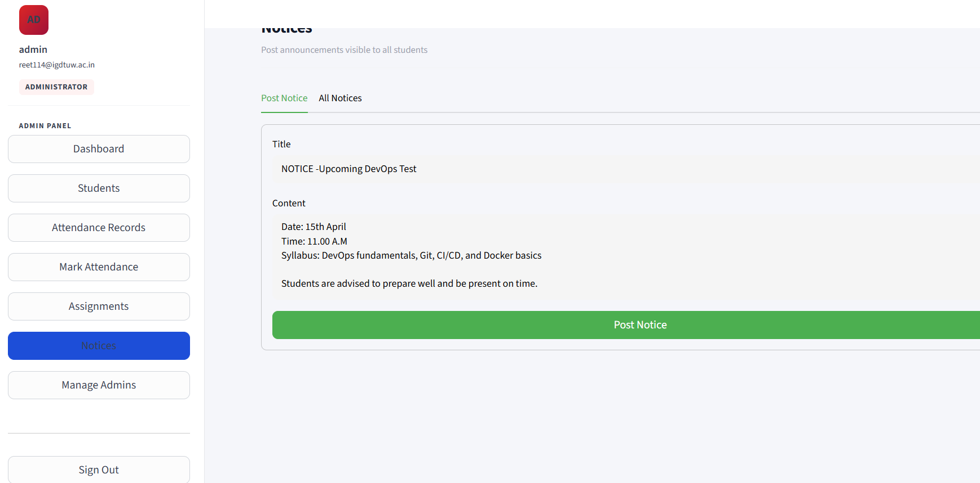
All Notices tab
- Lists every notice in an expandable accordion with title, post date, full body, and poster name.
- Delete button: Permanently removes the notice.
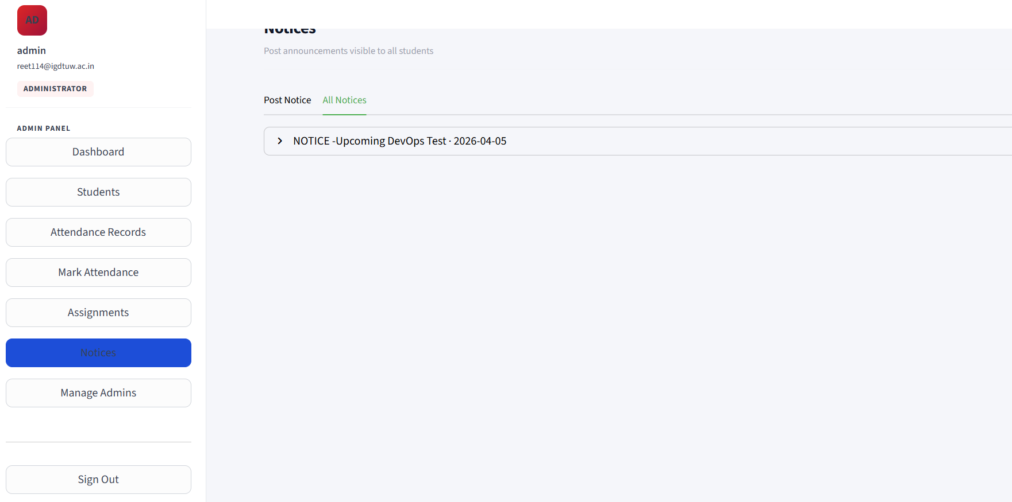

5.8 Manage Admins
A page exclusively for creating additional administrator accounts (not possible via the public signup page).
- Create Admin form: Username, Email, Password, Confirm Password — same validation rules as student signup, but creates an account with role='admin'.
- Current Administrators table: Lists all existing admin accounts with Username, Email, and Created date.
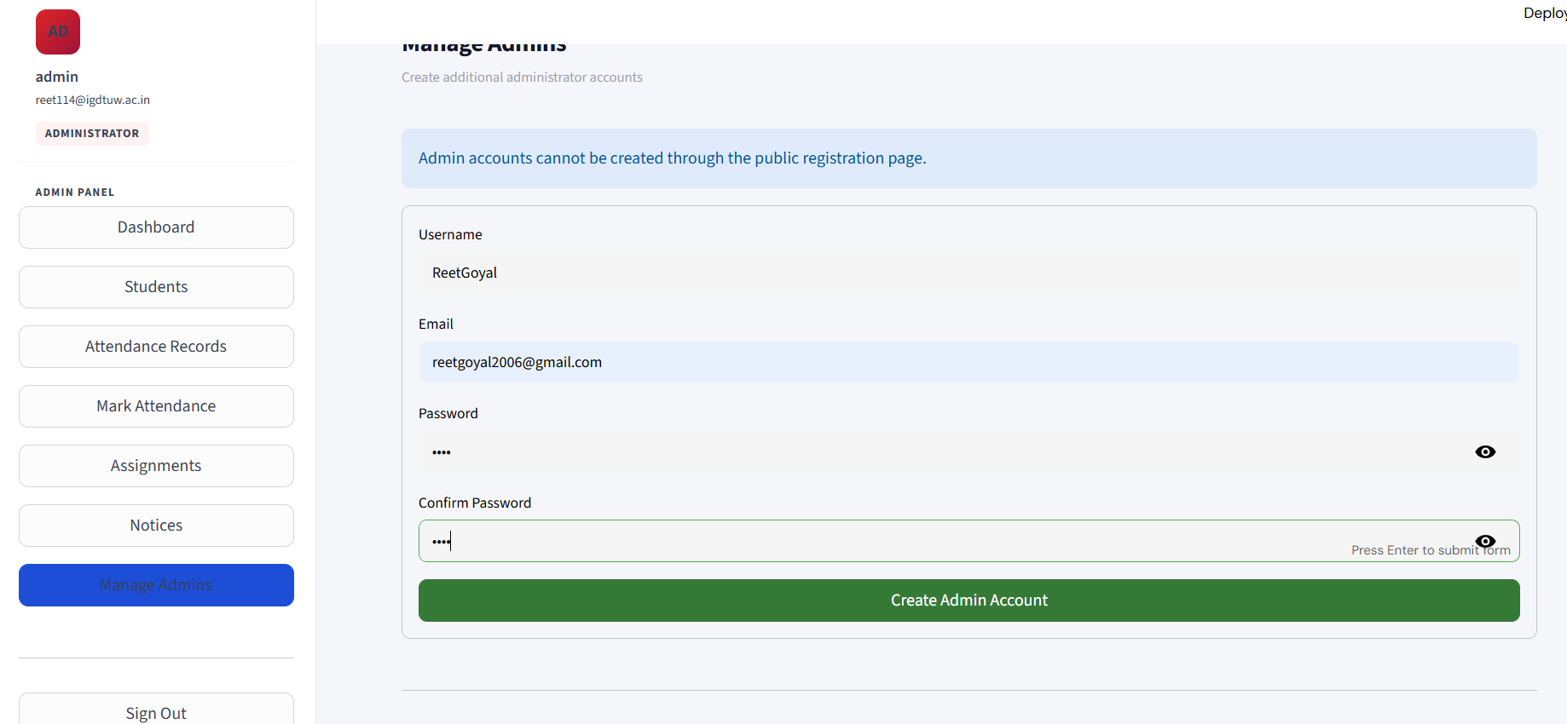

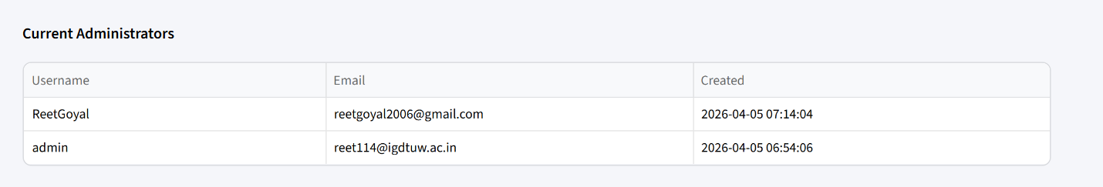

6. Security Considerations
Area | Implementation
Password storage | SHA-256 one-way hash — plain text never stored
SQL injection | All queries use parameterised statements (SQLite ?)
Role enforcement | Login checks role match client-side and server-side
Duplicate attendance | UNIQUE(user_id, date) constraint at DB level
Admin creation | Admin accounts cannot be self-registered — admin-only feature
Input validation | Username regex, email regex, password length — enforced in auth.py
File handling | Files saved to local uploads/ directory; paths stored in DB

Note: The default admin password (admin123) should be changed after first deployment. The SHA-256 algorithm, while functional, could be strengthened with bcrypt or Argon2 for production use.

7. Feature Summary
Feature | Student | Admin
Login / Logout | Yes | Yes
Self-registration | Yes | No (admin-created only)
Mark own attendance (today) | Yes | —
Mark attendance for any student / date | — | Yes
View own attendance records | Yes | —
View all students' attendance records | — | Yes
Filter & export attendance CSV | Own records only | All records, with filters
View assignments | Yes | Yes
Upload / delete assignments | — | Yes
View notices | Yes | Yes
Post / delete notices | — | Yes
View own profile & change password | Yes | —
Create admin accounts | — | Yes
Delete student accounts | — | Yes
Absent-today dashboard panel | — | Yes
30-day attendance trend chart | Yes | —
Due-soon assignment badge | Yes | Yes

8. Setup & Deployment

Prerequisites
- Python 3.8+ with pip
- pip install streamlit pandas

Running the Application
streamlit run main.py
The database (attendance.db) and uploads/ directory are created automatically on first run. The default admin account is seeded if no admin exists.

Resetting the Admin Account
python admin.py
This re-creates the admin account with username admin and password admin123. Change the password immediately after running.

