REELVAULT CINEMA
DBMS MINI PROJECT
Cinema Hall Movie
Ticket Booking System
A functional relational database and web application

PROJECT REPORT
Prepared for Database Management Systems
GROUP MEMBERS | [Enter names and roll numbers]
FACULTY | [Enter faculty name]
CLASS / DIVISION | [Enter class and division]
ACADEMIC YEAR | 2026-2027

PROJECT STACK Python + Flask · SQLite · HTML/CSS/JavaScript · SQL joins, constraints, indexes, triggers and transactions

01 Project Overview

Abstract
ReelVault Cinema is a database-driven web application for managing a cinema hall's movie catalogue, screens, seats, show schedules, customer details, ticket bookings and simulated payments. The prototype uses Python and Flask for the application layer and SQLite as its relational database. It supports seat selection, ticket confirmation, booking lookup, cancellation, catalogue administration and management reports. The core DBMS objective is to keep information normalized while enforcing referential integrity and preventing two active bookings for the same seat and show.

Problem Definition
Manual ticket booking can produce duplicate seat allocations, inconsistent totals, repeated customer information and slow reporting. A cinema needs one reliable source of truth for movies, screens, seats, scheduled shows, customers, reservations, tickets and payments. This project replaces informal tracking with a relational database and an interactive booking workflow. A seat is unavailable only when an active ticket exists for that particular show-seat combination.

Objectives
- Design a normalized relational database for cinema ticket booking and document it using an ER diagram.
- Implement create, read, update, cancellation and eligible deletion operations.
- Display showtime-based availability and calculate seat prices by seat type.
- Prevent duplicate active bookings with transactions, constraints and a unique index.
- Demonstrate joins, aggregate queries, a subquery, triggers, foreign keys and indexes.
- Produce reports for bookings, tickets sold, ticket revenue and screen occupancy.

Scope and Assumptions
The sample data uses fictional films and demo customers. The app seeds three screens with 48 seats each and fourteen days of showtimes on first launch. UPI, card and cash choices record a simulated payment result; no real payment gateway is called and no real money is charged. The admin page is for local classroom evaluation, not production use.
DESIGN PRINCIPLE The browser provides convenience, but the database is the final authority. A selected seat is checked again inside a write transaction and protected by a partial unique index.

02 Functional and Technical Design

Main Modules
MODULE | USER ACTION | DATABASE WORK
Movie catalogue | Browse films and upcoming times | SELECT from movies, shows and screens using JOINs
Seat selection | View availability and choose 1-8 seats | Query seats and active tickets for the selected show
Booking | Submit name, email, phone and payment method | Upsert customer; INSERT booking, ticket rows and payment in one transaction
Ticket / lookup | Retrieve booking by ID and email | JOIN booking, customer, show, movie, screen, tickets and payment
Cancellation | Cancel using the matching booking email | Update booking and ticket statuses; mark simulated payment refunded
Reports | Inspect bookings, sales and occupancy | COUNT, SUM, GROUP BY, LEFT JOIN and subquery logic
Admin | Add/edit/delete eligible movies; schedule/cancel shows | INSERT, UPDATE, DELETE and transaction-based show cancellation

Technology Stack
- Frontend: HTML templates, responsive CSS and JavaScript for movie filtering and live seat-total calculation.
- Backend: Python and Flask route handlers for browsing, booking, lookup, cancellation, reports and admin tools.
- Database: SQLite with foreign-key enforcement, checks, unique constraints, indexes and triggers.
- Persistence: local file at `instance/cinema.db`, created and seeded automatically on first launch.

Typical Booking Workflow
1 SELECT SHOW | 2 SELECT SEATS | 3 VALIDATE | 4 SAVE ATOMICALLY | 5 CONFIRM
Movie + show data | Seat map + price | Check customer and availability | Customer + booking + tickets + payment | Booking ID + receipt
The selected-seat total is a convenience for the user. Before saving, the backend rechecks seat availability inside `BEGIN IMMEDIATE`; it commits only when all related rows are inserted successfully.

Functional Requirements Covered
- Problem definition and objectives
- Database design and ER diagram
- Tables, primary/foreign keys and relationships
- SQL selection, insertion, update, deletion, join and aggregate operations
- Data insertion/retrieval through the interface
- Functional output via booking confirmation and reports
- Conclusion and future scope

03 Database Design
The schema contains eight core relations. The data dictionary below summarizes each table; the exact SQL data types, constraints, indexes and triggers are defined in `schema.sql`.
TABLE | KEYS | IMPORTANT ATTRIBUTES | PURPOSE / RULE
movies | PK: movie_id | title, genre, language, duration_minutes, certificate, release_date, description | Stores each film once. Duration must be positive.
screens | PK: screen_id | screen_name, total_seats | Represents each physical screen; name is unique.
seats | PK: seat_id; FK: screen_id | seat_number, seat_type | Stores individual REGULAR, PREMIUM and RECLINER seats. Seat number unique within a screen.
shows | PK: show_id; FKs: movie_id, screen_id | show_date, start_time, base_price, status | Connects one film to one screen at a date/time. Screen/date/time is unique.
customers | PK: customer_id | full_name, email, phone | Email is unique case-insensitively, so one email maps to one customer.
bookings | PK: booking_id; FKs: customer_id, show_id | booking_time, status, total_amount | Represents one customer's booking for one show. Amount cannot be negative.
tickets | PK: ticket_id; FKs: booking_id, show_id, seat_id | seat_price, status | One record per seat. Active (show, seat) is unique; cancelled ticket history is retained.
payments | PK: payment_id; FK: booking_id UNIQUE | amount, payment_method, payment_status, transaction_ref | At most one simulated payment per booking; transaction reference is unique.

Integrity Rules
- Foreign keys prevent orphaned records and prevent deleting a movie still referenced by a show.
- CHECK constraints restrict valid seat types, booking/payment statuses and non-negative amounts.
- UNIQUE constraints prevent duplicate screen showtimes, seat names within a screen, customer email and payment references.
- The ticket trigger verifies that the ticket belongs to the booking's show and that the selected seat belongs to the screen hosting that show.
- A partial unique index on active tickets `(show_id, seat_id) WHERE status = 'BOOKED'` prevents an active seat double-booking while allowing rebooking after cancellation.
NORMALIZATION Movie, screen, seat, customer, booking, ticket and payment facts are separated by entity. Multiple selected seats are stored as multiple ticket rows rather than a comma-separated field, reducing repeated data and update anomalies.

04 Entity-Relationship Diagram
The diagram represents the eight core tables and their primary relationships. `PK` identifies the primary key; `FK` identifies a foreign key. The full-size source files are included in `docs/erd.dot`, `docs/erd.svg` and `docs/erd.png`.
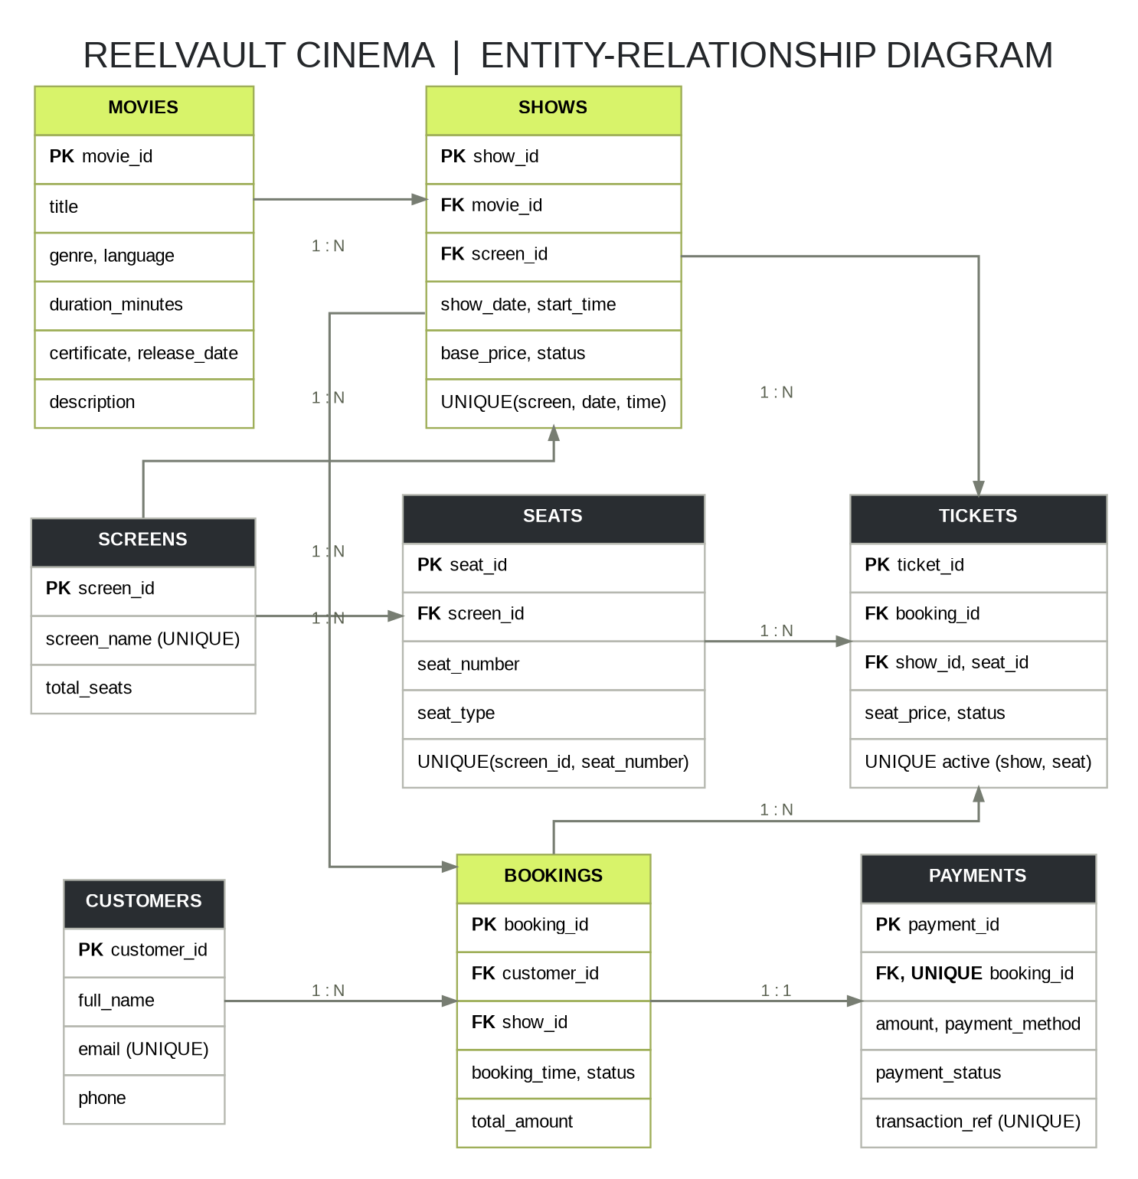
Figure 1. ReelVault Cinema entity-relationship diagram

Relationship Summary
RELATIONSHIP | CARDINALITY | MEANING
movies → shows | 1 : N | One film can be scheduled in many shows.
screens → seats / shows | 1 : N | A screen contains seats and hosts many non-overlapping shows.
customers → bookings | 1 : N | One customer can make multiple bookings.
shows → bookings / tickets | 1 : N | Many reservations and seat tickets can be associated with one show.
bookings → tickets | 1 : N | One booking can reserve several individual seats.
bookings → payments | 1 : 1 | Each booking can have at most one payment row.

05 SQL Queries and Database Operations
The accompanying `sql_queries.sql` contains runnable SELECT examples and commented CRUD/transaction examples. User-submitted values in the application are passed as SQL parameters instead of being concatenated into SQL text.

Example 1: Movie and Show Retrieval (JOIN)
SELECT sh.show_id, m.title, sh.show_date, sh.start_time,
sc.screen_name, sh.base_price
FROM shows sh
JOIN movies m ON m.movie_id = sh.movie_id
JOIN screens sc ON sc.screen_id = sh.screen_id
WHERE sh.status = 'SCHEDULED'
ORDER BY sh.show_date, sh.start_time;

Purpose: display each scheduled show with its film title and screen. The join prevents movie/screen details from being duplicated in every show record.

Example 2: Revenue by Movie (GROUP BY)
SELECT m.title, COUNT(t.ticket_id) AS seats_sold,
ROUND(COALESCE(SUM(t.seat_price), 0), 2) AS revenue
FROM movies m
LEFT JOIN shows sh ON sh.movie_id = m.movie_id
LEFT JOIN bookings b ON b.show_id = sh.show_id AND b.status = 'CONFIRMED'
LEFT JOIN tickets t ON t.booking_id = b.booking_id AND t.status = 'BOOKED'
GROUP BY m.movie_id, m.title
ORDER BY revenue DESC;

Purpose: provide ticket-sales reporting for every film, including films that do not yet have a confirmed booking.

Example 3: Seat Availability (EXISTS)
SELECT s.seat_number,
CASE WHEN EXISTS (
SELECT 1 FROM tickets t
WHERE t.show_id = ? AND t.seat_id = s.seat_id
AND t.status = 'BOOKED'
) THEN 'BOOKED' ELSE 'AVAILABLE' END AS seat_status
FROM seats s
JOIN shows sh ON sh.screen_id = s.screen_id
WHERE sh.show_id = ?;

Purpose: show the live state of each seat for the selected show. The application uses the same pattern for its seat map.

CRUD and Other SQL Features
- CREATE: add movie/screen/seat/show/customer/booking/ticket/payment rows.
- READ: SELECT with filtering, ordering and joins for the catalogue, ticket and reports.
- UPDATE: edit movie details; update booking, ticket and payment statuses on cancellation.
- DELETE: delete unused movie records. A foreign-key constraint blocks deletion of referenced films.
- Other constructs: `COUNT`, `SUM`, `ROUND`, `COALESCE`, `GROUP_CONCAT`, `NOT EXISTS`, indexes and triggers.

06 Data Insertion, Transactions and Testing

Data Insertion and Retrieval
On first launch the program applies `schema.sql` and seeds six fictional films, three screens, 144 seats, fourteen days of shows and three clearly labelled sample bookings. Those bookings create customer, booking, ticket and payment records so that the reporting page has non-zero example results. The database persists at `instance/cinema.db`.

Atomic Booking Transaction
- Validate customer details, payment method and 1-8 selected seat identifiers.
- Start `BEGIN IMMEDIATE` to take a write reservation before rechecking availability.
- Verify that every chosen seat belongs to the screen hosting the show and that no active ticket exists for it.
- Insert/update the customer, insert one booking row, insert one ticket per seat and insert one simulated payment row.
- Commit all writes together. If a uniqueness or database rule fails, roll back so no partial booking remains.
DOUBLE-BOOKING PROTECTION Application-level rechecking improves the message shown to a user. The database-level partial unique index remains the final safeguard if two requests arrive close together.

Cancellation Behavior
A customer must provide the email associated with the booking. The app marks the booking and its active ticket rows as `CANCELLED` and sets the simulated payment to `REFUNDED`. It retains historical rows for audit and frees the seats for rebooking because the uniqueness index applies only to active (`BOOKED`) tickets.

Automated Database Tests
TEST | EXPECTED DATABASE BEHAVIOR | RESULT
Core table/FK setup | All eight tables exist and foreign keys are enabled. | PASS
Duplicate show slot | Reject second show on same screen/date/start. | PASS
Duplicate active seat | Reject second active ticket for same show-seat pair. | PASS
Cancellation / rebooking | Cancelled ticket remains in history and seat can be rebooked. | PASS
Wrong-screen seat | Ticket trigger rejects a seat from another screen. | PASS
Referenced movie deletion | Foreign key blocks deletion when a show references the film. | PASS
Duplicate customer email | Case-insensitive unique email rejects duplicate customer. | PASS
Verified in the project environment with `python -m unittest discover -s tests -v`: all 7 SQLite integrity tests passed. These tests cover database rules directly; manual browser demonstration should still be performed on the target laptop before evaluation.

07 Output, Demonstration and Conclusion

Live Demonstration Checklist
- Home: show movie cards and scheduled dates/times.
- Seat map: choose a show and demonstrate regular, premium and recliner seat pricing.
- Booking output: confirm a booking and explain the database booking ID, seat list and transaction reference.
- Integrity: open the same show again and demonstrate the selected seat is unavailable.
- Reports: explain confirmed bookings, active tickets, simulated collection, per-film revenue and show occupancy.
- Cancellation: cancel a booking using its matching email and demonstrate that the seat is released.
- Admin: edit a movie, add a show, cancel a show, and try deleting a referenced film to demonstrate foreign-key protection.

Output Evidence
Capture screenshots from the live local application if your faculty requires visual output evidence. Recommended screenshots are the home catalogue, seat map, successful ticket confirmation, reports page and admin operations. Screenshots should come from the actual running project, not a design mockup.

Limitations and Future Scope
The admin page has no login, customer data is not encrypted, and payment processing is simulated. This application is an academic prototype. Future work could add role-based authentication, password hashing, CSRF protection, OTP/email notifications, a real payment gateway, expiring seat locks, backups, promotion codes and a production database server.

Conclusion
ReelVault Cinema demonstrates how a real-world ticketing problem can be modeled with a relational database and a functional web interface. It applies normalization, primary and foreign keys, unique and check constraints, indexes, triggers, transactions, CRUD operations, joins, aggregate queries and subqueries. The resulting prototype keeps booking data consistent, prevents duplicate active seat allocations and generates useful operational reports.

Project Files
- `app.py` - Flask routes and booking/business logic.
- `schema.sql` - table definitions, constraints, indexes and triggers.
- `sql_queries.sql` - query demonstration set for SQL evaluation.
- `docs/erd.png`, `docs/erd.svg`, `docs/erd.dot` - ER diagram outputs and source.
- `README.md` and `DEMO_GUIDE.md` - installation, live demonstration and viva support.
ACADEMIC USE The sample titles, sample customers and payment references are fictional. Replace the report cover placeholders with the actual group members, roll numbers, class, faculty name and any institution-specific details before submission.

