TASKY

OVERVIEW:
TASKY is a web-based task organization and assignment system designed to help individuals or teams create, assign, track, submit, and manage tasks from one place. It combines task management with a calendar-based view so users can easily plan their work and see upcoming deadlines.

Core Features
- Dashboard:
- Overview of total tasks
- Pending, in-progress, completed, and overdue tasks
- Upcoming deadlines and notifications
- Task Creation & Assignment
  - Create a task with:
    - Task title
    - Description/notes
    - Priority
    - Assignee
    - Start date
    - Due date
    - Status
    - Attachments, if required
  - Assign tasks to specific users/team members.
  - Reassign or update tasks when necessary.
- Task Submission
  - Assigned users can open a task and work on it.
  - Submit the completed task.
  - Add comments, notes, or attachments while submitting.
  - Task status can move through Pending → In Progress → Submitted → Completed.
- Notifications
  - Notify users when a task is assigned.
  - Notify users when a task is updated or reassigned.
  - Deadline/reminder notifications.
  - Notify the task creator when an assigned task is submitted.
  - Notifications can appear inside the web application and optionally through email.
- Calendar
  - Display tasks directly on a calendar.
  - Tasks can appear according to their start date and due date.
  - Different colors can represent task status or priority.
  - Users can switch between:
    - Monthly view
    - Weekly view
    - Daily view
  - Clicking a calendar task opens its details.
  - Users can create or edit tasks directly from a calendar date.
- Task Notes
  - Users can add notes to individual tasks.
  - Notes can contain progress updates, reminders, or additional instructions.
  - Task notes remain associated with the task for future reference.

LANGUAGES USED:

- Frontend: HTML, CSS, JavaScript
- Backend: Python Flask
- Database: MySQL
- SQL library: mysql-connector-python or SQLAlchemy
- Calendar: FullCalendar.js
- Notifications: Flask + database notifications, with optional email

Python Flask
│
┌──────────┼──────────┐
↓ ↓ ↓
Users Tasks Notifications
│
┌─────────┴─────────┐
↓ ↓
Notes Submissions
│ │
└─────────┬─────────┘
↓
Calendar
│
↓
MySQL
PROBLEM STATEMENT:
Managing and assigning tasks manually can lead to missed deadlines and poor task tracking.
Users need a centralized system to create, assign, update, and submit tasks efficiently.
The system should provide notifications and display tasks with deadlines on a calendar.
This project aims to improve task organization, communication, and productivity through a web-based Task Assigner.
PROPOSED SOLUTION:
The proposed system is a web-based Task Assigner that allows users to create, assign, update, and submit tasks in one platform.
It provides notifications for task assignments, updates, and upcoming deadlines.
Tasks and deadlines are displayed on an integrated calendar for easy scheduling and tracking.
The system helps improve task organization, communication, monitoring, and overall productivity.
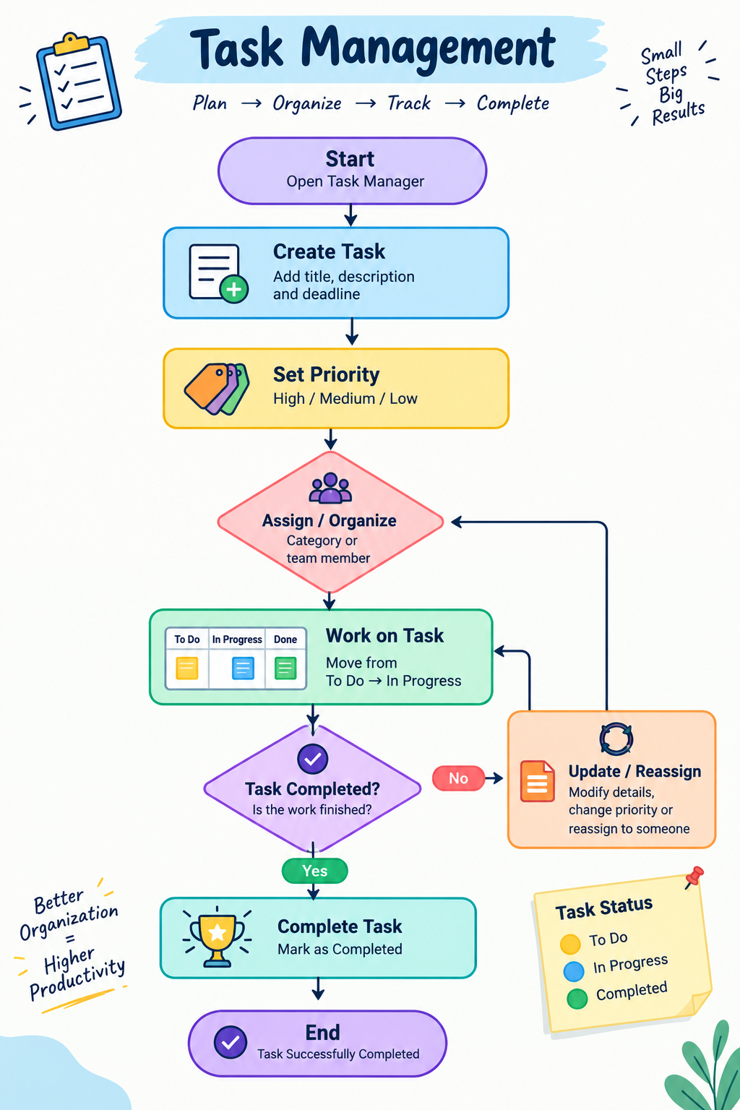

Advantages
- Easy to create, assign, and track tasks.
- Sends notifications for task assignments and deadlines.
- Calendar helps users manage tasks and schedules.
- Improves communication and productivity.

Disadvantages
- Requires internet access to use the web application.
- Users need to update task status regularly.
- System maintenance and database management are required.
- Notification delivery may depend on the network or email service.

Modules
- Login Module – User login and authentication.
- Task Module – Create, assign, edit, and delete tasks.
- Notification Module – Send task and deadline notifications.
- Calendar Module – Display tasks and deadlines on the calendar.
- Submission Module – Submit completed tasks and update status.
- Dashboard Module – View pending, completed, and upcoming tasks.

1. Login Module
Allows users to login securely using their username/email and password. Different users can have different roles such as admin, task assigner, or member.

2. Task Module
Allows the task assigner to create and assign tasks to users. Tasks can include a title, description, priority, start date, and deadlines.

3. Notification Module
Sends notifications when a new task is assigned, a task is updated, or a deadline is approaching.

4. Calendar Module
Displays assigned tasks and their deadlines on a calendar. Users can easily view their daily, weekly, or monthly tasks.

5. Submission Module
Allows users to update the task status and submit completed tasks. The assigner can review the submission and mark the task as completed.

6. Dashboard Module
Provides a simple summary of tasks, such as pending, completed, in-progress, and overdue tasks, so users can quickly understand their workload.

COSTUMER REVIEW:

Review 1: Very effective and efficient web easy to assign task and very easy to submit the task

Review 2: very good theme design ,looking neet ad presentable .easier access to all the task boxes and dashboard is very useful

Review 3: uploading profile picture is an amazing feature and after the task completion the assignment gets strikeout from the calendar

OUTPUT:

