Milestone-1 Assessment – Front-End Development
E-Commerce Product Management System
Name: Reethu M
Technologies Used: HTML5, CSS3, Bootstrap 5, JavaScript (ES6), TypeScript

1. Objective
The objective of this milestone assessment is to design and implement a functional, responsive, and data-driven E-Commerce Product Management Interface. The assessment evaluates front-end structuring, responsive UI design, dynamic data handling using JavaScript, and modular programming using TypeScript.

2. Project Structure
/ECommerceAssessment/
├── userstory1/
│ ├── index.html
│ ├── style.css
├── userstory2/
│ ├── products.html
│ ├── script.js
│ ├── products.json
├── userstory3/
│ ├── productManager.ts
│ ├── productManager.js
├── screenshots/
│ ├── home.png
│ ├── api_output.png
│ ├── ts_output.png
├── ECommerceAssessment.doc
3. User Story 1 – Product Showcase Home Page

Description
A responsive home page was created for an e-commerce portal showcasing featured products, category navigation, and a newsletter subscription form.

Features Implemented
- Semantic HTML5 structure using header, nav, main, section, and footer
- Responsive layout using Bootstrap grid system
- Product display using Bootstrap cards
- Newsletter subscription form with validation
- Hover effects using CSS transitions

Key Code Snippet
<section class="text-center">
<div class="card product-card">
<img src="https://picsum.photos/seed/backpack/600/400" class="card-img-top">
<div class="card-body">
<h5>College Backpack</h5>
<p>₹1299</p>
</div>
</div>
</section>

Output Screenshot
(home.png)
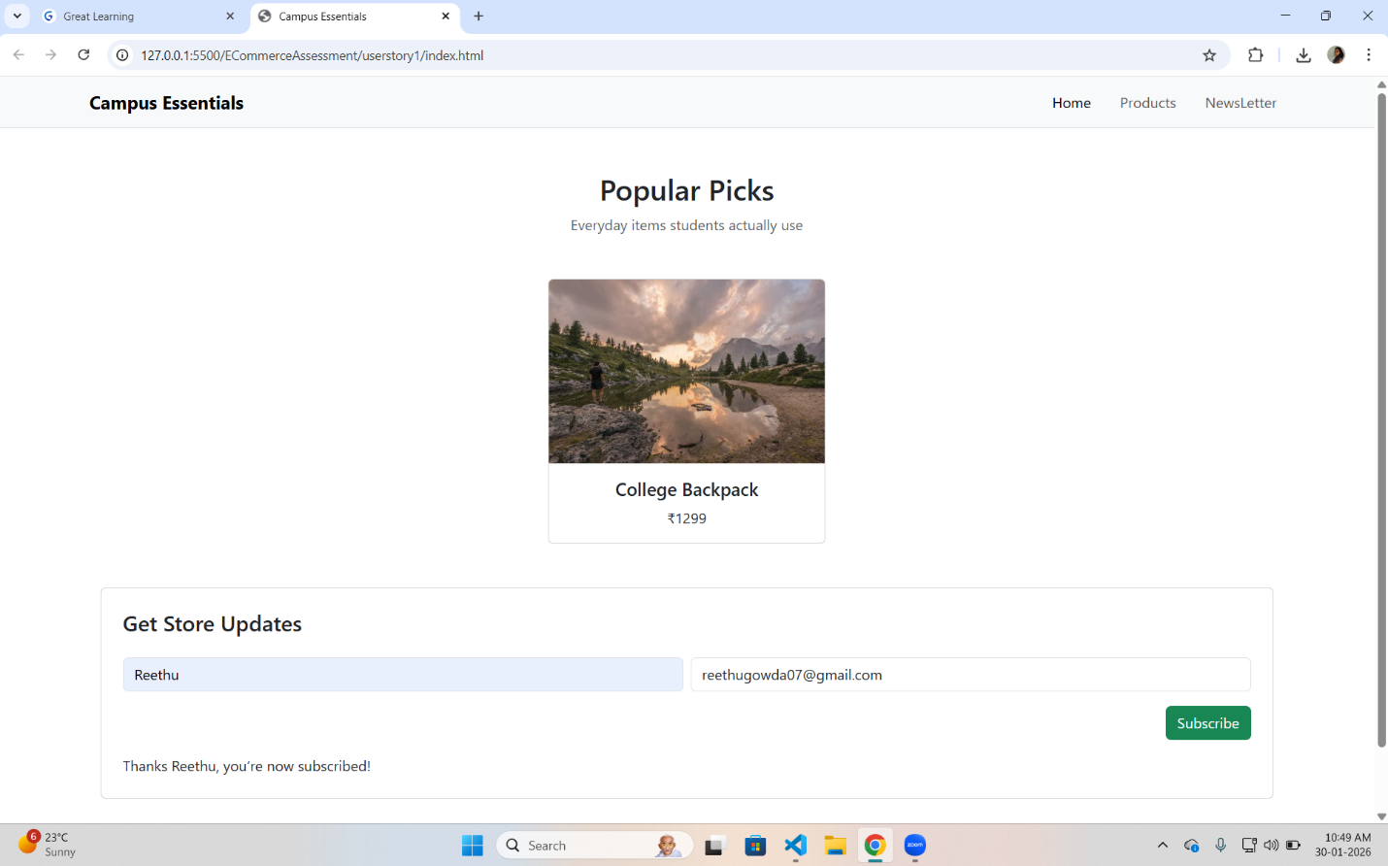

4. User Story 2 – Product Listing with API Fetch and Filtering

Description
A dynamic product listing page was developed that fetches product data from a mock API and allows users to filter and sort products.

Features Implemented
- Fetch API with async/await
- Error handling using try…catch
- Loading indicator during API calls
- Dynamic DOM manipulation to render products
- Category, price filtering, and sorting functionality
Key Code Snippet
async function loadProducts() {
try {
info.textContent = 'Loading products...';
const res = await fetch('products.json');
if (!res.ok) throw new Error('Fetch failed');
inventory = await res.json();
applyFilters();
} catch (error) {
info.innerHTML = '<div class="alert alert-danger">Failed to load products</div>';
}
}
Output Screenshot
(api_output.png)
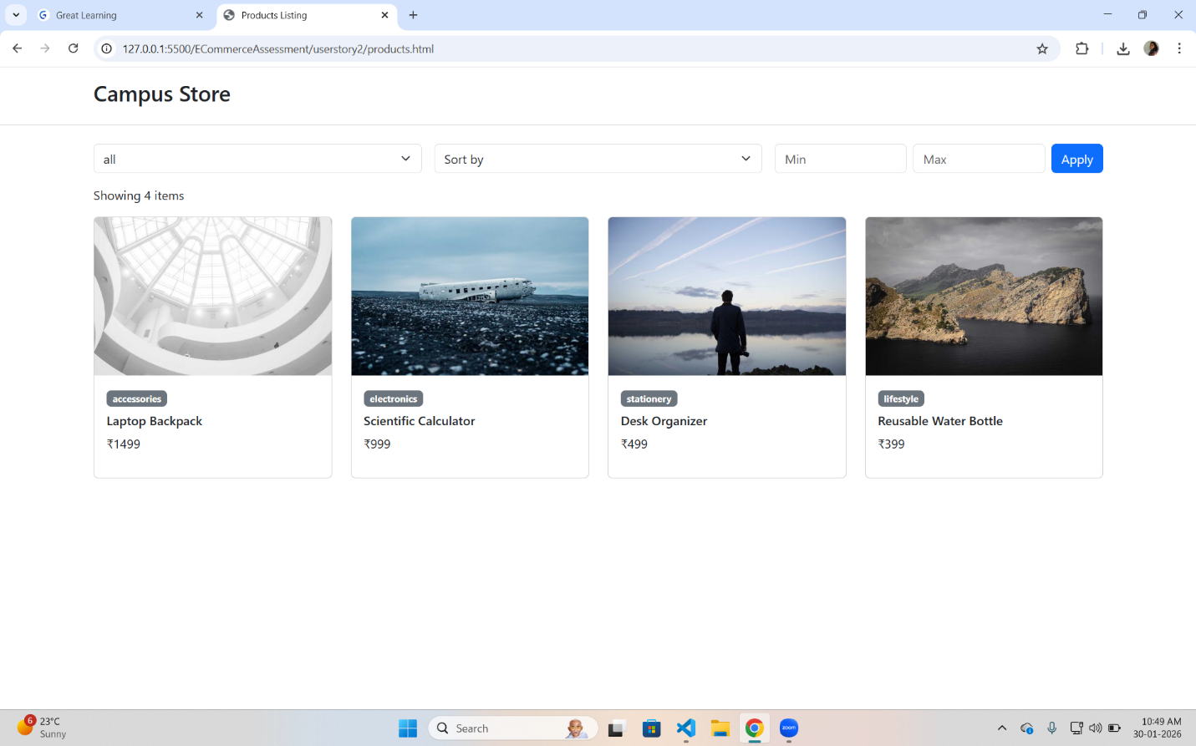
5. User Story 3 – Product Management Module (TypeScript)

Description
A TypeScript-based product management module was implemented to model and manage product inventory.

Features Implemented
- IProduct interface for product structure
- Product class implementing the interface
- Decorator to log changes in price and stock
- Product storage using Map
- Custom iterator using for…of

Key Code Snippet
@LogChange('price')
price!: number;
@LogChange('stock')
stock!: number;
Output Screenshot
(ts_output.png) 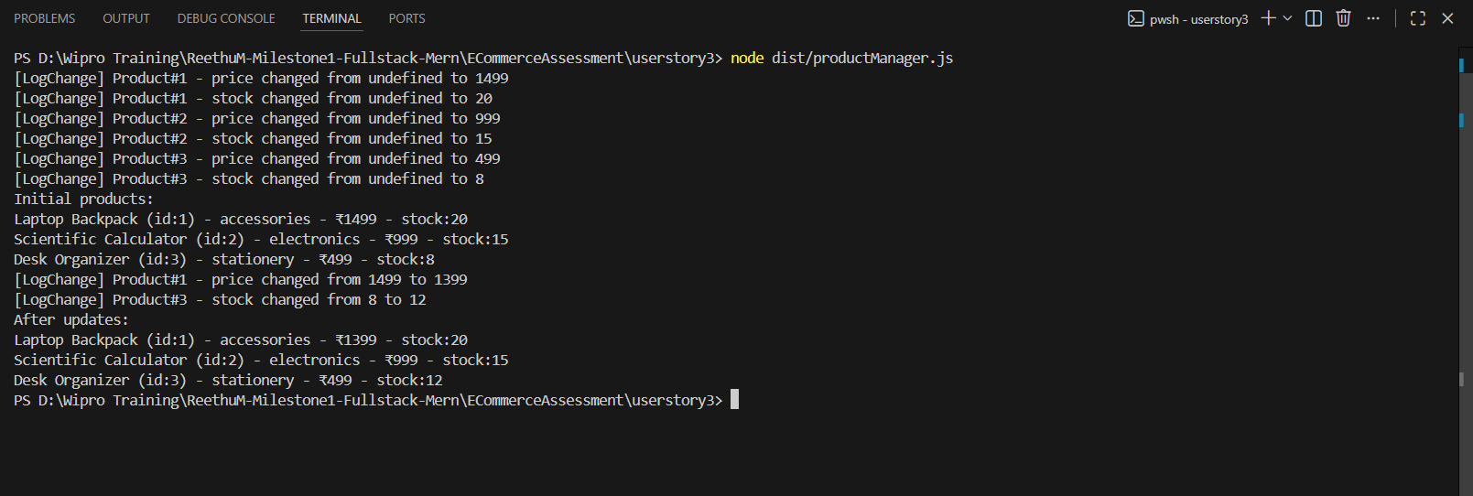

6. TypeScript Compilation
The project was compiled successfully using the following tsconfig.json configuration:
{
"compilerOptions": {
"target": "ES2016",
"module": "commonjs",
"strict": true,
"experimentalDecorators": true,
"outDir": "./dist"
}
}

7. Conclusion
All three user stories were implemented successfully according to the assessment guidelines. The project demonstrates strong understanding of responsive UI design, JavaScript-based data handling, and TypeScript object-oriented concepts. The application runs without dependency issues and meets all functional and technical requirements.

