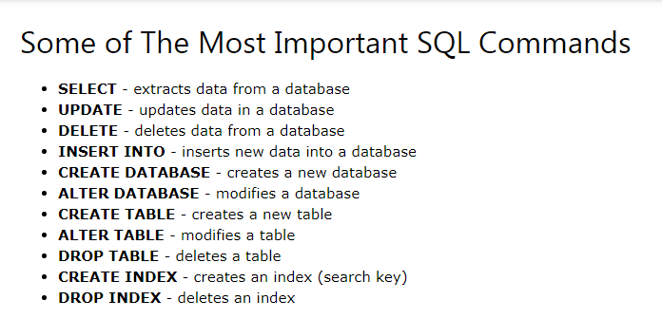

1. SELECT STATEMENT

The SELECT statement is used to select data from a database.

SELECT * FROM table_name;

SELECT count(*) from customers

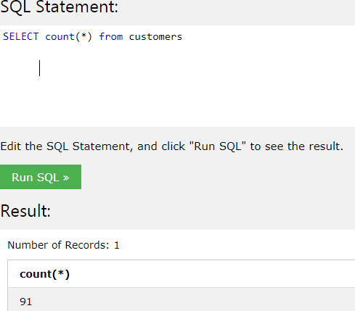

2. SELECT DISTINC:

The SELECT DISTINCT statement is used to return only distinct (different) values.[it will remove duplicate values]

SELECT DISTINCT column1, column2, ...  
FROM table_name;

SELECT DISTINCT Country FROM Customers;

SELECT COUNT(DISTINCT Country) FROM Customers;

## 3. The SQL WHERE Clause

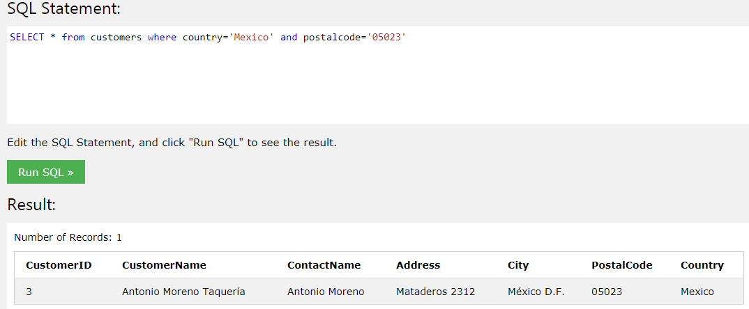

SELECT count(*) city from customers where country='Mexico'

SELECT city,address from customers where country='Mexico'

select * from customers where country='UK' or country='Mexico' and city='London'

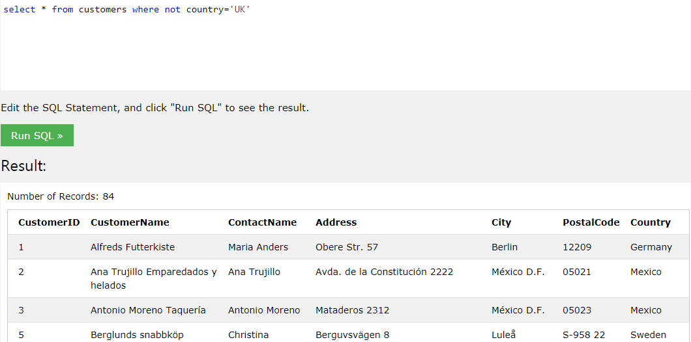

## 4. The SQL ORDER BY Keyword

The ORDER BY keyword is used to sort the result-set in ascending or descending order.

select * from customers order by city Desc | Asc

## 5. The SQL INSERT INTO Statement

## -> If you are adding values for all the columns of the table, you do not need to specify the column names in the SQL query.

## 

## insert into customers (CustomerID,CustomerName,ContactName,Address,City,Postalcode,Country)

## values ('93','Ramya', 'Bharath','Mysore','jayanagar','9200','IN')

## 6. The SQL UPDATE Statement

The UPDATE statement is used to modify the existing records in a table.

UPDATE Customers  
SET ContactName = 'Alfred Schmidt', City= 'Frankfurt'  
WHERE CustomerID = 1;

## 7. The SQL DELETE Statement

The DELETE statement is used to delete existing records in a table.

DELETE FROM Customers WHERE CustomerName='Alfreds Futterkiste';

**8.Select Top records**

Select top 3 * from customers

Select * from customers limit 3

Select * from Customers where rownum <=3

9.Min() and Max() functions

The MIN() function returns the smallest value of the selected column.

The MAX() function returns the largest value of the selected column.

SELECT MIN(Price) AS SmallestPrice FROM Products

SELECT MAX(Price) AS LargestPrice FROM Products

