
MULTI-AGENT AI RESEARCH PLATFORM
A PROJECT REPORT
Submitted by
25MCA10058 – Reetik Satapathy
25MCA10005 – Abhijeet Dey
25MCA10041 – Amit Mallik
25MCA10071 – Mayank Kumar Singh
25MCA10066 – Akash Kumar Prasad
in partial fulfillment for the award of the degree of
MASTER OF COMPUTER APPLICATIONS
in
COMPUTER SCIENCE AND ENGINEERING
SCHOOL OF COMPUTING SCIENCE AND ENGINEERING
VIT BHOPAL UNIVERSITY
KOTHRI KALAN, SEHORE
MADHYA PRADESH – 466114
JUN – OCT 2026

BONAFIDE CERTIFICATE
Certified that the project report entitled “Multi-Agent AI Research Platform” is the bonafide work of the following students of the Master of Computer Applications programme, who carried out the project work under the guidance of Dr. Sashmitha Padhy, Associate Professor, School of Computing Science and Engineering, VIT Bhopal University:
• 25MCA10058 – Reetik Satapathy
• 25MCA10005 – Abhijeet Dey
• 25MCA10041 – Amit Mallik
• 25MCA10071 – Mayank Kumar Singh
• 25MCA10066 – Akash Kumar Prasad
Certified further that, to the best of our knowledge, the work reported herein does not form part of any other project or research work on the basis of which a degree or award was conferred on any candidate on an earlier occasion.
Project exhibition / review date: ______________________________

PROGRAM CHAIR  Dr. A V R Mayuri  Associate Professor  School of Computing Science and Engineering  VIT Bhopal University  Signature: __________________ | PROJECT GUIDE  Dr. Sashmitha Padhy  Associate Professor  School of Computing Science and Engineering  VIT Bhopal University  Signature: __________________
School of Computing Science and Engineering
VIT Bhopal University, Kothri Kalan, Sehore
Madhya Pradesh – 466114

ACKNOWLEDGEMENT
We express our sincere gratitude to VIT Bhopal University and the School of Computing Science and Engineering for providing the academic environment and facilities in which this project was undertaken.
We are grateful to Dr. Sashmitha Padhy, Associate Professor and Project Guide, for her guidance, constructive feedback, and supervision throughout the design, implementation, and evaluation of the Multi-Agent AI Research Platform.
We acknowledge Dr. A V R Mayuri, Program Chair for the Master of Computer Applications programme, together with the faculty members and technical staff of the School, for their academic support and assistance.
We also thank the members of the project team for their collaboration in examining the requirements, implementing the application workflows, testing the software, and preparing the project documentation. The views and implementation details presented in this report are grounded in the project repository and do not imply endorsement by the external services referenced.
The Project Team

LIST OF ABBREVIATIONS
AI | Artificial Intelligence
API | Application Programming Interface
CLI | Command-Line Interface
CORS | Cross-Origin Resource Sharing
CSS | Cascading Style Sheets
DOI | Digital Object Identifier
HTTP | Hypertext Transfer Protocol
JSON | JavaScript Object Notation
LLM | Large Language Model
NLP | Natural Language Processing
OIDC | OpenID Connect
OAuth | Open Authorization
OCR | Optical Character Recognition
PDF | Portable Document Format
REST | Representational State Transfer
UI | User Interface
URL | Uniform Resource Locator
UX | User Experience

LIST OF FIGURES AND GRAPHS
FIGURE NO. | TITLE | PAGE NO.
1.1 | Overall System Architecture | 4
3.1 | CLI Multi-Agent Architecture | 12
3.2 | End-to-End Research Workflow | 12
3.3 | Browser Report Query Processing Flow | 12
3.4 | CrewAI Agent Interaction and Task Handoffs | 14
4.1 | Local Development Deployment Architecture | 21
4.2 | PDF Extraction and Grounded Question-Answering Pipeline | 25

LIST OF TABLES
TABLE NO. | TITLE | PAGE NO.
1.1 | Project Objectives and Evidence | 2
2.1 | Comparison of Research-Support Approaches | 9
3.1 | Configured CrewAI Agents | 13
3.2 | Search and Analysis Tools | 15
4.1 | Functional Requirements | 18
4.2 | Non-Functional Requirements | 18
4.3 | Technology Stack | 20
4.4 | API Endpoints and Responsibilities | 23
4.5 | Application Modules and Data Persistence | 23
5.1 | Selected Automated Test Cases | 31
5.2 | Executed Validation Summary | 32

ABSTRACT
Research literature discovery requires users to search scholarly services, screen records, compare prior approaches, and synthesize findings. These tasks are fragmented across interfaces. The Multi-Agent AI Research Platform combines early-stage search, report drafting, and PDF analysis in a React workspace backed by Python/FastAPI. It aims to reduce workflow friction, not replace expert appraisal or systematic review.
The implementation has two execution paths. The CLI uses CrewAI to coordinate three sequential roles: paper search, research analysis, and report writing. Search queries Crossref, OpenAlex, and Semantic Scholar concurrently, then applies metadata eligibility checks, deduplication, and lexical ranking. Analysis uses a deterministic token-overlap novelty heuristic and keyword-based gap suggestions; optional LLM tools are registered for the CLI agents. The browser report API instead calls shared search and analysis tools directly and makes one OpenRouter LLM call for report composition.
The React/TypeScript workspace provides paper discovery, bookmarks, report drafting, PDF upload and question answering, and two-PDF comparison. PyMuPDF and PyMuPDF4LLM extract selectable text; question answering retrieves page-aware chunks through keyword overlap rather than embeddings. Optional Google OpenID Connect displays a verified user identity. Browser localStorage retains selected results and drafts; extracted artifacts and backend reports use local files. No database is configured.
In validation, 25 backend tests and four subtests passed, and the frontend production build succeeded. These checks do not measure retrieval quality or live service performance. The prototype has explicit limits: peer-review screening is a metadata heuristic, novelty estimates are uncalibrated, OCR and vector retrieval are absent, and sign-in does not create server-side user-data persistence.
Keywords: research discovery, CrewAI, scholarly metadata, FastAPI, React, PDF processing, large language models

TABLE OF CONTENTS
Cover Page | i
Bonafide Certificate | ii
Acknowledgement | iii
List Of Abbreviations | iv
List Of Figures And Graphs | v
List Of Tables | vi
Abstract | vii
CHAPTER 1 – INTRODUCTION | 1
1.1 Introduction | 1
1.2 Motivation for the Work | 1
1.3 Problem Statement | 2
1.4 Objectives of the Project | 2
1.5 Scope of the Project | 3
1.6 Proposed Solution | 3
1.7 Organization of the Project | 4
1.8 Summary | 4
CHAPTER 2 – RELATED WORK INVESTIGATION | 6
2.1 Introduction | 6
2.2 Traditional Research and Literature Search | 6
2.3 Search Engines and Academic Search Platforms | 6
2.4 AI-Assisted Research Systems | 7
2.5 Large Language Model Based Research Assistance | 7
2.6 Multi-Agent AI Systems | 8
2.7 Agent Orchestration Frameworks | 8
2.8 Existing Approaches and Their Limitations | 8
2.9 Comparison of Existing Approaches | 9
2.10 Research Gap | 10
2.11 Summary | 10
CHAPTER 3 – METHODOLOGY | 11
3.1 Methodology | 11
3.2 Overall System Architecture | 11
3.3 User Query Processing | 11
3.4 Agent Architecture | 13
3.5 Agent Roles and Responsibilities | 13
3.6 Agent Communication / Coordination | 14
3.7 Research Paper Retrieval | 14
3.8 Information Processing | 15
3.9 Result Synthesis | 16
3.10 Error Handling / Validation | 16
3.11 End-to-End Workflow | 16
3.12 Summary | 17
CHAPTER 4 – REQUIREMENT AND IMPLEMENTATION | 18
4.1 Functional Requirements | 18
4.2 Non-Functional Requirements | 18
4.3 Hardware Requirements | 19
4.4 Software Requirements | 19
4.5 Technology Stack | 20
4.6 System Architecture | 20
4.7 Frontend Implementation | 21
4.8 Backend Implementation | 22
4.9 AI Agent Implementation | 22
4.10 API Integration | 22
4.11 Research Retrieval | 24
4.12 Agent Coordination | 24
4.13 Data Processing | 24
4.14 User Interface | 25
4.15 Error Handling | 26
4.16 Security Considerations | 26
4.17 Usability | 27
4.18 Dependability | 27
4.19 Deployment / Execution | 27
4.20 Documentation and Technical Records | 28
4.21 Summary | 28
CHAPTER 5 – RESULTS AND DISCUSSION | 29
5.1 Overview | 29
5.2 System Execution | 29
5.3 Research Query Processing | 29
5.4 Agent Execution | 29
5.5 Research Paper Retrieval | 30
5.6 Generated Research Results | 30
5.7 User Interface Results | 30
5.8 Functional Testing | 31
5.9 Test Cases | 31
5.10 Observations | 32
5.11 Discussion | 32
5.12 Limitations Observed During Testing | 33
5.13 Summary | 33
CHAPTER 6 – CONCLUSION AND FUTURE WORK | 34
6.1 Overview | 34
6.2 Achievement of Objectives | 34
6.3 Limitations / Constraints of the System | 34
6.4 Future Enhancements | 35
6.5 Inference / Conclusion | 35
REFERENCES | 37

CHAPTER 1 – INTRODUCTION

1.1 Introduction
A research project commonly begins with a broad topic and proceeds through literature discovery, screening, comparison, and synthesis. Researchers may need to consult multiple academic indexes, inspect publication records, and read full-text documents before identifying a tractable question. Search interfaces retrieve records, but the user still has to reconcile metadata and turn heterogeneous sources into a structured account of prior work.
This project implements a research-workflow application called Multi-Agent AI Research Platform in this report. Repository documentation also uses the names Multi-Agent Researcher, AI Knowledge Discovery Platform, and REWORK AI Research Workspace. Its architecture combines a React/Vite browser workspace and a Python/FastAPI backend. The command-line entry point uses CrewAI’s sequential process to define three specialist agents, while the web report endpoint uses a direct search-analysis-writer pipeline. This difference is important: the web report is not executed by three independently orchestrated CrewAI agents.
The application connects a user-entered topic to Crossref, OpenAlex, and Semantic Scholar metadata search; a deterministic analysis tool; and an OpenRouter-configured LLM. Separate PDF workflows extract selectable text, create page-aware chunks, summarize content, answer questions, and compare exactly two uploaded papers. The project therefore focuses on reducing operational friction in early-stage literature work; it does not claim to replace expert appraisal or a systematic review protocol.

1.2 Motivation for the Work
Scholarly literature is distributed across services with different record schemas, publication labels, and coverage. Repeating searches and manually reconciling duplicate records can interrupt the reasoning work of a student or researcher. A central workspace can make a topic, a collection of publication records, and a generated synthesis available through one application.
Large language models can transform supplied text into readable summaries, but a report system must connect generated prose to evidence. The project addresses this by supplying retrieved metadata and abstracts to its report prompt and by asking the writer not to invent unavailable details. This is a prompt-level safeguard, not independent citation verification. The PDF workflows also request page references and restrict answers to extracted excerpts, making the evidence source visible in the interaction.
The motivation for a multi-agent design is reflected mainly in the CLI path: search, landscape analysis, and report writing have distinct task definitions and context handoffs. Specialized roles provide an explicit process decomposition. The browser endpoint intentionally trades that orchestration for fewer LLM/tool round trips and uses the same search and deterministic analysis modules before a single writing call.

1.3 Problem Statement
The project addresses the practical difficulty of moving from a research topic to an organized initial view of related academic records and a draft synthesis. A manual workflow often requires separate searching, screening, duplicate handling, reading, and note preparation. The application seeks to bring these stages into a single workspace while exposing a topic search, metadata-based paper selection, report generation, and PDF analysis.
The software problem can be stated as follows: given a topic string, retrieve available publication records from configured scholarly services, normalize and screen them under explicit metadata rules, rank the retained records, provide a heuristic landscape analysis, and generate a structured draft using the supplied evidence; additionally, accept supported PDF inputs and answer or compare questions using extracted page-aware text.
This is not a claim that the system verifies scientific validity, proves novelty, guarantees peer review, or produces a systematic review. Those tasks require methods and human judgments beyond the current code.

1.4 Objectives of the Project
The project objectives and the observable implementation evidence are summarized in Table 1.1. They describe delivered software behavior rather than measured research-quality outcomes.
Table 1.1: Project Objectives and Evidence
Objective | Implemented evidence | Boundary
Search academic records for a topic | PaperSearchTool queries Crossref, OpenAlex, and Semantic Scholar concurrently; FastAPI exposes POST /api/papers/search. | Metadata coverage and peer-review status depend on provider records.
Support an explicit research pipeline | CLI CrewAI sequence defines search, analysis, and report-writing agents/tasks. | Browser report API does not invoke the Crew; it uses a direct pipeline.
Produce an evidence-oriented report draft | POST /api/research/report passes paper records, warnings, and deterministic analysis to one OpenRouter writer call. | LLM prose and citations are not independently fact-checked.
Support document-level work | PDF upload, summary, lexical chunk retrieval, single-paper questions, and two-document comparison. | Selectable text only; OCR, vector search, and original PDF persistence are not implemented.
Retain outputs while users navigate | Selected results, reports, bookmarks, document chats, comparison state, and report drafts use browser localStorage. | Browser-local only; not synchronized to accounts or devices.

1.5 Scope of the Project
The implemented scope includes topic-based academic search, local result sorting and year filtering, paper bookmarking, report generation, report reopening and draft editing, PDF summarization and question answering, comparison of two PDFs, optional Google profile sign-in, and browser-side retention of selected outputs. The backend also provides a command-line CrewAI execution path.
The repository does not define an account database, server-side multi-user workspace, research-history service, vector store, OCR subsystem, publication full-text crawler, evaluation corpus, deployment manifests, or cloud production configuration. Any discussion of these items in this report is explicitly treated as a limitation or possible extension rather than a delivered feature.
Some interface elements remain prototype-level. The code includes seeded demonstration papers, reports, projects, and a profile in mockData.ts. aiService.generateSummary and the legacy custom report/comparison helper paths return hard-coded or delay-based demo content. These are distinct from the live topic report API and live PDF comparison path. No results from seeded sample records are treated as real research evidence in this report.

1.6 Proposed Solution
The proposed software separates the browser interface, API boundary, research tools, external services, and local persistence. Figure 1.1 presents this architecture. A browser request is sent to FastAPI using JSON or multipart form data. The backend validates request shapes with Pydantic, calls the relevant search, analysis, PDF, or authentication module, and returns JSON. The frontend stores selected completed outputs in localStorage; backend-extracted document artifacts and CLI/API report files reside in the local output directory.
Figure 1.1 also distinguishes the two computational paths. The CLI delegates tasks to a sequential CrewAI crew. The web report handler directly invokes the search and novelty tools and then the configured LLM. This avoids redundant sequential agent turns in the interactive path while preserving the agent-based workflow for command-line use.
Figure 1.1: Overall System Architecture
Source: synthesized from the repository’s frontend, FastAPI API, tool, and configuration modules.
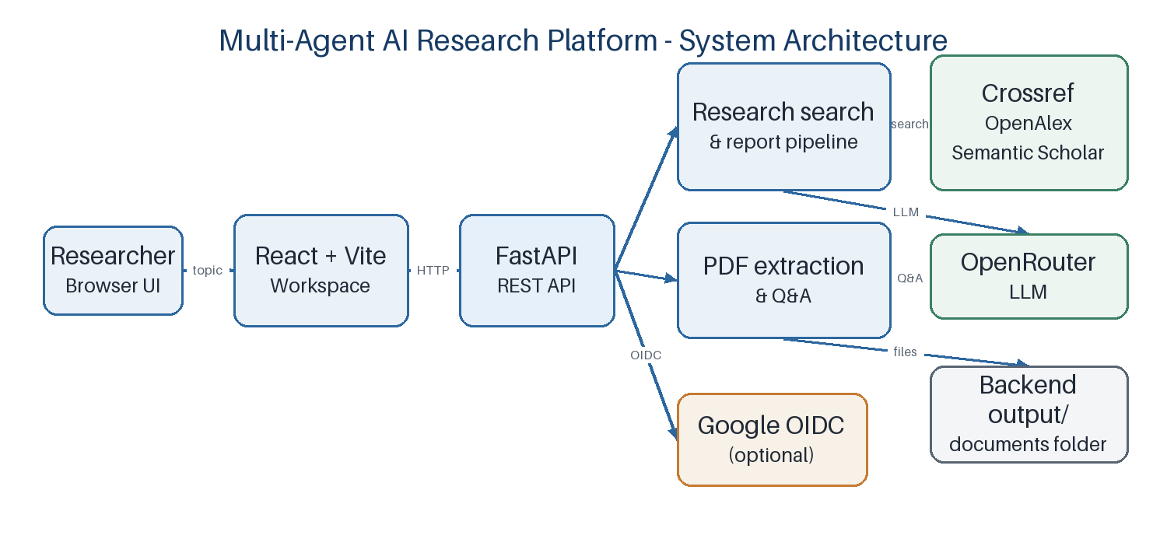

1.7 Organization of the Project
Chapter 1 introduces the project problem, objectives, and scope. Chapter 2 reviews academic search, language-model assistance, retrieval-augmented generation, and multi-agent orchestration. Chapter 3 explains the implemented workflows and configured agents. Chapter 4 documents requirements, technologies, API routes, persistence, security boundaries, and execution. Chapter 5 reports the automated test and build results and discusses observable limitations. Chapter 6 concludes and identifies future work.

1.8 Summary
The platform is a hybrid research-workflow prototype with both CrewAI CLI orchestration and direct web API workflows. It integrates scholarly metadata search, heuristic analysis, LLM-authored reports, selectable-text PDF processing, and browser-local persistence. The remainder of the report analyzes these implemented components without conflating design intent, mock interface behavior, or future extensions with tested backend functionality.

CHAPTER 2 – RELATED WORK INVESTIGATION

2.1 Introduction
This chapter considers the research and software concepts relevant to the project: information retrieval, academic metadata services, language-model generation, retrieval-augmented generation, and role-based agent orchestration. The review is intentionally scoped to approaches that explain design choices in the implementation. It does not claim that a complete systematic literature review was conducted.

2.2 Traditional Research and Literature Search
Information retrieval systems typically transform a user query and a document collection into ranked results. A research user then examines titles, abstracts, venue information, and full text to decide which records merit closer reading. Standard information-retrieval texts describe indexing, query processing, ranking, and evaluation as separate but connected concerns [1]. In the platform, search is federated across external APIs rather than based on an internally indexed corpus.
The project’s local ranking method is deliberately simpler than probabilistic or learning-to-rank methods. It tokenizes the topic and paper title/abstract, calculates query-term overlap, weights title overlap more heavily than abstract overlap, then uses logarithmic citation count, year, and title as tie-breakers. The method is transparent and computationally small, but it does not model synonyms, phrases, domain vocabularies, field-specific relevance, or calibrated retrieval effectiveness.

2.3 Search Engines and Academic Search Platforms
The project uses Crossref, OpenAlex, and Semantic Scholar as metadata providers. Crossref supplies registered scholarly metadata through its REST API [8]. OpenAlex exposes search endpoints over works and related scholarly entities [9]. Semantic Scholar provides a paper-search Graph API with selected bibliographic fields [10]. These services differ in coverage and field definitions; the application normalizes a limited set of fields into a common Paper model.
The platform does not query an internal database and does not crawl publisher full text. The `arxiv_search.py` module exists in the source tree, but the production PaperSearchTool wires only Crossref, OpenAlex, and Semantic Scholar. arXiv records are deliberately excluded from the configured peer-reviewed-only production candidate path; this does not mean the three metadata providers independently certify peer review.
The inclusion policy is implemented through publication type and metadata checks. Crossref records need supported journal/proceedings types plus DOI, venue, and year. OpenAlex records need an article/conference-paper type, journal/conference source type, DOI, venue, and year. Semantic Scholar records need mapped journal/conference publication type, DOI, venue, year, and no arXiv marker. The system labels candidates passing these rules `verified`; that label represents a metadata heuristic only.

2.4 AI-Assisted Research Systems
Language models can follow natural-language instructions and produce structured prose, but outputs depend on the supplied evidence, prompt, and model behavior. The GPT-3 study illustrates few-shot prompting as one method of eliciting task behavior from a large language model [2]. In this project, the LLM is accessed through OpenRouter using an OpenAI-compatible API shape; the configured default identifier is `openrouter/openai/gpt-4o-mini`.
The platform uses LLM calls for report writing, PDF summaries, document question answering, paper metadata/abstract questions, and (in the CLI tool set) optional query expansion, summaries, reranking, and novelty rationale. Its prompts instruct the model to rely on supplied paper content, flag missing information, and avoid unsupported factual claims. These instructions are safeguards, not a formal guarantee of factuality. The LLM endpoint and model identifier are configurable through OpenRouter [13].

2.5 Large Language Model Based Research Assistance
Retrieval-augmented generation (RAG) combines a generative model with retrieved evidence to support knowledge-intensive generation [3]. The project follows a limited evidence-supply pattern: research metadata and abstracts are placed in the report prompt, while PDF question answering first retrieves page-aware chunks using term overlap. It does not implement an embedding model, vector index, semantic retriever, or a conventional RAG stack. Accordingly, this report describes evidence-grounded prompting and lexical retrieval rather than claiming RAG implementation.
The PDF answer prompts request page citations and instruct the model to say when the supplied excerpts do not support an answer. The report prompt includes metadata warnings and the deterministic analysis result. At present, the application does not run a separate citation verification stage, compare claims against source passages, or enforce a structured citation schema after generation.

2.6 Multi-Agent AI Systems
Multi-agent language-model systems assign distinct roles to agents and coordinate them through messages or task outputs. CAMEL studies role-playing communicative agents [6], while AutoGen presents a framework for composing LLM applications through multi-agent conversation [5]. ReAct combines reasoning and tool actions in a language-model prompting framework [4]. These works illustrate design patterns; their published experiments do not constitute evaluation of this project.
The project’s CrewAI configuration uses three roles—paper search, research analysis, and report writing—and a sequential process. Outputs of the search and analysis tasks become context for later tasks. This is a task-sequenced crew, not a continuously operating autonomous swarm: the report agent has no configured external tools, the agents do not run in parallel, and the code does not expose an agent trace to the browser UI.

2.7 Agent Orchestration Frameworks
CrewAI provides the orchestration abstractions used in the CLI implementation: Agent, Task, Crew, process mode, and project decorators [7]. Agent and task descriptions are externalized in YAML. `crew.py` constructs the three agent objects with a shared OpenRouter LLM, registers tools by responsibility, builds the task contexts, and returns a sequential Crew.
The browser-facing report handler does not invoke the CrewAI Crew. It calls PaperSearchTool, NoveltyAnalysisTool, loads the report task instructions, and uses one LLM completion for the report. This separation is a deliberate throughput-oriented architecture reflected in the implementation and regression tests.

2.8 Existing Approaches and Their Limitations
A conventional search-only workflow returns references but leaves synthesis to the researcher. A generic conversational model can produce prose but may lack current or source-specific evidence unless context is supplied. Multi-agent orchestration can decompose tasks, but role separation alone does not ensure correctness and may add latency or repeated calls. Retrieval-augmented methods can connect generation to a corpus, but require retrieval/indexing and evaluation that this project does not provide.
The platform combines external metadata search with limited heuristic processing and LLM composition. Its constraints include heterogeneous source coverage, coarse metadata filters, lexical rather than semantic ranking, proxy novelty/gap calculations, no OCR, no embedding retrieval, and no automated validation of generated references. These are material limitations rather than evidence that the platform is equivalent to a production literature-review system.

2.9 Comparison of Existing Approaches
Table 2.1 compares broad workflow categories with the project as implemented. It is a conceptual comparison of capabilities, not a benchmark result or a claim that the application outperforms a commercial search service.
Table 2.1: Comparison of Research-Support Approaches
Dimension | Manual / conventional search | General LLM assistant | This project
Evidence source | Human searches one or more indexes and reviews records. | May rely on model knowledge unless supplied with sources. | Queries Crossref, OpenAlex, Semantic Scholar; passes selected metadata/abstracts to generation.
Screening | Researcher applies inclusion rules. | Usually prompt-dependent. | Metadata eligibility rules applied in provider parsers; not independent peer-review validation.
Synthesis | Human notes and writing. | Generated text may need source grounding. | Single report-writer call in web path; sequential writer task in CLI crew.
Coordination | User coordinates tools and reading. | Single conversational interaction. | CrewAI sequential agents in CLI; direct modular pipeline in web API.
Document Q&A | Manual full-text reading/search. | Depends on provided text/context. | Page-aware chunks ranked by keyword overlap; LLM receives excerpts and requested page citations.
Persistence | Personal notes/files. | Service dependent. | Browser localStorage and local output files; no shared database/account workspace.
Evaluation | Researcher assesses relevance and evidence. | Requires external fact checking. | Automated unit/regression tests; no measured relevance or factuality benchmark.

2.10 Research Gap
The design gap addressed here is an integration gap rather than a scientific claim: topic search, initial metadata screening, structured report drafting, and PDF-centric assistance are often separate user activities. The project demonstrates a modular workflow linking these operations and retains selected results locally. The report does not claim that the implementation resolves open research problems in multi-agent intelligence, scholarly discovery, or scientific novelty assessment.
A remaining engineering and research gap is rigorous evaluation. The repository’s tests verify code-level behavior under controlled fixtures, but do not measure recall, precision, ranking quality, citation accuracy, novelty-score validity, or usefulness to researchers. A future study would need a labeled topic-paper dataset, a defined review protocol, expert assessment, and reproducible baseline comparisons.

2.11 Summary
The related work motivates combining retrieval and generation but also highlights why the project must be described conservatively. Its API integrations retrieve metadata, its deterministic routines provide simple heuristics, and its LLM calls compose reports and answer questions from supplied context. The CrewAI CLI implements three sequential roles; the web report path is a separate optimized pipeline. No vector database or independently verified peer-review engine is present.

CHAPTER 3 – METHODOLOGY

3.1 Methodology
The system uses a modular, layered software methodology. User interactions begin in a React view, service modules issue HTTP requests, FastAPI validates the request, and backend modules perform provider search, rule-based analysis, PDF processing, OAuth handling, or LLM calls. Figure 3.1 details the CLI’s multi-agent branch; Figure 3.2 shows the web-facing topic-to-report path.
There are two related but non-identical paths. The CLI is implemented with CrewAI and `Process.sequential`. The web endpoint is an explicit FastAPI function that directly calls shared search and analysis tools before writing a prompt to the LLM. Explanations below distinguish them wherever coordination differs.

3.2 Overall System Architecture
The system consists of five logical layers: (1) a browser interface; (2) TypeScript service clients; (3) FastAPI request handlers and Pydantic models; (4) domain modules for search, analysis, PDF processing, and CrewAI; and (5) external scholarly/LLM/OAuth services plus local storage. The services are called over HTTP; the source tree does not define a message broker or independent microservices.
In development, Vite serves the client and the backend is started by Uvicorn. The API’s default CORS origins are localhost and 127.0.0.1 on port 5173. Configuration can override these origins and the frontend’s API base URL. Deployment beyond the documented local setup is not specified in the repository.

3.3 User Query Processing
For discovery, the user enters a topic and selects a requested count in the frontend. `paperService.searchPapers` sends `POST /api/papers/search` with topic and count; available choices in the UI are 10, 15, 20, and 25. The API accepts count values from 1 to 100, returns no more than the requested number, and preserves a smaller available result set while reporting both actual and requested counts. The client applies year filtering and citation/year sorting locally to the returned set.
For report generation, the topic is validated as 2–500 characters and sent to `POST /api/research/report`. The backend searches up to 10 candidate records per configured provider, runs deterministic analysis, loads report instructions from YAML, and supplies the results and warnings to one LLM writer call. The response returns Markdown to the frontend, where it is parsed into report sections and stored locally. Figure 3.3 shows this route.
Figure 3.1: CLI Multi-Agent Architecture
Source: `crew.py`, `agents.yaml`, and `tasks.yaml`; excludes the separate direct web report handler.
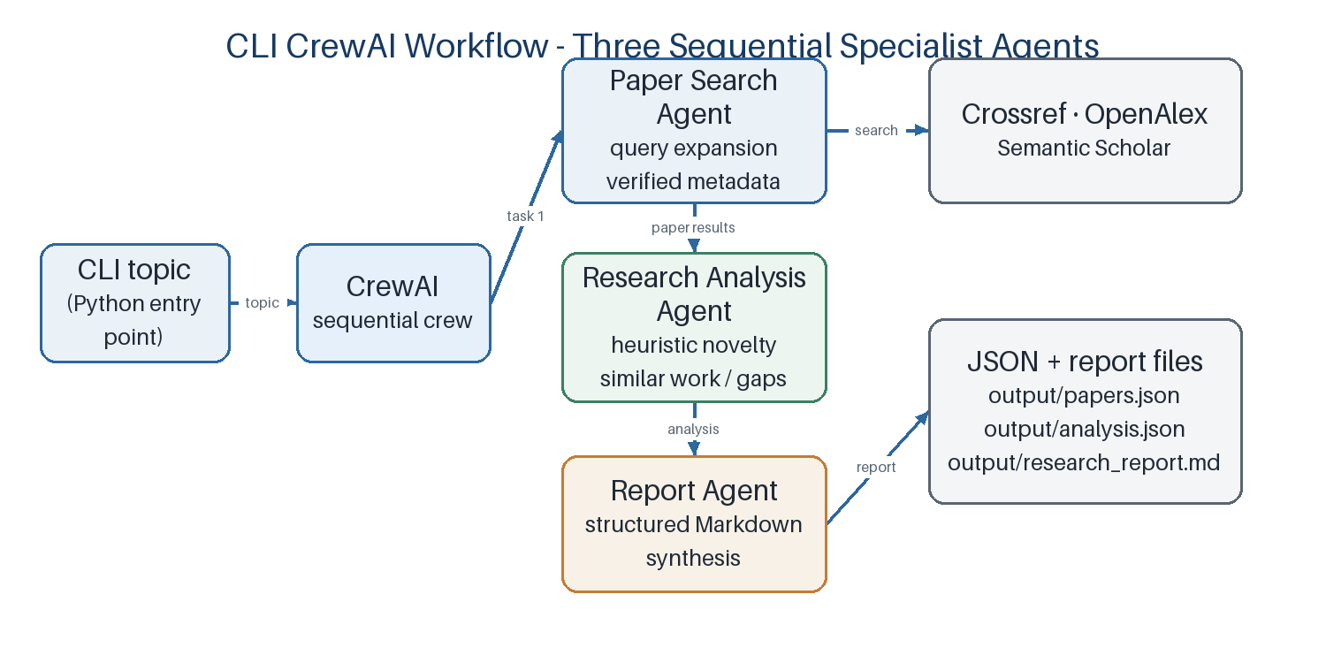
Figure 3.2: End-to-End Research Workflow
Source: FastAPI report route, search and analysis tools, and OpenRouter configuration.
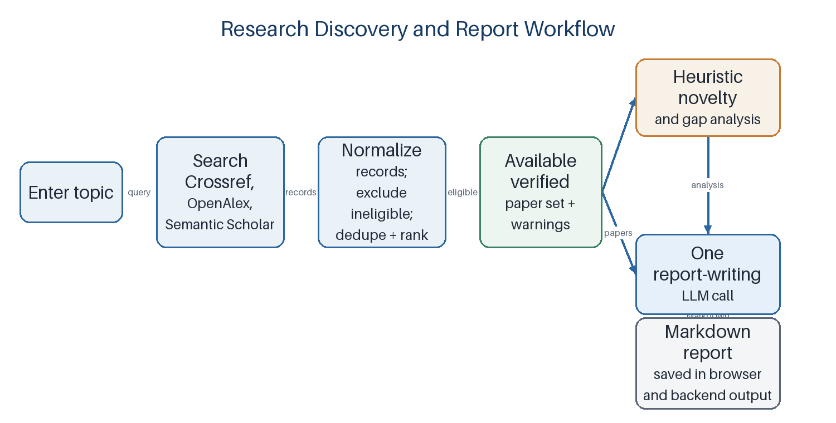
Figure 3.3: Browser Report Query Processing Flow
Source: `api.py`, `search_tools.py`, `analysis_tools.py`, and `utils/llm.py`.
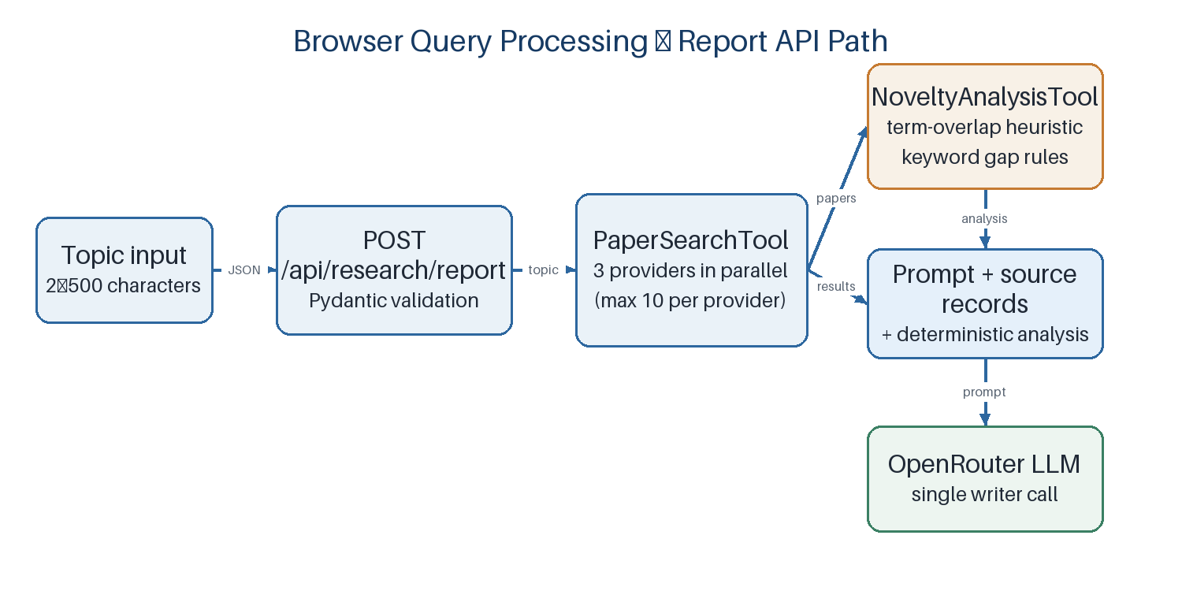

3.4 Agent Architecture
The CrewAI CLI defines exactly three configured agents in `agents.yaml`: Research Paper Search Specialist, Research Analysis Specialist, and Research Report Writer. `crew.py` builds these roles with one shared LLM configuration. Agent roles, goals, and backstories are descriptive configuration; task assignment and tool registration in Python determine the executable organization.
The first task is assigned to the paper search agent and writes `output/papers.json`. The second task receives the search task as context, is assigned to the research analysis agent, and writes `output/analysis.json`. The final task receives both prior task contexts and is assigned to the report agent, writing `output/research_report.md`. The Crew uses sequential process order.

3.5 Agent Roles and Responsibilities
Table 3.1 records the configured CLI agent roles and the tool assignments visible in `crew.py`. This table applies only to the CrewAI CLI path. The web API uses tools directly and should not be interpreted as running these three agents.
Table 3.1: Configured CrewAI Agents
Agent | Input / responsibility | Tools / processing | Output / handoff
Paper Search Agent | Topic; discover publication candidates. | PaperSearchTool, QueryExpanderTool, PaperSummarizerTool; provider search and filtering. | Verified metadata JSON; task output becomes context for analysis.
Research Analysis Agent | Topic and prior search task output; assess overlap and gaps. | NoveltyAnalysisTool, SemanticRerankerTool, LLMNoveltyScorerTool; last scorer is described as optional in the task. | Structured novelty/similar-work/gap analysis; context for report writer.
Report Agent | Topic, search results, and analysis task output. | Shared configured LLM; no external tool list registered. | Detailed evidence-oriented Markdown report.

3.6 Agent Communication / Coordination
Coordination is represented by CrewAI task dependencies. The analysis task names the search task in its context; the report task names both the search and analysis tasks. The framework supplies prior outputs to subsequent tasks in the sequential crew. The application does not define custom agent-to-agent protocols, shared memory storage, distributed coordination, or a browser-visible live trace. Figure 3.4 summarizes the configured handoffs.
Figure 3.4: CrewAI Agent Interaction and Task Handoffs
Source: task context configuration in `crew.py` and expected task outputs in `tasks.yaml`.
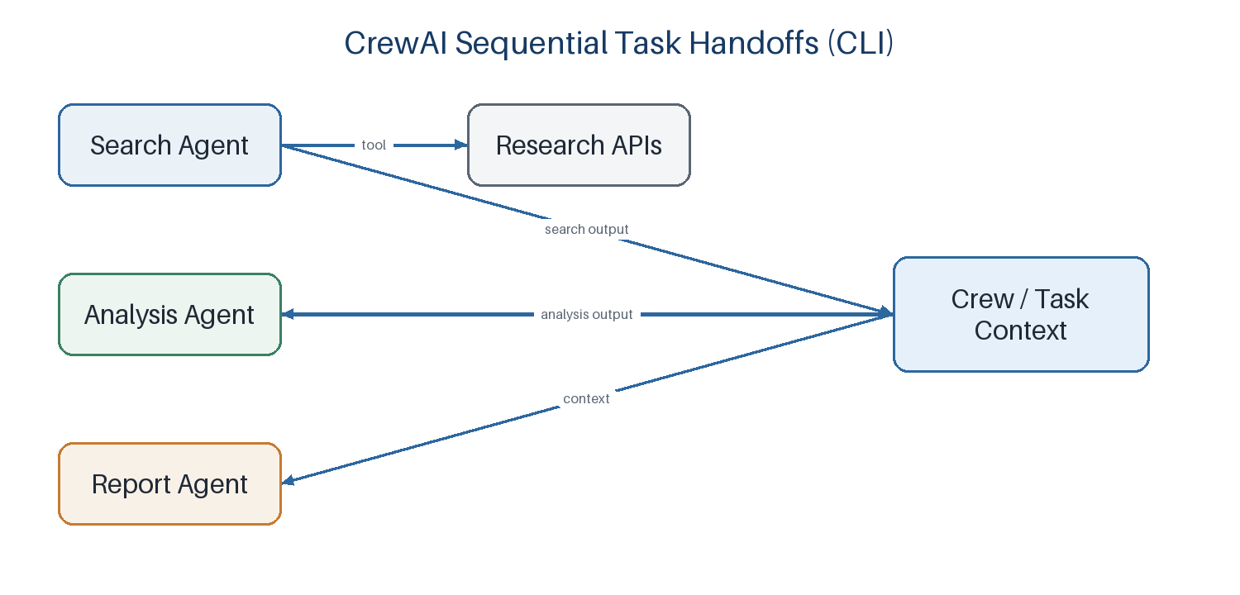

3.7 Research Paper Retrieval
Table 3.2 summarizes the registered search and analysis tools and distinguishes tools available to the CLI crew from tools called by the web report route. PaperSearchTool launches Crossref, OpenAlex, and Semantic Scholar searches using a thread pool, collecting successful provider responses and recording provider exceptions as warnings. API calls use bounded connect/read timeouts and a search-specific retry policy; 429 is not included in its retried status list. The search helper can therefore return partial results when a source fails instead of waiting through an unbounded rate-limit delay.
Provider-specific parsers map title, author names, year, abstract, citation count, source, DOI/URL, publication type, venue, and peer-review metadata into the Pydantic Paper model. The normalized set is deduplicated by DOI URL when possible, otherwise by normalized title, first author family name, and year. Records failing the exact `peer_review_status == 'verified'` check are excluded from the final candidate list.
Ranking uses lexical overlap. Query tokens of length greater than two are compared with title and abstract tokens after a small stopword list is removed. The relevance score is 0.7 × title overlap plus 0.3 × abstract overlap. Ties use descending log-transformed citation count, newer year, then case-folded title. This is a transparent heuristic, not a validated ranking model.
Table 3.2: Search and Analysis Tools
Tool | Operation | Where configured / used
PaperSearchTool | Concurrent provider search; filter, deduplicate, rank, serialize. | CrewAI search agent and direct web search/report routes.
QueryExpanderTool | LLM-generated search query variations. | Registered with CLI search agent; requested by CLI task instructions.
PaperSummarizerTool | LLM summaries for a bounded set of paper records. | Registered as an available CLI search-agent tool; not a separate stage in web report API.
NoveltyAnalysisTool | Token-overlap novelty estimate, similar-title ranking, keyword gap templates. | CLI analysis agent and direct web report route.
SemanticRerankerTool | LLM relevance score/near-duplicate suggestions. | Registered with CLI analysis agent; task asks it to cross-check results.
LLMNoveltyScorerTool | LLM qualitative novelty score/rationale. | Registered with CLI analysis agent; task describes use as optional.

3.8 Information Processing
The search pipeline normalizes and screens metadata before it reaches the analysis module. NoveltyAnalysisTool tokenizes the topic and each paper’s title/abstract, computes maximum and average overlap, and maps the weighted overlap to a bounded heuristic score. In code, novelty is `100 - (0.7 × max_overlap + 0.3 × average_overlap) × 100`, clamped between 5 and 95 when records are available. For no eligible papers it returns 85; an empty tokenized topic returns 50. These are code-defined defaults, not calibrated estimates of originality.
The same tool ranks similar titles using topic-term overlap and applies a small keyword-template set to suggest possible gaps. A keyword absent from the combined abstracts/titles can trigger a gap template about topics such as privacy, rural deployments, or real-time processing. These suggestions are prompts for investigation and cannot establish that a gap is absent from the literature.

3.9 Result Synthesis
The browser report synthesis prompt is assembled from YAML task instructions, the requested topic, eligible paper JSON, search metadata/warnings, and deterministic analysis JSON. It requests ten named sections, a paper-level related-work list, a comparative table, discussion of uncertainty, future opportunities, practical takeaways, and references. The model output is accepted as Markdown if non-empty, persisted to output files, and returned to the browser. The frontend stores generated report sections in localStorage for later reopening and draft editing.
The CLI report agent receives task outputs through CrewAI context and saves to the Markdown output path. Neither route includes a post-generation programmatic audit that verifies every sentence, citation, or comparison field against source metadata.

3.10 Error Handling / Validation
Pydantic request models constrain topic, count, question length, and chat history. Search provider failures are collected as warnings; successful providers can still contribute records. Invalid JSON returned from the search tool is surfaced as an HTTP 502. PDF extraction rejects non-PDF files, encrypted files, empty PDFs, inputs over 50 MB or 500 pages, and image-only/scanned files with no selectable text. PDF question and comparison endpoints validate document identifiers and require two distinct document IDs for comparison.
The PDF endpoints translate expected filesystem/value errors into client-visible HTTP errors. Google OAuth is optional; login is disabled with a 503 until client credentials are configured, and the callback rejects unverified email claims. Report generation fails if the writer returns an empty response. Network and model calls remain dependent on external services and configured credentials.

3.11 End-to-End Workflow
A typical topic workflow is: (1) enter a topic; (2) submit a search or report request; (3) call three providers concurrently; (4) normalize, deduplicate, filter, and rank available records; (5) run the deterministic analysis when generating a report; (6) call the configured LLM to synthesize the report; (7) return Markdown and store the completed report locally in the browser. In the CLI variant, the CrewAI sequential scheduler hands task outputs from search to analysis and then to the report agent.
A document workflow is: (1) upload a selectable-text PDF; (2) validate and extract metadata/text; (3) write metadata, Markdown, and chunks under `output/documents/<document_id>/`; (4) generate a structured summary or retrieve relevant chunks for a question; (5) ask the LLM to summarize or answer based on supplied text. The compare workflow repeats ingestion for two documents and asks the LLM for structured similarities, differences, gaps, and a comparison table.

3.12 Summary
The methodology is hybrid. Explicit CrewAI specialization is used in the CLI, direct function composition powers web report generation, provider metadata is normalized before analysis, and PDF question answering uses lexical retrieval over page-aware chunks. The implemented system does not contain a vector database, OCR process, model training stage, or database transaction layer.

CHAPTER 4 – REQUIREMENT AND IMPLEMENTATION

4.1 Functional Requirements
Table 4.1 lists the functional requirements evidenced in the current source tree. Requirements describe application behavior; status refers to the implementation available in this repository.
Table 4.1: Functional Requirements
ID | Requirement | Implementation status / evidence
FR-01 | Search academic publication metadata by topic. | Implemented: Discover Papers UI and POST /api/papers/search.
FR-02 | Choose result count and filter/sort current results. | Implemented: UI choices 10/15/20/25; year and sort applied client-side.
FR-03 | Keep partial discovery results when a provider fails. | Implemented in PaperSearchTool; warning field accompanies available results.
FR-04 | Bookmark papers and reopen saved items. | Implemented in browser localStorage; no account synchronization.
FR-05 | Generate and reopen a structured topic report. | Implemented via POST /api/research/report and locally stored reports.
FR-06 | Edit/save report draft and print/export. | Implemented locally; export uses browser print dialog.
FR-07 | Upload, extract, summarize, and question one PDF. | Implemented for selectable text with stated size/page limits.
FR-08 | Compare exactly two uploaded PDFs and ask follow-up questions. | Implemented by compare and compare/questions API routes.
FR-09 | Show optional Google account name/email and sign out. | Implemented as OIDC session display; credentials and Google Cloud setup are required.
FR-10 | Create and persist project records or user-owned research history. | Not implemented as backend persistence; project cards are in-memory/mock workspace data.

4.2 Non-Functional Requirements
Table 4.2 states non-functional properties that can be supported by implementation evidence and separates them from qualities that have not been measured.
Table 4.2: Non-Functional Requirements
Property | Implementation evidence | Qualification
Input validation | Pydantic length/range constraints; PDF and document-id validation. | Does not replace full threat modeling or content safety validation.
Resilience | Concurrent provider queries; partial results and warnings; bounded search timeouts/retries. | Provider availability, latency, and quotas are external.
Maintainability | Separate tools, clients, schemas, API routes, frontend services/views, and YAML agent/task definitions. | Some frontend services are prototype/mock implementations.
Usability | Separate workflow pages, loading/error states, real byte-based upload progress, clear/reset controls. | No formal usability study included.
Persistence | LocalStorage for selected outputs; local filesystem for extracted PDF artifacts and CLI output. | Not synchronized, multi-user, or durable cloud persistence.
Portability | Python 3.10–3.13 dependency range; browser frontend via Vite/Node. | No container manifest or production deployment profile.
Performance | Search providers are concurrent; web report uses one writer call after deterministic analysis. | No reproducible latency benchmark or SLA.

4.3 Hardware Requirements
The repository specifies no minimum processor, memory, storage, or GPU requirement, so a precise hardware specification cannot be claimed. Development requires a computer capable of running a supported Python environment, Node.js/Vite, a modern browser, and local file storage. LLM inference is performed through OpenRouter rather than a model bundled with the repository; therefore the project does not declare a local GPU requirement. Network access is required for scholarly provider and LLM calls.

4.4 Software Requirements
The backend project metadata supports Python 3.10 up to but not including 3.14 and uses FastAPI/Uvicorn. The frontend `.nvmrc` selects Node.js 22.14.0, and npm installs React, TypeScript, Vite, Tailwind CSS, and related packages. The report’s dependency table is derived from the manifests and source imports, not from unrelated optional packages.
Runtime configuration uses `OPENROUTER_API_KEY` for LLM operations; `OPENROUTER_MODEL` optionally changes the configured model from its default. Crossref and OpenAlex contact emails are recommended. `SEMANTIC_SCHOLAR_API_KEY` is optional, but absent credentials make that provider unavailable and the search tool can return partial results. Google login additionally requires `GOOGLE_CLIENT_ID`, `GOOGLE_CLIENT_SECRET`, `SESSION_SECRET_KEY`, callback configuration, and matching Google Cloud origins/redirect URI.

4.5 Technology Stack
Table 4.3 summarizes the technology stack that is directly used in the implemented application.
Table 4.3: Technology Stack
Layer | Technology | Role in the implementation
Frontend | React 19, TypeScript, Vite 8 | Single-page workspace and build/dev server.
Frontend styling/UI | Tailwind CSS, Lucide React, Framer Motion | Utility styling, icons, and UI animation dependency.
Backend API | Python, FastAPI, Pydantic, Uvicorn | HTTP endpoints, request validation, and local development server.
Agent orchestration | CrewAI, YAML | Sequential CLI agents, tasks, tool registration, and prompts.
LLM access | OpenRouter through CrewAI LLM configuration | Default model id openrouter/openai/gpt-4o-mini; configurable by environment.
Scholarly metadata | Crossref REST, OpenAlex API, Semantic Scholar Graph API | Provider search, metadata parsing, and citation counts.
PDF processing | PyMuPDF, PyMuPDF4LLM | PDF validation, metadata and text extraction, Markdown generation.
HTTP/config/auth | Requests, python-dotenv, Authlib, itsdangerous, Starlette sessions | External calls, environment loading, optional Google OIDC and signed session cookies.
Client persistence | Browser localStorage | Stores selected workspace results/drafts; not a server database.
Testing | pytest, unittest fixtures/mocks, TypeScript build | Backend regression tests and frontend type/build verification.

4.6 System Architecture
The code is organized around a single FastAPI application and a React client. The frontend’s `services/` modules centralize API calls, while `views/` bind workflow state to reusable components. The backend’s `api.py` defines routes and validation models; `tools/` contains source clients, search and analysis tools, and optional LLM tools; `pdf_processing.py` handles document operations; `crew.py` defines the CLI agent graph; `models/schemas.py` provides normalized data models.
The repository has no database schema, migration system, or ORM. Browser state is JSON serialized in localStorage; output reports, analysis JSON, extracted Markdown, metadata, and chunks are regular local files. Table 4.5 maps application modules to their persistence responsibilities. Figure 1.1 gives the system view and Figure 4.1 shows the development deployment arrangement.
Figure 4.1: Local Development Deployment Architecture
Source: README setup commands, Vite configuration, FastAPI service, and local output paths.
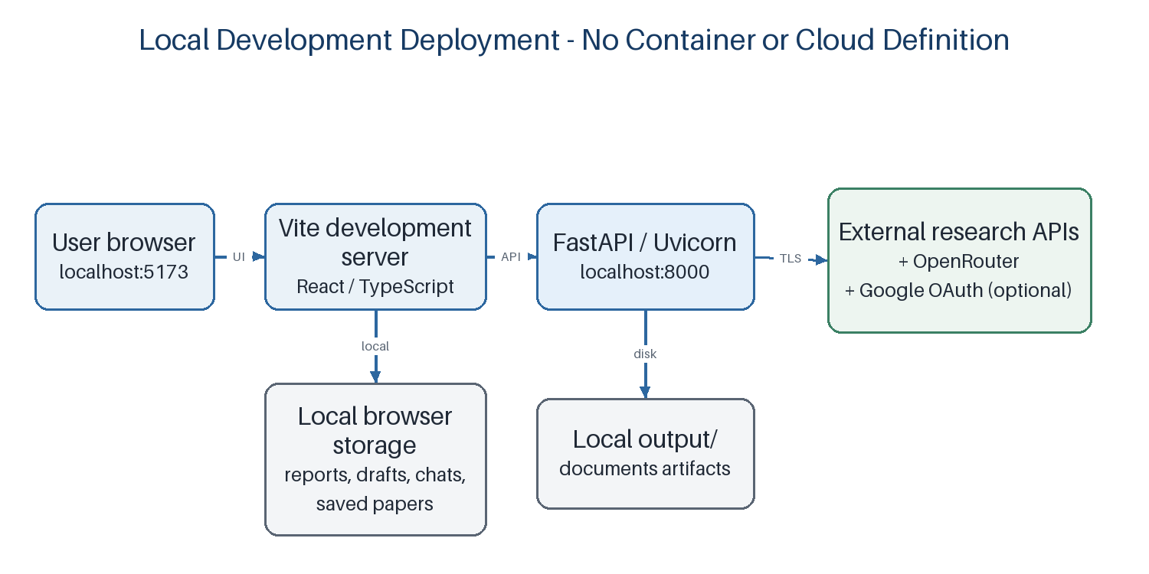

4.7 Frontend Implementation
The React application routes among Discover Papers, My Research, Compare Papers, Reports, Ask a PDF, paper detail/summary views, profile/settings, and saved workspace sections using active-tab state in `App.tsx`. Service modules call the FastAPI endpoints; `useLocalStorageState` loads and saves JSON values for selected workflow data.
Discovery stores the query, submitted query, search flag, result list, selected year, sort order, and requested count. Search count choices are 10, 15, 20, and 25; the API supports a broader count range. Sorting and year selection are applied to the current result set in the browser. Saved papers are stored locally and shown in the Saved Papers section. Reports, selected report, report topic, generated report drafts, PDF chat state, and comparison state are also persisted locally.
Upload progress uses XMLHttpRequest upload-byte events and reports loaded bytes, total bytes, and transfer percentage. It describes transfer progress; after the payload reaches 100%, PDF processing may still be underway. The original selected file bytes are not saved to browser localStorage.
[SCREENSHOT PLACEHOLDER — Discover Papers page showing a live search result, the 10/15/20/25 count selector, year filter, sort selector, and bookmark control.]
Insertion note: Capture this view from the running application and replace this callout with the screenshot; do not crop away the page title or relevant controls.

4.8 Backend Implementation
`api.py` instantiates the FastAPI application [11], sets CORS origins, configures Starlette’s signed-cookie SessionMiddleware, registers optional Google OAuth, and defines request/response handlers. Search and report request models constrain topic length; question endpoints constrain question/history sizes. The application uses dependency imports inside some route handlers so API imports remain separable from work that needs specific processing modules.
The backend writes CLI/report artifacts under `output/` and PDF-derived directories under `output/documents/`. Uploaded PDF bytes are first written to a temporary file; the extracted artifacts are retained, while the temporary upload file is removed. The API has no database-backed user association or document ownership mapping.

4.9 AI Agent Implementation
CrewAI configuration is defined in `agents.yaml` and `tasks.yaml`; Python registration is in `crew.py`. All three CLI agents receive the `get_llm()` provider configuration. The paper-search agent has PaperSearchTool, QueryExpanderTool, and PaperSummarizerTool. The analysis agent has NoveltyAnalysisTool, SemanticRerankerTool, and LLMNoveltyScorerTool. The report agent has no registered tools and produces the final synthesis from task context.
The web report handler is distinct: it uses PaperSearchTool and NoveltyAnalysisTool directly and invokes the LLM once. Thus, describing the entire browser application as a single multi-agent execution would be inaccurate. The platform includes an agent-based CLI and a direct web workflow that reuses selected modules.

4.10 API Integration
The FastAPI routes used by the browser are listed in Table 4.4. Request bodies are JSON except PDF upload, which uses multipart form data. Authentication routes serve the optional Google sign-in profile; they do not authorize or partition the other endpoints.
Table 4.4: API Endpoints and Responsibilities
Method and path | Purpose / input | Result or constraint
GET /api/health | Health check. | Returns status=ok.
GET /api/auth/me | Read current Google session. | User object or null and google_enabled flag.
GET /api/auth/google/login | Begin optional OIDC; frontend_origin query. | Rejects unconfigured OAuth or untrusted origin.
GET /api/auth/google/callback | Google OIDC callback. | Requires subject, email, and email_verified=true; stores name/email in session.
POST /api/auth/logout | Clear session. | Returns logged_out.
POST /api/papers/search | Topic (2–500 chars), count (1–100). | Normalized available records, count, requested_count, warnings if providers fail.
POST /api/research/report | Topic (2–500 chars). | Markdown report; writes report/papers/analysis files.
POST /api/papers/questions | Paper metadata/abstract, question, up to 8 chat messages. | LLM answer constrained to supplied metadata/abstract.
POST /api/documents/upload | PDF multipart payload. | Metadata and generated summary; extraction writes local artifacts.
POST /api/documents/{document_id}/questions | Question and history for extracted document. | Answer from retrieved excerpts with requested page citations.
POST /api/documents/compare | Exactly two distinct document IDs. | Structured comparison with overview, similarities, differences, gaps, table.
POST /api/documents/compare/questions | Two document IDs, question, up to 8 messages. | Question response grounded in excerpts from both papers.
Table 4.5: Application Modules and Data Persistence
Component / data | Implementation location | Persistence / responsibility
React workflow views | frontend/src/views/ and App.tsx | In-browser interface; selected state retained by localStorage hooks.
API client services | frontend/src/services/ | HTTP requests for papers, reports, documents, and auth.
FastAPI API | backend/src/knowledge_discovery/api.py | Validates and routes requests; no database-backed records.
Research tools and schemas | backend/src/knowledge_discovery/tools/ and models/ | Normalized Paper/ResearchAnalysis values; no relational schema.
CrewAI configuration | backend/src/knowledge_discovery/crew.py and config/*.yaml | Sequential agent/task orchestration and output files.
Browser-local workspace | window.localStorage | Search results, bookmarks, reports/drafts, PDF metadata/chat, comparison state.
Backend artifacts | output/ and output/documents/<id>/ | JSON, Markdown, metadata, and chunks on local filesystem.
User identity | Starlette signed session cookie | Optional Google name/email for display; no account-linked data persistence.

4.11 Research Retrieval
The provider clients use `requests` with source-specific headers and timeouts. Crossref and OpenAlex clients can include a contact email. Semantic Scholar uses an optional API key. The shared HTTP layer maintains thread-local sessions and a separate retry policy for search calls. Search fan-out executes concurrently; results are deduplicated and filtered before ranking. Source-level warnings are retained when a provider errors, so the application can display fewer results than requested rather than treating a partial set as a full count.
There is no stored scholarly corpus and no pagination loop over provider result pages. A per-source search is bounded by the requested limit (capped at 100); PaperSearchTool can return up to three times that limit across sources before the API truncates to the requested count. The browser report pipeline requests ten papers.

4.12 Agent Coordination
The CLI task graph uses CrewAI’s sequential process and explicit task context. The first output is a list of verified candidate paper records; the second is structured analysis; the third is a Markdown report. `output_file` values establish the CLI artifact paths. The browser report path has no Crew context or agent-to-agent messages; its data handoff is ordinary Python function composition.

4.13 Data Processing
Paper records are normalized to the Paper schema (title, authors, year, abstract, citation count, source, URL, publication type, venue, peer-review label). The analysis schema constrains novelty score to 0–100 and includes similar papers, existing work, research gaps, and future opportunities. These Pydantic models describe application data and are not database tables.
For PDFs, the API checks the `.pdf` suffix and the processing module checks file size, encryption, page count, and selectable text. Document IDs are the first 16 hexadecimal characters of the SHA-256 digest of uploaded bytes. PyMuPDF extracts page text [12]; PyMuPDF4LLM creates Markdown; per-page chunks default to 900 words with 120-word overlap. A simple token-overlap score retrieves the top chunks for question answering. This is lexical retrieval, not vector similarity. Figure 4.2 summarizes the implemented extraction and answer flow.
Figure 4.2: PDF Extraction and Grounded Question-Answering Pipeline
Source: `pdf_processing.py` and `/api/documents/*` routes.
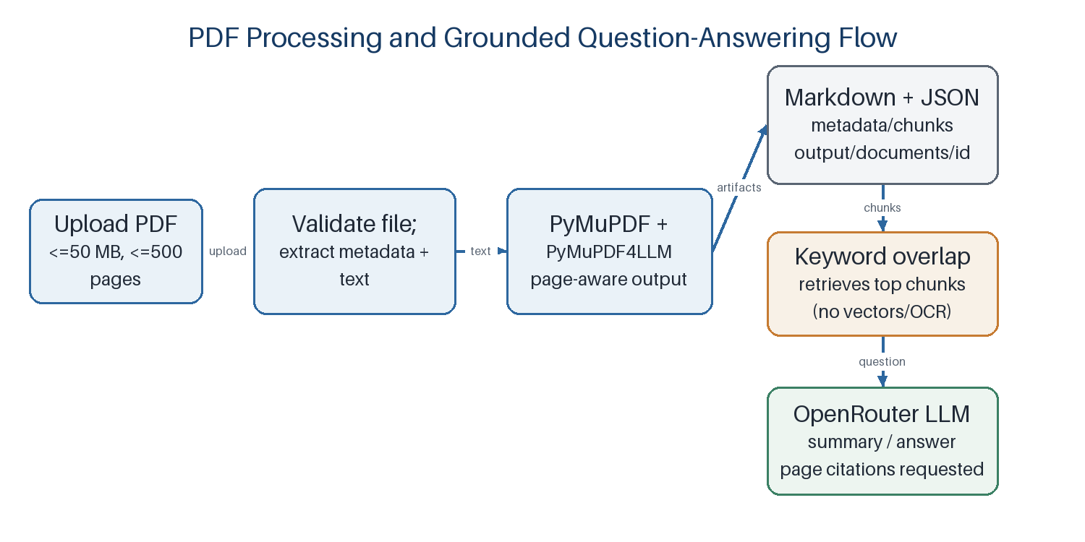

4.14 User Interface
The sidebar exposes Discover Papers, My Research, Compare Papers, Reports, Ask a PDF, Projects, and Saved Papers, plus Settings and the profile control. Research History and the former Dashboard are not in the current navigation. The Discover page supports clear results separately from Reset filters. Ask a PDF and Compare PDFs each have clear actions. Report cards reopen generated results and the report workspace persists edited drafts.
The current UI also contains demonstration content. Initial profile, projects, saved sample papers, and sample reports come from `mockData.ts`; project creation is held in an in-memory WorkspaceService rather than a server database. The AI Summary view uses a deterministic, hard-coded response builder with a delay rather than a live summary endpoint. In contrast, topic report generation, paper-metadata Q&A, PDF upload/summary/Q&A, and the two-PDF comparison use backend endpoints.
[SCREENSHOT PLACEHOLDER — Ask a PDF view after a selectable-text document has been uploaded, showing metadata, generated summary, and a page-cited answer.]
Insertion note: Capture this view from the running application and replace this callout with the screenshot; do not crop away the page title or relevant controls.
[SCREENSHOT PLACEHOLDER — Compare Papers view with two uploaded papers and the structured similarities/differences/comparison table.]
Insertion note: Capture this view from the running application and replace this callout with the screenshot; do not crop away the page title or relevant controls.
[SCREENSHOT PLACEHOLDER — Reports page and opened report workspace showing a generated report, saved-report list, and draft controls.]
Insertion note: Capture this view from the running application and replace this callout with the screenshot; do not crop away the page title or relevant controls.

4.15 Error Handling
Errors are represented through HTTP status codes and FastAPI detail messages for validation and processing failures. Frontend service functions reject non-success responses and views render user-visible error text. Search provider errors do not necessarily fail the entire request: the tool returns successful sources and a warnings array. Upload transfer events are reported by the browser; processing can continue after transfer completes.
The code does not implement a general job queue, retry UI, or resumable uploads. The backend output files are shared path names, so they represent the most recent report artifact rather than a versioned server-side report store. The frontend’s local report list provides browser-side per-item retention.

4.16 Security Considerations
Google login uses Authlib’s OpenID Connect client and Starlette’s signed session cookie. The callback accepts an identity only when a subject, email, and true `email_verified` claim are present. CORS origins are configurable, and the login route checks the requested frontend origin against the configured allowlist. The `SESSION_COOKIE_SECURE` setting enables HTTPS-only cookies when configured.
Important boundaries remain. Google login is optional and is not an authorization gate on research/document endpoints. The session holds display identity, not a server-side user account or data ownership relationship. If `SESSION_SECRET_KEY` is omitted, the backend generates a temporary key and logs that sessions will not survive restart. LocalStorage is not encrypted by the application and is available to same-origin browser scripts. Local extracted artifacts are not partitioned by authenticated user. The sample environment file contains placeholders only; real OAuth credentials and Google Cloud setup are not included in the repository.
Prompts mark PDF and paper content as untrusted reference material and instruct the LLM not to follow instructions embedded in those sources. That is a prompt-level mitigation and not a substitute for security testing of prompt injection or hostile documents. The project report therefore describes implemented controls without asserting comprehensive security certification.

4.17 Usability
The interface separates discovery, reporting, PDF Q&A, and PDF comparison into dedicated views. Result counts, sorting, year filters, bookmark actions, byte-based upload progress, clear/reset actions, saved report cards, and inline error messages support common workflow tasks. Report and document chats retain a bounded conversation history in the browser.
No formal usability test or participant study is included in the repository. Seeded mock records and hard-coded AI Summary behavior can also make some parts of the interface appear more complete than their backend integration; those items should be treated as prototype surfaces.

4.18 Dependability
The search layer uses concurrent provider requests, finite connect/read timeouts, and a retry policy that avoids retrying search 429 responses. Search results can be partial, and the API preserves that availability with warning metadata. The test suite uses fixtures and mocks to verify selected failure and normalization cases.
Dependability is constrained by external APIs, network connectivity, model-provider credentials, request quotas, local filesystem state, and browser-local persistence. No uptime target, backup schedule, database transaction, monitoring stack, or production failover configuration is present.

4.19 Deployment / Execution
The repository documents local development rather than packaged deployment. The backend is launched from `backend/` with the shared root virtual environment and Uvicorn, using `PYTHONPATH=src`; the frontend is started from `frontend/` with npm and Vite. `VITE_API_BASE_URL` changes the frontend API host. Backend `.env` configuration supplies LLM and optional provider/OAuth settings. No Dockerfile, Kubernetes manifest, production reverse proxy, or CI deployment workflow is part of the tracked project structure.
The backend setup document and root README describe installation and local execution. The report endpoint writes to `output/papers.json`, `output/analysis.json`, and `output/research_report.md`; PDF artifacts are written below `output/documents/`. Browser state remains in the active browser profile.

4.20 Documentation and Technical Records
Technical setup and API notes are available in the root README, `backend/README.md`, and `backend/LOCAL_SETUP.md` [14]. Agent roles and tasks are maintained in YAML, API schemas are declared in Python, and npm/Python dependencies are described by `frontend/package.json`, `frontend/package-lock.json`, `backend/pyproject.toml`, `backend/requirements.txt`, and `backend/uv.lock`. Tests are under `backend/tests/`. No dedicated architecture diagram or database migration record is included in the source tree; diagrams in this report are derived from the reviewed code.

4.21 Summary
The implementation uses a React/TypeScript frontend, a FastAPI/Pydantic backend, CrewAI for the sequential CLI workflow, provider-specific REST clients, OpenRouter for LLM calls, PyMuPDF/PyMuPDF4LLM for document processing, browser localStorage, and local output files. It is testable as a prototype but does not have server-side user persistence, a database, vector retrieval, OCR, or production deployment assets.

CHAPTER 5 – RESULTS AND DISCUSSION

5.1 Overview
Results in this chapter refer to source-level tests and reproducible build checks run for this report, not to an external user study or an evaluation of research relevance. Backend tests use controlled fixtures/mocks for external services and model calls; the frontend build validates TypeScript compilation and Vite bundling.

5.2 System Execution
The application exposes a locally served browser workspace and FastAPI backend according to the repository’s setup instructions. The API’s health route returns a status object. A working LLM API key and network access are required for report generation and PDF summarization/question answering; without a Semantic Scholar key, search can proceed with other providers and an accompanying provider warning. Google sign-in requires external credentials and a correctly configured OAuth client.
As summarized in Table 5.2, the validation run for this report completed `uv run --project backend --extra dev pytest -q`: 25 tests passed, with four subtests passing and one Authlib deprecation warning. The frontend command `cd frontend && npm run build` completed TypeScript project compilation and Vite production bundling successfully. These local checks did not exercise live scholarly APIs, actual OpenRouter completion, or real Google OAuth credentials.

5.3 Research Query Processing
The test suite verifies API behavior for requested result counts, including returning fewer papers than requested when that is all the mocked search result contains, and capping results at the request count. It also verifies that a provider failure does not discard successful provider results. These tests establish behavior under controlled inputs, not retrieval recall or user-perceived speed.

5.4 Agent Execution
The automated tests validate the web report API’s direct pipeline by replacing search, analysis, and the LLM with mocks and checking that the search is called once, analysis is called once, and the writer is called once. They also check that the prompt includes required report instructions and that report-related files are written. This test documents the optimized web path; it is not a live run of all three CrewAI agents.

5.5 Research Paper Retrieval
Provider parser and search-tool tests cover Crossref/OpenAlex/Semantic Scholar field normalization, peer-review metadata rules, exclusion of arXiv-marked Semantic Scholar records, deduplication, ranking, partial provider failures, and available-paper count handling. Because provider responses are mocked in unit tests, no conclusion is drawn about current provider coverage or the correctness of all external metadata.

5.6 Generated Research Results
The report endpoint is designed to return Markdown with ten structured sections and writes corresponding paper-search and analysis JSON files. Its automated test checks the route’s inputs/outputs and required prompt sections with a fake writer response. No genuine research report produced from a live topic is included as a controlled evaluation artifact in the repository; therefore this report makes no assertion about its factuality, completeness, citation correctness, or output quality beyond the tested request assembly.

5.7 User Interface Results
The frontend build confirms that the current TypeScript application compiles and bundles. Implemented views include discovery, saved papers, reports, PDF chat, and two-PDF comparison. LocalStorage hooks retain saved frontend state across navigation/reload in the same browser profile. The project does not include automated browser end-to-end tests or screenshots in the source tree; placeholders below identify appropriate captures to add after running the application with configured services.
[SCREENSHOT PLACEHOLDER — Discover Papers results after a topic query, including a partial-results message where the API returns fewer records than requested.]
Insertion note: Capture this view from the running application and replace this callout with the screenshot; do not crop away the page title or relevant controls.
[SCREENSHOT PLACEHOLDER — Saved Papers sidebar section after bookmarking a result, demonstrating browser-local saved-paper state.]
Insertion note: Capture this view from the running application and replace this callout with the screenshot; do not crop away the page title or relevant controls.
[SCREENSHOT PLACEHOLDER — Generated report opened from the saved reports list, with the report title, sections, and save-draft action visible.]
Insertion note: Capture this view from the running application and replace this callout with the screenshot; do not crop away the page title or relevant controls.

5.8 Functional Testing
The backend tests use Python unittest assertions and pytest discovery. `test_pdf_processing.py` constructs small PDFs and fake LLM responses to test extraction metadata/chunks, non-PDF rejection, retrieved page use, and two-document comparison/question behavior. `test_research_pipeline.py` stubs the minimal CrewAI surface and mocks provider and LLM calls to test API handlers, metadata parsing, report prompt assembly, partial results, and OAuth session checks.

5.9 Test Cases
Table 5.1 reports selected test cases that are present in the repository and passed in the recorded run. The “actual output” column describes assertions/results from the controlled test, not live third-party output.
Table 5.1: Selected Automated Test Cases
Test case | Expected behavior | Actual test observation | Status
Search returns fewer than requested | Return all available papers and preserve requested count. | Mocked 3 records returned for requested values 10, 15, 20, and 25; actual count stayed 3. | Passed
Provider partial failure | Keep successful-source records and report failed source warning. | Test verifies usable results remain when a provider raises an exception. | Passed
Search result capping | Never return more records than requested. | Test confirms API truncates a mocked result list to the requested count. | Passed
Report API orchestration | Run search, deterministic analysis, one writer call, and persist artifacts. | Mocks confirm each call and expected prompt content; files are created in a temporary directory. | Passed
PDF extraction | Write metadata, extracted Markdown, and page-aware chunks. | Generated one-page test PDF produced expected files and page-1 chunk. | Passed
PDF question retrieval | Provide matched excerpts and page markers to the answer path. | Fake LLM answer contains the retrieved dataset fact and `[p. 4]` citation. | Passed
Two-PDF compare and question | Use both document contexts and return structured comparison data. | Fake comparison table and answer identify Paper 1 and Paper 2. | Passed
Google login/session checks | Reject missing OAuth or untrusted origin; expose and clear session. | Tests verify 503/400 failures and user/session clear behavior. | Passed
Table 5.2: Executed Validation Summary
Validation | Observed result | What it establishes / does not establish
Backend regression suite | 25 passed; 4 subtests passed; 1 Authlib deprecation warning. | Selected backend logic passes controlled assertions; not a live API/model evaluation.
Frontend production build | TypeScript compilation and Vite build completed successfully. | Static build integrity; not browser end-to-end behavior.
Live provider/model tests | Not run as part of this report-generation validation. | No measured live latency, source coverage, or generated-report factuality is claimed.
Google OAuth against Google | Not run; sample configuration contains placeholders. | OAuth setup and real credentials remain deployment prerequisites.

5.10 Observations
The implemented separation allows provider search and PDF processing to be tested without making real external calls. Tests specifically protect result fallback, supported metadata parsing, input-shape validation for novelty analysis, and route orchestration. The report-generation route’s test enforces the intended single-writer-call path.
The frontend production build succeeding provides evidence of static type/build integrity, but not of visual correctness or runtime integration. No automated browser test suite, load test, mutation test, retrieval benchmark, live OAuth verification, or user evaluation is present.

5.11 Discussion
The delivered system demonstrates end-to-end software integration across discovery, analysis, report composition, PDF extraction, and UI persistence. It makes a useful separation between the full sequential CrewAI workflow and a leaner web report endpoint. The distinction also sets a limit on what can be concluded about agent behavior from browser usage: the web report is not evidence that all three configured agents ran.
The strongest validation evidence is the passing automated backend suite and successful frontend build. These establish selected code paths and compilation. They do not establish that metadata screening correctly identifies peer review, that a heuristic score estimates novelty, that generated claims are accurate, or that service responses meet performance expectations.

5.12 Limitations Observed During Testing
Testing substitutes fake records and LLM completions, which makes the suite deterministic but leaves provider-specific live behavior unverified in this run. The repository has no browser E2E suite. Google OAuth routes are tested for configuration/origin/session conditions, but real credentials and the external Google consent/redirect setup are not included. The test suite emits an Authlib deprecation warning about its httpx integration; this warning did not fail tests.
The search and novelty algorithms are heuristic and have no labeled evaluation set. Search data are limited to provider metadata and abstracts; PDFs must contain selectable text. User data are browser local rather than account-linked. These constraints bound the conclusions from the current system execution.

5.13 Summary
The recorded test run passed 25 backend tests and four subtests; the frontend type-check and Vite build succeeded. Test assertions cover key search, PDF, API, report-prompt, and session behaviors with controlled dependencies. They do not quantify research quality, provider performance, or production reliability. The outcome is a functioning software prototype whose academic claims should remain proportional to its validation evidence.

CHAPTER 6 – CONCLUSION AND FUTURE WORK

6.1 Overview
The Multi-Agent AI Research Platform provides a connected environment for discovering scholarly metadata, drafting topic reports, and working with research-paper PDFs. Its implementation combines a three-agent sequential CLI workflow with direct browser API workflows, a shared provider search layer, deterministic analysis utilities, and OpenRouter-powered generation.

6.2 Achievement of Objectives
The project implements federated search over three scholarly metadata providers, conservative metadata screening, deduplication/ranking, a heuristic landscape analysis, and structured report generation. It provides a React workspace for searches, saved papers, reports, PDF Q&A, comparison, and local persistence. It also integrates optional Google OIDC for displaying account name and verified email. The backend tests and frontend build passed in the validation run reported in Chapter 5.
The implementation meets its software-integration objectives at prototype level. The objectives do not extend to a validated bibliographic systematic review, scientific novelty certification, multi-user server product, or measured research-quality improvement.

6.3 Limitations / Constraints of the System
The publication eligibility label is based on metadata rules and is not an independent publisher or peer-review audit. Search coverage, field quality, citation counts, and rate limits depend on external providers. Search ranking and novelty/gap estimates are lexical heuristics without benchmark calibration. Report and PDF outputs are generated by an external LLM and are not automatically fact-checked.
PDF workflows require selectable text and do not perform OCR. Chunk retrieval uses keyword overlap rather than embeddings; no vector store is present. Browser localStorage and local filesystem outputs are not a cross-device account database, and Google profile sign-in does not gate API access or assign documents to users. Several UI components use seeded mock data or hard-coded demo summaries. No production deployment artifacts, performance study, or formal user evaluation are included.

6.4 Future Enhancements
Future work should proceed from the current boundaries and be evaluated explicitly:
• Improve source verification by retaining per-field provenance, linking each report claim to a specific record or PDF passage, and validating DOI and venue information against authoritative sources.
• Evaluate retrieval with a labeled query-paper benchmark and report precision, recall, and ranking measures; compare the current lexical heuristic with established baselines before adopting semantic ranking.
• Calibrate or replace the novelty score and gap templates using expert-labeled topic/literature examples. Present heuristic scores as exploratory signals unless an evaluation establishes validity.
• Add additional scholarly catalogs only with documented coverage, terms, failure behavior, and deduplication tests; consider citation-graph exploration where supported by reliable data.
• Add OCR for scanned documents and evaluate text quality. A vector/embedding retrieval layer could be investigated for longer PDFs, but it is not part of the current implementation and would need page-level provenance and retrieval evaluation.
• Provide account-scoped server persistence, document ownership, deletion controls, and backups if multi-device continuity is required; an opt-in, user-controlled research history could be built on that foundation. Google sign-in would then need to be integrated with authorization policies rather than remaining a profile-only feature.
• Add browser end-to-end tests, live-provider contract tests with rate limits respected, report citation checks, accessibility review, and usability evaluation with representative researchers.
• Expose job status or streaming for lengthy model operations, add configurable output limits, and prevent shared output filenames from colliding when concurrent report requests are made.
• Replace the static AI Summary and mock workspace data paths with evidence-grounded API calls, or clearly label them as demonstrations until those connections exist.

6.5 Inference / Conclusion
This project demonstrates how scholarly metadata services, a small set of analysis tools, an LLM, and a web application can be combined to support early-stage research workflows. Its clearest architectural contribution is the explicit distinction between a sequential multi-agent CLI and a direct browser pipeline that reuses search and analysis components. The implementation supports discovery, drafting, PDF exploration, and browser-local continuity, while its heuristics and external dependencies make human verification essential.
Within the limits of the available tests, the application is a working prototype: the backend regression suite and frontend production build completed successfully. The project should be understood as a research-assistance workspace rather than an autonomous authority on peer review, originality, or scientific conclusions. Future progress depends on stronger evidence traceability, systematic evaluation, persistence design, and validation against real user tasks.

REFERENCES
[1] C. D. Manning, P. Raghavan, and H. Schütze, Introduction to Information Retrieval. Cambridge, U.K.: Cambridge University Press, 2008. [Online]. Available: https://nlp.stanford.edu/IR-book/
[2] T. B. Brown et al., “Language Models are Few-Shot Learners,” in Advances in Neural Information Processing Systems, vol. 33, 2020. [Online]. Available: https://papers.nips.cc/paper/2020/hash/1457c0d6bfcb4967418bfb8ac142f64a-Abstract.html
[3] P. Lewis et al., “Retrieval-Augmented Generation for Knowledge-Intensive NLP Tasks,” in Advances in Neural Information Processing Systems, vol. 33, 2020. [Online]. Available: https://arxiv.org/abs/2005.11401
[4] S. Yao et al., “ReAct: Synergizing Reasoning and Acting in Language Models,” in Proc. International Conference on Learning Representations (ICLR), 2023. [Online]. Available: https://arxiv.org/abs/2210.03629
[5] Q. Wu et al., “AutoGen: Enabling Next-Gen LLM Applications via Multi-Agent Conversation,” arXiv:2308.08155, 2023. [Online]. Available: https://arxiv.org/abs/2308.08155
[6] G. Li et al., “CAMEL: Communicative Agents for ‘Mind’ Exploration of Large Scale Language Model Society,” arXiv:2303.17760, 2023. [Online]. Available: https://arxiv.org/abs/2303.17760
[7] CrewAI, “CrewAI Documentation.” Accessed: Oct. 4, 2026. [Online]. Available: https://docs.crewai.com/
[8] Crossref, “REST API.” Accessed: Oct. 4, 2026. [Online]. Available: https://www.crossref.org/documentation/retrieve-metadata/rest-api/
[9] OpenAlex, “API Documentation.” Accessed: Oct. 4, 2026. [Online]. Available: https://docs.openalex.org/
[10] Semantic Scholar, “Academic Graph API.” Accessed: Oct. 4, 2026. [Online]. Available: https://api.semanticscholar.org/api-docs/graph
[11] FastAPI, “FastAPI Documentation.” Accessed: Oct. 4, 2026. [Online]. Available: https://fastapi.tiangolo.com/
[12] PyMuPDF, “PyMuPDF Documentation.” Accessed: Oct. 4, 2026. [Online]. Available: https://pymupdf.readthedocs.io/
[13] OpenRouter, “API Reference.” Accessed: Oct. 4, 2026. [Online]. Available: https://openrouter.ai/docs/api-reference/overview
[14] Multi-Agent Researcher project, README.md, backend/README.md, backend/LOCAL_SETUP.md, and source tree, VIT Bhopal University project repository, 2026.

