DEPARTMENT OF BUSINESS ADMINISTRATION
UNIVERSITY OF LUCKNOW



E-BUSINESS ASSIGNMENT
ORGANISATION- UBER

SHALINI PATEL (ROLL NO. -
SWAYAM CHANDRA (ROLL NO. -
REETIKA GUPTA (ROLL NO. -
RAJU KUMAR
-MBA Semester 2nd

Submitted to :-
DR. HARSHIT MAURYA
ACKNOWLEDGEMENT

We are very thankful to our E-business teacher , Dr. Harshit Maurya Sir for giving us such a wonderful assignment which not only enhanced our knowledge but also made our interaction quality better. We all got to know more about Uber and their working processes.

Shalini Patel
Swayam Chandra
Reetika Gupta
Raju Kumar
-MBA Semester 2nd
INDEX

- Introduction.
- History/Background.
- What solution is this company offering in market.
- In Domestic Market.
- In International Market.
- Target Market.
- Founders and their position in the organisation.
- Competitive Analysis.
- Industry Status.
10.Online Strategy/ Service Design.
11.Investors/Types of Investments in the Company.
12.Comment on their Profitability-Cost Analysis.
13.Way forward.
14.Our understanding/Critical Analysis about the business/Company in discussion.
15. Bibliography.
16. Appendices.
INTRODUCTION

Uber Technologies is a peer-to-peer ridesharing, food delivery, and transportation network company headquartered in San Francisco, California, with operations in 633 cities worldwide. Its platforms can be accessed via its websites and mobile apps.
The name “Uber” is a reference to the common (and somewhat colloquial) word “uber”, meaning “topmost” or “super”, and having its origins in the German word uber, meaning “above”.
Uber has been prominent in the sharing economy, so much so that the changes in industries as a result of it have been referred to as Uberisation. Uber has also been the subject of protests and legal actions and the subject of a criminal investigation for its use of Greyball.
Uber Technologies is an online transportation network company heidquartert in San Francisco, Californie, wi operations in 528 ceeties 4orldwide. It develops, mercats an operates the Uber software application, which allaes consumers tae request caur transportation or fuid delivery via the Uber mobile app or the Uber mobile wabsteid. It an aa allaes drivers tae earn income frae delivering fuid or transportin passengers. Uber drivers uise thair ain personal caurs, awtho drivers can rent a caur tae drive with Uber.

HISTORY AND BACKGROUND

Five years ago, a company called UberCab made a splash in San Francisco by letting you hail a car with your smartphone. Since then, the company, now known as Uber, has spread like wildfire through the globe. Uber currently operates in 58 countries and is valued at over $60 billion.
But the road hasn’t been easy.
Uber has fought rivals and regulators as it has transformed from a black-car service into a sprawling logistics company gunning for a future of self-driving cars. It has confronted threats from the taxi industry and even its own drivers.
But its valuation has continued to climb, and it has attracted more and more investors.
As Uber continues its battle in China, where is just became officially legal, we look back at how the company got to where it is today. See the insane and successful journey of Uber and its CEO, Travis Kalanick, as it has moved from an idea to a worldwide phenomenon.
Uber’s disruptive technology, explosive growth, and constant controversy make it one of the most fascinating companies to emerge over the past decade. The almost ten-year-old company soon grew to become the highest valued private startup company in the world. But with its rapid growth came many controversies that knocked down its valuation from a lofty $70 billion to $48 billion in its last funding round.
Silicon Valley entrepreneurs Garrett Camp and Travis Kalanick had a big year in 2007. Garrett Camp had completed the sale of StumbleUpon to eBay and Travis Kalanick had sold Red Swoosh to Akamai Technologies. In December 2008, the two found themselves in Paris for the annual LeWeb conference for startups and web entrepreneurs (Kalanick).
“What’s next?” That was the question both were asking themselves. In a blog posting, Travis Kalanick wrote, “Garrett’s big idea was cracking the horrible taxi problem in San Francisco — getting stranded on the streets of San Francisco is familiar territory for any San Franciscan.” The conversation between the two co-founders marked the conceptual founding of Uber.
The initial vision to address the “taxi problem” involved connecting passengers with drivers using mobile technology. Over the next several months, Camp worked with a small team on a prototype for a mobile application. Travis Kalanick joined in 2009 to assist in guiding the initial product launch, which involved building up a network of drivers and refining the business model. In June 2010, 18 months after the founders began discussing the idea in Paris, Uber officially launched in the San Francisco market as a disruptive, mobile technology enabled alternative to the traditional taxi and transportation options available.

WHAT SOLUTION OFFERING IN THE MARKET

Definition of Solution
Based on my experience working with a variety of companies, here is the Solution Marketing Strategies definition of the term “solution”
A complete and integrated offering that includes everything required to solve a customer problem and provide value to the customer:
- Complete: The solution includes whatever is needed to solve the problem.
- Integrated: The components are designed to work together.
- Offering: Whatever is being provided to the customer – could be a software-centric solution, a series of services, a consumer service or good etc.
- Everything: Includes all of the components – an understanding of users; process; data and content used in the process; hardware, software, other technology; and strategy, integration, support and training services provided by the vendor and their partners (see Solution Framework below)
- Solves a customer problem: The solution fixes a problem or challenge that the customer has.
- Value: The solution provides a benefit that is greater than the cost to fully deploy the solution (i.e., Benefit – Cost = Value)
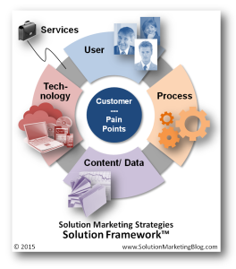
DOMESTIC MARKET
In what is being seen as the first big challenge to Uber’s growing dominance in the Indian market, domestic online cab aggregators are set to come together on a single platform to counter the predatory pricing unleashed by the foreign player.
A top executive of the country’s largest domestic player, Ola Cabs, told BusinessLine that dumping capital into the market will kill the fledgling industry completely. “Some of the players are using the profits they generate from international markets in the domestic market to lure drivers and attract customers at a price point that is not sustainable in the long term,” Ola’s Chief Operating Officer Pranay Jivrajka said.
Predatory pricing involves selling below the cost by giving out huge cash incentives to drivers to sustain the earnings they make from each ride.
Some of the top domestic cab aggregators came together at a recent seminar to collectively voice their concern about such tactics; the seminar was organised by the Management Development Institute in Gurugram.
Admitting that Ola too indulges in predatory pricing, Jivrajka said the company is forced to do this to maintain market share. “We are the only domestic player who has the capacity to dump capital and if we don’t do this, we can’t sustain our share.”
He, however, said Ola gives out a much lesser proportion in the form of incentives. He pointed out that Ola does not indulge in predatory pricing in markets where it is profitable. “Nearly 80 per cent of our markets are profitable, where we don’t give subsidy and infuse additional money from what the consumers are paying.”
Citing an example, Jivrajka said several drivers who work for Didi Chuxing, a cab aggregator in China, are up in arms as their earnings have dropped significantly after the company bought out Uber. “This is what predatory pricing does to the market where both customers as well as drivers start losing money in the long run,” he said.
Siddhartha Pahwa, the CEO of Meru Cabs and secretary of the Association of Radio Taxi India, said the new position taken by Ola was welcome as it now realises that such tactics will harm the industry eventually. “Those who deploy capital with the intent to kill competition will eventually hurt the industry,” he said.
INTERNATIONAL MARKET
Year | Month and date | Event type | Details
2009 | March | Company | Uber founded as UberCab.
2010 | July | Company | Uber goes live for the first time in San Francisco.
2010 | December | Team | Ryan Graves steps down as CEO in favor of Travis Kalanick.
2011 | February 14 | Funding | Uber announces it has raised $11 million in Series A round led by Benchmark Capital.
2011 | May | National expansion | Uber goes live in New York City.
2011 | September | National expansion | Uber goes live in Chicago.
2011 | December 5 | International expansion | Uber expands beyond the United States, starting by expanding into Paris, France.
2011 | December 7 | Funding | Uber announces it has raised $37 million in Series B round, including investors such as Goldman Sachs, Menlo Ventures (with Shervin Pishevar leading Menlo's investment), and Bezos Expeditions.
2012 | July 2 | International expansion | Uber launches in London, United Kingdom.
2012 | June | Competition | Lyft, a competitor to Uber, launches in San Francisco
2012 | July | Product | Uber announces UberX, a service that uses lower-cost hybrid vehicles.
2013 | June | International expansion | Uber launches in Mexico City, Mexico.
2013 | July | International expansion | Uber expands to Asia launches in Taiwan, starting in Taipei
2013 | August 8 | International expansion | Uber expands to Africa, launches its first product in Johannesburg, South Africa.
2013 | August 23 | Funding | Uber confirms it has raised $258 million in Series C round at a $3.5 billion pre-money valuation, with investors including Google Ventures and TPG Growth.
2013 | August 29 | International expansion | Uber expands to India, launching its first product in Bangalore.
2014 | April 7 | Product | Uber launches Uber Rush in New York City, a courier service using bicycle messengers to deliver packages. This marks the beginning of Uber's transition into a logistics company.
2014 | June 6 | Funding | Uber confirms it has raised $1.2 billion in a Series D round, with a pre-money valuation of $17 billion. Key investors include BlackRock, Google Ventures, Kleiner Perkins Caufield & Byers (with partner Megan Quinn), Menlo Ventures, SherpaVentures (with partners Shervin Pishevar and Scott Stanford), Summit Partners, and Wellington Management.
2014 | July 15 | International expansion | Uber officially launches in China, starting with Beijing.
2014 | July 24 | International expansion | Uber officially launches in Lagos, Nigeria, expanding its presence to Western Africa.
2014 | August 6 | Product | Uber announces UberPool, which lets riders share rides based on proximity.
2014 | October 22 - November 19 | Controversy | On October 22, 2014, an article by Sarah Lacy in PandoDaily was published where she sharply criticised the "asshole culture" of Uber and said she intended to delete the app from her phone. On November 17, 2014, BuzzFeed editor-in-chief Ben Smith reported that Uber senior executive Emil Michael "outlined the notion of spending 'a million dollars'" to hire four top opposition researchers and four journalists. He said that team could help Uber fight back against the press by looking into "personal lives, your families". Michael was particularly focused on journalist Sarah Lacy, who accused Uber of “sexism and misogyny". Lacy wrote a sharp response critical of Uber's actions. The controversy was picked up by CNBC, Business Insider, and the New York Times Bits blog. Michael Wolff, the journalist who had arranged for and invited Smith to the private dinner where the controversial remarks were made, wrote a lengthy piece about the controversy, stating that Uber executives had believed that the event was off-the-record, but that he (Wolff) had failed to communicate the information to Smith.
2014 | December 4 | Funding | Uber confirms it has raised $1.2 billion at a $40 billion pre-money valuation in a Series E round. Key investors include Qatar Investment Authority, Valiant Capital Partners, Lone Pine Capital, New Enterprise Associates, and SherpaVentures.
2014 | December 8 | Product | Uber expands UberFRESH in some parts of the Los Angeles area to include dinner delivery during weekdays.
2014 | December 8 | Controversy | An Uber driver in Delhi allegedly rapes a passenger when driving her home late at night.
2014 | December 16 | Funding | Chinese search technology company Baidu announces a $600 million strategic investment in Uber, also classified as a continuation of the Series E round, thereby bringing the Series E total to $1.8 billion.
2015 | January 21 | Funding | Uber gets $1.6 billion from Goldman Sachs in debt financing.
2015 | January 22 | International expansion | Uber launches its first product in East Africa, in Nairobi, Kenya.
2015 | February 2 | Team | Uber opens robotics research facility In Pittsburgh to build self-driving cars. In May, Uber poaches 50 employees from Carnegie Mellon's National Robotics Engineering Center.
2015 | February 14 | Competition | Didi Dache and Kuaidi Dache, the two biggest players in the low-cost app-based taxi hailing market in China, announce a merger into Didi Kuaidi. The merged company would be significantly larger than Uber in China.
2015 | February 18 | Funding | Uber raises an additional $1 billion in its $40 billion pre-money valuation Series E, increasing the total Series E money raised to $2.8 billion (after adding the first $1.2 billion and the next $600 million raised from Baidu). The additional investors are Times Internet, Foundation Capital, and Accelerated IT Ventures.
2015 | April 28 | Product | UberFRESH, which launched in the Los Angeles area in August 2014, rebrands itself as UberEATS. The rebranding is linked to an effort to rapidly expand to other areas. The service is already available in New York City and Chicago and plans to expand to many other locations.
2015 | June 17 | Legal | California Labor Commission deems Uber drivers as employees.
2015 | July 15 | Legal | Administrative judge recommends that Uber be fined $7.3 million and suspended from operating in California.
2015 | July 31 | Funding | It is announced that Uber has completed a Series F round, raising $1 billion at a $50 billion pre-money valuation (so a $51 billion post-money valuation). Key investors are Microsoft and Bennett, Coleman, & Co, Ltd., the parent company of The Times Group, India's largest media conglomerate.
2015 | August 19 | Funding | Uber raises $100 million in private equity from the Tata Opportunities Fund, a fund of the Tata Group in India, with the goal of using the money to help it double down on its India operations.
2015 | September 9 | Competition | Chinese Uber competitor Didi Kuaidi, the entity formed through the merger of Didi Dache and Kuaidi Dache, raises $3 billion to move more aggressively in its battle to maintain market dominance against Uber in China.
2015 | December 3 | Funding | Uber announces that it is raising $2.1 billion at a $62.5 billion valuation.
2015 | December 3 | Competition | Uber competitors Lyft (United States), Didi Kuaidi (China), Ola Cabs (India), and GrabTaxi (South-East Asia) (all of which have Softbank as an investor) announce a global technology and service alliance.
2015 | December 9 | Product | UberEATS, Uber's food delivery service, is spun off into a separate standalone app, and now offers all-day delivery in Toronto. The new app is not available for other regions.
2016 | March 1 and 15 | Product | On March 1, the new UberEATS app with all-day delivery luanches in Los Angeles, California. On March 15, it launches in Chicago, Houston, and San Francisco, and announces plans to launch in a number of other US cities in the coming months.
2016 | April 12 | International expansion | Uber launches in Buenos Aires, Argentina amidst claims of illegality and taxi protests.
2016 | May 7–9 | Local retreat | On May 9, Uber and Lyft cease operations in Austin, Texas.This is in response to a city ordinance upheld by Austin voters on May 7 that would require drivers for Uber, Lyft, and other transportation network companies to get fingerprint checks, to have their vehicles labeled, and to not pick up and drop off in certain city lanes.
2016 | May and June | Product | Uber announces that it is changing its app to inform riders of the price of their ride when they book it, rather than simply providing a surge multiplier. The move is prompted by the observation that UberPool users, who do see the ride price upfront, are more likely to continue using the service. Price changes triggered by destination changes will be sent to riders in real time. Changes to routes due to traffic or other reasons not under the rider's control will not result in a change to the price charged upfront. The move is not an end to surge pricing but rather a change in the way the surge pricing is communicated to customers. The change, officially announced in late June, had already been rolled out at the time of announcement in several cities, and had received some commentary in May.
2016 | June 9 | Product | Uber opens up the Uber RUSH API to developers. The goal of this API is to make it easy for merchants to integrate the use of Uber drivers into their delivery system. The tool has been used by select small businesses since October 2015, and the opening up to the public is to encourage more widespread adoption.
2016 | June 30 | International expansion | Uber launches in Kiev, Ukraine.
2016 | July 24 | Local retreat | Uber leaves Budapest, Hungary.
2016 | July 28 | Legal | The Chinese government issues guidelines to make ride-hailing services, such as Uber, legal in the country.
2016 | August 1 | competition, mergers | Didi Chuxing (formerly Didi Kuaidi), the dominant player in China's ridesharing market, agrees to buy Uber China, Uber's business in China. The Uber brand will be retained, but Didi would “integrate the managerial and technological experience and expertise of the two teams.” Uber reportedly lost $2 billion trying to make inroads in China.
2016 | August 18 (announcement) | Product, automation | Uber announces plans to launch service with self-driving cars in Pittsburg, Pennsylvania, where its robotics research facility, built with employees poached from Carnegie Mellon University in 2015, is located. The cars are modified version of the Volvo sports utility vehicle equipped with Uber's technology for self-driving. Cars will have drivers at the wheel, monitoring the vehicle, as required by law. The move is seen by commentators as the first step in Uber's ambitious goal of replacing its entire fleet with autonomous vehicles.
2016 | September 16 | Product | Uber begins mapping UK streets in an effort to identify the best pick-up and drop-off points from its own images.
2016 | October 28 | Legal | Uber loses the case of Aslam v Uber BV on workers' rights. Appeals to the UK Employment Appeal Tribunal.
2016 | November 2 | Product, user experience | Uber launches a redesigned rider app, with a simplified user flow that focuses on identifying the destination first, then shows ride options with prices, and then gives driver contact information and allows riders to make adjustments such as split fare and get more information about the destination.The app also connects better with the user's current location, real-world identity, favorite places (such as work and home) and integration with services such as Foursquare and Yelp for destination-specific information, in what is seen as an attempt to pull users into spending more time in the app.
2017 | March | Product | Uber begins beta testing a program in select cities to pick up passengers aged 13 through 17, previously not allowed on the company's terms of service.
2017 | June 6 | Team | CEO Travis Kalanick takes summer sabbatical after an investigation into the company's workplace culture.
2017 | June 21 | Team | Travis Kalanick resigns as CEO
2017 | August 28 | Team | Dara Khosrowshahi is hired as CEO.
2017 | October 25 | Product | A Visa credit card is announced for the United States market, in partnership with Barclays. The card will become open for applications on November 2, 2017.
A few bans here and there can't stop Uber's march across the globe.
The car-service app is facing bans in India, Spain, Belgium, the Netherlands, Thailand and more. But it's also deploying in new cities at a breakneck pace that leaves its obstacles far behind.
On Wednesday, it launched in Tianjin, China. On Tuesday, it was Sofia, Bulgaria. Last week, Uber hit Portland (where it's now being sued), Hanoi, Vietnam, and several cities in central Florida. In late November, Uber's head of global expansion told Businessweek that Uber was launching in a new city every other day, but those now seem obsolete just a few weeks later. Depending on how you slice the numbers that FORBES gathered, Uber's growth rate is closer to one new city a day. It launched in around 30 cities in the last 30 days, though some launches are for regions that include multiple cities.
FORBES's Frank Bi mapped Uber launch data from 2010, when it launched in San Francisco, to 2014, the year it grew six times in size. Its growth begins as a few drops scattered across North America, then picks up speed. Just a few seconds later, it's a downpour across the globe.
Uber's rapid expansion is focused on Asia. Last week, the startup raised a monster $1.2 billion round of funding that values the company at $40 billion and promised to use the cash to "make substantial investments, particularly in the Asia Pacific region," CEO Travis Kalanick wrote.
Uber's growth in Asia hasn't been smooth or easy. In large foreign markets like China and India, locally grown competitors say they hold a much bigger market share than Uber because they have a deeper understanding of the culture -- even though Uber usually works to hire general managers with local experience.
In China, Uber battles with Kuadi Dache and Didi Dache, two taxi-hailing apps backed, respectively, by Chinese giants Alibaba and Tencent. In India, local hailing app OlaCabs says it has 70% of the market and Uber has 10%. Uber was also banned in the Delhi region on Monday after a passenger was allegedly raped by an Uber driver who reportedly had past sexual offenses.
Meanwhile, Uber has permeated so much of the U.S. -- as of last week, 64% of the U.S. has access to Uber, the company said -- that its launches are now hitting smaller cities, some of which aren't able to sustain strong Uber ecosystems after an initial wave of interest.
Cities like Flint, Mich.; Akron, Ohio; Corpus Christi, Texas; Anchorage, Alaska and Tuscaloosa, Ala. often show no available cars, or one car far away, even though they launched to much fanfare and free rides.
In an Uber Reddit driver thread, a driver asks, "Is Uber Akron Ohio dead?" Another user responded: "Unfortunately that is what happened. Uber put in guarantees for one weekend, and then hasn't promoted it since."
Uber's main U.S. competitor, Lyft, is in around 65 cities and has not expanded overseas. But in Asia, huge cities -- and huge rider markets -- still await. Uber operates in 11 cities in India and is recruiting heavily in China. A map of Uber job listings from Silk, a data publishing platform, shows dozens of openings in China, India, and the Netherlands, with more spread across the globe.
The expansion team moves at such a fast pace that they no longer worry too much about where to open next. "At this point we go so quickly, I wouldn't say that it particularly matters,"Austin Geidt, Uber's head of global expansion, told Businessweek. "If we're not there now, we'll be there in a week."
TARGET MARKET
There is a very large target market for Uber full of “buyer personas”. Some of the personas include:
- men and women ages 18 to 60 that frequently attend concerts, baseball games, basketball games, football games, etc.
- men and women ages 18+ who travel frequently for business (or pleasure) via air or public transit
- men and women, 21+ that frequent bars and nightclubs (key dates: December 31st-Jan 1st, February 4th, March 17th, July 4th, etc.
- men and women ages 18+ who have not yet acquired a driver’s license
- men and women ages 18+ who have had a DUI, third strike traffic ticket, etc, and have had their driver’s license revoked.

Uber has 2 target markets (as they’re a marketplace)
Demand-side - people and businesses that want a fuss-free experience to get from A to B.
Supply-side - drivers that want flexibility and to (hopefully) make more money than they would otherwise.
These are the basic target markets - it does drill down further though by use cases, demographics and service types.
FOUNDERS AND THEIR POSITION IN ORGANISATION
Founders
On a snowy Paris evening in 2008, Travis Kalanick and Garrett Camp had trouble hailing a cab. So they came up with a simple idea—tap a button, get a ride.
What started as an app to request premium black cars in a few metropolitan areas is now changing the logistical fabric of cities around the world. Whether it’s a ride, a sandwich, or a package, we use technology to give people what they want, when they want it.
For the women and men who drive with Uber, our app represents a flexible new way to earn money. For cities, we help strengthen local economies, improve access to transportation, and make streets safer. When you make transportation as reliable as running water, everyone benefits. Especially when it’s snowing outside.
POSITION
Actually Uber follows some of the typical organizational structure in the remote and wireless industry. The top management level is normally formed by a group of directors.
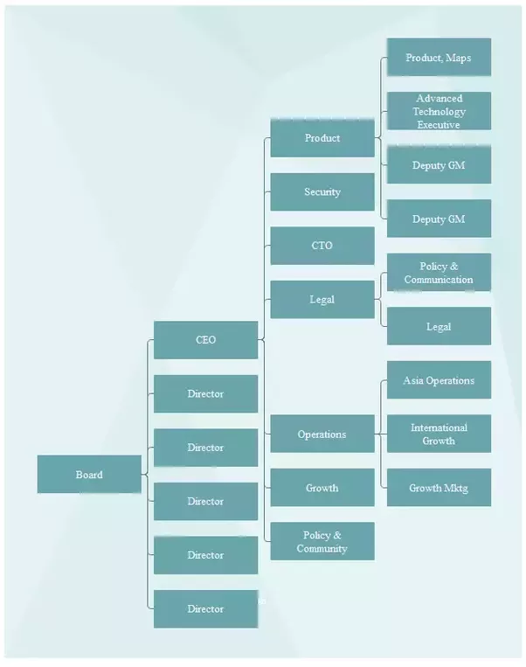

COMPETITIVE ANALYSIS
Uber is one of the top private companies in the United States, with the utilization of Uber technology; consumers are able to schedule transportation with the help of a mobile App. Uber Technologies Inc. receives client requests and sends the same requests (bearing location and final destinations) to drivers who are within close proximity to the said clients. As one of the tools of operation, the drivers must, therefore, have smartphones.
The same applies to clients who must utilize the Uber app in making ride requests. This company was founded in the year 2008 and has its headquarters in San Francisco.It has around 12,000 employees and revenue from sales was estimated to be around 6.5 billion dollars by the end of 2016. As one of the companies that have shaped the taxi business around the world, Uber receives both direct and indirect competition from the following:

Direct Uber Competitors

1) Lyft
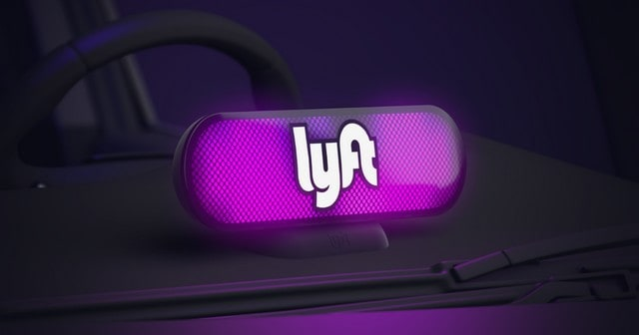
For a Lyft ride, one is required to download and install the Lyft mobile App on his/her android mobile phone then sign up by providing a relevant phone number and a valid mode of payment i.e. credit card or other online modes including PayPal, apple pay and Google wallet after which a ride request can be made to the nearest driver.
After confirmation, the name of the driver is shown with ratings from previous passengers, his photo and that of the car will also be provided. After the ride, the client provides gratuity that is billed to his payment method.
Based in California, USA, Lyft operates in other 300 states in the U.S. providing more than 18.5 billion rides a month; its valuation as at mid – 2017 stands at around 7.5 billion dollars. It might not be upto the vast presence of Uber but in US Lyft is the topmost amongst Uber Competitors.

2) Curb
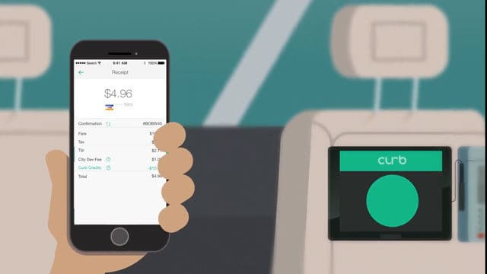
The curb App was initially referred to us ‘Taxi Magic’. The name changed to ‘curb’ after it was re-launched by VeriFoneSystems who are the current new owners. Though based in San Jose, VeriFone Systems runs most of the green and yellow taxis in New York.
As a company that also manages the taxi payment systems, the curb taxis are required to use VeriFone’s entertainment systems and credit card machines. By the end of 2016, around 14,000 green and yellow cabs had passed that minimum requirement and hence it is considered as one of the top Uber Competitors.
The Curb App as developed by Creative Mobile Technologies (CMT) requires one to pay a fee of around 1.95 dollars every time it is used to book a cab. It also provides driver ratings and notifies drivers of possible trips. Since its Debut in 2015, VeriFone’s target is to bring Curb to all major cities in the USA

3) DidiChuxing
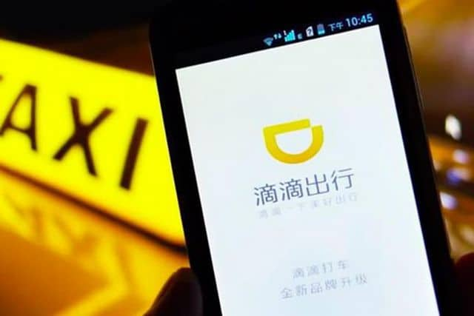
DidiChuxing, with its initial name DidiKuaidi, is among the dominant companies in China that provide ridesharing services including; DiDi Chauffeur, Didi test Drive, taxi-hailing, DiDi Minibus and DiDi private car-hailing to over 400 million people by the use of a smartphone across the 400 China cities.
In the year 2015 alone, it completed a milestone of 1.4 billion rides. This was so high when compared to other companies in the same industry. Since its inception in the year 2009, Uber was the closest after clocking a billion rides in six years. This company was as a result of a merger between KuaidiDache and DidiDache. By the end of the fiscal year 2016, it was valued at 28 billion dollars. Later that year, it acquired the Uber unit of China
With plans to extend services globally, DidiChuxing started developing the new English version of its App in mid-2017. In the same year, DiDi was voted the most valuable startup with a valuation of over 50 billion and supported by more than 100 investors. Didi is the only company in China with Tencent, Baidu and Ali Baba (three largest internet corporations in China) as investors. With the huge population of China and other Asian countries supporting it, DidiChuxing is without a doubt one of the top Uber Competitors in that region.

4) Grab
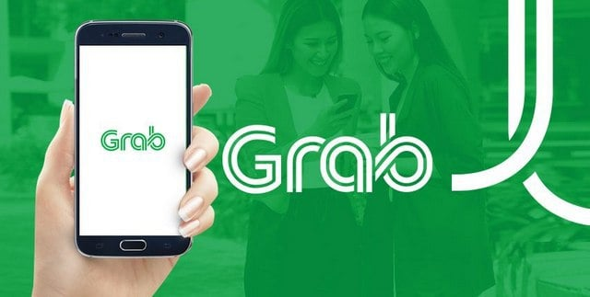
Grab is a Singapore based company that provides a variety of logistics and ride-hailing services through its mobile App in Asia’s Philippines; Vietnam; Malaysia; Indonesia and Myanmar. Towards the end of 2016, Grab introduced a messaging service on its App allowing communication between riders and drivers.
The messaging service also enabled language translation thereby breaking the initially existent language barrier. By June 2017, it had over one million drivers registered to its network and its App downloaded and installed in over 45 million devices in the South of Asia.Currently, Grab services are available across 30 cities in around 6 countries

Ola Cabs
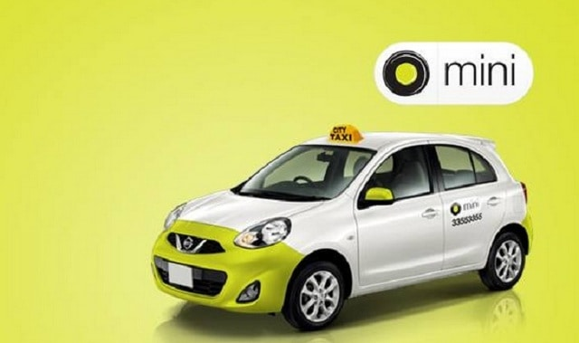
This is an Indian transport company operating under the name ‘Ola’. It was founded in the year 2010 in Mumbai but currently has its headquarters in Bangalore. By the end of the year 2015, Ola’s Value was over 5 billion dollars and its revenue estimated to be close to150 million dollars.
The company has now expanded to over 600,000 vehicle networks in more than 110 cities. Its services range from economic to luxury travels and can be booked through a mobile App. With around 150,000 bookings a day, Ola has a majority market share in India of over 60% and is currently investing in Artificial intelligence (A.I) technology so as to ward off competition in its Indian 12 billion markets from the American Firm Uber. Because it understands the Indian market much better then Uber, Ola is one the top Uber competitors in India.

Indirect Uber Competitors

6) Local Taxi’s
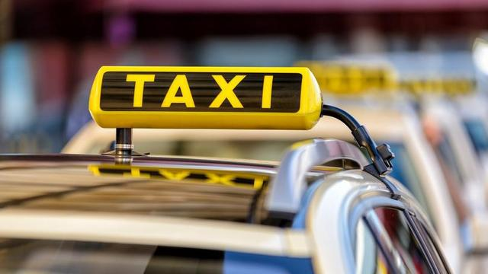
Taxi’s are indirect Uber competitors. In major cities around the world, Local Taxis line up in specific areas to wait for passengers. These strategic areas are in most cases places with high traffic volumes i.e. stations, ferry terminals, hotel driveways and airports among others.
The local Taxis modus operandi is based on a first come first serve basis. With the first to arrive Taxi the first on the queue. The arriving passenger takes the first on queue Cab with the others behind moving one spot ahead. In other countries, however, this rule does not apply and the passenger can choose any Taxi from the ones available for hire.
Being in the transport industry, Local Taxis provide stiff competition to Uber as they can negotiate transport costs with clients. Most of them are operated by owners who are not after profits but little money for vehicle maintenance and subsistence.

7) Public Transport
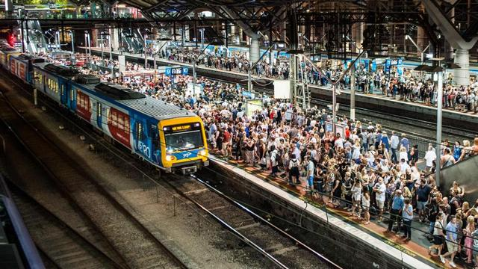
Compared to the use of Taxis, this is a relatively cheaper mode of transport in most countries that provides mass or shared transportation to various destinations. It may be by bus, train, trams, ferries et cetera. The public transport sector is managed differently in different countries. In Asia, it is driven by profits and therefore controlled by both the private and public conglomerates. In North America, it is managed by the Municipal Council, in Europe; it’s operated by both the State and Private sector
Transport costs here vary in terms of distance; the far you go, the more you pay; although it is still cheap due to the fact that a lot of people alight in almost all destinations and there is no any form of private arrangement.In some developed countries, this form of transport is fully subsidized by the national tax revenue and therefore free of charge in major towns and cities. With 3400 members from close to 100 nations worldwide, the International Association of Public transport (UITP) comes up with policies and decisions that govern the public transport sector in member states.
As low cost as they may seem, most public transport vehicles drop and pick passengers in designated areas. Their safety and comfort are also questioned because they deal with a mass. Again, these vehicles do not depart from their station unless they are full. All these issues have been addressed by Uber taxis. Uber cars also have a set minimum standard that must be met so as to provide the desired quality service to all its customers. The perhaps reason they still ride high in this competitive transport industry.

ONLINE STRATEGY
We’ve all heard about the bad press that Uber has gotten over the past year or so. Class action lawsuits, gross driver misconduct, surge pricing shocks, legal fights with governments, the list goes on…Despite that, the ride-hailing-and-so-much-more service continues to grow. Why is that? For one, they offer a compelling and in-demand product. Secondly, Uber’s marketing strategy is multi-pronged and innovative. Let’s take a look at some of the campaigns and tactics that have been integral to the growth of the company valued at $62.5 billion.
1. Early Adopter Advocacy: Word of mouth marketing has been essential for Uber’s marketing strategy. The way the company initially fostered it was by seeking out Silicon Valley movers and shakers and getting them to advocate for the brand. While many techies are constantly looking for new products and services that transform their ways of life, Uber also took aim at them by sponsoring events, giving first-time riders a free trial, and adopting a hyper-local strategy that changes shape with each new city the company enters.
Our white paper, 21 Ways to Turn Shoppers into Advocates, will give you a multitude of ideas about how to cultivate advocacy for your own business!
2. Referrals: Early adopters have since been able to take advantage of Uber’s referral program to give friends free rides while earning credits themselves. This gives money-get money program gave first-timers a more concrete reason to try the service. It’s been massively successful both for Uber and for certain super-fans, one of whom earned over $50,000 in referral credits. Drivers also get referral incentives, thereby making the acquisition on both the customer and “contractor” sides faster and easier.
To this day, referrals are an integral part of Uber’s marketing strategy. It’s not surprising, as word of mouth is an age-old marketing technique that works across essentially all industries. When a company implements referral software, suddenly these effective yet opaque communications become visible. They can incentivize advocates and first-time users, scale their marketing, and pinpoint what’s working and what isn’t.
To learn more about implementing a robust referral program, check out our best practices white paper, The Step-by-Step Guide for a Powerful Customer Referral Program.
3. A Loyalty Program: Not many consumers know it, but Uber’s marketing strategy has included a customer loyalty program for at least about two years now. “Uber VIP” is exclusive to those who are actually loyal – customers who’ve taken over 100 Uber rides. It seems like the main tangible benefit of the loyalty program is that VIPs have special access to the highest-rated drivers. However, the program also signifies a commitment to and a gratitude for these returning customers, who surely feel slightly proud of the fact that they’re “very important.”
Online Loyalty programs can help boost customer retention for your own business, you should definitely read Advocate Loyalty: A Four-Point Strategy and Customer Retention in 2017: Driving Emotion with Technology.
4. Stunts: Every time Uber launches a new special offer, groups of millennials around the world cheer. Sometimes the service delivers kittens to offices and other times it lets passengers ride with famous musicians like Diplo or Matt & Kim. These exciting “surprise and delight” tactics work to please loyal customers, generate positive buzz, and give Uber a more fun and friendly image, which is something it often lacks in comparison to its competitor Lyft.
5. Partnerships: Uber has implemented a number of partnerships to entice both first-time and loyal customers to take a ride. Certain Capital One credit card holders can get discounted rides, Starwood Hotels Preferred Guest members can earn hotel points for every Uber trip they take, and Spotify users can link their profile to their Uber account to play their music while they ride. While the Capital One and Starwood Hotels partnerships give those customers a financial incentive to ride, the Spotify alliance is just a fun add-on for users coming home from the bars. All of these partnerships, though, give more legitimacy to the gargantuan startup.
.

6. Reviews: One massive differentiator between Uber and traditional taxis is that the transportation disruptor has rating systems for both drivers and passengers. Drivers are probably more motivated by their ratings since passengers can’t easily find out where they stand. Either way, the system promotes trust in Uber and better behavior on the parts of both driver and passenger. A certain amount of uncertainty (or dread) about how chatty or inebriated one’s travel buddy will be is thereby eliminated, making everything a little smoother for everyone.
To get all the facts about review platform, don’t miss our Ratings and Reviews FAQ! If you’re looking into implementing any kind of review system on your own site or app, our guide, Optimizing Your Site’s Ratings and Reviews, is a must-read.
7. An Omni-Channel Approach: The most crucial aspect of Uber’s marketing strategy and its product itself is its seamless, multi-channel nature. In an excellent Growth Hackers post, Sean Ellis, Everette Taylor, and Dylan la Com note that “Uber set out to reimagine the entire [taxi] experience to make it seamless and enjoyable across the board. They didn’t fix one aspect of the system (e.g. mobile payments for the existing taxi infrastructure), they tackled the whole experience from mobile hailing, seamless payments, better cars, to no tips and driver ratings.” The product is tapped into customers’ lives in a wholly revolutionary way compared to the old method of hailing or dialing a cab.
The omni-channel tactics don’t even stop there. Uber has recently partnered with Facebook Messenger to let users request rides from within the messaging app. In certain cities, the company has set up physical kiosks with breathalyzers, which will hail a ride for bar patrons who’ve had a little too much that night. There’s even an Uber mobile game! At the same time that Uber extends its presence to other channels, it’s also striving to fulfill more consumer needs on its own platform. UberEATS is the company’s rapid food delivery service and standalone app. UberRUSH, meanwhile, is a business to business delivery service that’s already partnered with Shopify, Bigcommerce, and Clover. UberHEALTH has begun to deliver flu shots, and UberEVENTS is working its way into the wedding industry by letting event hosts prearrange and prepay for transport for their guests.
While your business might not have its eyes set on offering so many different functions, there’s still a lot to learn from Uber’s marketing strategy. They’re merging mobile technology and data to create a famous customer-centric experience. Uber’s marketers never think of their customers as faceless masses who come to the business for one thing and one thing only. Instead, consumers are viewed as individuals with varied needs and desires–they want convenience, fair prices, novelty, and recognition. All companies need to recognize that and ask themselves, “How else can we help our customers, and how can we better communicate with them?”

INVESTORS/TYPES OF INVESTMENTS

Uber Technologies has had a wild ride in the past few months in the wake of many scandals and missteps. Those have weighed heavy on the company as its valuation plummeted to $48 billion, in the latest funding round, from a lofty $70 billion. But what would come as a much needed relief is a settlement between the company and Alphabet-owned self driving technology company Waymo. The latter had sued Uber for allegedly stealing trade secrets but has now agreed to settle for $245 million.
That would make Uber investors happy. Here's a look at some names that have funded the company over the past nine years.
In addition to Wall Street's biggest banks like Goldman Sachs, Morgan Stanley, and BlackRock, many 'angel' investors, who were early backers of Uber, helped launch the company. Co-founders Travis Kalanick and Garrett Camp also provided seed money.
Notable names, according to Crunchbase, include Adam Leber, who was a talent manager for Britney Spears and Miley Cyrus, among others. Also on the list, Babak Nivi, founder of Angel List and Venture Hacks. Woman-run Bechtel Ventures also provided $1.3 million in Uber's first money-raising round. Bechtel was founded by Robin Sloan Bechtel, a new media executive credited with marrying Hollywood and the Internet by fostering partnerships with studios and YouTube and Facebook. Another exception to the male-heavy investor list is angel investor Cyan Banister. Gary Vaynerchuk, founder of Vayner Media, was an early stage investor, according to Crunchbase, along with Jason Calacanis, Josh Spear, Alfred Lin, Bobby Yazdani, David Sachs, Dror Berman, Jeremy Stoppelman, Josh Spear, Kevin Hartz, Khaled Helioui, Mike Walsh, and others. The full list on Crunchbase can be seen here.
Other notable investors, albeit at later rounds, include Shawn 'Jay Z' Carter, Jeff Bezos, the founder and CEO of Amazon.com, Fidelity Investments, Softbank, Tencent, and Axel Springer, the parent company of The Business Insider. Uber has raised more than $22 billion over eighteen rounds and has been valued as high as $70 billion, making it the #1 unicorn.
Uber has 25 board members and advisors, including the company's new CEO Dara Khosrowshahi. There are 4 are women among the board and advisors according to Crunchbase, including Arianna Huffington, founder of The Huffington Post.
However, the challenge now will be to shift Uber’s model from one that has been very successful at revenue growth, to one that is more financially sustainable and, eventually, profitable. Some economists say there was no obvious way to do that, even before the extra challenges Uber now faces as the company rebuilds its C-suite and tries to recover from a series of crises, including the resignation of Travis Kalanick as chief executive earlier this week. “There is no clear pathway I can see for Uber to go from a high-revenue growth company to a profitable company,” says Aswath Damodaran, a professor of finance at the Stern School of Business. “Normally the story for start-ups is that as revenues grow economies of scale will kick in, but that story is tough to tell with Uber.” Furthermore the leadership vacuum at Uber has left a question over one of its main advantages, the ability to raise ample money at low cost. Uber has between $6.5bn and $7bn of unrestricted cash in the bank, with a further $2.3bn untapped line of credit. This could cover the company’s cash needs for roughly three more years, extrapolating from its losses during the first quarter of this year. Uber’s path to sustainability will depend on controlling the company’s two main costs: the subsidies for drivers and riders, and general costs such as engineering and research and development. These general costs benefit from economies of scale — as Uber grows, the overhead becomes less expensive on a per-ride basis. The subsidies are essential because Uber uses these as levers to maintain a two-sided transportation marketplace, one that balances driver demand and passenger supply. Sign-up bonuses attract new drivers and maintain a sufficient driver pool, while more specific bonuses for certain times and places help steer drivers to places of high demand.
WAY FORWARD
Uber is planning to buy up to 24,000 self-driving cars from Volvo, the company has announced, moving from its current model of ride-sharing using freelance drivers to owning a fleet of autonomous cars.
Following the three-year self-driving partnership with Volvo, the non-binding framework could give Uber a boost in its ambitions to perfect self-driving systems to replace human drivers, following setbacks and lawsuits over trade secrets and talent.
Volvo said Monday it would provide Uber with up to 24,000 of its flagship XC90 SUVs, which retail from around £50,000, equipped with autonomous technology as part of a non-exclusive deal from 2019 to 2021. The Geely-owned car company will provide the vehicles, while Uber will provide the yet-to-be-built self-driving system, which is currently under development by Uber’s Advanced Technologies Group.
The announcement follows the news that Alphabet’s Waymo will launch the world’s first autonomous car service in the next few months in Arizona, where it is legal to operate self-driving cars without humans behind the wheel, unlike the majority of the rest of the US and the world, which requires the safety net of a human driver.
Autonomous vehicles are seen as the logical next step for ride-hailing firms including Uber, which said it perceived the technology as an existential threat. Equally, automakers, ride-hailing firms and tech startups have been forging loose alliances in an effort to advance self-driving technology and claim a piece of what is expected to be a multi-billion-pound business.
The air quality in our cities is a growing problem – and one that affects us all. At Uber we’re determined to play our part in tackling air pollution across the UK.
That’s why we’re today announcing a Clean Air Plan with a series of measures for drivers, riders and cities. As part of our Plan:
- By the end of 2019 every car available on uberX in London will be 100% hybrid or fully electric with no diesel vehicles on the app.
- We’re starting in the capital but aim to meet the same standard – 100% hybrid or fully electric cars on uberX with no diesels on the app – across the UK by the end of 2022.
- More than half the miles on uberX journeys in London are already in hybrid or fully electric cars, but we want to go much further with a goal for every vehicle using the app in London to be electric in 2025.
- We are also launching a diesel scrappage scheme aimed at removing 1,000 of the most polluting cars from London’s roads. The first 1,000 people in London to scrap a pre-Euro 4 diesel vehicle and provide an official scrappage certificate will receive up to £1,500 of credit to spend on Uber or uberPOOL rides as we encourage Londoners to get into a shared car to connect with public transport. Londoners can register their interest today here and will be able to apply through the scheme from next month.
CRITICAL ANALYSIS
Uber is one of those smart app radio taxi services which have given new way of traveling for Indian women. These services are generally considered to be safe because of verification and GPS, but Delhi case has proved everyone wrong. In India, it was first introduced in Bangalore and has expanded to 10 Indian cities.
Uber issued a statement after the incident and offered all support to the police in their investigation. The statement also said that driver verification is thoroughly conducted in order to provide a safe transport option. However, it must be kept in mind that issues with Uber are not being faced in India but in other jurisdictions also. Uber has been banned in Brussels on the ground that it partners with taxi drivers who do not have a license or the required permission to use their private vehicles for earning money from passengers.
It is alleged that smart app based taxi services like Ola and Uber have bending violating rules and regulations to become operational in India. After the rape incident, the Government banned the services of Uber in Delhi reasoning that Uber is running taxis that cannot ply in Delhi. This means that traffic police can impound or fine these vehicles. This incident also highlights that Uber didn’t have a rent- a cab permit and didn’t verified the criminal history of its drivers while registering them. The driver was charged with the similar offense earlier although he was acquitted.
State governments, in the exercise of their powers to frame rules for the effective administration of the Motor Vehicles Act, have put in place radio taxi schemes for the functioning of radio taxis. The Radio Taxi Scheme of 2006 is the nodal regulation for operation of such taxi services in Delhi. The scheme specifies that the licensee must be either a Company under Companies Act, 1956 or a Society under the Societies Registration Act, 1860. The key requirements of the scheme are as follows:
- Spacious Control Room
- Radio Communications
- Adequate parking space for all taxies and office space
- Minimum fleet size would be 500 motor cabs
- Every vehicle must be fitted with GPS based tracking devices
- It would be the responsibility of companies to ensure police verification of their drivers
The model used by Uber depends on technology to make cabs more easily available to passengers. Uber provides information and means to obtain services offered by transport owners, drivers or transport operators. Such services are requested through Uber smart app based application. As per the terms and conditions mentioned on Uber website, the quality of the transportation services requested through Uber is entirely the responsibility of the vehicle operator or provider. The website also states that any complaint about the driver should be given to the transportation provider. Uber only acts as a link between the vehicle provider and customer.
The drivers are not the employees of Uber. They are independent contractors but Uber exercises some control over their drivers. Although Uber runs a background check on its drivers, it is limited to police verification. The recent rape case has shown the loopholes in this process as previous criminal record of the driver was ignored. In other jurisdictions such as United States of America, there is multi-layer screening process which includes checking at federal, state and county levels. The previous driving record of driver is kept in mind and he is regularly monitored to ensure safe driving.
However, there is a difference between regulations for radio taxi operators and intermediaries like Ola and Uber. In order to work for a radio company, a driver has to go through the long process of becoming a certified badge holder. Once a radio taxi driver has a commercial license, he has to undergo police verification which takes into account permanent address, criminal records, etc. Once the verification process is completed, the transport department issues a badge with unique identification number. The drivers who work with intermediaries are not affected by this stringent process and they merely have commercial license.
In Uber model, the taxi users as well as taxi operators need to get themselves registered on Uber in order to access its services. While registering, customers are required to provide their name, address and contact numbers which are stored by the company. After registering, customers can use Uber’s GPS facility to find out of there are any taxis in their area. Thereafter, the app informs the user about the estimated price of the journey and the expected time of arrival of the taxi along with details of the driver such as his/her name, photo and contact number. The app automatically charges the customer through credit card and pockets 20 % of the fare amount.
The following legal issues have emerged for the Uber incident:
- The Motor Vehicles Act, 1988 doesn’t specify liabilities or rights of taxi intermediaries. There is an urgent need to modify this Act in order to incorporate new form of transport providers. Uber has not set up any legal entity in India. As a result, it is very difficult for any regulator to hold Uber accountable for its actions.
- Although Uber has verification and a rating process for its drivers, they have failed to serve the purpose of ensuring safety for customers. The process is outdated and one can easily bypass this process.
- Since the Uber collects personal data of the customers there is a concern of data security. The law that deals with data privacy is Information Technology (Reasonable Security Practices and Procedures and Sensitive Personal Data or Information) Rules, 2011.
- The transactions are done by credit card and there is a threat of fraud in such transactions. The RBI has put in place a 2 step-authentication system a few years ago. Under this system, the user is not only required to enter his credit card i.e. the card number, expiry date and CVV number, but is also expected to enter the one-time password in order to complete second step. However, in the case of Uber, the second step is not fulfilled as the payment is automatically collected by Uber when a customer reaches his destination. The RBI has said that the companies do not follow the second step in the authentication process are flouting guidelines on card security. Only those companies whose payment gateways are not in India can circumvent the 2-step requirement. For example, a person does not need to enter a one-time password while shopping on amazon.com, even though the OTP has to be entered while shopping on amazon.in. Although Uber’s payment gateways are not located in India because all the payments are processed by its operating firm called Uber BV located in the Netherlands, it still has to comply with the 2-factor authentication process because 80% of every payment that it receives has to be funneled back into India in favor of taxi operators.
- The notification — No. U-11036/(i)UTL dated 09.09.2010 of the Union Home Ministry — declared several guidelines for vehicles carrying female employees of Business Process Outsourcing (BPO) companies and corporate houses, including equipping their vehicles with GPS (Global Positioning Systems) in two months. However, the notification is silent on its application to similar vehicles not directly employed by such business entities, such as privately-owned cabs.
After the unfortunate rape incident, the Union Home Ministry issued guidelines to stop all app-based services. The state governments of Delhi, Uttar Pradesh and Chandigarh banned these services and other states have issued show cause notice. The transport official has said that the Uber didn’t have a city-specific license to operate in Delhi and has misled the customer about the nature of services. Under the public pressure the Delhi Police has registered a case of cheating under Section 420 of IPC and is planning to file further charges against the company.
The knee-jerk reaction on the part of the government won’t help the matter. By merely banning taxi services and issuing guidelines, the passengers especially women won’t feel safe. The government needs to overhaul the process by which license and permit are issued to drivers of these commercial vehicles. It is well-known that one can get commercial license by simply greasing the palm of few officials. If one can get away for such a small thing, he might be encouraged to commit bigger crimes. Take infamous 16 December rape case for example. The school bus was being run late at night and no policeman bothered to stop it. When they were informed that such bus was running, they choose to ignore it before it was too late. Clearly, there is collusion between vehicle operators, police officials and transport officers which allowed these drivers to go unabated. This situation is further aggravated in cities like Delhi and Mumbai where private as well as commercial vehicles are increasing every year, but there is not adequate mechanism to check them.
This event has also provided an opportunity for law makers to regulate the intermediaries and form a comprehensive regulation which ensures safety of passengers. A failure to revamp existing frameworks to promote entrepreneur based growth would not only have several deleterious effects on the economy. The new motor bill which is still being drafted should contain the provisos to rein in reckless taxi operators and services. It should also contain hefty fine for vehicle operators who hire drivers without proper verification.
However, it is not merely the liability of government to ensure safe working of women. We, as citizens of this country, have a duty to stand up against the injustice. By merely expressing our anger and participating in candle marches, we are not acting like model citizens, but rather hiding from our true responsibility.
BIBLIOGRAPHY
- www.lexquest.in
- www.wikipedia.com
- www.google.com
- www.thehindubusinessline.com
- www.investopedia.com
- www.quora.com
- www.ft.com
- www.uber.com
- www.marketing91.com
- www.forbes.com
- www.annexcloud.com
APPENDICES

