UNIVERSITY OF LUCKNOW
DEPARTMENT OF BUSINESS ADMINISTRATION



REETIKA GUPTA
MBA SEMESTER 2ND
ROLL NO. – 10
SECTION- B
INFORMATION MANAGEMENT SYSTEM
ASSIGNMEMT
ORGANISATION- DIESEL LOCOMOTIVE WORKS, VARANASI

Submitted to:-
DR. SANJAY MEDHAVI SIR

ACKNOWLEDGEMENT

My name is Reetika Gupta, student of Department of Business Administration, UNIVERSITY OF LUCKNOW. I am very thankful to my teacher Dr. Sanjay Medhavi Sir for giving me opportunity to do this amazing assignment which further not only enhanced my knowledge but also made me aware about the organisation and its working. Overall it was good experience of visiting organisation and interacting with the employees there.

Reetika Gupta
MBA Semester 2nd
DBA,LU
INDEX
- Background of DLW.
- Technology.
- Hardware.
- Operating Systems and databases.
- Network.
- Applications.
- Production Planning and Control.
- Material Management Information System.
- Security Management Information System.
10.Personnel Management Information System.
11.Financial Management Information System.
12. Messaging and Integrated Email.
13. FOXNET.
14. Other activities on EDP centre.
15. Website of DLW.
16. E-tendering.
17. Work Progress at EDP centre.
18. Benefits of ISM in DLW.
19. Negative Impacts of ISM in DLW.
20. Effect on Employees.
21. Conclusion.
22. Bibliography.
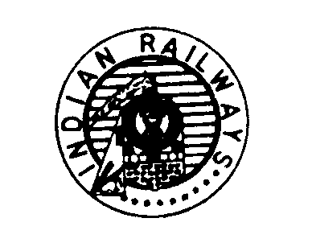
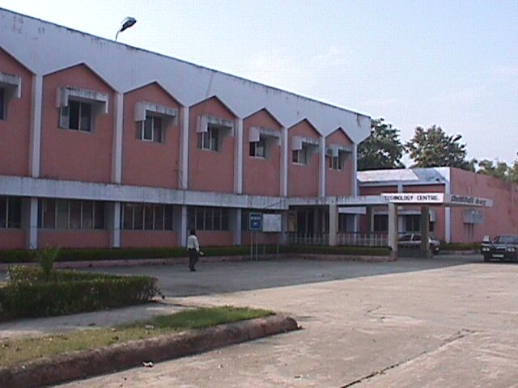

A Brief on Their Activities



EDP CENTER
DIESEL LOCOMOTIVE WORKS
VARANASI

BACKGROUND

DLW was one of the pioneer Production units of Indian Railways to come under the ambit of computerization, way back in 1964. Traditional batch processing systems covering Payroll, Inventory Control, and Production Planning etc were developed and run on mainframes – IBM-1401 from 1968 to 1986 and ICIM-6060 from 1986 to 1996. These applications served the information requirements of DLW for a very long span. These systems were using the classical batch processing technology. The scope was limited to payroll generation, production documents printing and basic transaction processing for the stores side. Further there was no direct user interaction and data was put into the systems in batch mode monthly much after the completion of the actual activities. Thus the system was not online. It was required to be replaced by an online system which could effectively cater to the information requirements of the managers and decision makers.

Over time with the evolution of the real time information System, data capture directly from the user has become an essential requirement of any information system. Further there is a need for an integrated application to cover the complete gamut of the business processes so that the system may not only satisfy the needs of the individual users but also cater to the multi functional requirements. This is essential, to improve the quality of data and also to enhance efficiency and effectiveness of working of the individual users. At DLW, the EDP started work in this direction in 1996. The basic infrastructure for such a system is a computer network which was first established. The mainframe computer system were replaced by a RISC based HP-9000 computer system in April 1997 to function as a robust Database Server for on-line applications under the railway boards scheme of production units EDP center up gradation. Over time a number of Intel based servers have been added to the server room for specific requirements. A total of about 200 computer nodes have been provided and installed at various user locations connected to the EDP Network. On the FOXPRO database platform a number of customized on-line applications have been developed and deployed by the in-house team of software developers. The DLW EDP center has so managed to shift almost all its traditional centralized Batch Processing at EDP Center to on-line working. It has also enhanced the system to have a more extensive features list and cater to the needs of many users from almost all areas of DLW.

TECHNOLOGY

The applications at DLW have been implemented as very low cost solutions. In fact the entire applications at DLW are on a very low cost platform. The online applications are running on DOS based diskless nodes connected to Novel Netware Server and applications have been developed in FoxPro (including major part of E-Mail/ Messaging System). To enable the messaging, a low end Linux Server has been used with free Web and Mail servers, thoughtfully configured for enhanced security and performance. Perl scripts have been used for handling Web and Mail request. By use of the perl script, a system has also been developed to enable access of information in FoxPro databases over Web and over Railnet.
Hardware

The Comprehensive Payroll Processing System (CPPS) & Personnel Management Information System (PMIS) is running on IBM P615 RISC Dual Processor AIX Server. The System running the RDBMS database on ORACLE 9i.

A Pentium III server and a Pentium-II server are together running the network operating systems from Novel Netware which connects the 200 nodes provided all over DLW. These servers also maintain the server the FOXPRO databases for the online applications run in the various application areas.

SERVERS AND THEIR OPERATING SYSTEMS
IBM P 615

RISC Dual CPU
AIX
HCL Global Line RC2

Intel
Novell Netware DOS
HP Proliant ML330
G3

Intel Xeon
Novell Netware DOS
PCS Work Station

Intel Celeron Win. NT
ACER Altos

Intel Xeon
Redhat Linux 6.0
IBM X225

Intel Xeon Dual
Windows 2000
Compaq Proliant ML350

Intel Xeon Dual Redhat Linux 9.0
Oracle
FoxPro Database
IVRS
Apache
Mail
Citrix Terminal services
Linux Terminal Services
CPPS
PMIS
Visitor Gate pass system
FOXPRO Applications
FMIS
MMIS
PPNC
Mail, Web Services, IVRS, FOXNET
Office Packages Oracle Front End

Applications Running on the Servers

Separate Intel based servers are also provided running the web services, email applications, IVRS systems, windows thin client environment and the Linux thin client environment. These are detailed out as follows
- One ACER Altos server under Linux runs Web and E-Mail applications.
- One Dual Xeon CPU IBM server with 2 GB ram serves the windows thin client environment to the diskless nodes.
- One dual Xeon CPU Compaq server with 2 GB ram serves the Linux thin client environment to the diskless nodes.
- One Intel CPU boxes run the Foxnet applications for providing a web based interface to the FOXPRO databases running in DOS.
- One Intel CPU box runs the IVRS system caters to telephonic enquiries by connecting to the FOXPRO databases.
- One Intel server runs the Railnet mail and web services.

These servers form the heart of the EDP system and the provide the platform from which the services are provided to internal and external users of the systems.

Operating Systems and Databases.

The EDP system has over time gained proficiency of working on various platforms. The current systems work on the Novel Netware NOS and Fox PRO database which is able to server information to the Linux based web server and the NT based IVRS system. The Railnet services are running on the Windows NT platform and the intranet is working on the Windows 2000 web server. The new systems introduced are using Windows 2000 server based thin client technology on Citrix Metaframe and Linux Redhat 9.0 terminal services. Recently CPPS application on Oracle platform developed by M/s CRIS/NDLS for payroll and other application is introduced at IT Centre to replace the old COBOL based payroll applications.

Network

To facilitate on-line working, a widespread Computer Network has been set up over time. All external networking is done using Fiber optics and over time DLW has laid over 8000 ms of Fiber optics cable connecting about 25 different locations. The internal wiring within any building is done using UTP CAT 5 cabling of which over 20 kms has been laid over time. The different networks at DLW have been consolidated under one head at the EDP center which is running two separate networks.
- The EDP network on Novel Netware using IPX protocol which connects about 200 nodes. This network has reached all the stores wards, all shops sheds, all the key offices in accounts, purchase, material control, production planning, Production control organization, personnel offices etc.
- The Railnet network which uses the standard TCP/IP network protocol and connects over 100 standalone PC’s in the office blocks. These systems are generally running applications for office use and use the network to access the EDP network , Railnet sites and share information between themselves.

The network at DLW is connected to the Railnet network at Railway board. This link was set up under the centralized IRCOT project in 1997. This link consists of the following parts
- Optical fiber in the New Delhi area.
- OFC from Delhi to Mugalsarai.
- Microwave from Mugalsarai to N.Rly. Microwave, Varanasi
- OFC from N.Rly Microwave Varanasi to DLW Exchange
- 8 mbps dedicated MPLS Railnet connection has been upgrade from 2 mbps through Railtel Corporation.

APPLICATIONS

Business Applications

The team of system developers and programmers at the EDP center have developed a complete set of business applications which cater to the DLW’s requirements in all most all areas. To manage this large set of critical applications a systems management solution has been made. The different applications have been grouped as per the financial area in which function . Each is these is detailed out below.

Security Management System

The various applications made in FoxPro cater to the requirements of various users distributed all over DLW. Some of these users of the system need to make data entry in a secure system, some need to certify the transactions already entered into the system and still some others need to just view the reports in their area. To manage the security on the applications level special management software has been developed in-house with various levels of security built into it as under: -

- Section Level Security: User of one section cannot access data of other sections, except where especially provided by software for query. E.g. A shop floor production user does have access to the materials database in any circumstances.

- User Level Security: Users of each level are authorized to specific tasks as per rules.

- Application Level Security: Various users are presented with only modules permitted to them as per work distribution. E.g. The screen for the stores clerk has selected modules for material receipt and issue available. The system does not give him access to any other applications of the system.

- Workstation Level Security: Some applications can run only from specified workstations to ensure security. Application of one area does not run from workstation located in a different area, except where specially permitted. E.g. Cheque printing only allowed from one terminal.

Thus there is a very elaborate security system under whose control the various ON-LINE applications are successfully running for so many years.

Production Planning & Control (PPNC)

The PPNC Area applications are divided into the following sub areas
- Shop For managing the shop floor related application
- GML For all applications for the GM Loco area.
- MNP For all applications relating to the machinery and plant area.
- MDB For all applications related to the maintenance for the manufacturing databases.

The primary activity of DLW is to build locomotives to a design. The design is finalized by the design office and items produced by the shop floor. The Bill of Materials is provided by the design office and is maintained in the form of a tree structure of parent and child parts. The changes to the design databases are controlled by Change Notices and history of changes is maintained. The Manufacturing Database forms the basis for generation of Material Requisitions by MMIS sub-system. This area is managed by the MDB area.

The manufacturing processes elaborating how each activity is to be carried out is also maintained in a database. Similarly the timing fixed for each activity is also captured in to the databases. All this data is provided by the planning office and maintained current by them. The production documents viz Route Cards, Job Cards and Workshop Issue slips are generated by explosion routines when ever the locomotive production plan is finalized and the work order is released by the planning office. These production documents are printed in the EDP center and distributed by the Production Control organization in the shop floor. These documents are filled by the shop floor staff. The Issue slips generated from IT Centre on the basis for issue of stores for manufacturing. The job cards are centrally punched into the system by the staff of Time Keeping Office for incentive payments. The Job cards forms the basis for incentive payment based on allowed time and time actually taken on each job. These job cards are processed through incentive module of CPPS.

There are also modules for Cost Estimation, Capacity Requirement Planning and Rejection Analysis which work on the same databases. The system has been extended by allowing for all the data entry into the database for even adhoc issue of job cards and material requisitions slips so that a discipline can be ensure for the same. The following new modules to the system are being added.
- A complete system for management of tools in the various tools crib.
- A system for capture of the machinery and plant break down information into the system.
- A system for generation of a database at time of rejection so that the same can be traced and all documents form the system.
- A system for entry of critical inspection forms into the system so that the locomotive manufacturing database can be maintained at the source of information generation.

Material Management Information System ( MMIS )

All application areas covering Material Requirement Planning, Tendering and Purchase Management, Receipt Inspection and Accountal, Stocking and Inventory Control are fully computerized and on-line. Material Requisitions (ML’s and Estimate Sheets) are being generated on-line from the Manufacturing Databases taking into account the on-line stock, covered and uncovered dues from Purchase, Receipt and Stock Modules. The Purchase Management System covers the entire activity starting from registration of demand, issue of tenders, opening of tenders, preparation of comparative tabulation statement, printing of purchase orders and P.O. amendments. Receipt & Accountal of material is totally on-line covering RR/Challan registration, Receipt of consignment, Receiving Inspection, Preparation of Receipt Notes and Preparation of Rejection Advices. As all the stock transactions of Receipt, Issues & Transfers are captured on-line in receipt and storage wards; thus maintaining current stock status all the time.

The system is fully integrated and data capture takes place at source, resulting in efficiency of working and accurate and reliable data. There is provision for extensive queries for effective and timely decision making. The system is integrated with FMIS to enable on-line verification of Receipt for Payment and automatic generation of TCs and TVs for sale of spares to Railway units. Integration with PPNC ensures that materials can only be drawn against current and running Work Orders for production. The integration of the system with Web and E-Mail systems enables on-line status query from Internet as well as local Intranet and Railnet.
- A system is being conceived to do away with printing of materials indent for shop floor material issue.
- A full system for management of auction in the scarp yard has been built.
- An agreement with M/s RITES for conversion of MMIS application has been done on 15.07.2010. The implementation of MMIS Application is expected in Dec. 2012.

Financial Management Information System (FMIS)

Payment of all types of bills is fully computerized. The system caters to on-line registration of bills, its passing, cheque writing and dispatch of cheques to party. The system tracks movement of bills inside the organization for strict control and monitoring. The system provides effective exception statement for managerial control and useful status query to suppliers through IVRS and Website/E-Mail.

Other major computerized functions are Purchase Suspense maintenance & monitoring, capture of Cash Receipts, Transfer Vouchers and Journals, Billing for Shops and Gumties, Labor Accounting, Workshop General Register etc. The system has been designed to improve efficiency of working with validation of data. The system prepare works register in reference to estimates and agreement. The periodical statement of Account current is completely computerised for final submission to Railway Board. To keep a cheque on final payment cheque and scroll statement is prepared. This has resulted in tremendous saving of time in preparation of statements of Accounts and availability of reliable on-line data for query.

Most recent payment mode of RTGS/IFSC system has been adopted for early payment to suppliers.

Comprehensive Payroll Processing System (CPPS)

Recently CPPS application on Oracle platform developed by M/s CRIS/NDLS for payroll and other application is introduced at IT Centre to replace the old COBOL based payroll applications.

Payroll, Incentive, Loans & Advances, PF, Pension, Increment drawl and Supplementary Bills are all computerized. Pay slips of about 6000 employees are being printed using high-speed LIPI line matrix printer. The monthly salary payments are automatically transferred to the bank (SBI) electronically, thus eliminating handling of cash and cutting down any delays.

All inputs to Payroll except attendance and minor inputs are captured on-line directly from Personnel Branch Time office and Meter Reading Section.. The calculation and recovery of Income Tax and Pension is fully automated and on-line.
Developed in house Employee Payroll Information System (EPIS) web based application running from July 2007 for the query of Pay, PF, Income Tax etc. protected by password is available to all DLW officers and staff.

Personnel Management Information System (PMIS)

Covering Cadre Management, Residential Quarters Allotment/vacation, Training and all Human Resource Development activities developed by C-DAC/NOIDA under implementation stage.

Integrated E-mail and Messaging.

The system has been enhanced by integrating an E-Mail and messaging system into its core. This enables all the users of these integrated applications to interact with each other as well as with outside suppliers and customers. In addition to this, the applications have also been provided with the capability to interact with each other as well as out side supplies and customers based on certain events and exception conditions specified into the system.

At present the system automatically under-takes the following messaging activities:-
- All limited tender documents and call attention letters for Advertised Tenders are automatically E-Mailed to the concerned suppliers. For this E-Mails of suppliers are maintained in the vendor master which is updated by suppliers directly from DLW's Website http://www.diesellocoworks.com/.
- As soon as stores material is received from suppliers in the Stores Depot, the system automatically acknowledges the same through E-Mail, mentioning the Receipt Serial No. (RSL No.). In case there is any deficiency with the consignment (e.g. D.P expired) then the system informs the supplier as well as the concerned purchase officer about the same, so that the bills are not held up on this account. The suppliers can make further query regarding latest status of the payment process for the supply from the website, which the system answers automatically through E-Mail.
- Amendments to Purchase Orders are automatically E-mailed to the suppliers and to the Stores Depot to enable timely action.
- After Receipt Note is prepared, the system informs the suppliers automatically giving full details. The system also informs the suppliers in case of rejection giving reasons thereof.
- As soon as the bills from suppliers are received the system acknowledges the same through E-Mail, mentioning CO6 Number allotted. Also there is an exclusive counter setup at DLW for receiving the Bills by hand and acknowledgement slips are generated by the system. The suppliers can do further enquiry about latest status of the bill from our Website.
- When the Cheque is ready, the system again informs the suppliers giving full details and reasons for recovery or deduction if any. In case the Bill is returned to the suppliers the system informs about the same giving reason. Cheques and their covering letters are printed on computer and issued through window type envelopes.

Interactive Voice Response System (IVRS)

A four-port IVRS system was installed at DLW in Jan 2000. Two ports are being used for internal EPBAX exchange lines for PF and Leave balance enquiries for DLW employees. The other two ports are used on the DOT lines for DLW suppliers inside or outside Varanasi for their Bill position and stores supply status to DLW. The users interact with the system based on the an Interactive Voice system and the telephone touchpad. This system takes information from the online databases as per the queries and dictates it over the over telephone to the person making the inquiry.

FOXNET

A web based interface has been built on the FOXPRO database. By completely in-house efforts a system has been made where any one in DLW if on a network has access to his web mail box and can make a selected number of queries form the system. The queries made in the web page are sent to the FOXPRO database , and the results are displayed on the web page.
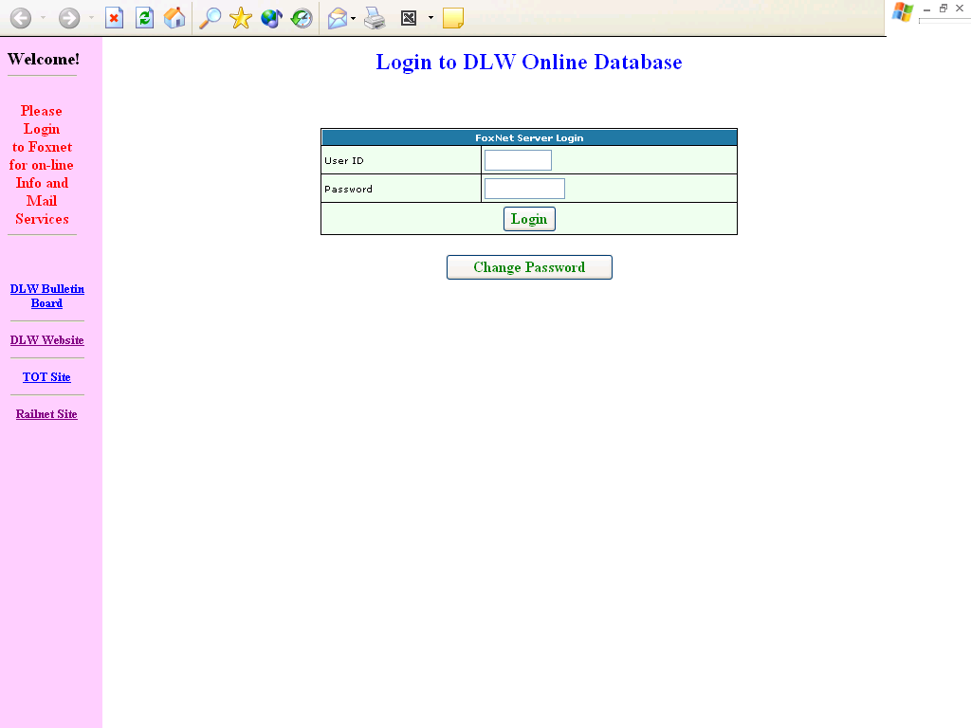

The integrated nature of all the above applications has led to a great amount of improvement in working efficiency, cutting down of lead times and accuracy of documents forming the basis of the business processes. The managers have quality information at their command for quick and correct decision making.

Other Activities of EDP center

Computer Training

The EDP center is the hub of the information technology at DLW. Hence it is also the IT training hub for DLW staff. The EDP center holds various training programs for the staff of DLW some of which are planned in advance and others are planned as per specific requirements.

Infrastructure Maintenance

Sr.EDPM provides the specifications for all IT hardware purchased by DLW. This is to ensure that the equipment is purchased to standard and uniform specifications. The EDP center also coordinates for the repair and maintenance activities of all the IT hardware with the end users. It also supplies printer ribbon cartridges centrally to all users of dotmatrix printers.

The EDP Center is putting in a centralized annual maintenance contract for all the IT hardware at DLW. The maintenance contact will enable the EDP centre to run help desk services and provide prompt service support to the users. The contract is expected to become functional soon. This contact will cover the complete computers systems and their peripherals in warranty or outside. The scope would cover all the systems in the administrative office and in the shop area.

Website of DLW

The existing website of DLW has been designed in house . It is hosted at an external ISP and has the following site address is http://www.dlw.indianrailways.gov.in/. This website has been made bi-lingual in English/Hindi using Dynamic Fonts. This website contains general and technical information about DLW and its products and services. In addition, all stores tenders, works tenders and details of purchase orders valued over Rs. 5 lakh are posted to this website from the on-line data through program. This site also has links for suppliers to do status query for Tender, Purchase Orders, Stores Receipt, Payment of Bills etc. The system sends the reply status report to the suppliers automatically at the E-mail address stored in the on-line vendor master. There is also link for the suppliers to update their E-mail address and password. The suppliers are required to mention their vendor code and password for status query. Information regarding Advertised Works Tenders is also being posted on the Website.

Thus the effort has been made to effectively integrate suppliers into DLW's Network so that information transparency and the coordination with the suppliers can be enhanced. Now the new website is launched by CRB on 16th march 2008. All details and link working in existing site will be working in new website. Moreover all the information regarding DLW has been updated by respective departments. Some new features such as Discussion Board, Dynamic Information regarding Locomotive Feedback, Loco out turn etc. have been added in new website. The DLW website previously hosted by M/s Omninet, Lucknow is now being hosted by CRIS/New Delhi.

E-Tendering

The Advertised stores tenders can be downloaded from the Website in PDF format. The documents are posted automatically in PDF format along with drawing and Bid Invitation Notice from the on-line databases. The system automatically maintains records about the downloaded documents.

The e-procurement system has also been introduced & monitoring by CRIS, New Delhi. The tender form on-line databases are being selected by program and being uploaded on IREPS server. In this system, following modules such as Draft tenders, like tender, tender pending for opening, tender opened, tenders finalized, tender tabulation are being done.

Work in Progress at IT Centre

1. DLW is facing a lot of problems of hardware and software of Fox-Pro based MIS applications. Keeping this in view DLW has done an agreement with M/s RITES, Gurgaon for conversion of existing Fox-Pro based MIS applications on ORACLE platform and conversion work is in progress with following details:-

S.N. | Work | Value | Agreement date | Completion date
1 | MMIS | 48,75,260.00 | 15.07.2010 | Dec’.2012
2 | PPNC | 24,26,600.00 | 01.02.2011 | Mar’.2013
3 | FMIS | 30,88,400.00 | 30.08.2011 | Jun’.2013

MMIS Progress:-Application software under development stage
PPNC Progress:- SRS submitted
FMIS Progress:- SRS is under preparation

- In this regard, under Plan head-17 (computerization) for the year 2012-13 Rs. 1.76 Cr. was sanctioned by Railway Board. Under this head Database Server, Application server, Storage (SAN) and Oracle 11g have been procured and procurement of Rack, Switched, Firewall, Router, Proxy Server, VB, and Windows Server 2008 are under process.
BENEFITS OF ISM IN DLW

- Limited employees required because technology has made work easy and better.
- Data does not scatter here and there , it is collected at one place.
- Information is taken out easily without any problem.
- Everything is properly managed and placed.
- Better handling of Data and Informations.

NEGATIVE IMPACTS OF ISM IN DLW

- Technology is used , then there is chance of hacking.
- Hacking can cause loss of data.
- Limited employees requirement creates unemployement.
- Easily information can be taken out which can further create problem in privacy.

EFFECTS ON EMPLOYEES

- Unemployement takes place because of least requirement of workers.
- Easy working for employees.
- Better handling of informations.
- Burden on employees is reduced.

CONCLUSION
Information Management System at Diesel Locomotive Works, Varanasi is a success and successfully leading.
BIBLIOGRAPHY

  - Visited DLW at Varanasi and took some information from the Employees over there.
  - www.wikipedia.com
  - www.google.com
  - www.dlw.indianrailways.gov.in

