This report collates and evaluates the run time of our implementation of Red-Black Tree and Skip List. The two implementation performances are also compared with Java’s TreeSet.

The table below shows the performance evaluation for all the three trees based on the test cases provided for LP-3.

| **LP3 Test Cases** | | | | | | |
| --- | --- | --- | --- | --- | --- | --- |
| **No. Of Operations** | **Tree Set** | | **Skip List** | | **Red-Black Tree** | |
| **Time** | **Memory** | **Time** | **Memory** | **Time** | **Memory** |
|  |  |  |  |  |  |  |
| 201 (sk-t01) | 9 msec | 3 MB / 128 MB | 8 msec | 3 MB / 128 MB | 8 msec | 3 MB / 128 MB |
| 50001 (sk-t02) | 119 msec | 8 MB / 128 MB | 140 msec | 16 MB / 128 MB | 204 msec | 40 MB / 128 MB |
| 1000000 (sk-t03) | 1272 msec | 125 MB / 375 MB | 1684 msec | 210 MB / 128 MB | 2251 msec | 96 MB / 548 MB |
| 1001 (sk-t11) | 13 msec | 4 MB / 128 MB | 18 msec | 4 MB / 128 MB | 14 msec | 5 MB / 128 MB |
| 50000 (sk-t12) | 97 msec | 4 MB / 128 MB | 144 msec | 9 MB / 128 MB | 161 msec | 16 MB / 128 MB |
| 1000000 (sk-t13) | 1072 msec | 239 MB / 394 MB | 1562 msec | 63 MB / 128 MB | 2011 msec | 30 MB / 588 MB |

Type to enter text

The graph here shows the run time of the three tree algorithms against the inputs provided in the test cases. It clearly shows that Tree Set’s algorithm is the most efficient, followed by Skip List and the least efficient among the three being Red-Black tree.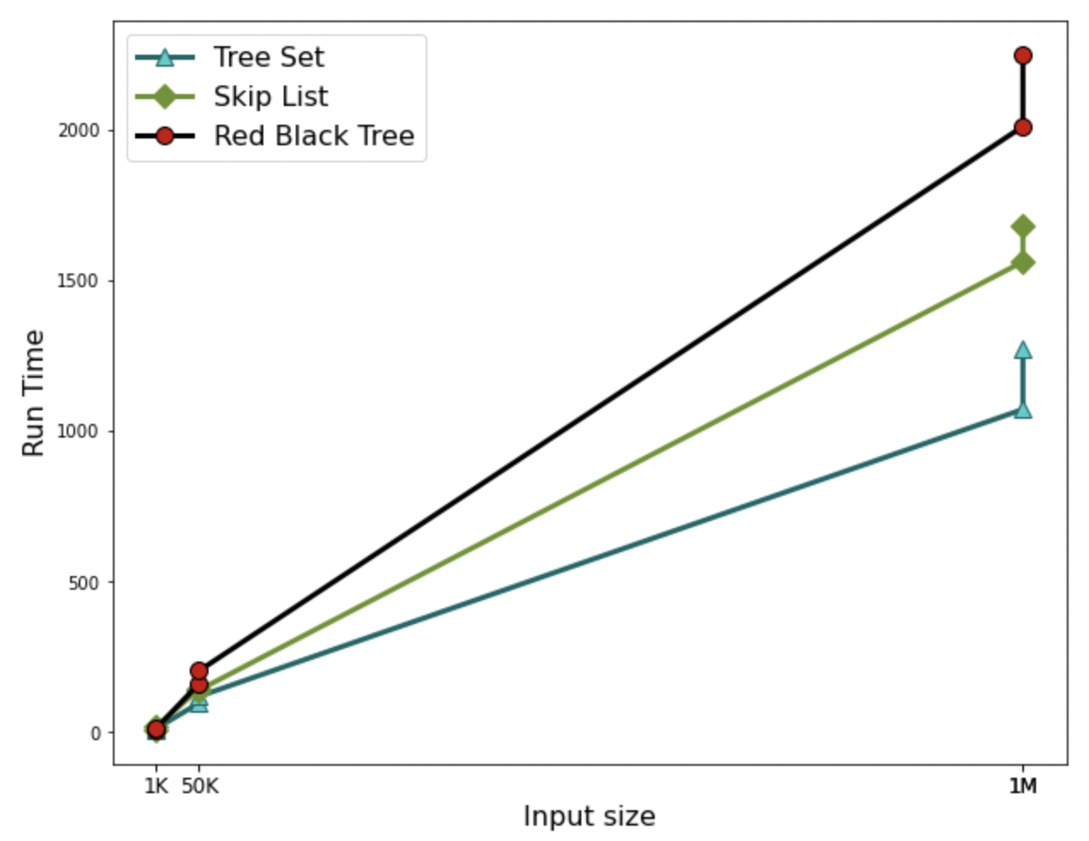

The table below shows the performance evaluation for all the three trees based on random numbers.

| **Tests based on Random numbers** | | | | | | |
| --- | --- | --- | --- | --- | --- | --- |
| **No. Of Operations** | **Tree Set** | | **Skip List** | | **Red-Black Tree** | |
| **Time** | **Memory** | **Time** | **Memory** | **Time** | **Memory** |
|  |  |  |  |  |  |  |
| 1M | 390 msec | 58 MB / 128 MB | 1198 msec | 90 MB / 190 MB | 3187 msec | 39 MB / 460 MB |
| 4M | 1260 msec | 88 MB / 128 MB | 3847 msec | 53 MB / 168 MB | 10307 msec | 148 MB / 416 MB |
| 8M | 2444 msec | 81 MB / 375 MB | 6542 msec | 112 MB / 201 MB | 19697 msec | 248 MB / 367 MB |
| 16M | 4711 msec | 198 MB / 229 MB | 13789 msec | 193 MB / 267 MB | 38019 msec | 244 MB / 445 MB |
| 32M | 9002 msec | 325 MB / 432 MB | 25342 msec | 264 MB / 472 MB | 75543 msec | 294 MB / 489 MB |
| 64M | 18116 msec | 734 MB / 837 MB | 49408 msec | 772 MB / 870 MB | 150957 msec | 737 MB / 842 MB |
| 128M | 36096 msec | 1142 MB / 1654 MB | 99074 msec | 1145 MB / 1687 MB | 301165 msec | 1308 MB / 1665 MB |
| 256M | 75845 msec | 1994 MB / 2048 MB | 247233 msec | 1995 MB / 2048 MB | 727006 msec | 2036 MB / 2048 MB |

The graph here shows the run time of the three tree algorithms against the inputs provided by random number generator. Similar to the efficiency from the test cases, Tree set is the most efficient when using larger inputs as well.