Q1. Write compound SQL statements to demonstrate the following SET operations on the

tables created for your Application domain.

UNION, UNION ALL, INTERSECT and MINUS

Specifications:

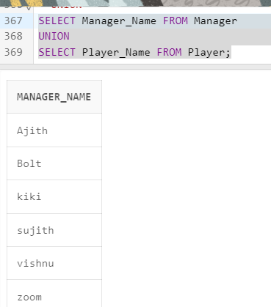

Union: The union operation combines the result table of two or more select queries into a single table, removing duplicate rows, in this case table between manager and player.

So that the administrator can see all the managers and players in the program.

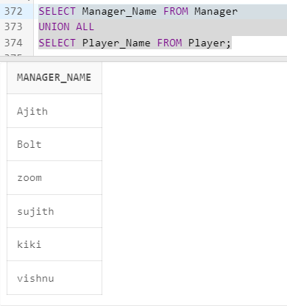

Union all: this operations combines the result set of two or more select queries into a single result set, it doesn’t remove duplicates.

In this case we performing the union all from manager and player.

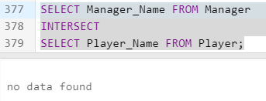

Intersect: This operation retrieves the common rows that exist in the result of two or more select queries.

This case from manager and player as there are no common values it shows no data.

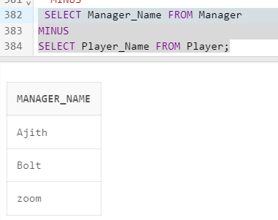

Minus: it shows the rows from the first result set that are not present it the second result set.

Here in between manager and players

a. The Operations should be performed on tables with logical sense and mention

valid justification.

Union: The union operation combines the result table of two or more select queries into a single table, removing duplicate rows, in this case table between manager and player.

So that the administrator can see all the managers and players in the program.

In this case we performing the union all from manager and player.

Union all: this operations combines the result set of two or more select queries into a single result set, it doesn’t remove duplicates.

Intersect: This operation retrieves the common rows that exist in the result of two or more select queries.

This case from manager and player as there are no common values it shows no data.

Minus: it shows the rows from the first result set that are not present it the second result set.

Here in between manager and players

b. What is the difference between UNION and UNION ALL?

Union: it gives a result with unique rows, and the duplicates will be removed .

Union all: includes all rows from both result sets, including duplicates.

c. Show how to sort the result set of a compound query which performs SET operations.

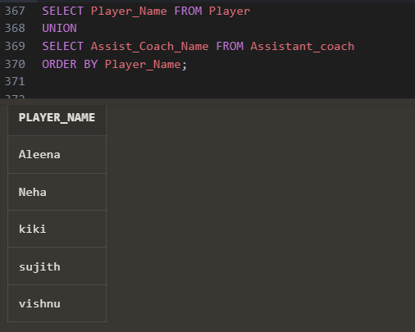

Q2. Demonstrate the usage of Sub queries to implement the operations to be performedon the tables created for your Application domain.

Specification:

1. At least 5 Queries should be demonstrated.

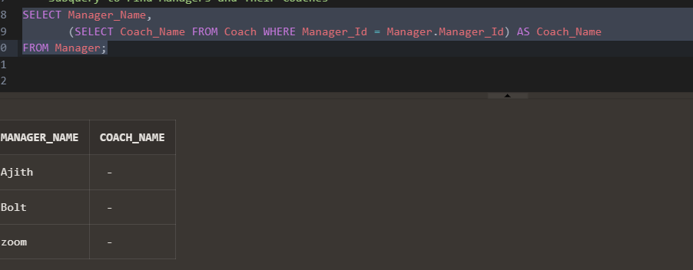

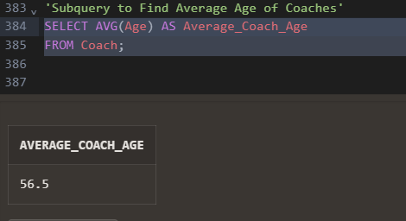

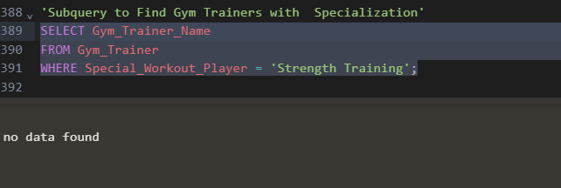

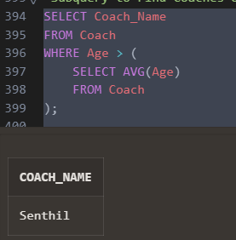

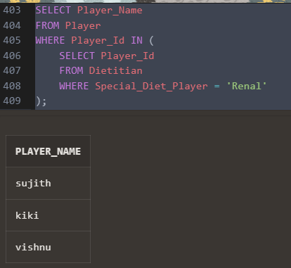

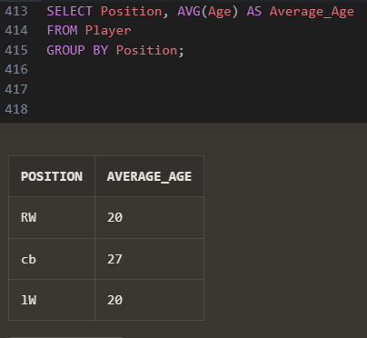

1. All tables should be used in at least 1 Compound SQL Query to perform a specified operation.

SELECT Player_Name

FROM Player

WHERE Manager_Id IN (

SELECT Coach.Manager_Id

FROM Coach

WHERE Previous_Club = 'city'

);

1. The Operations should be performed on tables with logical sense and mention valid justification

with this query we can connect the player table to the manager table which are very distinctly related to each other.

d. Mention the types of subqueries and its differences.

Single-row subquery:

1. Returns a single value

* Used with comparison operators
* The outer query expects a single value from the subquery
* Eg; finding employees with a salary greater than the average salary.

1. Multiple-row subquery

* Returns multiple rows
* Used with operators like in, any or all
* Compares a value with a set of values from the subquery.
* Eg; finding products that have been ordered more than once.

1. Correlated subquery

* Returns values for each row of the outer query.
* References colums from the outer query within the subquery
* Typically used with exits or not exists clauses
* Eg; checking if a manager has employees in a certain age range

1. Nested subquery

* Contains a subquery inside another subquery
* Can be of any type single row, multiple row, correlated
* Allows for complex filtering and calculations
* Eg; finding managers with employees whose average salary is above the company's average salary

Differences

* Single-row returns a single value
* Multiple rows returns multiple values
* Correlated returns values for each row of the outer query
* Nested contains a subquery inside another subquery

Usage

* Single-row comparing a value with a single value
* Multiple rows comparing a value with multiple values
* Correlated checking conditions for each row using values from the outer query
* Nested performing complex filtering or calculations involving subqueries

create table Football (

Admin_Id varchar2(20) constraint Admin_Id_pk primary key,

Admin_Name varchar2(50)not null,

Manager_Name varchar2(50) not null,

Manager_Id varchar2(50) not null,

Player_Id varchar2(30)not null,

Game_Data varchar2(50)not null);

create table Manager (

Manager_Name varchar2(50) NOT NULL,

Manager_Id varchar2(30) constraint Manager_Id_pk primary key,

Address varchar2(80)NOT NULL,

Email varchar2(60)NOT NULL,

contact_No varchar2(50)NOT NULL,

Age varchar2(30)NOT NULL,

Achievements varchar2(100)NOT NULL,

Previous_Club varchar2(80)NOT NULL,

Admin_Id varchar2(20) references Football( Admin_Id));

create table Coach (

Coach_Name varchar2(50) NOT NULL,

Coach_Id varchar2(30) constraint Coach_Id_pk primary key,

Address varchar2(80)NOT NULL,

Email varchar2(60)NOT NULL,

Contact_No varchar2(50)NOT NULL,

Age varchar2(30)NOT NULL,

Achievements varchar2(100)NOT NULL,

Previous_Club varchar2(80)NOT NULL,

Manager_Id varchar2(20) references Manager( Manager_Id));

create table Assistant_coach (

Assist_Coach_Name varchar2(50)NOT NULL,

Assist_Coach_Id varchar2(30) constraint Assistant_coach_Id_pk primary key,

Address varchar2(80)NOT NULL,

Email varchar2(60)NOT NULL,

Contact_No varchar2(50)NOT NULL,

Age varchar2(30)NOT NULL,

Achievements varchar2(100)NOT NULL,

Previous_Club varchar2(80)NOT NULL,

Coach_Id varchar2(20) references Coach( Coach_Id));

create table Gym_Trainer (

Gym_Trainer_Name varchar2(50) not null,

Gym_Trainer_Id varchar2(30) constraint Gym_Trainer_pk primary key,

Address varchar2(80),

Email varchar2(60),

Contact_No varchar2(50),

Age varchar2(30),

Special_Workout_Player varchar2(100),

Previous_Club varchar2(80));

create table Physiotherapist (

Physiotherapist_Name varchar2(50)NOT NULL,

Physiotherapist_Id varchar2(30) constraint Physiotherapist_Id_pk primary key,

Address varchar2(80)NOT NULL,

Email varchar2(60)NOT NULL,

Contact_No varchar2(50)NOT NULL,

Age varchar2(30)NOT NULL,

Special_Exercise_Player varchar2(100)NOT NULL,

Previous_Club varchar2(80)NOT NULL,

Assist_Coach_Id varchar2(20) references Assistant_coach(Assist_Coach_Id));

create table Dietitian (

Dietitian_Name varchar2(50)NOT NULL,

Dietitian_Id varchar2(30) constraint Dietitian_Id_pk primary key,

Address varchar2(80)NOT NULL,

Email varchar2(60)NOT NULL,

Contact_No varchar2(50)NOT NULL,

Age varchar2(30)NOT NULL,

Special_Diet_player varchar2(100)NOT NULL,

Previous_Club varchar2(80)NOT NULL,

Assist_Coach_Id varchar2(20) references Assistant_coach(Assist_Coach_Id));

create table Game_Data (

Game_Id varchar2(30) constraint Game_Id_pk primary key,

Ball_Possession varchar2(30)NOT NULL,

Keyy_Chances varchar2(30)NOT NULL,

Goal_Scored varchar2(20)NOT NULL,

Pass_Completion varchar2(20)NOT NULL,

Interception varchar2(30)NOT NULL,

Assists varchar2(30)NOT NULL,

Yellow_Card varchar2(30)NOT NULL,

Break_The_Defence varchar2(30)NOT NULL,

Admin_Id varchar2(20) references Football( Admin_Id));

create table Player (

Player_Name varchar2(50)NOT NULL,

Player_Id varchar2(30) constraint Player_Id_pk primary key,

Address varchar2(80)NOT NULL,

Email varchar2(60)NOT NULL,

Contact_No varchar2(50)NOT NULL,

Age varchar2(30)NOT NULL,

Position varchar2(80)NOT NULL,

Admin_Id varchar2(20) references Football( Admin_Id));

create table Player_Data (

Player_Data_Id varchar2(30) constraint Player_Data_Id_pk primary key,

Health_Details varchar2(50)NOT NULL,

Touches_On_Ball varchar2(50)NOT NULL,

Pass_Completion varchar2(50)NOT NULL,

Pass_Received varchar2(50)NOT NULL,

Pass_Missed varchar2 (50)NOT NULL,

Goal_Scored varchar2 (50)NOT NULL,

Key_Pass varchar2 (50)NOT NULL,

Interceptions varchar2(50)NOT NULL,

Play_Time varchar2(50)NOT NULL,

Position_Of_Player varchar2(50) NOT NULL,

Player_Id varchar2(20) references Player( Player_Id)

);

"Insert into the first table football"

insert into Football(

Admin_Id,

Admin_Name,

Manager_Name,

Manager_Id,

Player_Id,

Game_Data)values ('008','Reeve','Ajith','Man001','Pla001','Gd001');

"Insert into the first table Manager"

insert into Manager(

Manager_Name,

Manager_Id,

Address,

Email,contact_No,

Age,

Achievements,

Previous_Club)

values ('Ajith','Man004','abc','xyz@gmail.com','1234567899','50','premier league','mancity');

insert into Manager(

Manager_Name,

Manager_Id,

Address,

Email,contact_No,

Age,

Achievements,

Previous_Club)

values ('Bolt','Man002','agbc','xyzz@gmail.com','1234567599','54','ligue1 league','man united');

insert into Manager(

Manager_Name,

Manager_Id,

Address,

Email,contact_No,

Age,

Achievements,

Previous_Club)

values ('zoom','Man003','bbc','yyz@gmail.com','1234567898','68','champions league','mancity');

"Insert into the first table Coach"

insert into Coach(

Coach_Name,

Coach_Id,

Address,

Email,

contact_No,

Age,

Achievements

,Previous_Club)

values ('Senthil','Coa003','abc','xyz@gmail.com','1234567899','58','Isl league',' city');

insert into Coach(

Coach_Name,

Coach_Id,

Address,

Email,

contact_No,

Age,

Achievements

,Previous_Club)

values ('Nadhan_sir','Coa002','abc','xyzzz@gmail.com','1234547899','55','Isl league',' gg city');

"Insert into the first table Assistant coach"

insert into Assistant_coach(

Assist_coach_Name,

Assist_coach_Id,

Address,

Email,

contact_No,

Age,

Achievements,

Previous_Club)

values ('Neha','Acoa004','abc','xyz@gmail.com','1234567899','60','Christ league','jain');

insert into Assistant_coach(

Assist_coach_Name,

Assist_coach_Id,

Address,

Email,

contact_No,

Age,

Achievements,

Previous_Club)

values ('Aleena','Acoa002','abccc','xysz@gmail.com','1234563899','40','tow league','savior');

"Insert into the first table Gym Trainer"

insert into Gym_Trainer(

Gym_Trainer_Name,

Gym_Trainer_Id,

Address,

Email,

contact_No,

Age,

Special_Workout_Player,

Previous_Club)

values ('Christina','Gt002','abc','xyz@gmail.com','1234567899','30','stregthening','mancity');

"Insert into the first table Physiotherapist"

insert into physiotherapist (

physiotherapist_Name,

physiotherapist_Id,

Address,

Email,

contact_No,

Age,

Special_Exercise_Player,

Previous_Club)

values ('Sathyam','Phy001','abc','xyz@gmail.com','1234567899','30','Condition','mancity');

"Insert into the first table Dietitian"

insert into Dietitian (

Dietitian_Name,

Dietitian_Id,

Address,

Email,

contact_No,Age,

Special_Diet_Player,

Previous_Club)

values ('Sneha','Die002','abc','xyz@gmail.com','1234567899','40','Renal','mancity');

"Insert into the first table Game data"

insert into Game_Data

( Game_Id,

Ball_Possession,

Keyy_Chances,

Goal_Scored,

Pass_Completion,

Interception,Assists,Yellow_Card,Break_The_Defence)

values ('Pl01','10','5','4','7','8','10','10','8');

"Insert into the first table Player"

insert into Player(Player_Name,

Player_Id,

Address,

Email,

contact_No,

Age,

position)

values ('sujith','pl05','abc','xxyz@gmail.com','1234567899','20','RW');

insert into Player(Player_Name,

Player_Id,

Address,

Email,

contact_No,

Age,

position)

values ('vishnu','pl002','abec','xtyz@gmail.com','1234277899','20','lW');

insert into Player(Player_Name,

Player_Id,

Address,

Email,

contact_No,

Age,

position)

values ('kiki','pl003','abc','xysz@gmail.com','1234544899','27','cb');

"Insert into the first table Player_Data"

insert into Player_Data (

Player_Data_Id,

Health_Details,

Touches_On_Ball,

Pass_Completion,

Pass_Received,

Pass_Missed,

Goal_Scored,

Key_Pass,

Interceptions,

Play_Time,

Position_Of_Player)

values ('Pld001','fit','5','8','18','5','2','7','4','12','RW');

insert into Player_Data (

Player_Data_Id,

Health_Details,

Touches_On_Ball,

Pass_Completion,

Pass_Received,

Pass_Missed,

Goal_Scored,

Key_Pass,

Interceptions,

Play_Time,

Position_Of_Player)

values ('Pld002','fit','6','5','19','5','2','8','4','19','RW');

insert into Player_Data (

Player_Data_Id,

Health_Details,

Touches_On_Ball,

Pass_Completion,

Pass_Received,

Pass_Missed,

Goal_Scored,

Key_Pass,

Interceptions,

Play_Time,

Position_Of_Player)

values ('Pld003','un_fit','8','8','18','12','1','9','14','15','RW');

select*from Football;

select *from Manager;

select*from Coach;

select*from Assistant_coach;

select*from Gym_Trainer;

select*from Physiotherapist;

select*from Dietitian;

select*from Game_Data;

select*from Player;

select*from Player_Data;

-- Retrieve a list of unique names from Managers and players

SELECT Manager_Name FROM Manager

UNION

SELECT Player_name FROM Player;

-- Retrieve a list of all names from Managers and Player, including duplicates

SELECT Manager_Name FROM Manager

UNION ALL

SELECT Player_name FROM Player;

-- Retrieve Manager names who are also Player

SELECT Manager_Name FROM Manager

INTERSECT

SELECT Player_name FROM Player;

-- Retrieve Manager names who are not Player

SELECT Manager_Name FROM Manager

MINUS

SELECT Player_name FROM Player;

SELECT Player_Name FROM Player

UNION

SELECT Assist_Coach_Name FROM Assistant_coach

ORDER BY Player_Name;

SELECT Manager_Name,

(SELECT Coach_Name FROM Coach WHERE Manager_Id = Manager.Manager_Id) AS Coach_Name

FROM Manager;

SELECT AVG(Age) AS Average_Coach_Age

FROM Coach;

SELECT Gym_Trainer_Name

FROM Gym_Trainer

WHERE Previous_Club IS NULL;

SELECT Coach_Name

FROM Coach

WHERE Age > (

SELECT AVG(Age)

FROM Coach

);

SELECT Player_Name

FROM Player

WHERE Player_Id IN (

SELECT Player_Id

FROM Dietitian

WHERE Special_Diet_Player = 'Renal'

);

SELECT Position, AVG(Age) AS Average_Age

FROM Player

GROUP BY Position;

SELECT DISTINCT M.Manager_Name, AC.Assist_Coach_Name

FROM Manager M

JOIN Coach C ON M.Manager_Id = C.Manager_Id

JOIN Assistant_coach AC ON C.Coach_Id = AC.Coach_Id

JOIN Player P ON C.Manager_Id = P.Manager_Id

JOIN Player_Data PD ON P.Player_Id = PD.Player_Id

WHERE PD.Health_Details = 'fit';

SELECT Player_Name

FROM Player

WHERE Manager_Id IN (

SELECT Coach.Manager_Id

FROM Coach

WHERE Previous_Club = 'city'

);