Q1. Perform the different JOIN operations on the tables created for your Application

domain.

Specification:

a. The Operations should be performed on tables with logical sense and mention

valid justification

b. At least 5 Queries should be demonstrated to join 2 Tables, 3 Tables and 4 Tables.

c. All the types of Joins should be demonstrated (Cross Join, Inner Join, Left outerJoin, Right Outer Join and Self Join)

d. Write a SQL query using Outer Join which returns the records from minimum of 3Tables.

* INNER JOIN: Returns only the rows that have matching values in both tables.
* LEFT OUTER JOIN (or LEFT JOIN): Returns all the rows from the left table and the matching rows from the right table. If there's no match, NULL values are returned for the right table's columns.
* RIGHT OUTER JOIN (or RIGHT JOIN): Similar to LEFT JOIN, but returns all the rows from the right table and the matching rows from the left table. If there's no match, NULL values are returned for the left table's columns.
* FULL OUTER JOIN: Returns all rows when there is a match in either the left or right table. If there's no match, NULL values are returned for the columns of the table without a match.
* SELF JOIN: When a table is joined with itself, usually with the help of aliases, to create a relationship between rows within the same table.
* CROSS JOIN: Returns the Cartesian product of two tables, resulting in all possible combinations of rows from both tables.

1. Inner Join between Manager and Coach

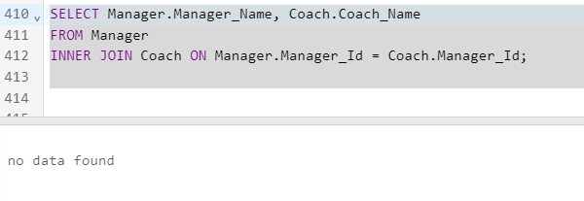

Justification: The query retrieves the names of managers and their corresponding coaches using an inner join.

2. Left Outer Join between Player and Player_Data

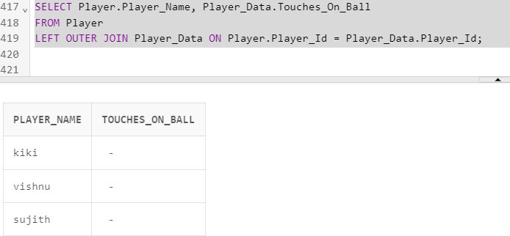

justification: This query shows the player names and the number of touches on the ball, including players who may not have player data

3. Right Outer Join between Assistant_coach and Gym_Trainer

SELECT Assistant_coach.Assist_Coach_Name, Gym_Trainer.Gym_Trainer_Name

FROM Assistant_coach

RIGHT OUTER JOIN Gym_Trainer ON Assistant_coach.Assist_Coach_Id = Gym_Trainer.Coach_Id;

Justification: This query displays the names of assistant coaches and gym trainers, including gym trainers who may not have an assistant coach..

4. Self Join on Manager table to find Managers with Previous Experience

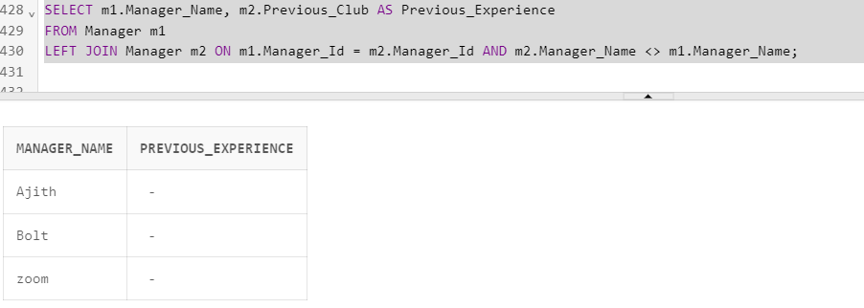

Justification: This query finds managers and their previous experience by self-joining the Manager table.

5. Cross Join between Dietitian and Physiotherapist

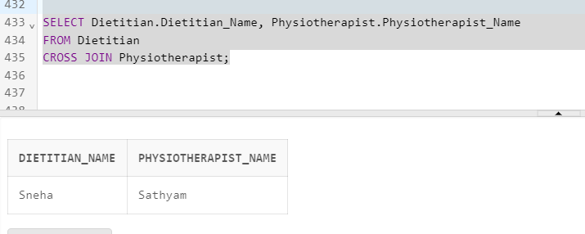

Justification: This query performs a cross join between dietitians and physiotherapists, creating combinations of all dietitians and all physiotherapists.

6. Outer Join involving Manager, Coach, and Assistant_coach (at least 3 tables)

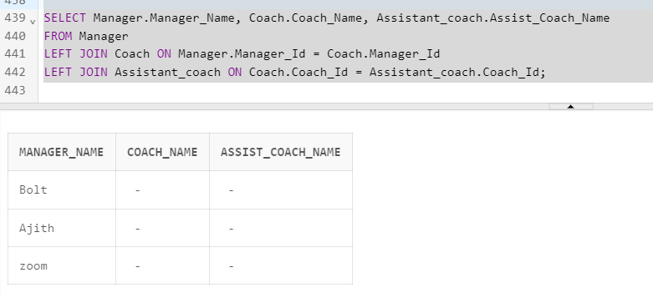

Justification: This query uses two outer joins to show the names of managers, coaches, and assistant coaches, including cases where any of these roles might be missing.Justification: This query uses two outer joins to show the names of managers, coaches, and assistant coaches, including cases where any of these roles might be missing.

e. Mention the difference between Join and Set operations used in SQL.

Difference between JOIN and Set operations in SQL:

JOIN Operations: JOIN operations are used to combine rows from two or more tables based on a related column between them. JOINs are used to retrieve data from multiple tables by linking rows in one table with corresponding rows in another. The result of a JOIN operation includes columns from all joined tables.

Set Operations: Set operations, such as UNION, INTERSECT, and EXCEPT/MINUS, involve combining the results of two or more SELECT queries. These operations are applied to the result sets of individual queries and don't necessarily require a related column. Set operations help merge, intersect, or exclude rows from multiple result sets. In summary, JOIN operations focus on combining rows from tables based on matching columns, while set operations combine rows from the results of separate SELECT queries.

Q2. Write at least 5 compound SQL statements to demonstrate at least any 5 of thefollowing Aggregate functions on the tables created for your application domain (AVG,SUM, COUNT, MIN, MAX, MEDIAN, CORR and STDDEV) and appropriately use

GROUPBY and HAVING clause

Specification:

1. The operations should be performed on tables with logical sense and mention valid justification.

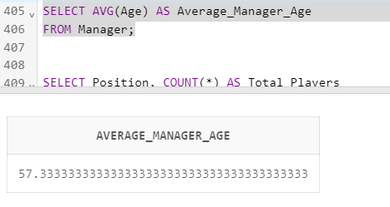

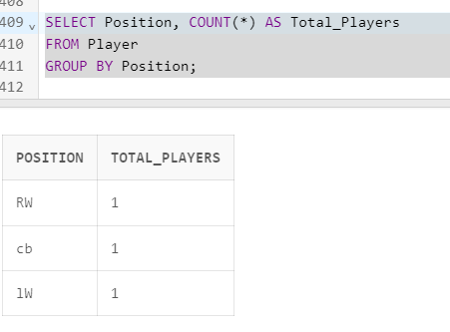

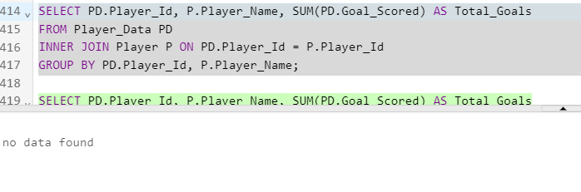

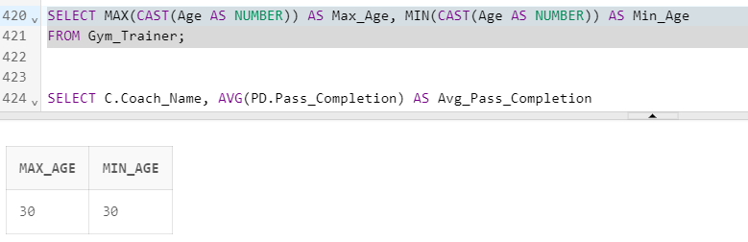

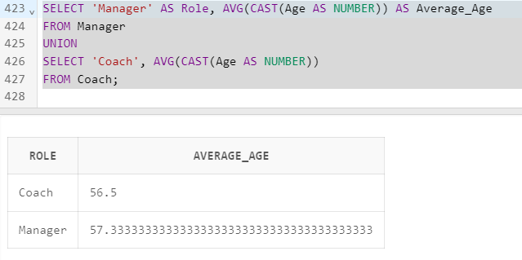

1. At least 1 Compound SQL Query with a suitable aggregate function should be demonstrated for all the Tables.

Manager Table - Count the number of managers with an age greater than 50:

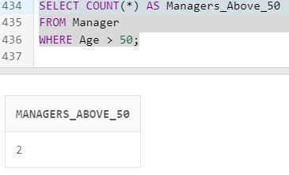

Coach Table - Count the number of coaches with an age greater than 45

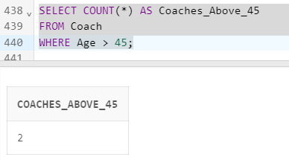

Assistant_coach Table - Count the number of assistant coaches with an age greater than 55:

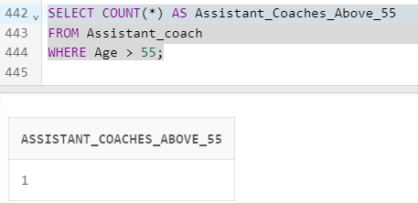

Gym_Trainer Table - Count the number of gym trainers with an age greater than 30:

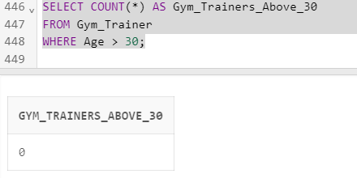

Physiotherapist Table - Count the number of physiotherapists with an age greater than 35:

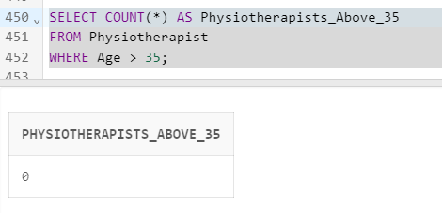

Dietitian Table - Count the number of dietitians with an age greater than 40

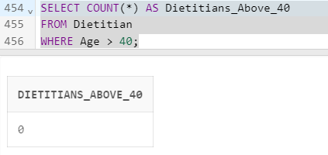

Player Table - Count the number of players with an age less than 25:

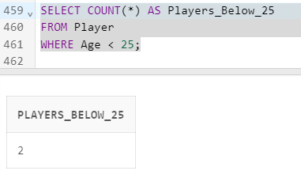

create table Football (

Admin_Id varchar2(20) constraint Admin_Id_pk primary key,

Admin_Name varchar2(50)not null,

Manager_Name varchar2(50) not null,

Manager_Id varchar2(50) not null,

Player_Id varchar2(30)not null,

Game_Data varchar2(50)not null);

create table Manager (

Manager_Name varchar2(50) NOT NULL,

Manager_Id varchar2(30) constraint Manager_Id_pk primary key,

Address varchar2(80)NOT NULL,

Email varchar2(60)NOT NULL,

contact_No varchar2(50)NOT NULL,

Age varchar2(30)NOT NULL,

Achievements varchar2(100)NOT NULL,

Previous_Club varchar2(80)NOT NULL,

Admin_Id varchar2(20) references Football( Admin_Id));

create table Coach (

Coach_Name varchar2(50) NOT NULL,

Coach_Id varchar2(30) constraint Coach_Id_pk primary key,

Address varchar2(80)NOT NULL,

Email varchar2(60)NOT NULL,

Contact_No varchar2(50)NOT NULL,

Age varchar2(30)NOT NULL,

Achievements varchar2(100)NOT NULL,

Previous_Club varchar2(80)NOT NULL,

Manager_Id varchar2(20) references Manager( Manager_Id));

create table Assistant_coach (

Assist_Coach_Name varchar2(50)NOT NULL,

Assist_Coach_Id varchar2(30) constraint Assistant_coach_Id_pk primary key,

Address varchar2(80)NOT NULL,

Email varchar2(60)NOT NULL,

Contact_No varchar2(50)NOT NULL,

Age varchar2(30)NOT NULL,

Achievements varchar2(100)NOT NULL,

Previous_Club varchar2(80)NOT NULL,

Coach_Id varchar2(20) references Coach( Coach_Id));

create table Gym_Trainer (

Gym_Trainer_Name varchar2(50) not null,

Gym_Trainer_Id varchar2(30) constraint Gym_Trainer_pk primary key,

Address varchar2(80),

Email varchar2(60),

Contact_No varchar2(50),

Age varchar2(30),

Special_Workout_Player varchar2(100),

Previous_Club varchar2(80));

create table Physiotherapist (

Physiotherapist_Name varchar2(50)NOT NULL,

Physiotherapist_Id varchar2(30) constraint Physiotherapist_Id_pk primary key,

Address varchar2(80)NOT NULL,

Email varchar2(60)NOT NULL,

Contact_No varchar2(50)NOT NULL,

Age varchar2(30)NOT NULL,

Special_Exercise_Player varchar2(100)NOT NULL,

Previous_Club varchar2(80)NOT NULL,

Assist_Coach_Id varchar2(20) references Assistant_coach(Assist_Coach_Id));

create table Dietitian (

Dietitian_Name varchar2(50)NOT NULL,

Dietitian_Id varchar2(30) constraint Dietitian_Id_pk primary key,

Address varchar2(80)NOT NULL,

Email varchar2(60)NOT NULL,

Contact_No varchar2(50)NOT NULL,

Age varchar2(30)NOT NULL,

Special_Diet_player varchar2(100)NOT NULL,

Previous_Club varchar2(80)NOT NULL,

Assist_Coach_Id varchar2(20) references Assistant_coach(Assist_Coach_Id));

create table Game_Data (

Game_Id varchar2(30) constraint Game_Id_pk primary key,

Ball_Possession varchar2(30)NOT NULL,

Keyy_Chances varchar2(30)NOT NULL,

Goal_Scored varchar2(20)NOT NULL,

Pass_Completion varchar2(20)NOT NULL,

Interception varchar2(30)NOT NULL,

Assists varchar2(30)NOT NULL,

Yellow_Card varchar2(30)NOT NULL,

Break_The_Defence varchar2(30)NOT NULL,

Admin_Id varchar2(20) references Football( Admin_Id));

create table Player (

Player_Name varchar2(50)NOT NULL,

Player_Id varchar2(30) constraint Player_Id_pk primary key,

Address varchar2(80)NOT NULL,

Email varchar2(60)NOT NULL,

Contact_No varchar2(50)NOT NULL,

Age varchar2(30)NOT NULL,

Position varchar2(80)NOT NULL,

Admin_Id varchar2(20) references Football( Admin_Id));

create table Player_Data (

Player_Data_Id varchar2(30) constraint Player_Data_Id_pk primary key,

Health_Details varchar2(50)NOT NULL,

Touches_On_Ball varchar2(50)NOT NULL,

Pass_Completion varchar2(50)NOT NULL,

Pass_Received varchar2(50)NOT NULL,

Pass_Missed varchar2 (50)NOT NULL,

Goal_Scored varchar2 (50)NOT NULL,

Key_Pass varchar2 (50)NOT NULL,

Interceptions varchar2(50)NOT NULL,

Play_Time varchar2(50)NOT NULL,

Position_Of_Player varchar2(50) NOT NULL,

Player_Id varchar2(20) references Player( Player_Id)

);

"Insert into the first table football"

insert into Football(

Admin_Id,

Admin_Name,

Manager_Name,

Manager_Id,

Player_Id,

Game_Data)values ('008','Reeve','Ajith','Man001','Pla001','Gd001');

"Insert into the first table Manager"

insert into Manager(

Manager_Name,

Manager_Id,

Address,

Email,contact_No,

Age,

Achievements,

Previous_Club)

values ('Ajith','Man004','abc','xyz@gmail.com','1234567899','50','premier league','mancity');

insert into Manager(

Manager_Name,

Manager_Id,

Address,

Email,contact_No,

Age,

Achievements,

Previous_Club)

values ('Bolt','Man002','agbc','xyzz@gmail.com','1234567599','54','ligue1 league','man united');

insert into Manager(

Manager_Name,

Manager_Id,

Address,

Email,contact_No,

Age,

Achievements,

Previous_Club)

values ('zoom','Man003','bbc','yyz@gmail.com','1234567898','68','champions league','mancity');

"Insert into the first table Coach"

insert into Coach(

Coach_Name,

Coach_Id,

Address,

Email,

contact_No,

Age,

Achievements

,Previous_Club)

values ('Senthil','Coa003','abc','xyz@gmail.com','1234567899','58','Isl league',' city');

insert into Coach(

Coach_Name,

Coach_Id,

Address,

Email,

contact_No,

Age,

Achievements

,Previous_Club)

values ('Nadhan_sir','Coa002','abc','xyzzz@gmail.com','1234547899','55','Isl league',' gg city');

"Insert into the first table Assistant coach"

insert into Assistant_coach(

Assist_coach_Name,

Assist_coach_Id,

Address,

Email,

contact_No,

Age,

Achievements,

Previous_Club)

values ('Neha','Acoa004','abc','xyz@gmail.com','1234567899','60','Christ league','jain');

insert into Assistant_coach(

Assist_coach_Name,

Assist_coach_Id,

Address,

Email,

contact_No,

Age,

Achievements,

Previous_Club)

values ('Aleena','Acoa002','abccc','xysz@gmail.com','1234563899','40','tow league','savior');

"Insert into the first table Gym Trainer"

insert into Gym_Trainer(

Gym_Trainer_Name,

Gym_Trainer_Id,

Address,

Email,

contact_No,

Age,

Special_Workout_Player,

Previous_Club)

values ('Christina','Gt002','abc','xyz@gmail.com','1234567899','30','stregthening','mancity');

"Insert into the first table Physiotherapist"

insert into physiotherapist (

physiotherapist_Name,

physiotherapist_Id,

Address,

Email,

contact_No,

Age,

Special_Exercise_Player,

Previous_Club)

values ('Sathyam','Phy001','abc','xyz@gmail.com','1234567899','30','Condition','mancity');

"Insert into the first table Dietitian"

insert into Dietitian (

Dietitian_Name,

Dietitian_Id,

Address,

Email,

contact_No,Age,

Special_Diet_Player,

Previous_Club)

values ('Sneha','Die002','abc','xyz@gmail.com','1234567899','40','Renal','mancity');

"Insert into the first table Game data"

insert into Game_Data

( Game_Id,

Ball_Possession,

Keyy_Chances,

Goal_Scored,

Pass_Completion,

Interception,Assists,Yellow_Card,Break_The_Defence)

values ('Pl01','10','5','4','7','8','10','10','8');

"Insert into the first table Player"

insert into Player(Player_Name,

Player_Id,

Address,

Email,

contact_No,

Age,

position)

values ('sujith','pl05','abc','xxyz@gmail.com','1234567899','20','RW');

insert into Player(Player_Name,

Player_Id,

Address,

Email,

contact_No,

Age,

position)

values ('vishnu','pl002','abec','xtyz@gmail.com','1234277899','20','lW');

insert into Player(Player_Name,

Player_Id,

Address,

Email,

contact_No,

Age,

position)

values ('kiki','pl003','abc','xysz@gmail.com','1234544899','27','cb');

"Insert into the first table Player_Data"

insert into Player_Data (

Player_Data_Id,

Health_Details,

Touches_On_Ball,

Pass_Completion,

Pass_Received,

Pass_Missed,

Goal_Scored,

Key_Pass,

Interceptions,

Play_Time,

Position_Of_Player)

values ('Pld001','fit','5','8','18','5','2','7','4','12','RW');

insert into Player_Data (

Player_Data_Id,

Health_Details,

Touches_On_Ball,

Pass_Completion,

Pass_Received,

Pass_Missed,

Goal_Scored,

Key_Pass,

Interceptions,

Play_Time,

Position_Of_Player)

values ('Pld002','fit','6','5','19','5','2','8','4','19','RW');

insert into Player_Data (

Player_Data_Id,

Health_Details,

Touches_On_Ball,

Pass_Completion,

Pass_Received,

Pass_Missed,

Goal_Scored,

Key_Pass,

Interceptions,

Play_Time,

Position_Of_Player)

values ('Pld003','un_fit','8','8','18','12','1','9','14','15','RW');

select*from Football;

select *from Manager;

select*from Coach;

select*from Assistant_coach;

select*from Gym_Trainer;

select*from Physiotherapist;

select*from Dietitian;

select*from Game_Data;

select*from Player;

select*from Player_Data;

'join'

SELECT Manager.Manager_Name, Coach.Coach_Name

FROM Manager

INNER JOIN Coach ON Manager.Manager_Id = Coach.Manager_Id;

SELECT Player.Player_Name, Player_Data.Touches_On_Ball

FROM Player

LEFT OUTER JOIN Player_Data ON Player.Player_Id = Player_Data.Player_Id;

SELECT Assistant_coach.Assist_Coach_Name, Gym_Trainer.Gym_Trainer_Name

FROM Assistant_coach

RIGHT OUTER JOIN Gym_Trainer ON Assistant_coach.Assist_Coach_Id = Gym_Trainer.Coach_Id;

SELECT m1.Manager_Name, m2.Previous_Club AS Previous_Experience

FROM Manager m1

LEFT JOIN Manager m2 ON m1.Manager_Id = m2.Manager_Id AND m2.Manager_Name <> m1.Manager_Name;

SELECT Dietitian.Dietitian_Name, Physiotherapist.Physiotherapist_Name

FROM Dietitian

CROSS JOIN Physiotherapist;

SELECT Manager.Manager_Name, Coach.Coach_Name, Assistant_coach.Assist_Coach_Name

FROM Manager

LEFT JOIN Coach ON Manager.Manager_Id = Coach.Manager_Id

LEFT JOIN Assistant_coach ON Coach.Coach_Id = Assistant_coach.Coach_Id;

'avg count'

SELECT AVG(Age) AS Average_Manager_Age

FROM Manager;

SELECT Position, COUNT(*) AS Total_Players

FROM Player

GROUP BY Position;

SELECT PD.Player_Id, P.Player_Name, SUM(PD.Goal_Scored) AS Total_Goals

FROM Player_Data PD

INNER JOIN Player P ON PD.Player_Id = P.Player_Id

GROUP BY PD.Player_Id, P.Player_Name;

SELECT MAX(CAST(Age AS NUMBER)) AS Max_Age, MIN(CAST(Age AS NUMBER)) AS Min_Age

FROM Gym_Trainer;

SELECT 'Manager' AS Role, AVG(CAST(Age AS NUMBER)) AS Average_Age

FROM Manager

UNION

SELECT 'Coach', AVG(CAST(Age AS NUMBER))

FROM Coach;

"compound sql"

SELECT COUNT(*) AS Managers_Above_50

FROM Manager

WHERE Age > 50;

SELECT COUNT(*) AS Coaches_Above_45

FROM Coach

WHERE Age > 45;

SELECT COUNT(*) AS Assistant_Coaches_Above_55

FROM Assistant_coach

WHERE Age > 55;

SELECT COUNT(*) AS Gym_Trainers_Above_30

FROM Gym_Trainer

WHERE Age > 30;

SELECT COUNT(*) AS Physiotherapists_Above_35

FROM Physiotherapist

WHERE Age > 35;

SELECT COUNT(*) AS Dietitians_Above_40

FROM Dietitian

WHERE Age > 40;

SELECT COUNT(*) AS Players_Below_25

FROM Player

WHERE Age < 25;